Week 1 Progress Summary
MIT ACT — Crennotech Group Project (Smart Document Scan AI) · 20–26 July 2026

1. Team Working Agreement
Item | Agreed by team
Communication channel | Microsoft Teams
Meeting frequency | Mon & Thu, 6:00 PM
Response time | Within 24 hours
Decisions | Consensus; PM decides if no agreement
GitHub / Jira rules | Commit / move own cards same day as the work

Team
Team member | Role
Amrit Dahal | Project Manager
Madhab Poudel | Business Analyst
Subham Giri | Technical Lead
Sujit Budhathoki | Team Member

2. Project Charter (short version)
Project | Smart Document Scan AI — SOW Import Engine for CleanTasker
Client | Crennotech Pty Ltd (mentor: Kiran Vilasagaram)
Supervisor | Dr Ashraf Uddin

Problem: CleanTasker has no structured way to read Scope of Work (SOW) documents, which come in different formats. Setting up each client by hand is slow and error-prone.

Main goals:
- Analyse SOW samples and document structures (Week 2)
- Design extraction fields and requirements (Week 3)
- Design system architecture and AI workflow (Week 4)
- Build API spec, UI prototype and final report (Week 5)

3. Stakeholder Analysis
Stakeholder | Interest | Influence | How we engage
Kiran Vilasagaram (mentor) | High | High | Weekly meeting
CleanTasker staff | High | Low | Via mentor
Unit supervisor | High | High | Teams Classroom
Student project team | Medium | High | Jira / Teams

4. GitHub & Jira Setup
Jira project | student-team-fy1l7vz1.atlassian.net/jira/software/projects/ICSP
GitHub repo | github.com/AmritDahal1/MIT-ACT-Crennotech-Smart-Document-Scan-AI
Folders created | charter, meeting-minutes, requirements, diagrams, risk, final-report

Jira board screenshot

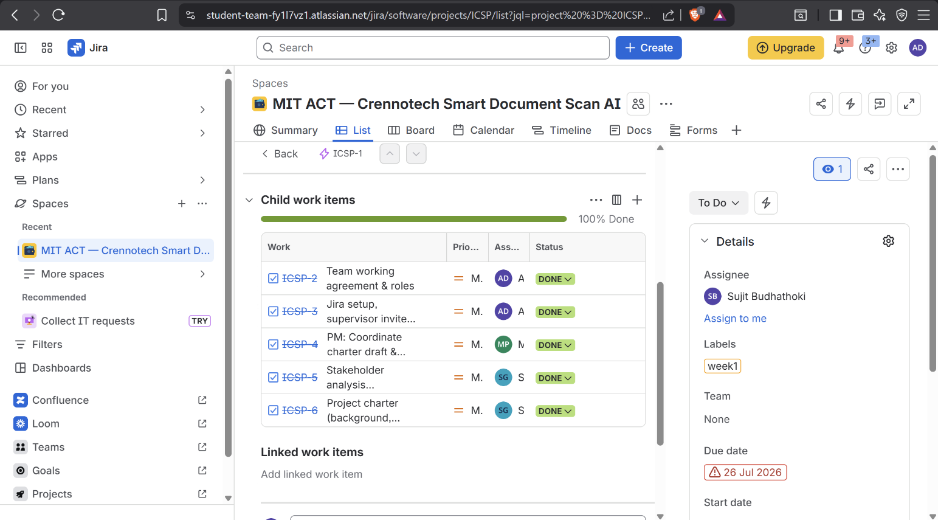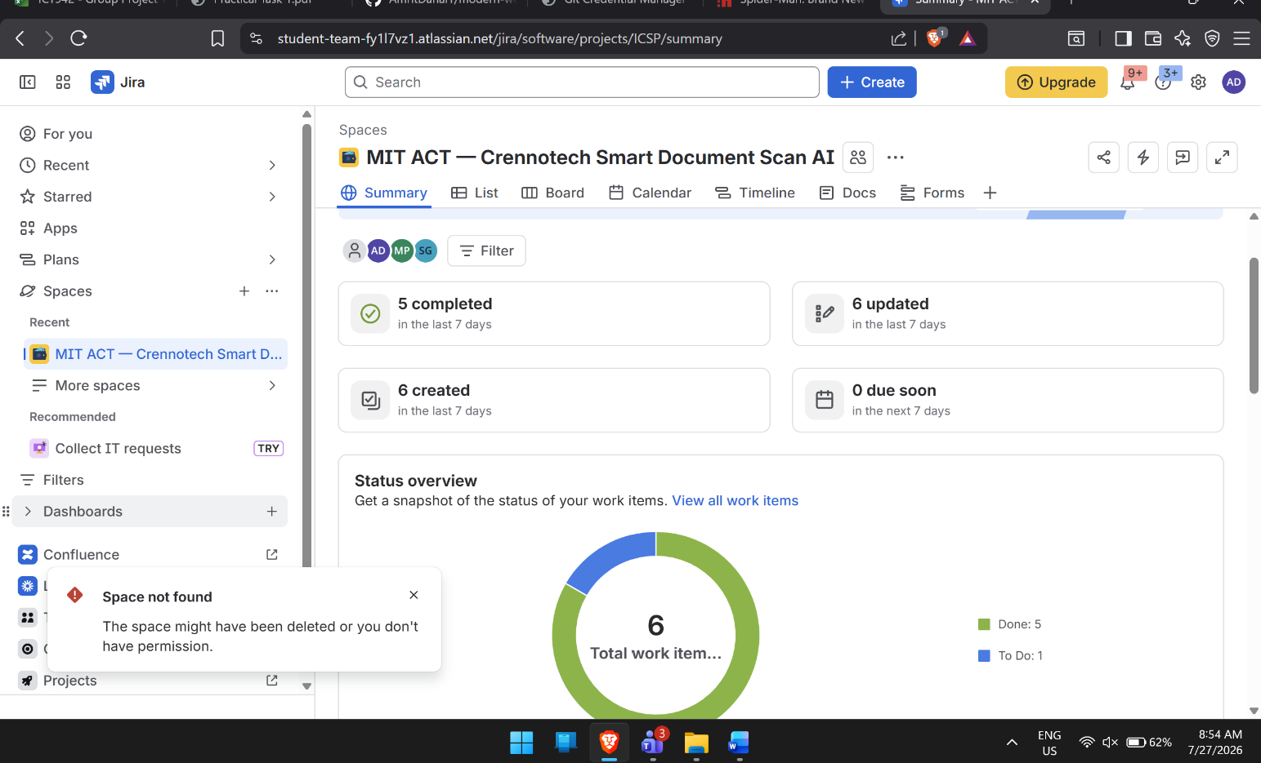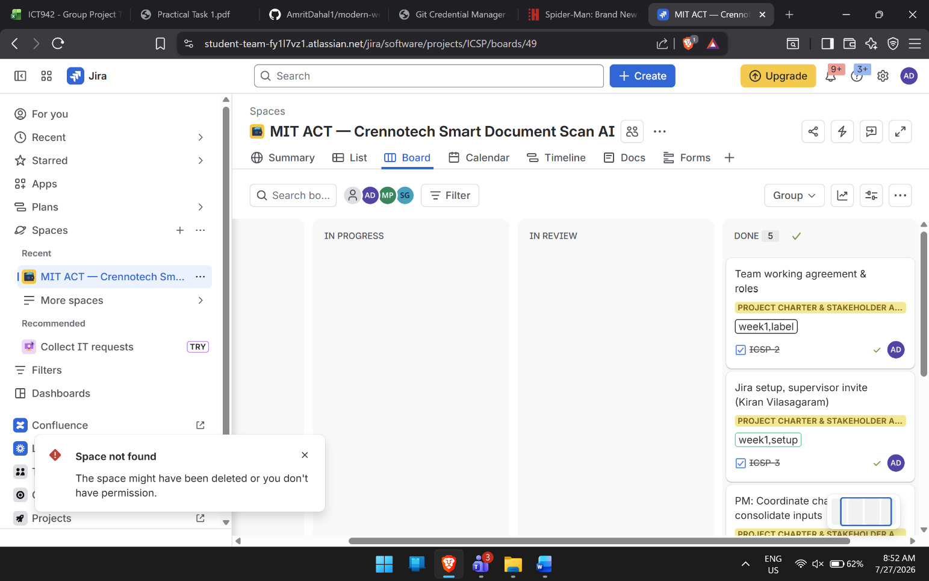

GitHub folders / commit history screenshot

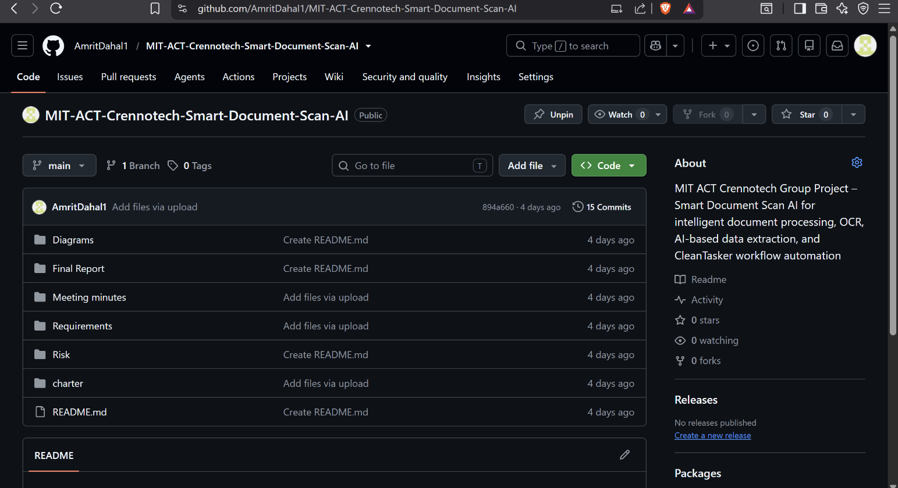

5. Meeting Minutes Summary
- Mon 20 Jul: agreed working agreement & roles; discussed the SOW problem; set up Jira/GitHub.
- Thu 23 Jul: reviewed & finalised charter and stakeholder analysis; confirmed tasks on track.

