Week 5 — Risk Register and Cybersecurity Risk Assessment
Project: SiteChat (CleanTasker site communication platform) — Crennotech Pty Ltd
Prepared by: Amrit Dahal (Project Manager), Madhab Poudel, Subham Giri, Sujit Budhathoki

1. Risk Register
Risk ID | Risk Description | Probability | Impact | Mitigation
R1 | Misconfigured Firestore security rules exposing cross-site chat data. | Medium | High | Peer-review all security rules; automated rule-testing before deployment; least-privilege design.
R2 | Former employees retaining access to site chat after offboarding. | Medium | High | Tie chat access directly to CleanTasker's active-user status; automated de-provisioning on offboarding.
R3 | Sensitive operational data leaked via chat messages or attachments. | Medium | Medium | User guidance on appropriate chat content; optional message retention/expiry policy.
R4 | Denial-of-service or abuse of Cloud Functions driving unexpected cost or downtime. | Low | Medium | Rate limiting on Cloud Functions; Firebase App Check; budget alerts.
R5 | Integration failure between SiteChat and existing CleanTasker APIs. | Medium | Medium | Early integration testing; documented API contracts; fallback error handling.
R6 | Low user adoption if SiteChat is seen as harder to use than existing channels. | Medium | Medium | Usability testing with cleaning staff; simple onboarding walkthrough.
R7 | Data-residency or compliance concern due to Firebase/Google Cloud hosting location. | Low | High | Confirm Firebase region settings; review against Crennotech's compliance obligations before build.
R8 | Further scope changes mid-project, as already experienced with the Week 4 brief pivot. | Medium | Medium | Maintain a change-log in Jira; re-baseline objectives and timeline promptly when scope changes.

2. Risk Probability–Impact Matrix
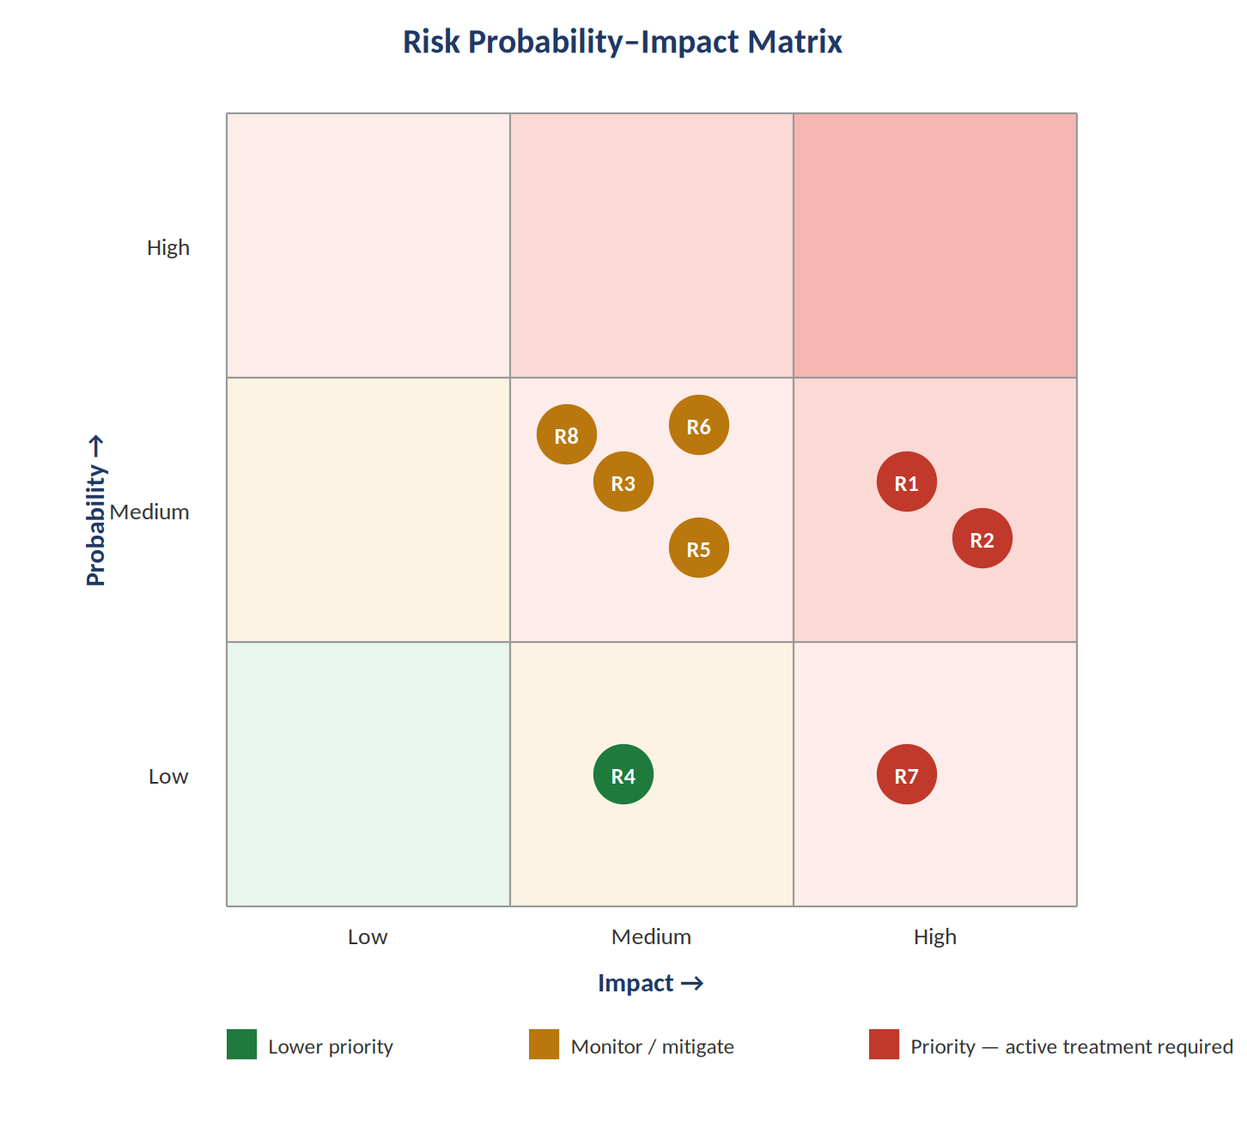
Figure: Risk probability–impact matrix for the SiteChat risk register

3. Cybersecurity Risk Assessment
Threat | Vulnerability | Impact | Control
Cross-tenant data exposure | Overly permissive or misconfigured Firestore security rules | Unauthorised access to another site's operational and chat data | Least-privilege, per-site Firestore rules; automated rule tests in CI/CD
Message injection / stored XSS | Unsanitised message content rendered in web/mobile clients | Malicious script execution in another user's client | Input sanitisation; content-security-policy headers; output encoding
Insecure client-side authentication tokens | Tokens stored or handled insecurely on mobile/web clients | Session hijacking, impersonation | Use Firebase Auth best practices; short-lived tokens; secure storage (Keychain/Keystore)
Abuse of Cloud Functions endpoints | Insufficient rate limiting on serverless functions | Service disruption, unexpected cost, denial of service | Rate limiting, Firebase App Check, monitoring and budget alerts
Unencrypted attachment storage | Shared files stored without encryption or access review | Exposure of operational documents shared in chat | Encrypt Cloud Storage buckets; signed, time-limited access URLs
Insider misuse of moderation/admin privileges | Excessive administrator permissions over chat rooms | Unauthorised reading, deletion, or manipulation of chat history | Role-based access control; audit logging of admin actions; periodic access review

