Week 7 ��� Diagrams

Proposed Architecture — C4-Style Diagram & Data Flow Narrative
SiteChat for CleanTasker Week 7 · Solution Design · Push date: 3 Sept 2026

1. C4 Level 1 — System Context
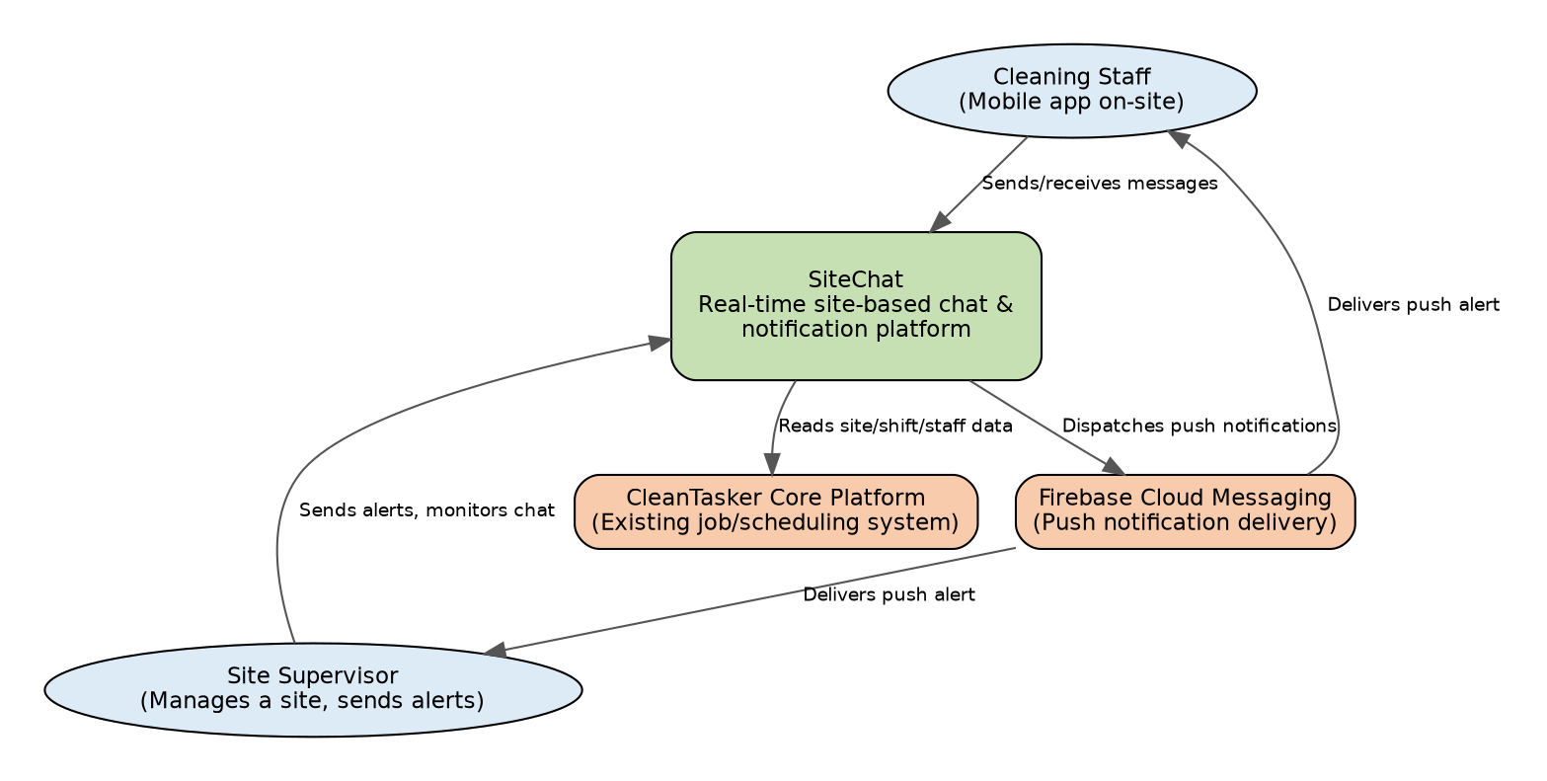
System Context Diagram

2. C4 Level 2 — Container Diagram
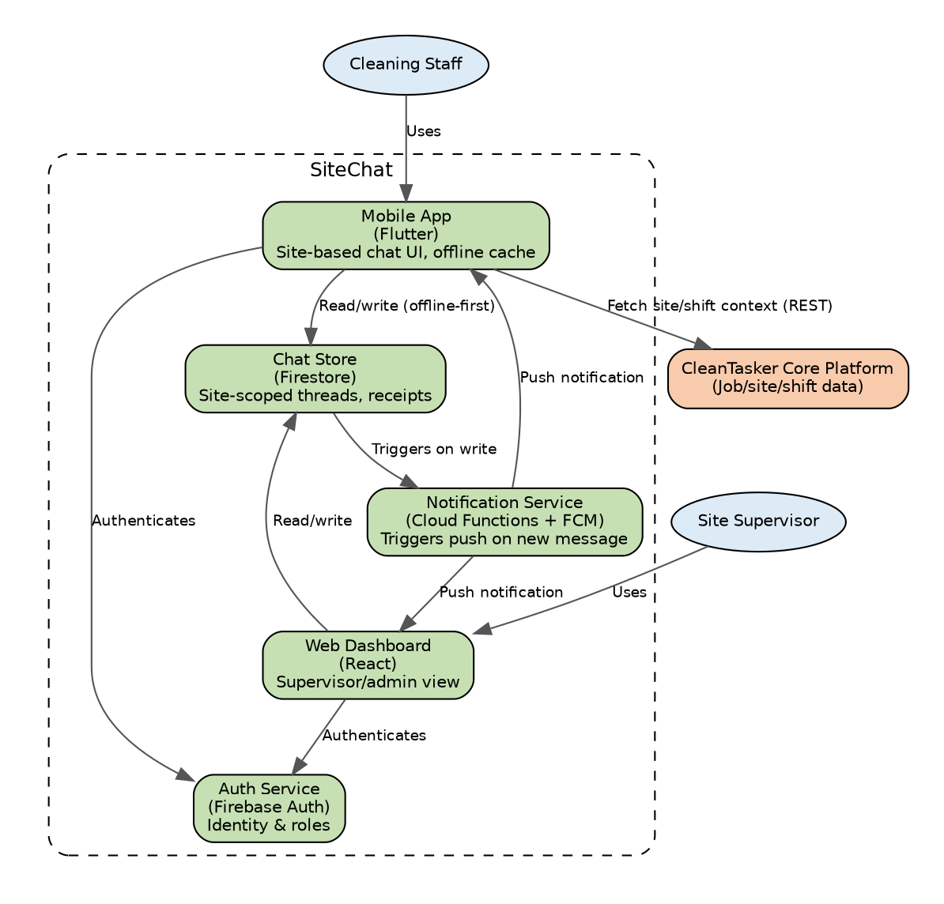
Container Diagram

3. Data Flow Narrative
- Authentication — A worker or supervisor logs into the mobile app (Flutter) or web dashboard (React) via Firebase Auth, which issues a session token scoped to their role (worker vs supervisor) and assigned site(s).
- Site context load — On login, the app fetches the user’s active site/shift assignment from the CleanTasker core platform, and joins the corresponding Firestore chat collection for that site (addresses gap G2 — site-scoped channels).
- Message send — When a user sends a message, the client writes directly to the site’s Firestore document collection. Firestore’s offline persistence queues the write locally if connectivity is poor and syncs automatically on reconnect (addresses gap G5).
- Real-time propagation — Firestore’s realtime listeners push the new message to all currently connected clients subscribed to that site’s thread (addresses gap G1).
- Notification trigger — A Cloud Function listens for new writes to the chat collection. If the message is flagged urgent, or the recipient is offline, the function calls Firebase Cloud Messaging to dispatch a push notification (addresses gap G3).
- Persistence & audit — Every message is stored permanently in Firestore with sender ID, timestamp, site ID, and read-receipt status, providing a queryable audit trail (addresses gap G4).
- Supervisor oversight — The web dashboard aggregates read access across all sites a supervisor manages, using Firestore security rules to enforce role-based visibility (partial groundwork for gap G6, full dashboard deferred to Epic 8/stretch scope).

4. Design Rationale
This architecture reuses Firebase’s integrated auth, database, and messaging stack (per the Technology & Market Survey) to minimise integration overhead within the Weeks 7–8 PoC window, while keeping the CleanTasker core platform as an external system of record for site/shift/staff data rather than duplicating it.

Contributors: Amrit (PM), Madhab, Sujit, Subham Labels: week7, solution-design

