PROJECT 2 – WEEK 4

FINAL PENETRATION TESTING REPORT AND REMEDIATION ANALYSIS

Introduction
Penetration testing is a systematic process used to identify, analyze, and evaluate security vulnerabilities within web applications. The purpose of this project was to assess the security posture of OWASP Juice Shop by performing reconnaissance, traffic analysis, API enumeration, security misconfiguration testing, and access control assessments using industry-standard tools.
Throughout the project, multiple testing phases were conducted to understand application behavior, identify weaknesses, and document findings. The final week focused on consolidating all observations, preparing proof-of-concept documentation, and providing remediation recommendations.

Objectives
The primary objectives of Week 4 were:
- To summarize all findings identified during previous phases.
- To validate discovered vulnerabilities.
- To create professional Proof-of-Concept (PoC) documentation.
- To assess the security impact of identified issues.
- To recommend remediation strategies.
- To prepare a comprehensive penetration testing report.
- To document testing evidence through screenshots and logs.

Tools Used
Tool | Purpose
Kali Linux | Penetration Testing Platform
OWASP Juice Shop | Vulnerable Target Application
Docker | Container Deployment
Burp Suite Community Edition | Traffic Analysis and Request Manipulation
Firefox Browser | Web Application Access
Nmap | Service Discovery
cURL | HTTP Analysis and API Enumeration
Gobuster | Directory Enumeration

Final Environment Verification

Commands Used
“docker ps”
“nmap -sV 127.0.0.1”

Findings
The OWASP Juice Shop application was verified to be operational throughout the assessment period. Nmap identified active services and confirmed application availability.

Figures
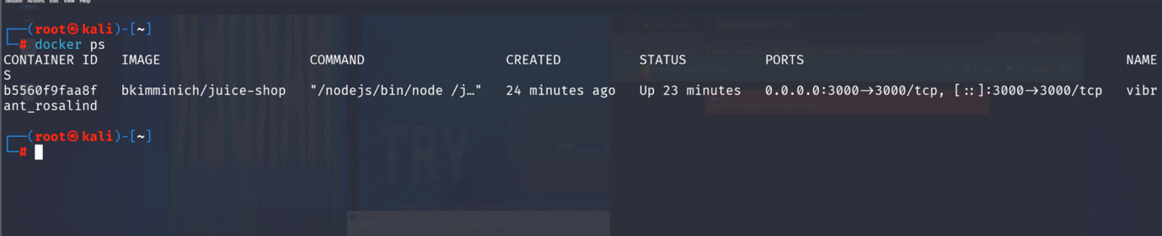
Figure 24: OWASP Juice Shop Container Running Successfully

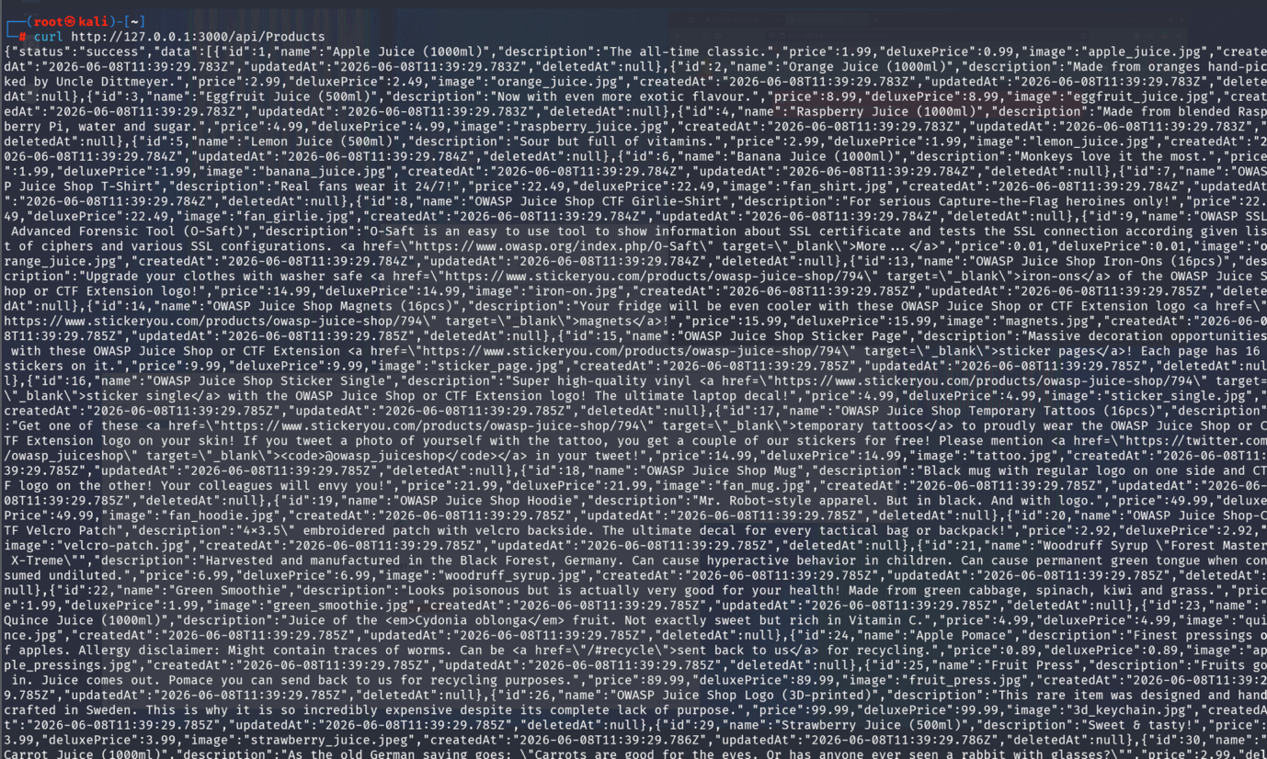
Figure 25: Final Service Enumeration Using Nmap

Testing Methodology
The assessment followed the following phases:

Phase 1: Reconnaissance
Activities:
- Service Enumeration
- Port Scanning
- Application Discovery
Tools:
“nmap -sV 127.0.0.1”

Phase 2: Traffic Analysis
Activities:
- HTTP Request Analysis
- HTTP Response Inspection
- API Enumeration
Tools:
“curl http://127.0.0.1:3000/api/Products”
“curl http://127.0.0.1:3000/api/Challenges”

Phase 3: Security Assessment
Activities:
- Security Misconfiguration Testing
- Broken Access Control Testing
- Authentication Analysis
- Input Validation Testing
Tools:
- Burp Suite
- Browser Testing
- cURL
- Gobuster

Findings and Vulnerability Assessment

Finding 1: Security Misconfiguration

Description
The application exposed administrative configuration information through publicly accessible endpoints.

Evidence
“curl http://127.0.0.1:3000/rest/admin/application-configuration”

Impact
- Information Disclosure
- Increased Attack Surface
- Reconnaissance Facilitation

Risk Level
Medium

Remediation
- Restrict Administrative Endpoints
- Implement Authentication Controls
- Disable Unnecessary Information Disclosure

Finding 2: Information Disclosure Through APIs

Description
Several APIs exposed application metadata and internal information.

Evidence
“curl http://127.0.0.1:3000/api/Products”
“curl http://127.0.0.1:3000/api/Challenges”

Impact
- Exposure of Application Structure
- Improved Attacker Reconnaissance

Risk Level
Medium

Remediation
- Limit Information Exposure
- Apply Proper Authorization Checks

Finding 3: Broken Access Control Assessment

Description
Restricted resources were tested to determine whether unauthorized access was possible.

Evidence
“#/administration”
“#/privacy-security”
“#/accounting”

Impact
Potential unauthorized access to administrative functionality.

Risk Level
Medium

Remediation
- Enforce Server-Side Authorization
- Implement Role-Based Access Control
- Deny Access by Default

Finding 4: Input Validation Testing

Description
Basic XSS payloads were tested against application input fields.

Payload
“<script>alert(1)</script>”

Result
The payload was not executed, indicating the presence of input filtering or sanitization mechanisms.

Risk Level
Low

Remediation
- Continue Input Validation
- Use Context-Aware Output Encoding

Vulnerability Summary
Vulnerability | Risk | Status
Security Misconfiguration | Medium | Identified
Information Disclosure | Medium | Identified
API Enumeration | Low | Identified
Broken Access Control Testing | Medium | Tested
Authentication Analysis | Medium | Tested
Input Validation Testing | Low | Tested

Proof-of-Concept (PoC)

Vulnerability Name
Security Misconfiguration

Description
Administrative configuration information was accessible through a publicly exposed endpoint.

Steps to Reproduce
- Open Burp Suite.
- Browse OWASP Juice Shop.
- Capture request:
“GET /rest/admin/application-configuration”
- Analyze response.
- Observe exposed configuration information.

Impact
Attackers may gain insight into application internals and use the information to facilitate future attacks.

Remediation
Restrict access to administrative APIs and implement authentication controls.

Issues Encountered and Resolutions

Issue 1: Burp Suite Traffic Capture Failure
Cause:
Incorrect browser proxy configuration.
Solution:
Configured Firefox to use Burp Proxy.
Result:
Traffic successfully captured.

Issue 2: Docker Container Accessibility Issues
Cause:
Container configuration problems.
Solution:
Restarted Docker container and verified service availability.
Result:
Application became accessible.

Issue 3: Empty Burp Site Map
Cause:
Community Edition limitations.
Solution:
Used HTTP History and Repeater for analysis.
Result:
Successfully analyzed application traffic.

Outcome
The penetration testing assessment of OWASP Juice Shop was successfully completed.

Achievements
- Reconnaissance completed.
- Traffic analysis performed.
- API endpoints identified.
- Authentication workflow analyzed.
- Security Misconfiguration tested.
- Broken Access Control assessed.
- Input validation testing performed.
- Proof-of-Concept documentation prepared.
- Remediation recommendations provided.

Conclusion
The Web Application Penetration Testing project successfully demonstrated the practical use of industry-standard tools such as Burp Suite, Nmap, Docker, Gobuster, and cURL. Multiple security assessment techniques were applied to OWASP Juice Shop to understand application behavior, identify potential weaknesses, and document security findings. The project provided valuable hands-on experience in reconnaissance, traffic analysis, vulnerability assessment, and reporting, thereby strengthening practical cybersecurity skills and knowledge.

