**APIs**

**API full form** is an **Application Programming Interface** that is a collection of communication protocols and subroutines used by various programs to communicate between them.

**How does API work?**

**Client-Server architecture**

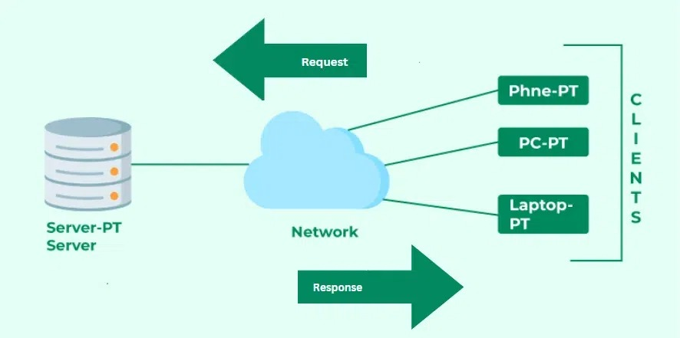

Steps followed in the working of APIs –

* The client initiates the requests via the APIs URI (Uniform Resource Identifier)
* The API makes a call to the server after receiving the request
* Then the server sends the response back to the API with the information
* Finally, the API transfers the data to the client