SCALE-Monaco-MAVRIC/DAKOTA: Distribution Checks

2019-05-17 20:46:55

### Input(s) (Samples = 240)

* Parallel batches of 15
* Total wall clock = 20199.7

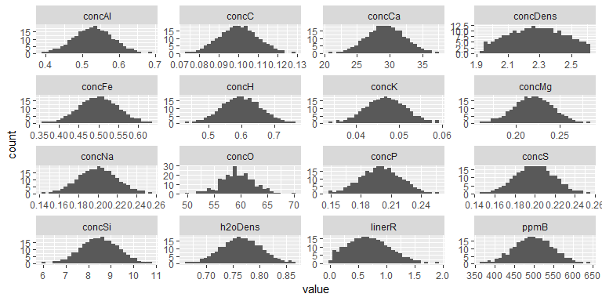

### Output(s)

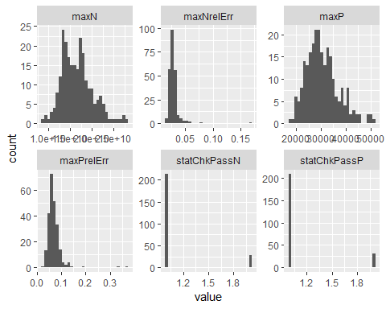

### Correlations

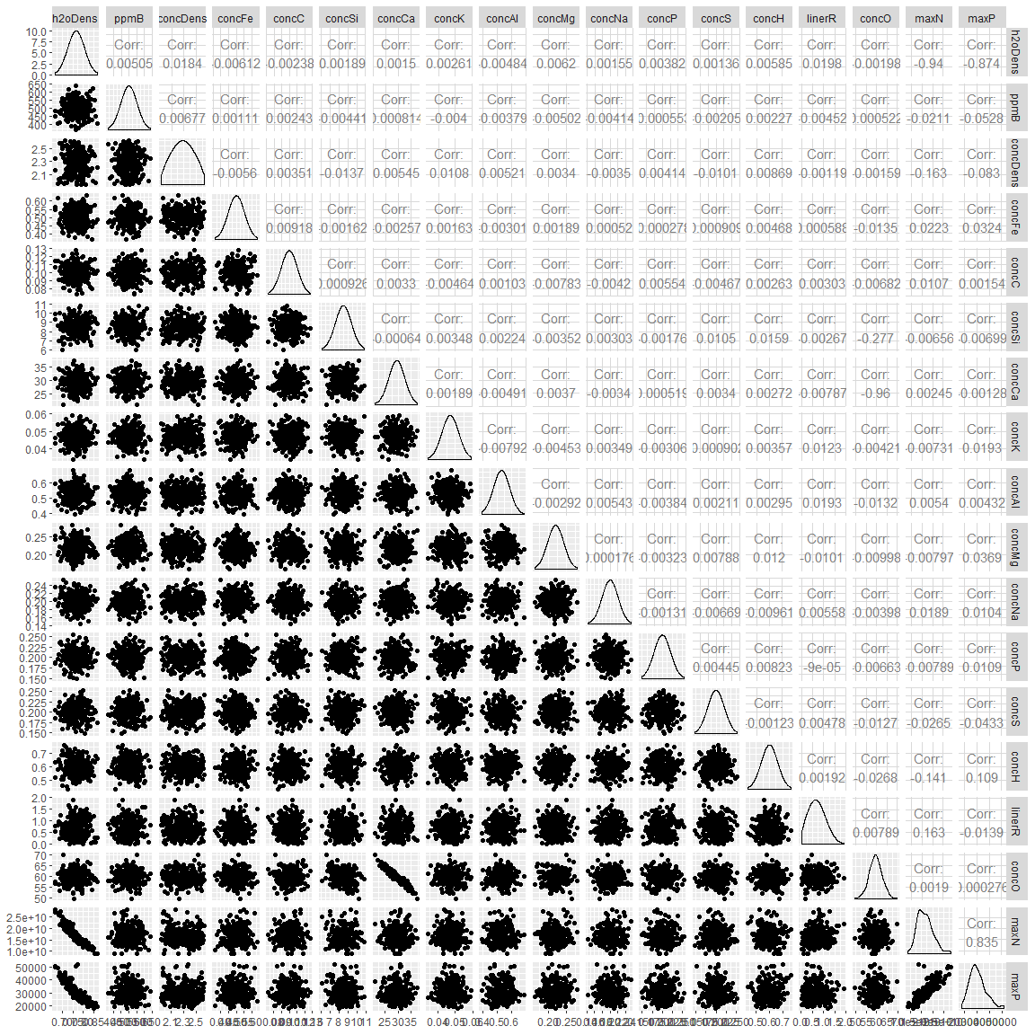

## # A tibble: 17 x 2  
## rowname maxN  
## <chr> <dbl>  
## 1 h2oDens -0.940   
## 2 maxP 0.835   
## 3 concDens -0.163   
## 4 linerR 0.163   
## 5 concH -0.141   
## 6 concS -0.0265   
## 7 concFe 0.0223   
## 8 ppmB -0.0211   
## 9 concNa 0.0189   
## 10 concC 0.0107   
## 11 concMg -0.00797  
## 12 concP -0.00789  
## 13 concK -0.00731  
## 14 concSi -0.00656  
## 15 concAl 0.00540  
## 16 concCa 0.00245  
## 17 concO 0.00190

## # A tibble: 17 x 2  
## rowname maxP  
## <chr> <dbl>  
## 1 h2oDens -0.874   
## 2 maxN 0.835   
## 3 concH 0.109   
## 4 concDens -0.0830   
## 5 ppmB -0.0528   
## 6 concS -0.0433   
## 7 concMg 0.0369   
## 8 concFe 0.0324   
## 9 concK 0.0193   
## 10 linerR -0.0139   
## 11 concP 0.0109   
## 12 concNa 0.0104   
## 13 concSi -0.00699   
## 14 concAl 0.00432   
## 15 concC 0.00154   
## 16 concCa -0.00128   
## 17 concO 0.000276

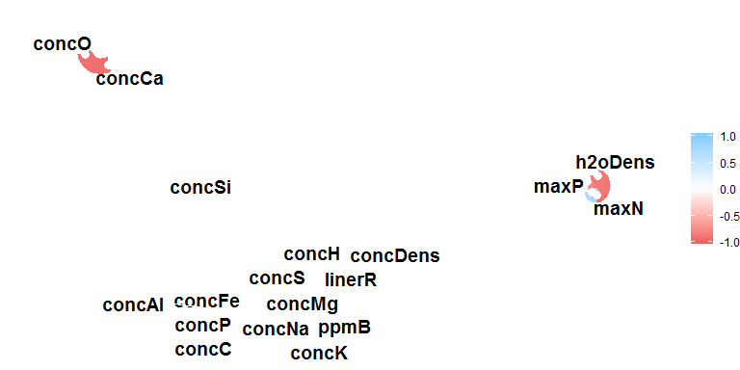

### Summary

## # A tibble: 22 x 5  
## key average sd min max  
## <chr> <dbl> <dbl> <dbl> <dbl>  
## 1 concAl 5.30e- 1 5.24e-2 3.93e-1 6.85e- 1  
## 2 concC 10.00e- 2 9.89e-3 7.29e-2 1.28e- 1  
## 3 concCa 2.94e+ 1 2.91e+0 2.10e+1 3.74e+ 1  
## 4 concDens 2.28e+ 0 1.70e-1 1.94e+0 2.62e+ 0  
## 5 concFe 5.00e- 1 4.94e-2 3.65e-1 6.33e- 1  
## 6 concH 6.00e- 1 5.92e-2 4.38e-1 7.62e- 1  
## 7 concK 4.70e- 2 4.63e-3 3.42e-2 5.90e- 2  
## 8 concMg 2.20e- 1 2.18e-2 1.61e-1 2.82e- 1  
## 9 concNa 2.00e- 1 1.98e-2 1.43e-1 2.53e- 1  
## 10 concO 5.95e+ 1 3.03e+0 4.97e+1 6.98e+ 1  
## 11 concP 2.00e- 1 1.98e-2 1.48e-1 2.54e- 1  
## 12 concS 2.00e- 1 1.97e-2 1.47e-1 2.54e- 1  
## 13 concSi 8.50e+ 0 8.41e-1 6.08e+0 1.08e+ 1  
## 14 h2oDens 7.66e- 1 3.78e-2 6.66e-1 8.67e- 1  
## 15 linerR 6.93e- 1 3.72e-1 1.17e-2 1.91e+ 0  
## 16 maxN 1.66e+10 3.56e+9 8.88e+9 2.83e+10  
## 17 maxNrelErr 2.85e- 2 1.17e-2 1.59e-2 1.68e- 1  
## 18 maxP 3.06e+ 4 6.49e+3 1.78e+4 5.17e+ 4  
## 19 maxPrelErr 7.00e- 2 3.33e-2 2.92e-2 3.75e- 1  
## 20 ppmB 5.00e+ 2 4.95e+1 3.67e+2 6.40e+ 2  
## 21 statChkPassN 1.11e+ 0 3.17e-1 1.00e+0 2.00e+ 0  
## 22 statChkPassP 1.13e+ 0 3.36e-1 1.00e+0 2.00e+ 0