SCALE-Monaco-MAVRIC/DAKOTA: Distribution Checks

2019-05-17 20:56:16

### Input(s) (Samples = 552)

* Max parallel batches of 15
* Total wall clock = 339952

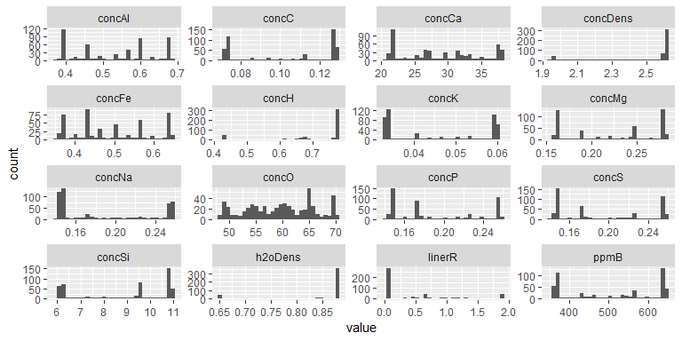

### Output(s)

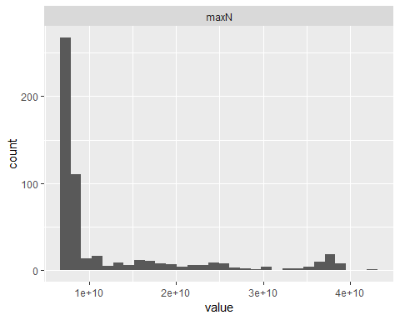

### Correlations

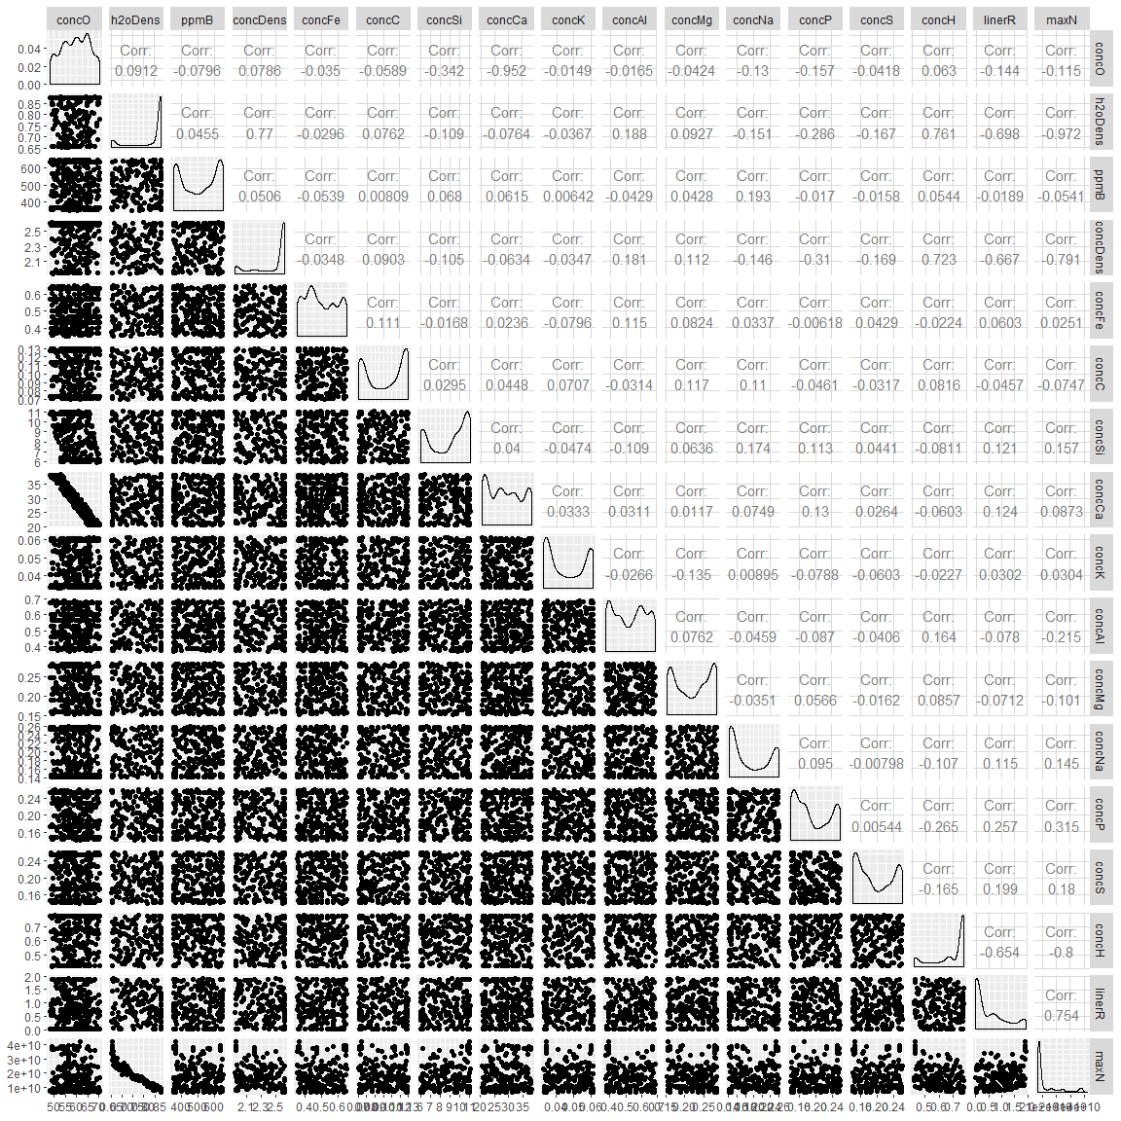

## # A tibble: 16 x 2  
## rowname maxN  
## <chr> <dbl>  
## 1 h2oDens -0.972   
## 2 concH -0.800   
## 3 concDens -0.791   
## 4 linerR 0.754   
## 5 concP 0.315   
## 6 concAl -0.215   
## 7 concS 0.180   
## 8 concSi 0.157   
## 9 concNa 0.145   
## 10 concO -0.115   
## 11 concMg -0.101   
## 12 concCa 0.0873  
## 13 concC -0.0747  
## 14 ppmB -0.0541  
## 15 concK 0.0304  
## 16 concFe 0.0251

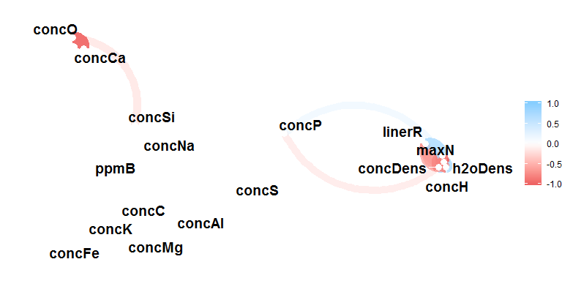

### Summary

## # A tibble: 17 x 5  
## key average sd min max  
## <chr> <dbl> <dbl> <dbl> <dbl>  
## 1 concAl 5.26e- 1 1.05e-1 3.72e-1 6.88e- 1  
## 2 concC 1.03e- 1 2.40e-2 7.03e-2 1.30e- 1  
## 3 concCa 2.88e+ 1 5.91e+0 2.06e+1 3.82e+ 1  
## 4 concDens 2.47e+ 0 2.25e-1 1.94e+0 2.62e+ 0  
## 5 concFe 4.93e- 1 9.47e-2 3.51e-1 6.49e- 1  
## 6 concH 6.94e- 1 1.18e-1 4.22e-1 7.78e- 1  
## 7 concK 4.57e- 2 1.14e-2 3.29e-2 6.11e- 2  
## 8 concMg 2.23e- 1 4.87e-2 1.54e-1 2.85e- 1  
## 9 concNa 1.88e- 1 4.83e-2 1.41e-1 2.59e- 1  
## 10 concO 5.96e+ 1 6.30e+0 4.82e+1 7.04e+ 1  
## 11 concP 1.91e- 1 4.30e-2 1.40e-1 2.60e- 1  
## 12 concS 1.94e- 1 4.46e-2 1.40e-1 2.60e- 1  
## 13 concSi 8.94e+ 0 1.92e+0 5.97e+0 1.10e+ 1  
## 14 h2oDens 8.32e- 1 7.61e-2 6.52e-1 8.80e- 1  
## 15 linerR 5.19e- 1 6.26e-1 1.11e-2 1.91e+ 0  
## 16 maxN 1.24e+10 8.94e+9 6.70e+9 4.20e+10  
## 17 ppmB 5.05e+ 2 1.14e+2 3.52e+2 6.50e+ 2