SCALE-Monaco-MAVRIC/DAKOTA: Distribution Checks

2019-05-18 11:49:54

### Input(s) (Samples = 625)

* Max parallel batches of 15
* Total wall clock = 53039.8

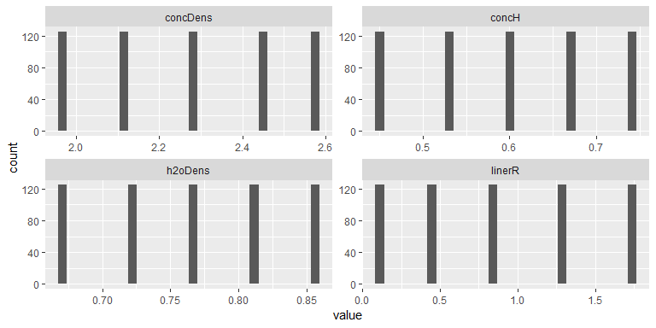

### Output(s)

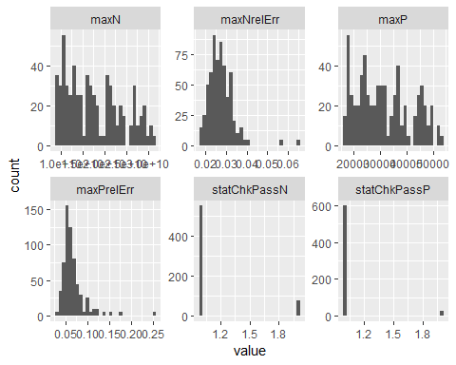

### Correlations

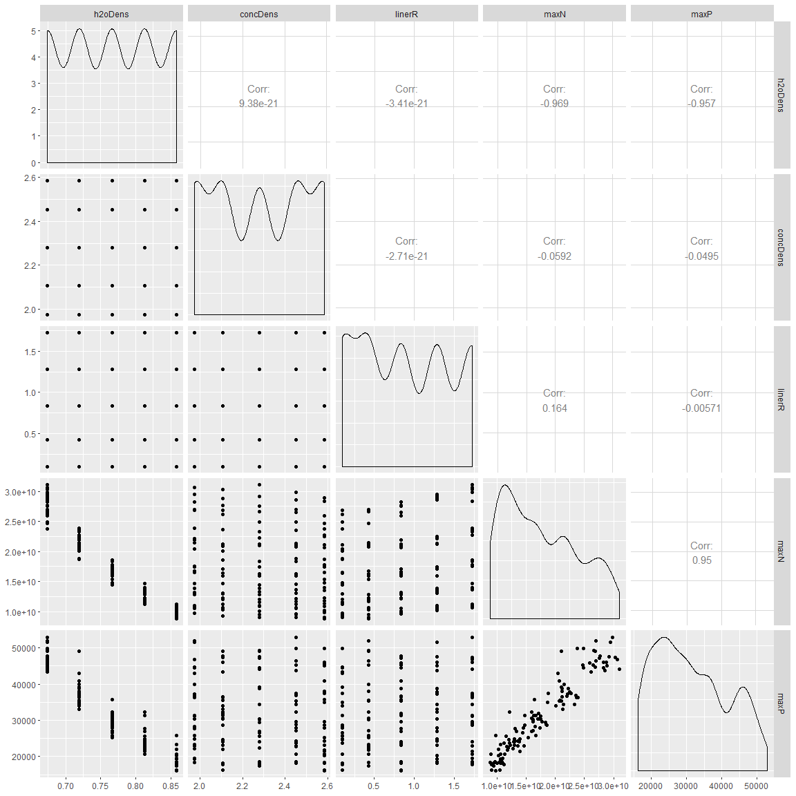

## # A tibble: 5 x 2  
## rowname maxN  
## <chr> <dbl>  
## 1 h2oDens -9.69e- 1  
## 2 maxP 9.50e- 1  
## 3 linerR 1.64e- 1  
## 4 concDens -5.92e- 2  
## 5 concH -2.14e-21

## # A tibble: 5 x 2  
## rowname maxP  
## <chr> <dbl>  
## 1 h2oDens -9.57e- 1  
## 2 maxN 9.50e- 1  
## 3 concDens -4.95e- 2  
## 4 linerR -5.71e- 3  
## 5 concH 3.72e-21

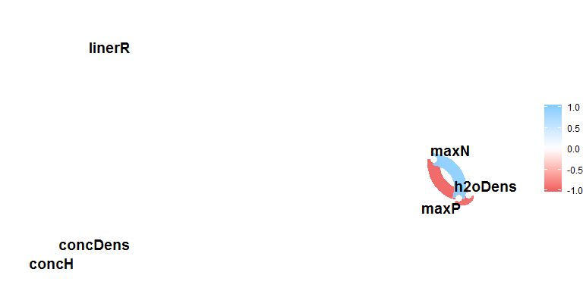

### Summary

## # A tibble: 10 x 5  
## key average sd min max  
## <chr> <dbl> <dbl> <dbl> <dbl>  
## 1 concDens 2.28e+ 0 2.21e-1 1.98e+0 2.58e+ 0  
## 2 concH 6.00e- 1 1.03e-1 4.55e-1 7.45e- 1  
## 3 h2oDens 7.66e- 1 6.56e-2 6.73e-1 8.59e- 1  
## 4 linerR 8.73e- 1 5.82e-1 9.91e-2 1.72e+ 0  
## 5 maxN 1.77e+10 6.36e+9 8.83e+9 3.10e+10  
## 6 maxNrelErr 2.75e- 2 6.29e-3 1.77e-2 6.47e- 2  
## 7 maxP 3.15e+ 4 1.02e+4 1.61e+4 5.30e+ 4  
## 8 maxPrelErr 6.74e- 2 2.83e-2 3.36e-2 2.56e- 1  
## 9 statChkPassN 1.12e+ 0 3.27e-1 1.00e+0 2.00e+ 0  
## 10 statChkPassP 1.04e+ 0 2.03e-1 1.00e+0 2.00e+ 0