SCALE-MAVRIC/DAKOTA Input/Output Data Summaries

2019-05-22 20:07:58

### Samples = 240

* Parallel batches of 15
* Total wall clock = 29476.4

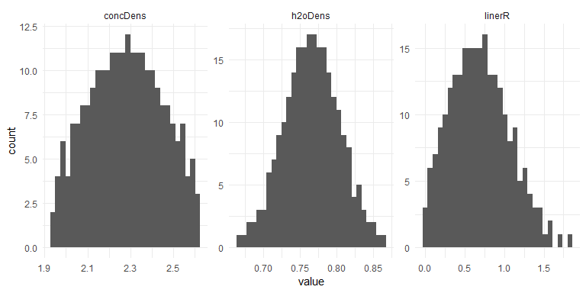

## Warning: Removed 4600 rows containing missing values (geom_path).

## Warning: Removed 4600 rows containing missing values (geom_errorbar).

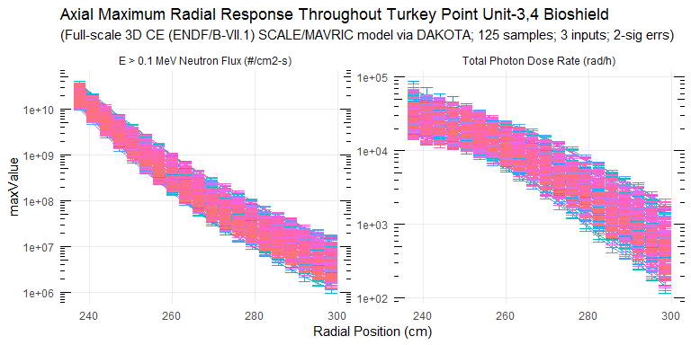

### Response Summary Statistics

## rPos case maxNradial   
## Min. :237.6 Length:4800 Min. :1.139e+06   
## 1st Qu.:252.8 Class :character 1st Qu.:1.962e+07   
## Median :268.0 Mode :character Median :1.250e+08   
## Mean :268.0 Mean :2.281e+09   
## 3rd Qu.:283.2 3rd Qu.:1.359e+09   
## Max. :298.4 Max. :3.790e+10   
## NA's :2300   
## maxNradialErr maxPradial maxPradialErr maxNradialRelErr  
## Min. :9.564e+04 Min. : 145.2 Min. : 12.75 Min. :0.0166   
## 1st Qu.:1.345e+06 1st Qu.: 2033.0 1st Qu.: 123.34 1st Qu.:0.0402   
## Median :6.818e+06 Median : 7028.6 Median : 363.22 Median :0.0544   
## Mean :7.933e+07 Mean :11194.5 Mean : 720.68 Mean :0.0561   
## 3rd Qu.:5.422e+07 3rd Qu.:17429.7 3rd Qu.: 978.53 3rd Qu.:0.0697   
## Max. :1.937e+09 Max. :66374.7 Max. :10926.70 Max. :0.1241   
## NA's :2300 NA's :2300 NA's :2300 NA's :2300   
## maxPradialRelErr  
## Min. :0.0233   
## 1st Qu.:0.0497   
## Median :0.0589   
## Mean :0.0628   
## 3rd Qu.:0.0720   
## Max. :0.2291   
## NA's :2300

### DAKOTA Input/Output Summary Statistics

## # A tibble: 83 x 5  
## key average sd min max  
## <chr> <dbl> <dbl> <dbl> <dbl>  
## 1 concDens 2.28e+ 0 1.70e-1 1.94e+ 0 2.62e+ 0  
## 2 h2oDens 7.66e- 1 3.78e-2 6.68e- 1 8.66e- 1  
## 3 linerR 6.93e- 1 3.71e-1 5.29e- 3 1.84e+ 0  
## 4 maxNradial_1 1.90e+10 4.10e+9 1.08e+10 3.28e+10  
## 5 maxNradial_10 1.58e+ 8 5.79e+7 5.79e+ 7 4.54e+ 8  
## 6 maxNradial_11 1.04e+ 8 3.95e+7 3.78e+ 7 2.93e+ 8  
## 7 maxNradial_12 7.04e+ 7 2.65e+7 2.48e+ 7 1.88e+ 8  
## 8 maxNradial_13 4.83e+ 7 1.87e+7 1.67e+ 7 1.20e+ 8  
## 9 maxNradial_14 3.39e+ 7 1.35e+7 1.17e+ 7 8.64e+ 7  
## 10 maxNradial_15 2.41e+ 7 9.95e+6 7.97e+ 6 6.41e+ 7  
## 11 maxNradial_16 1.72e+ 7 7.25e+6 5.65e+ 6 4.89e+ 7  
## 12 maxNradial_17 1.25e+ 7 5.37e+6 3.69e+ 6 3.58e+ 7  
## 13 maxNradial_18 9.09e+ 6 4.01e+6 2.63e+ 6 2.42e+ 7  
## 14 maxNradial_19 6.67e+ 6 3.03e+6 1.94e+ 6 1.79e+ 7  
## 15 maxNradial_2 1.02e+10 2.20e+9 5.80e+ 9 1.89e+10  
## 16 maxNradial_20 4.91e+ 6 2.40e+6 1.48e+ 6 1.60e+ 7  
## 17 maxNradial_3 5.58e+ 9 1.28e+9 3.18e+ 9 1.13e+10  
## 18 maxNradial_4 3.13e+ 9 7.79e+8 1.72e+ 9 6.43e+ 9  
## 19 maxNradial_5 1.80e+ 9 4.84e+8 9.33e+ 8 3.75e+ 9  
## 20 maxNradial_6 1.05e+ 9 3.04e+8 5.12e+ 8 2.37e+ 9  
## 21 maxNradial_7 6.31e+ 8 1.95e+8 2.83e+ 8 1.48e+ 9  
## 22 maxNradial_8 3.88e+ 8 1.28e+8 1.61e+ 8 9.45e+ 8  
## 23 maxNradial_9 2.44e+ 8 8.50e+7 9.67e+ 7 6.27e+ 8  
## 24 maxNradialErr_1 6.88e+ 8 6.99e+8 3.00e+ 8 1.03e+10  
## 25 maxNradialErr_10 8.57e+ 6 3.18e+6 3.14e+ 6 2.25e+ 7  
## 26 maxNradialErr_11 5.88e+ 6 2.29e+6 1.95e+ 6 1.64e+ 7  
## 27 maxNradialErr_12 4.21e+ 6 1.50e+6 1.41e+ 6 1.03e+ 7  
## 28 maxNradialErr_13 3.01e+ 6 1.16e+6 1.02e+ 6 7.74e+ 6  
## 29 maxNradialErr_14 2.18e+ 6 8.69e+5 7.17e+ 5 5.80e+ 6  
## 30 maxNradialErr_15 1.65e+ 6 6.90e+5 5.48e+ 5 4.14e+ 6  
## 31 maxNradialErr_16 1.20e+ 6 5.04e+5 3.51e+ 5 2.85e+ 6  
## 32 maxNradialErr_17 9.07e+ 5 3.94e+5 2.38e+ 5 2.37e+ 6  
## 33 maxNradialErr_18 6.96e+ 5 3.08e+5 1.78e+ 5 1.52e+ 6  
## 34 maxNradialErr_19 5.38e+ 5 2.44e+5 1.58e+ 5 1.31e+ 6  
## 35 maxNradialErr_2 3.52e+ 8 9.79e+7 1.70e+ 8 7.91e+ 8  
## 36 maxNradialErr_20 4.28e+ 5 2.12e+5 1.09e+ 5 1.31e+ 6  
## 37 maxNradialErr_3 2.02e+ 8 5.45e+7 9.11e+ 7 5.30e+ 8  
## 38 maxNradialErr_4 1.17e+ 8 3.26e+7 5.46e+ 7 2.63e+ 8  
## 39 maxNradialErr_5 7.04e+ 7 2.20e+7 2.97e+ 7 1.63e+ 8  
## 40 maxNradialErr_6 4.40e+ 7 1.40e+7 1.63e+ 7 1.16e+ 8  
## 41 maxNradialErr_7 2.90e+ 7 1.02e+7 1.27e+ 7 8.39e+ 7  
## 42 maxNradialErr_8 1.83e+ 7 6.57e+6 7.36e+ 6 4.90e+ 7  
## 43 maxNradialErr_9 1.24e+ 7 4.58e+6 3.70e+ 6 3.44e+ 7  
## 44 maxPradial_1 3.27e+ 4 6.74e+3 2.01e+ 4 6.41e+ 4  
## 45 maxPradial_10 8.02e+ 3 2.14e+3 3.82e+ 3 1.76e+ 4  
## 46 maxPradial_11 6.39e+ 3 1.77e+3 2.97e+ 3 1.35e+ 4  
## 47 maxPradial_12 5.04e+ 3 1.49e+3 2.30e+ 3 1.13e+ 4  
## 48 maxPradial_13 3.95e+ 3 1.24e+3 1.65e+ 3 9.11e+ 3  
## 49 maxPradial_14 3.06e+ 3 1.02e+3 1.25e+ 3 7.32e+ 3  
## 50 maxPradial_15 2.36e+ 3 8.26e+2 9.42e+ 2 5.85e+ 3  
## 51 maxPradial_16 1.81e+ 3 6.75e+2 6.92e+ 2 5.06e+ 3  
## 52 maxPradial_17 1.38e+ 3 5.46e+2 4.86e+ 2 4.12e+ 3  
## 53 maxPradial_18 1.06e+ 3 4.45e+2 3.38e+ 2 3.24e+ 3  
## 54 maxPradial_19 8.07e+ 2 3.53e+2 2.45e+ 2 2.45e+ 3  
## 55 maxPradial_2 2.74e+ 4 5.57e+3 1.48e+ 4 4.42e+ 4  
## 56 maxPradial_20 6.14e+ 2 2.77e+2 1.82e+ 2 1.84e+ 3  
## 57 maxPradial_3 2.48e+ 4 5.21e+3 1.37e+ 4 4.41e+ 4  
## 58 maxPradial_4 2.24e+ 4 4.71e+3 1.20e+ 4 3.86e+ 4  
## 59 maxPradial_5 1.99e+ 4 4.23e+3 1.03e+ 4 3.38e+ 4  
## 60 maxPradial_6 1.73e+ 4 3.86e+3 9.26e+ 3 3.13e+ 4  
## 61 maxPradial_7 1.46e+ 4 3.30e+3 7.98e+ 3 2.77e+ 4  
## 62 maxPradial_8 1.22e+ 4 2.90e+3 6.52e+ 3 2.49e+ 4  
## 63 maxPradial_9 9.93e+ 3 2.50e+3 5.07e+ 3 2.13e+ 4  
## 64 maxPradialErr_1 3.03e+ 3 2.48e+3 1.29e+ 3 3.53e+ 4  
## 65 maxPradialErr_10 4.05e+ 2 1.55e+2 1.63e+ 2 1.34e+ 3  
## 66 maxPradialErr_11 3.33e+ 2 1.29e+2 1.04e+ 2 1.18e+ 3  
## 67 maxPradialErr_12 2.72e+ 2 1.14e+2 8.01e+ 1 1.12e+ 3  
## 68 maxPradialErr_13 2.22e+ 2 9.40e+1 5.00e+ 1 7.74e+ 2  
## 69 maxPradialErr_14 1.78e+ 2 7.40e+1 4.89e+ 1 5.93e+ 2  
## 70 maxPradialErr_15 1.45e+ 2 6.14e+1 4.62e+ 1 5.06e+ 2  
## 71 maxPradialErr_16 1.16e+ 2 4.92e+1 4.09e+ 1 3.99e+ 2  
## 72 maxPradialErr_17 9.26e+ 1 3.92e+1 3.15e+ 1 2.91e+ 2  
## 73 maxPradialErr_18 7.55e+ 1 3.46e+1 2.10e+ 1 2.28e+ 2  
## 74 maxPradialErr_19 6.11e+ 1 2.77e+1 1.64e+ 1 1.68e+ 2  
## 75 maxPradialErr_2 2.18e+ 3 8.98e+2 8.88e+ 2 8.78e+ 3  
## 76 maxPradialErr_20 5.02e+ 1 2.32e+1 9.85e+ 0 1.48e+ 2  
## 77 maxPradialErr_3 1.71e+ 3 6.28e+2 6.70e+ 2 4.32e+ 3  
## 78 maxPradialErr_4 1.37e+ 3 4.60e+2 6.36e+ 2 3.38e+ 3  
## 79 maxPradialErr_5 1.11e+ 3 4.05e+2 4.20e+ 2 2.99e+ 3  
## 80 maxPradialErr_6 9.20e+ 2 3.44e+2 4.23e+ 2 3.06e+ 3  
## 81 maxPradialErr_7 7.63e+ 2 2.82e+2 3.42e+ 2 2.74e+ 3  
## 82 maxPradialErr_8 6.19e+ 2 2.31e+2 3.08e+ 2 1.91e+ 3  
## 83 maxPradialErr_9 5.05e+ 2 1.93e+2 1.96e+ 2 1.59e+ 3

### Absolute/Relative Uncertainty Data

## # A tibble: 40 x 8  
## type rCoords average sd min max unc1Sig uncMax  
## <chr> <dbl> <dbl> <dbl> <dbl> <dbl> <dbl> <dbl>  
## 1 E > 0.1 MeV~ 238. 1.90e10 4.10e9 1.08e10 3.28e10 21.5 72.4  
## 2 E > 0.1 MeV~ 241. 1.02e10 2.20e9 5.80e 9 1.89e10 21.5 85.1  
## 3 E > 0.1 MeV~ 244 5.58e 9 1.28e9 3.18e 9 1.13e10 22.8 102.   
## 4 E > 0.1 MeV~ 247. 3.13e 9 7.79e8 1.72e 9 6.43e 9 24.9 105.   
## 5 E > 0.1 MeV~ 250. 1.80e 9 4.84e8 9.33e 8 3.75e 9 26.9 109.   
## 6 E > 0.1 MeV~ 254. 1.05e 9 3.04e8 5.12e 8 2.37e 9 28.9 125.   
## 7 E > 0.1 MeV~ 257. 6.31e 8 1.95e8 2.83e 8 1.48e 9 30.9 134.   
## 8 E > 0.1 MeV~ 260 3.88e 8 1.28e8 1.61e 8 9.45e 8 32.9 144.   
## 9 E > 0.1 MeV~ 263. 2.44e 8 8.50e7 9.67e 7 6.27e 8 34.9 157.   
## 10 E > 0.1 MeV~ 266. 1.58e 8 5.79e7 5.79e 7 4.54e 8 36.7 188.   
## 11 E > 0.1 MeV~ 270. 1.04e 8 3.95e7 3.78e 7 2.93e 8 37.9 181.   
## 12 E > 0.1 MeV~ 273. 7.04e 7 2.65e7 2.48e 7 1.88e 8 37.6 168.   
## 13 E > 0.1 MeV~ 276 4.83e 7 1.87e7 1.67e 7 1.20e 8 38.6 148.   
## 14 E > 0.1 MeV~ 279. 3.39e 7 1.35e7 1.17e 7 8.64e 7 39.7 155.   
## 15 E > 0.1 MeV~ 282. 2.41e 7 9.95e6 7.97e 6 6.41e 7 41.3 167.   
## 16 E > 0.1 MeV~ 286. 1.72e 7 7.25e6 5.65e 6 4.89e 7 42.1 184.   
## 17 E > 0.1 MeV~ 289. 1.25e 7 5.37e6 3.69e 6 3.58e 7 43.1 187.   
## 18 E > 0.1 MeV~ 292 9.09e 6 4.01e6 2.63e 6 2.42e 7 44.1 166.   
## 19 E > 0.1 MeV~ 295. 6.67e 6 3.03e6 1.94e 6 1.79e 7 45.5 168.   
## 20 E > 0.1 MeV~ 298. 4.91e 6 2.40e6 1.48e 6 1.60e 7 48.8 225.   
## 21 Total Photo~ 238. 3.27e 4 6.74e3 2.01e 4 6.41e 4 20.6 96.2  
## 22 Total Photo~ 241. 2.74e 4 5.57e3 1.48e 4 4.42e 4 20.4 61.6  
## 23 Total Photo~ 244 2.48e 4 5.21e3 1.37e 4 4.41e 4 21.1 78.3  
## 24 Total Photo~ 247. 2.24e 4 4.71e3 1.20e 4 3.86e 4 21.1 72.5  
## 25 Total Photo~ 250. 1.99e 4 4.23e3 1.03e 4 3.38e 4 21.3 69.7  
## 26 Total Photo~ 254. 1.73e 4 3.86e3 9.26e 3 3.13e 4 22.4 81.4  
## 27 Total Photo~ 257. 1.46e 4 3.30e3 7.98e 3 2.77e 4 22.6 89.8  
## 28 Total Photo~ 260 1.22e 4 2.90e3 6.52e 3 2.49e 4 23.8 104.   
## 29 Total Photo~ 263. 9.93e 3 2.50e3 5.07e 3 2.13e 4 25.1 114.   
## 30 Total Photo~ 266. 8.02e 3 2.14e3 3.82e 3 1.76e 4 26.7 120.   
## 31 Total Photo~ 270. 6.39e 3 1.77e3 2.97e 3 1.35e 4 27.7 111.   
## 32 Total Photo~ 273. 5.04e 3 1.49e3 2.30e 3 1.13e 4 29.6 125.   
## 33 Total Photo~ 276 3.95e 3 1.24e3 1.65e 3 9.11e 3 31.5 131.   
## 34 Total Photo~ 279. 3.06e 3 1.02e3 1.25e 3 7.32e 3 33.3 139.   
## 35 Total Photo~ 282. 2.36e 3 8.26e2 9.42e 2 5.85e 3 35.0 148.   
## 36 Total Photo~ 286. 1.81e 3 6.75e2 6.92e 2 5.06e 3 37.3 180.   
## 37 Total Photo~ 289. 1.38e 3 5.46e2 4.86e 2 4.12e 3 39.4 197.   
## 38 Total Photo~ 292 1.06e 3 4.45e2 3.38e 2 3.24e 3 41.9 205.   
## 39 Total Photo~ 295. 8.07e 2 3.53e2 2.45e 2 2.45e 3 43.7 204.   
## 40 Total Photo~ 298. 6.14e 2 2.77e2 1.82e 2 1.84e 3 45.2 200.

### Neutron Fluence (E > 1 MeV) and Total Photon Dose Relative Uncertainty

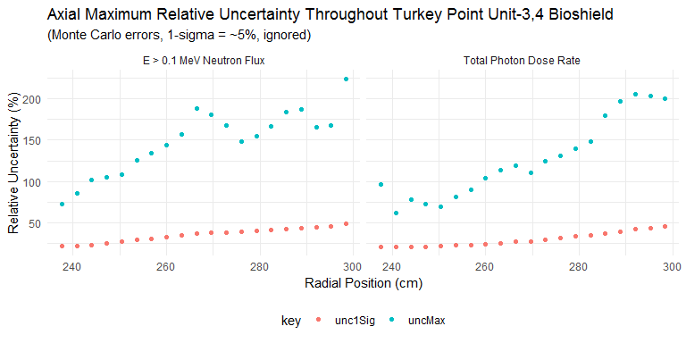

### Penetration Depth Underprediction Due to Lack of Analytic (Epistemic) Uncertainty Treatment of Bioshield Materials

Radiation penetration depths (in centimeters) up to defined thresholds.

|  |  |  |  |  |
| --- | --- | --- | --- | --- |
| type | BE | maxUnc | absDiff | relDiff |
| neutron | 245.6 | 249.6233 | -4.023331 | -0.0163816 |
| photon | 255.2 | 267.7568 | -12.556753 | -0.0492036 |