SCALE-MAVRIC/DAKOTA Input/Output Data Summaries

2019-05-21 18:56:09

### Samples = 240

* Parallel batches of 15
* Total wall clock = 26926

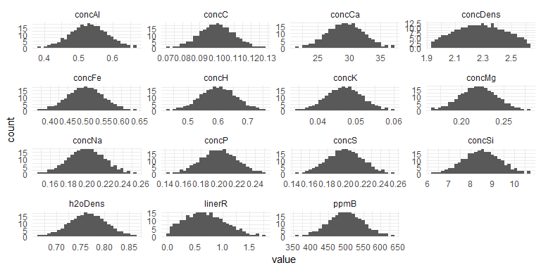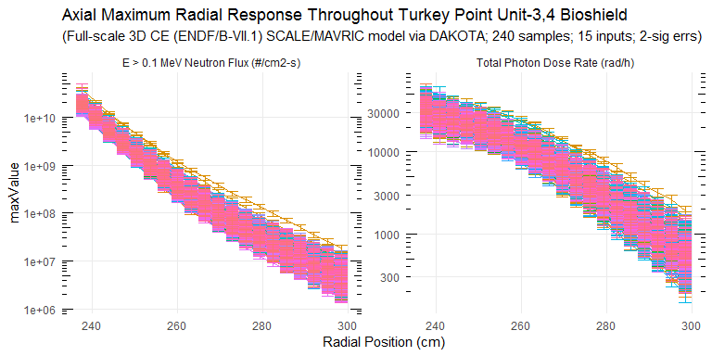

### Response Summary Statistics

## rPos case maxNradial   
## Min. :237.6 Length:4800 Min. :1.659e+06   
## 1st Qu.:252.8 Class :character 1st Qu.:1.937e+07   
## Median :268.0 Mode :character Median :1.244e+08   
## Mean :268.0 Mean :2.142e+09   
## 3rd Qu.:283.2 3rd Qu.:1.354e+09   
## Max. :298.4 Max. :3.870e+10   
## maxNradialErr maxPradial maxPradialErr   
## Min. :1.224e+05 Min. : 184.9 Min. : 15.63   
## 1st Qu.:1.360e+06 1st Qu.: 1995.9 1st Qu.: 122.88   
## Median :6.749e+06 Median : 6987.6 Median : 355.00   
## Mean :7.944e+07 Mean :10716.6 Mean : 694.98   
## 3rd Qu.:5.423e+07 3rd Qu.:17757.3 3rd Qu.: 963.63   
## Max. :8.435e+09 Max. :54120.7 Max. :10688.25   
## maxNradialRelErr maxPradialRelErr   
## Min. :0.01733 Min. :0.02493   
## 1st Qu.:0.04116 1st Qu.:0.04926   
## Median :0.05414 Median :0.05848   
## Mean :0.05700 Mean :0.06325   
## 3rd Qu.:0.07013 3rd Qu.:0.07268   
## Max. :0.25484 Max. :0.23737

### DAKOTA Input/Output Summary Statistics

## # A tibble: 95 x 5  
## key average sd min max  
## <chr> <dbl> <dbl> <dbl> <dbl>  
## 1 concAl 5.30e- 1 5.22e-2 3.86e- 1 6.65e- 1  
## 2 concC 1.00e- 1 9.92e-3 7.18e- 2 1.28e- 1  
## 3 concCa 2.94e+ 1 2.90e+0 2.16e+ 1 3.69e+ 1  
## 4 concDens 2.28e+ 0 1.70e-1 1.94e+ 0 2.62e+ 0  
## 5 concFe 5.00e- 1 4.94e-2 3.66e- 1 6.34e- 1  
## 6 concH 6.00e- 1 5.94e-2 4.36e- 1 7.57e- 1  
## 7 concK 4.70e- 2 4.64e-3 3.50e- 2 6.01e- 2  
## 8 concMg 2.20e- 1 2.17e-2 1.64e- 1 2.78e- 1  
## 9 concNa 2.00e- 1 1.97e-2 1.49e- 1 2.54e- 1  
## 10 concP 2.00e- 1 1.97e-2 1.45e- 1 2.52e- 1  
## 11 concS 2.00e- 1 1.97e-2 1.47e- 1 2.56e- 1  
## 12 concSi 8.50e+ 0 8.39e-1 6.30e+ 0 1.07e+ 1  
## 13 h2oDens 7.66e- 1 3.77e-2 6.65e- 1 8.63e- 1  
## 14 linerR 6.93e- 1 3.71e-1 3.52e- 3 1.77e+ 0  
## 15 maxNradial_1 1.91e+10 4.36e+9 1.14e+10 3.87e+10  
## 16 maxNradial_10 1.61e+ 8 6.82e+7 7.12e+ 7 5.47e+ 8  
## 17 maxNradial_11 1.06e+ 8 4.59e+7 4.63e+ 7 3.79e+ 8  
## 18 maxNradial_12 7.16e+ 7 3.16e+7 2.99e+ 7 2.58e+ 8  
## 19 maxNradial_13 4.94e+ 7 2.27e+7 1.89e+ 7 1.93e+ 8  
## 20 maxNradial_14 3.45e+ 7 1.63e+7 1.27e+ 7 1.36e+ 8  
## 21 maxNradial_15 2.46e+ 7 1.19e+7 9.12e+ 6 9.80e+ 7  
## 22 maxNradial_16 1.76e+ 7 8.60e+6 6.48e+ 6 7.04e+ 7  
## 23 maxNradial_17 1.27e+ 7 6.29e+6 4.74e+ 6 5.00e+ 7  
## 24 maxNradial_18 9.29e+ 6 4.73e+6 3.27e+ 6 3.53e+ 7  
## 25 maxNradial_19 6.84e+ 6 3.63e+6 2.23e+ 6 2.55e+ 7  
## 26 maxNradial_2 1.03e+10 2.42e+9 6.03e+ 9 2.15e+10  
## 27 maxNradial_20 5.02e+ 6 2.73e+6 1.66e+ 6 1.89e+ 7  
## 28 maxNradial_3 5.64e+ 9 1.43e+9 3.33e+ 9 1.22e+10  
## 29 maxNradial_4 3.17e+ 9 8.79e+8 1.83e+ 9 7.21e+ 9  
## 30 maxNradial_5 1.82e+ 9 5.62e+8 9.73e+ 8 4.53e+ 9  
## 31 maxNradial_6 1.06e+ 9 3.57e+8 5.58e+ 8 2.92e+ 9  
## 32 maxNradial_7 6.39e+ 8 2.31e+8 3.05e+ 8 1.78e+ 9  
## 33 maxNradial_8 3.94e+ 8 1.51e+8 1.84e+ 8 1.18e+ 9  
## 34 maxNradial_9 2.50e+ 8 1.03e+8 1.06e+ 8 8.04e+ 8  
## 35 maxNradialErr_1 6.87e+ 8 6.02e+8 2.71e+ 8 8.44e+ 9  
## 36 maxNradialErr_10 8.69e+ 6 3.72e+6 3.57e+ 6 3.12e+ 7  
## 37 maxNradialErr_11 5.93e+ 6 2.60e+6 2.17e+ 6 1.97e+ 7  
## 38 maxNradialErr_12 4.26e+ 6 1.90e+6 1.22e+ 6 1.39e+ 7  
## 39 maxNradialErr_13 3.06e+ 6 1.42e+6 9.00e+ 5 1.22e+ 7  
## 40 maxNradialErr_14 2.23e+ 6 1.04e+6 7.35e+ 5 7.40e+ 6  
## 41 maxNradialErr_15 1.68e+ 6 7.94e+5 5.61e+ 5 6.49e+ 6  
## 42 maxNradialErr_16 1.24e+ 6 5.87e+5 3.74e+ 5 4.20e+ 6  
## 43 maxNradialErr_17 9.57e+ 5 4.81e+5 2.77e+ 5 3.24e+ 6  
## 44 maxNradialErr_18 7.28e+ 5 3.58e+5 2.32e+ 5 2.38e+ 6  
## 45 maxNradialErr_19 5.60e+ 5 2.93e+5 1.46e+ 5 2.09e+ 6  
## 46 maxNradialErr_2 3.65e+ 8 1.44e+8 1.71e+ 8 1.58e+ 9  
## 47 maxNradialErr_20 4.37e+ 5 2.32e+5 1.22e+ 5 1.58e+ 6  
## 48 maxNradialErr_3 2.10e+ 8 7.38e+7 9.48e+ 7 7.39e+ 8  
## 49 maxNradialErr_4 1.21e+ 8 4.03e+7 5.41e+ 7 4.04e+ 8  
## 50 maxNradialErr_5 7.06e+ 7 2.43e+7 3.16e+ 7 2.09e+ 8  
## 51 maxNradialErr_6 4.48e+ 7 1.65e+7 1.90e+ 7 1.30e+ 8  
## 52 maxNradialErr_7 2.87e+ 7 1.01e+7 1.24e+ 7 6.53e+ 7  
## 53 maxNradialErr_8 1.83e+ 7 6.87e+6 8.06e+ 6 5.51e+ 7  
## 54 maxNradialErr_9 1.26e+ 7 5.23e+6 4.91e+ 6 4.01e+ 7  
## 55 maxPradial_1 3.21e+ 4 6.77e+3 1.82e+ 4 5.41e+ 4  
## 56 maxPradial_10 8.03e+ 3 2.15e+3 4.35e+ 3 1.74e+ 4  
## 57 maxPradial_11 6.41e+ 3 1.83e+3 3.28e+ 3 1.37e+ 4  
## 58 maxPradial_12 5.05e+ 3 1.52e+3 2.52e+ 3 1.12e+ 4  
## 59 maxPradial_13 3.95e+ 3 1.29e+3 1.88e+ 3 1.00e+ 4  
## 60 maxPradial_14 3.07e+ 3 1.06e+3 1.32e+ 3 7.96e+ 3  
## 61 maxPradial_15 2.37e+ 3 8.68e+2 9.69e+ 2 6.50e+ 3  
## 62 maxPradial_16 1.83e+ 3 7.14e+2 7.36e+ 2 4.96e+ 3  
## 63 maxPradial_17 1.39e+ 3 5.74e+2 5.46e+ 2 3.91e+ 3  
## 64 maxPradial_18 1.07e+ 3 4.60e+2 4.05e+ 2 3.20e+ 3  
## 65 maxPradial_19 8.19e+ 2 3.78e+2 2.77e+ 2 2.62e+ 3  
## 66 maxPradial_2 2.71e+ 4 5.80e+3 1.54e+ 4 5.03e+ 4  
## 67 maxPradial_20 6.27e+ 2 3.01e+2 1.85e+ 2 1.92e+ 3  
## 68 maxPradial_3 2.45e+ 4 5.18e+3 1.36e+ 4 4.28e+ 4  
## 69 maxPradial_4 2.22e+ 4 4.74e+3 1.23e+ 4 3.96e+ 4  
## 70 maxPradial_5 1.98e+ 4 4.23e+3 1.17e+ 4 3.57e+ 4  
## 71 maxPradial_6 1.72e+ 4 3.79e+3 1.04e+ 4 3.18e+ 4  
## 72 maxPradial_7 1.46e+ 4 3.30e+3 8.77e+ 3 2.79e+ 4  
## 73 maxPradial_8 1.22e+ 4 2.91e+3 7.11e+ 3 2.40e+ 4  
## 74 maxPradial_9 9.95e+ 3 2.53e+3 5.55e+ 3 2.09e+ 4  
## 75 maxPradialErr_1 2.82e+ 3 1.22e+3 1.25e+ 3 1.07e+ 4  
## 76 maxPradialErr_10 4.09e+ 2 1.47e+2 1.62e+ 2 1.12e+ 3  
## 77 maxPradialErr_11 3.37e+ 2 1.22e+2 1.51e+ 2 8.77e+ 2  
## 78 maxPradialErr_12 2.77e+ 2 1.05e+2 1.21e+ 2 8.95e+ 2  
## 79 maxPradialErr_13 2.22e+ 2 8.22e+1 9.26e+ 1 6.49e+ 2  
## 80 maxPradialErr_14 1.79e+ 2 6.79e+1 5.91e+ 1 4.80e+ 2  
## 81 maxPradialErr_15 1.42e+ 2 5.50e+1 5.10e+ 1 3.56e+ 2  
## 82 maxPradialErr_16 1.15e+ 2 4.55e+1 3.60e+ 1 2.70e+ 2  
## 83 maxPradialErr_17 9.28e+ 1 3.88e+1 3.03e+ 1 2.46e+ 2  
## 84 maxPradialErr_18 7.57e+ 1 3.17e+1 2.42e+ 1 2.02e+ 2  
## 85 maxPradialErr_19 6.17e+ 1 2.83e+1 1.90e+ 1 1.66e+ 2  
## 86 maxPradialErr_2 2.14e+ 3 8.17e+2 9.42e+ 2 5.99e+ 3  
## 87 maxPradialErr_20 5.10e+ 1 2.52e+1 1.56e+ 1 1.64e+ 2  
## 88 maxPradialErr_3 1.69e+ 3 6.56e+2 6.69e+ 2 5.63e+ 3  
## 89 maxPradialErr_4 1.36e+ 3 4.72e+2 5.83e+ 2 3.64e+ 3  
## 90 maxPradialErr_5 1.12e+ 3 4.04e+2 4.69e+ 2 2.93e+ 3  
## 91 maxPradialErr_6 9.22e+ 2 3.18e+2 4.07e+ 2 2.57e+ 3  
## 92 maxPradialErr_7 7.60e+ 2 2.65e+2 3.68e+ 2 1.83e+ 3  
## 93 maxPradialErr_8 6.24e+ 2 2.21e+2 2.81e+ 2 1.50e+ 3  
## 94 maxPradialErr_9 5.11e+ 2 1.80e+2 2.54e+ 2 1.15e+ 3  
## 95 ppmB 5.00e+ 2 4.95e+1 3.63e+ 2 6.38e+ 2

### Absolute/Relative Uncertainty Data

## # A tibble: 40 x 8  
## type rCoords average sd min max unc1Sig uncMax  
## <chr> <dbl> <dbl> <dbl> <dbl> <dbl> <dbl> <dbl>  
## 1 E > 0.1 MeV~ 238. 1.91e10 4.36e9 1.14e10 3.87e10 22.8 103.   
## 2 E > 0.1 MeV~ 241. 1.03e10 2.42e9 6.03e 9 2.15e10 23.6 110.   
## 3 E > 0.1 MeV~ 244 5.64e 9 1.43e9 3.33e 9 1.22e10 25.4 117.   
## 4 E > 0.1 MeV~ 247. 3.17e 9 8.79e8 1.83e 9 7.21e 9 27.7 127.   
## 5 E > 0.1 MeV~ 250. 1.82e 9 5.62e8 9.73e 8 4.53e 9 30.9 149.   
## 6 E > 0.1 MeV~ 254. 1.06e 9 3.57e8 5.58e 8 2.92e 9 33.6 175.   
## 7 E > 0.1 MeV~ 257. 6.39e 8 2.31e8 3.05e 8 1.78e 9 36.2 178.   
## 8 E > 0.1 MeV~ 260 3.94e 8 1.51e8 1.84e 8 1.18e 9 38.2 200.   
## 9 E > 0.1 MeV~ 263. 2.50e 8 1.03e8 1.06e 8 8.04e 8 41.1 222.   
## 10 E > 0.1 MeV~ 266. 1.61e 8 6.82e7 7.12e 7 5.47e 8 42.4 240.   
## 11 E > 0.1 MeV~ 270. 1.06e 8 4.59e7 4.63e 7 3.79e 8 43.3 257.   
## 12 E > 0.1 MeV~ 273. 7.16e 7 3.16e7 2.99e 7 2.58e 8 44.2 261.   
## 13 E > 0.1 MeV~ 276 4.94e 7 2.27e7 1.89e 7 1.93e 8 45.9 290.   
## 14 E > 0.1 MeV~ 279. 3.45e 7 1.63e7 1.27e 7 1.36e 8 47.1 295.   
## 15 E > 0.1 MeV~ 282. 2.46e 7 1.19e7 9.12e 6 9.80e 7 48.2 298.   
## 16 E > 0.1 MeV~ 286. 1.76e 7 8.60e6 6.48e 6 7.04e 7 48.9 301.   
## 17 E > 0.1 MeV~ 289. 1.27e 7 6.29e6 4.74e 6 5.00e 7 49.5 293.   
## 18 E > 0.1 MeV~ 292 9.29e 6 4.73e6 3.27e 6 3.53e 7 50.9 280.   
## 19 E > 0.1 MeV~ 295. 6.84e 6 3.63e6 2.23e 6 2.55e 7 53.0 273.   
## 20 E > 0.1 MeV~ 298. 5.02e 6 2.73e6 1.66e 6 1.89e 7 54.3 277.   
## 21 Total Photo~ 238. 3.21e 4 6.77e3 1.82e 4 5.41e 4 21.1 68.4  
## 22 Total Photo~ 241. 2.71e 4 5.80e3 1.54e 4 5.03e 4 21.4 85.4  
## 23 Total Photo~ 244 2.45e 4 5.18e3 1.36e 4 4.28e 4 21.1 74.6  
## 24 Total Photo~ 247. 2.22e 4 4.74e3 1.23e 4 3.96e 4 21.3 78.1  
## 25 Total Photo~ 250. 1.98e 4 4.23e3 1.17e 4 3.57e 4 21.4 80.3  
## 26 Total Photo~ 254. 1.72e 4 3.79e3 1.04e 4 3.18e 4 22.1 85.0  
## 27 Total Photo~ 257. 1.46e 4 3.30e3 8.77e 3 2.79e 4 22.6 91.3  
## 28 Total Photo~ 260 1.22e 4 2.91e3 7.11e 3 2.40e 4 23.9 96.8  
## 29 Total Photo~ 263. 9.95e 3 2.53e3 5.55e 3 2.09e 4 25.4 110.   
## 30 Total Photo~ 266. 8.03e 3 2.15e3 4.35e 3 1.74e 4 26.8 117.   
## 31 Total Photo~ 270. 6.41e 3 1.83e3 3.28e 3 1.37e 4 28.6 114.   
## 32 Total Photo~ 273. 5.05e 3 1.52e3 2.52e 3 1.12e 4 30.1 122.   
## 33 Total Photo~ 276 3.95e 3 1.29e3 1.88e 3 1.00e 4 32.6 154.   
## 34 Total Photo~ 279. 3.07e 3 1.06e3 1.32e 3 7.96e 3 34.5 159.   
## 35 Total Photo~ 282. 2.37e 3 8.68e2 9.69e 2 6.50e 3 36.7 174.   
## 36 Total Photo~ 286. 1.83e 3 7.14e2 7.36e 2 4.96e 3 39.1 172.   
## 37 Total Photo~ 289. 1.39e 3 5.74e2 5.46e 2 3.91e 3 41.1 180.   
## 38 Total Photo~ 292 1.07e 3 4.60e2 4.05e 2 3.20e 3 43.1 200.   
## 39 Total Photo~ 295. 8.19e 2 3.78e2 2.77e 2 2.62e 3 46.1 220.   
## 40 Total Photo~ 298. 6.27e 2 3.01e2 1.85e 2 1.92e 3 48.1 207.

### Neutron Fluence (E > 1 MeV) and Total Photon Dose Relative Uncertainty

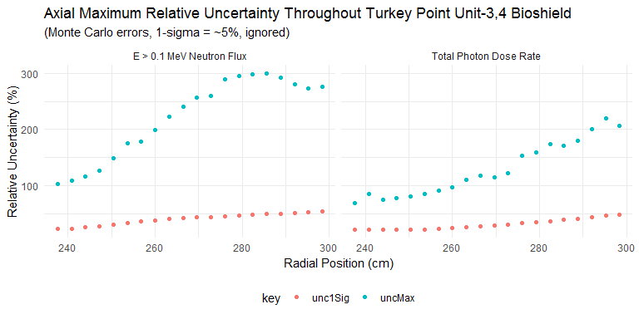

### Penetration Depth Underprediction Due to Lack of Analytic (Epistemic) Uncertainty Treatment of Bioshield Materials

Radiation penetration depths (in centimeters) up to defined thresholds.

|  |  |  |  |  |
| --- | --- | --- | --- | --- |
| type | BE | maxUnc | absDiff | relDiff |
| neutron | 245.6 | 250.6485 | -5.048547 | -0.0205560 |
| photon | 255.2 | 267.7783 | -12.578284 | -0.0492879 |