SCALE-MAVRIC/DAKOTA Input/Output Data Summaries

2019-05-21 18:55:43

### Samples = 240

* Parallel batches of 15
* Total wall clock = 30114.9

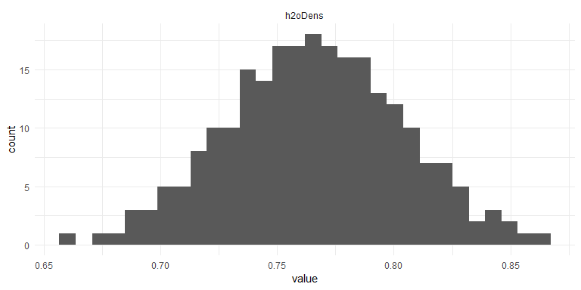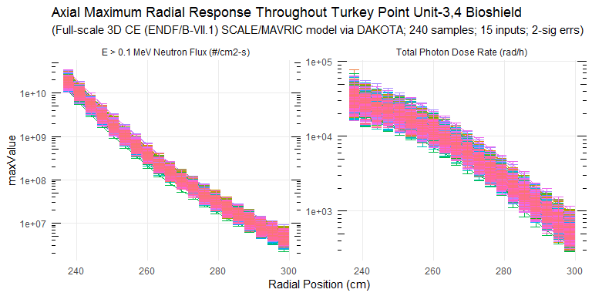

### Response Summary Statistics

## rPos case maxNradial   
## Min. :237.6 Length:4800 Min. :2.717e+06   
## 1st Qu.:252.8 Class :character 1st Qu.:1.877e+07   
## Median :268.0 Mode :character Median :1.210e+08   
## Mean :268.0 Mean :2.111e+09   
## 3rd Qu.:283.2 3rd Qu.:1.329e+09   
## Max. :298.4 Max. :3.270e+10   
## maxNradialErr maxPradial maxPradialErr maxNradialRelErr   
## Min. :1.684e+05 Min. : 332 Min. : 21.05 Min. :0.01575   
## 1st Qu.:1.303e+06 1st Qu.: 1943 1st Qu.: 122.15 1st Qu.:0.04098   
## Median :6.635e+06 Median : 6958 Median : 351.05 Median :0.05410   
## Mean :7.395e+07 Mean :10813 Mean : 698.34 Mean :0.05661   
## 3rd Qu.:5.404e+07 3rd Qu.:17903 3rd Qu.: 957.81 3rd Qu.:0.07010   
## Max. :1.976e+09 Max. :58235 Max. :10326.17 Max. :0.12746   
## maxPradialRelErr   
## Min. :0.02556   
## 1st Qu.:0.04931   
## Median :0.05860   
## Mean :0.06296   
## 3rd Qu.:0.07210   
## Max. :0.28030

### DAKOTA Input/Output Summary Statistics

## # A tibble: 81 x 5  
## key average sd min max  
## <chr> <dbl> <dbl> <dbl> <dbl>  
## 1 h2oDens 7.66e- 1 3.78e-2 6.60e- 1 8.64e- 1  
## 2 maxNradial_1 1.89e+10 3.97e+9 1.11e+10 3.27e+10  
## 3 maxNradial_10 1.51e+ 8 2.84e+7 8.03e+ 7 2.43e+ 8  
## 4 maxNradial_11 9.95e+ 7 1.84e+7 5.64e+ 7 1.59e+ 8  
## 5 maxNradial_12 6.70e+ 7 1.23e+7 4.05e+ 7 1.07e+ 8  
## 6 maxNradial_13 4.57e+ 7 8.33e+6 2.71e+ 7 7.10e+ 7  
## 7 maxNradial_14 3.19e+ 7 5.71e+6 1.87e+ 7 4.99e+ 7  
## 8 maxNradial_15 2.26e+ 7 4.01e+6 1.30e+ 7 3.47e+ 7  
## 9 maxNradial_16 1.62e+ 7 2.85e+6 9.47e+ 6 2.50e+ 7  
## 10 maxNradial_17 1.17e+ 7 2.08e+6 7.22e+ 6 1.80e+ 7  
## 11 maxNradial_18 8.50e+ 6 1.52e+6 5.27e+ 6 1.33e+ 7  
## 12 maxNradial_19 6.23e+ 6 1.12e+6 3.63e+ 6 9.88e+ 6  
## 13 maxNradial_2 1.01e+10 2.09e+9 5.74e+ 9 1.71e+10  
## 14 maxNradial_20 4.55e+ 6 8.46e+5 2.72e+ 6 7.62e+ 6  
## 15 maxNradial_3 5.56e+ 9 1.15e+9 3.07e+ 9 9.42e+ 9  
## 16 maxNradial_4 3.11e+ 9 6.43e+8 1.74e+ 9 5.39e+ 9  
## 17 maxNradial_5 1.77e+ 9 3.63e+8 9.78e+ 8 2.97e+ 9  
## 18 maxNradial_6 1.03e+ 9 2.07e+8 5.83e+ 8 1.76e+ 9  
## 19 maxNradial_7 6.13e+ 8 1.23e+8 3.44e+ 8 1.06e+ 9  
## 20 maxNradial_8 3.75e+ 8 7.31e+7 2.06e+ 8 6.44e+ 8  
## 21 maxNradial_9 2.34e+ 8 4.45e+7 1.26e+ 8 3.74e+ 8  
## 22 maxNradialErr_1 6.16e+ 8 2.05e+8 2.33e+ 8 1.98e+ 9  
## 23 maxNradialErr_10 8.33e+ 6 2.11e+6 3.43e+ 6 1.56e+ 7  
## 24 maxNradialErr_11 5.66e+ 6 1.47e+6 2.19e+ 6 1.22e+ 7  
## 25 maxNradialErr_12 4.07e+ 6 9.59e+5 1.78e+ 6 7.43e+ 6  
## 26 maxNradialErr_13 2.84e+ 6 6.98e+5 1.27e+ 6 5.13e+ 6  
## 27 maxNradialErr_14 2.07e+ 6 5.02e+5 1.06e+ 6 3.87e+ 6  
## 28 maxNradialErr_15 1.57e+ 6 3.92e+5 7.66e+ 5 3.09e+ 6  
## 29 maxNradialErr_16 1.15e+ 6 2.83e+5 4.68e+ 5 2.21e+ 6  
## 30 maxNradialErr_17 8.71e+ 5 2.07e+5 4.05e+ 5 1.44e+ 6  
## 31 maxNradialErr_18 6.58e+ 5 1.46e+5 3.40e+ 5 1.21e+ 6  
## 32 maxNradialErr_19 5.11e+ 5 1.14e+5 2.43e+ 5 8.18e+ 5  
## 33 maxNradialErr_2 3.43e+ 8 8.91e+7 1.71e+ 8 6.64e+ 8  
## 34 maxNradialErr_20 4.01e+ 5 9.61e+4 1.68e+ 5 8.02e+ 5  
## 35 maxNradialErr_3 2.02e+ 8 5.16e+7 9.40e+ 7 4.01e+ 8  
## 36 maxNradialErr_4 1.18e+ 8 3.10e+7 5.68e+ 7 2.58e+ 8  
## 37 maxNradialErr_5 7.01e+ 7 1.89e+7 3.23e+ 7 1.68e+ 8  
## 38 maxNradialErr_6 4.39e+ 7 1.14e+7 1.86e+ 7 8.03e+ 7  
## 39 maxNradialErr_7 2.83e+ 7 7.30e+6 1.05e+ 7 5.22e+ 7  
## 40 maxNradialErr_8 1.80e+ 7 4.63e+6 8.97e+ 6 3.33e+ 7  
## 41 maxNradialErr_9 1.21e+ 7 3.08e+6 5.28e+ 6 2.04e+ 7  
## 42 maxPradial_1 3.28e+ 4 7.09e+3 1.94e+ 4 5.82e+ 4  
## 43 maxPradial_10 8.01e+ 3 1.67e+3 4.73e+ 3 1.39e+ 4  
## 44 maxPradial_11 6.34e+ 3 1.32e+3 3.71e+ 3 1.10e+ 4  
## 45 maxPradial_12 4.96e+ 3 1.02e+3 2.95e+ 3 8.96e+ 3  
## 46 maxPradial_13 3.84e+ 3 7.74e+2 2.45e+ 3 6.81e+ 3  
## 47 maxPradial_14 2.95e+ 3 5.82e+2 1.82e+ 3 5.19e+ 3  
## 48 maxPradial_15 2.26e+ 3 4.55e+2 1.34e+ 3 4.17e+ 3  
## 49 maxPradial_16 1.73e+ 3 3.53e+2 9.97e+ 2 3.04e+ 3  
## 50 maxPradial_17 1.31e+ 3 2.63e+2 7.20e+ 2 2.15e+ 3  
## 51 maxPradial_18 9.97e+ 2 2.06e+2 5.42e+ 2 1.75e+ 3  
## 52 maxPradial_19 7.50e+ 2 1.60e+2 4.22e+ 2 1.34e+ 3  
## 53 maxPradial_2 2.78e+ 4 5.91e+3 1.63e+ 4 4.92e+ 4  
## 54 maxPradial_20 5.67e+ 2 1.22e+2 3.32e+ 2 1.03e+ 3  
## 55 maxPradial_3 2.51e+ 4 5.37e+3 1.49e+ 4 4.47e+ 4  
## 56 maxPradial_4 2.25e+ 4 4.71e+3 1.33e+ 4 3.82e+ 4  
## 57 maxPradial_5 2.00e+ 4 4.18e+3 1.22e+ 4 3.49e+ 4  
## 58 maxPradial_6 1.74e+ 4 3.71e+3 1.03e+ 4 3.05e+ 4  
## 59 maxPradial_7 1.48e+ 4 3.15e+3 8.56e+ 3 2.63e+ 4  
## 60 maxPradial_8 1.22e+ 4 2.58e+3 7.07e+ 3 2.11e+ 4  
## 61 maxPradial_9 9.95e+ 3 2.09e+3 5.86e+ 3 1.72e+ 4  
## 62 maxPradialErr_1 2.89e+ 3 1.26e+3 1.18e+ 3 1.03e+ 4  
## 63 maxPradialErr_10 4.09e+ 2 1.24e+2 1.84e+ 2 9.27e+ 2  
## 64 maxPradialErr_11 3.34e+ 2 1.00e+2 1.56e+ 2 8.21e+ 2  
## 65 maxPradialErr_12 2.70e+ 2 7.47e+1 1.21e+ 2 6.69e+ 2  
## 66 maxPradialErr_13 2.14e+ 2 6.11e+1 1.02e+ 2 4.64e+ 2  
## 67 maxPradialErr_14 1.74e+ 2 4.71e+1 7.48e+ 1 3.62e+ 2  
## 68 maxPradialErr_15 1.42e+ 2 4.38e+1 3.66e+ 1 3.23e+ 2  
## 69 maxPradialErr_16 1.12e+ 2 3.73e+1 4.57e+ 1 2.59e+ 2  
## 70 maxPradialErr_17 9.01e+ 1 2.95e+1 4.37e+ 1 2.21e+ 2  
## 71 maxPradialErr_18 7.23e+ 1 2.29e+1 3.12e+ 1 1.84e+ 2  
## 72 maxPradialErr_19 5.76e+ 1 1.86e+1 2.64e+ 1 1.58e+ 2  
## 73 maxPradialErr_2 2.14e+ 3 8.35e+2 8.79e+ 2 7.57e+ 3  
## 74 maxPradialErr_20 4.67e+ 1 1.53e+1 2.11e+ 1 1.27e+ 2  
## 75 maxPradialErr_3 1.72e+ 3 6.69e+2 7.50e+ 2 5.92e+ 3  
## 76 maxPradialErr_4 1.38e+ 3 5.33e+2 5.66e+ 2 4.45e+ 3  
## 77 maxPradialErr_5 1.11e+ 3 3.92e+2 4.16e+ 2 3.28e+ 3  
## 78 maxPradialErr_6 9.29e+ 2 3.68e+2 4.00e+ 2 3.58e+ 3  
## 79 maxPradialErr_7 7.61e+ 2 2.74e+2 3.24e+ 2 2.15e+ 3  
## 80 maxPradialErr_8 6.18e+ 2 2.06e+2 2.46e+ 2 1.55e+ 3  
## 81 maxPradialErr_9 5.10e+ 2 1.61e+2 2.15e+ 2 1.23e+ 3

### Absolute/Relative Uncertainty Data

## # A tibble: 40 x 8  
## type rCoords average sd min max unc1Sig uncMax  
## <chr> <dbl> <dbl> <dbl> <dbl> <dbl> <dbl> <dbl>  
## 1 E > 0.1 MeV~ 238. 1.89e10 3.97e9 1.11e10 3.27e10 21.0 73.1  
## 2 E > 0.1 MeV~ 241. 1.01e10 2.09e9 5.74e 9 1.71e10 20.6 68.7  
## 3 E > 0.1 MeV~ 244 5.56e 9 1.15e9 3.07e 9 9.42e 9 20.7 69.3  
## 4 E > 0.1 MeV~ 247. 3.11e 9 6.43e8 1.74e 9 5.39e 9 20.7 73.4  
## 5 E > 0.1 MeV~ 250. 1.77e 9 3.63e8 9.78e 8 2.97e 9 20.4 67.6  
## 6 E > 0.1 MeV~ 254. 1.03e 9 2.07e8 5.83e 8 1.76e 9 20.0 70.6  
## 7 E > 0.1 MeV~ 257. 6.13e 8 1.23e8 3.44e 8 1.06e 9 20.0 72.1  
## 8 E > 0.1 MeV~ 260 3.75e 8 7.31e7 2.06e 8 6.44e 8 19.5 71.8  
## 9 E > 0.1 MeV~ 263. 2.34e 8 4.45e7 1.26e 8 3.74e 8 19.0 59.9  
## 10 E > 0.1 MeV~ 266. 1.51e 8 2.84e7 8.03e 7 2.43e 8 18.8 60.9  
## 11 E > 0.1 MeV~ 270. 9.95e 7 1.84e7 5.64e 7 1.59e 8 18.5 59.9  
## 12 E > 0.1 MeV~ 273. 6.70e 7 1.23e7 4.05e 7 1.07e 8 18.3 60.3  
## 13 E > 0.1 MeV~ 276 4.57e 7 8.33e6 2.71e 7 7.10e 7 18.2 55.3  
## 14 E > 0.1 MeV~ 279. 3.19e 7 5.71e6 1.87e 7 4.99e 7 17.9 56.4  
## 15 E > 0.1 MeV~ 282. 2.26e 7 4.01e6 1.30e 7 3.47e 7 17.7 53.3  
## 16 E > 0.1 MeV~ 286. 1.62e 7 2.85e6 9.47e 6 2.50e 7 17.6 54.9  
## 17 E > 0.1 MeV~ 289. 1.17e 7 2.08e6 7.22e 6 1.80e 7 17.8 54.6  
## 18 E > 0.1 MeV~ 292 8.50e 6 1.52e6 5.27e 6 1.33e 7 17.9 56.1  
## 19 E > 0.1 MeV~ 295. 6.23e 6 1.12e6 3.63e 6 9.88e 6 18.0 58.5  
## 20 E > 0.1 MeV~ 298. 4.55e 6 8.46e5 2.72e 6 7.62e 6 18.6 67.5  
## 21 Total Photo~ 238. 3.28e 4 7.09e3 1.94e 4 5.82e 4 21.6 77.4  
## 22 Total Photo~ 241. 2.78e 4 5.91e3 1.63e 4 4.92e 4 21.3 77.3  
## 23 Total Photo~ 244 2.51e 4 5.37e3 1.49e 4 4.47e 4 21.4 78.3  
## 24 Total Photo~ 247. 2.25e 4 4.71e3 1.33e 4 3.82e 4 20.9 69.8  
## 25 Total Photo~ 250. 2.00e 4 4.18e3 1.22e 4 3.49e 4 20.9 74.0  
## 26 Total Photo~ 254. 1.74e 4 3.71e3 1.03e 4 3.05e 4 21.3 75.0  
## 27 Total Photo~ 257. 1.48e 4 3.15e3 8.56e 3 2.63e 4 21.3 77.9  
## 28 Total Photo~ 260 1.22e 4 2.58e3 7.07e 3 2.11e 4 21.1 73.1  
## 29 Total Photo~ 263. 9.95e 3 2.09e3 5.86e 3 1.72e 4 20.9 72.7  
## 30 Total Photo~ 266. 8.01e 3 1.67e3 4.73e 3 1.39e 4 20.9 73.9  
## 31 Total Photo~ 270. 6.34e 3 1.32e3 3.71e 3 1.10e 4 20.8 74.0  
## 32 Total Photo~ 273. 4.96e 3 1.02e3 2.95e 3 8.96e 3 20.6 80.6  
## 33 Total Photo~ 276 3.84e 3 7.74e2 2.45e 3 6.81e 3 20.1 77.2  
## 34 Total Photo~ 279. 2.95e 3 5.82e2 1.82e 3 5.19e 3 19.7 75.8  
## 35 Total Photo~ 282. 2.26e 3 4.55e2 1.34e 3 4.17e 3 20.1 84.3  
## 36 Total Photo~ 286. 1.73e 3 3.53e2 9.97e 2 3.04e 3 20.4 75.5  
## 37 Total Photo~ 289. 1.31e 3 2.63e2 7.20e 2 2.15e 3 20.1 63.9  
## 38 Total Photo~ 292 9.97e 2 2.06e2 5.42e 2 1.75e 3 20.6 75.1  
## 39 Total Photo~ 295. 7.50e 2 1.60e2 4.22e 2 1.34e 3 21.4 79.1  
## 40 Total Photo~ 298. 5.67e 2 1.22e2 3.32e 2 1.03e 3 21.5 81.2

### Neutron Fluence (E > 1 MeV) and Total Photon Dose Relative Uncertainty

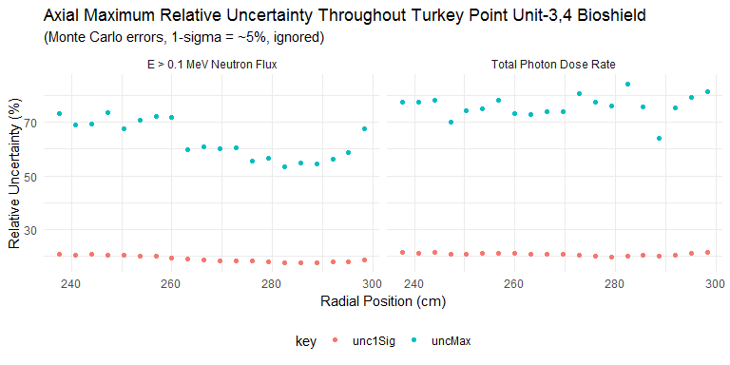

### Penetration Depth Underprediction Due to Lack of Analytic (Epistemic) Uncertainty Treatment of Bioshield Materials

Radiation penetration depths (in centimeters) up to defined thresholds.

|  |  |  |  |  |
| --- | --- | --- | --- | --- |
| type | BE | maxUnc | absDiff | relDiff |
| neutron | 245.6 | 248.5124 | -2.912386 | -0.0118583 |
| photon | 255.2 | 264.5182 | -9.318210 | -0.0365134 |