SCALE-MAVRIC/DAKOTA Input/Output Data Summaries

2019-05-21 18:56:29

### Samples = 125

* Parallel batches of 15
* Total wall clock = 15480.2

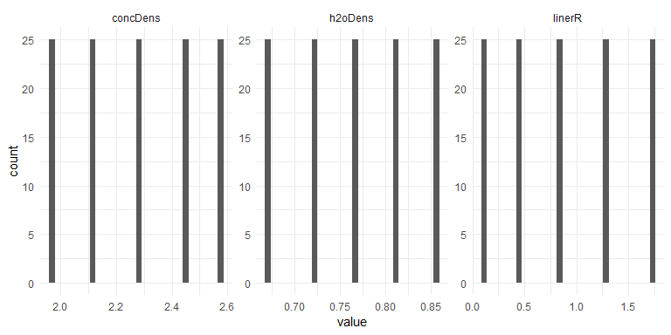

## Warning: Removed 4600 rows containing missing values (geom_path).

## Warning: Removed 4600 rows containing missing values (geom_errorbar).

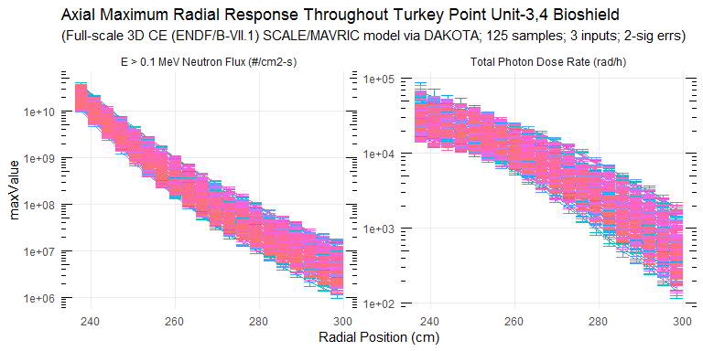

### Response Summary Statistics

## rPos case maxNradial   
## Min. :237.6 Length:4800 Min. :1.139e+06   
## 1st Qu.:252.8 Class :character 1st Qu.:1.962e+07   
## Median :268.0 Mode :character Median :1.250e+08   
## Mean :268.0 Mean :2.281e+09   
## 3rd Qu.:283.2 3rd Qu.:1.359e+09   
## Max. :298.4 Max. :3.790e+10   
## NA's :2300   
## maxNradialErr maxPradial maxPradialErr maxNradialRelErr  
## Min. :9.564e+04 Min. : 145.2 Min. : 12.75 Min. :0.0166   
## 1st Qu.:1.345e+06 1st Qu.: 2033.0 1st Qu.: 123.34 1st Qu.:0.0402   
## Median :6.818e+06 Median : 7028.6 Median : 363.22 Median :0.0544   
## Mean :7.933e+07 Mean :11194.5 Mean : 720.68 Mean :0.0561   
## 3rd Qu.:5.422e+07 3rd Qu.:17429.7 3rd Qu.: 978.53 3rd Qu.:0.0697   
## Max. :1.937e+09 Max. :66374.7 Max. :10926.70 Max. :0.1241   
## NA's :2300 NA's :2300 NA's :2300 NA's :2300   
## maxPradialRelErr  
## Min. :0.0233   
## 1st Qu.:0.0497   
## Median :0.0589   
## Mean :0.0628   
## 3rd Qu.:0.0720   
## Max. :0.2291   
## NA's :2300

### DAKOTA Input/Output Summary Statistics

## # A tibble: 83 x 5  
## key average sd min max  
## <chr> <dbl> <dbl> <dbl> <dbl>  
## 1 concDens 2.28e+ 0 2.21e-1 1.98e+ 0 2.58e+ 0  
## 2 h2oDens 7.66e- 1 6.58e-2 6.73e- 1 8.59e- 1  
## 3 linerR 8.73e- 1 5.84e-1 9.91e- 2 1.72e+ 0  
## 4 maxNradial_1 2.04e+10 7.38e+9 1.01e+10 3.79e+10  
## 5 maxNradial_10 1.68e+ 8 8.55e+7 5.24e+ 7 4.26e+ 8  
## 6 maxNradial_11 1.11e+ 8 5.78e+7 3.37e+ 7 2.95e+ 8  
## 7 maxNradial_12 7.50e+ 7 3.97e+7 2.18e+ 7 2.05e+ 8  
## 8 maxNradial_13 5.18e+ 7 2.78e+7 1.49e+ 7 1.42e+ 8  
## 9 maxNradial_14 3.62e+ 7 1.95e+7 1.01e+ 7 9.78e+ 7  
## 10 maxNradial_15 2.59e+ 7 1.44e+7 6.89e+ 6 6.71e+ 7  
## 11 maxNradial_16 1.85e+ 7 1.05e+7 4.45e+ 6 4.93e+ 7  
## 12 maxNradial_17 1.35e+ 7 7.91e+6 3.11e+ 6 3.82e+ 7  
## 13 maxNradial_18 9.77e+ 6 5.77e+6 2.14e+ 6 2.61e+ 7  
## 14 maxNradial_19 7.23e+ 6 4.45e+6 1.58e+ 6 2.04e+ 7  
## 15 maxNradial_2 1.09e+10 3.99e+9 4.93e+ 9 2.06e+10  
## 16 maxNradial_20 5.32e+ 6 3.36e+6 1.14e+ 6 1.50e+ 7  
## 17 maxNradial_3 5.98e+ 9 2.24e+9 2.56e+ 9 1.18e+10  
## 18 maxNradial_4 3.36e+ 9 1.32e+9 1.34e+ 9 6.97e+ 9  
## 19 maxNradial_5 1.93e+ 9 8.02e+8 7.15e+ 8 4.36e+ 9  
## 20 maxNradial_6 1.13e+ 9 5.00e+8 4.13e+ 8 2.61e+ 9  
## 21 maxNradial_7 6.74e+ 8 3.14e+8 2.46e+ 8 1.63e+ 9  
## 22 maxNradial_8 4.15e+ 8 2.01e+8 1.44e+ 8 1.02e+ 9  
## 23 maxNradial_9 2.61e+ 8 1.30e+8 8.83e+ 7 6.43e+ 8  
## 24 maxNradialErr_1 6.77e+ 8 3.05e+8 2.86e+ 8 1.94e+ 9  
## 25 maxNradialErr_10 9.16e+ 6 4.59e+6 2.80e+ 6 2.30e+ 7  
## 26 maxNradialErr_11 6.30e+ 6 3.29e+6 1.88e+ 6 2.00e+ 7  
## 27 maxNradialErr_12 4.61e+ 6 2.62e+6 1.13e+ 6 1.41e+ 7  
## 28 maxNradialErr_13 3.23e+ 6 1.82e+6 9.13e+ 5 1.01e+ 7  
## 29 maxNradialErr_14 2.31e+ 6 1.28e+6 7.02e+ 5 6.85e+ 6  
## 30 maxNradialErr_15 1.78e+ 6 1.03e+6 4.04e+ 5 5.23e+ 6  
## 31 maxNradialErr_16 1.31e+ 6 7.69e+5 3.23e+ 5 3.74e+ 6  
## 32 maxNradialErr_17 9.80e+ 5 5.56e+5 2.39e+ 5 2.70e+ 6  
## 33 maxNradialErr_18 7.45e+ 5 4.26e+5 1.57e+ 5 1.94e+ 6  
## 34 maxNradialErr_19 5.72e+ 5 3.49e+5 1.11e+ 5 1.50e+ 6  
## 35 maxNradialErr_2 3.60e+ 8 1.41e+8 1.35e+ 8 7.86e+ 8  
## 36 maxNradialErr_20 4.54e+ 5 2.97e+5 9.56e+ 4 1.24e+ 6  
## 37 maxNradialErr_3 2.10e+ 8 8.60e+7 8.48e+ 7 4.55e+ 8  
## 38 maxNradialErr_4 1.24e+ 8 5.12e+7 4.09e+ 7 2.90e+ 8  
## 39 maxNradialErr_5 7.48e+ 7 3.39e+7 2.65e+ 7 1.76e+ 8  
## 40 maxNradialErr_6 4.57e+ 7 2.11e+7 1.47e+ 7 1.10e+ 8  
## 41 maxNradialErr_7 3.03e+ 7 1.43e+7 1.14e+ 7 7.85e+ 7  
## 42 maxNradialErr_8 1.94e+ 7 9.66e+6 5.51e+ 6 5.56e+ 7  
## 43 maxNradialErr_9 1.31e+ 7 6.63e+6 3.81e+ 6 3.71e+ 7  
## 44 maxPradial_1 3.33e+ 4 1.16e+4 1.70e+ 4 6.64e+ 4  
## 45 maxPradial_10 8.45e+ 3 3.44e+3 3.35e+ 3 1.83e+ 4  
## 46 maxPradial_11 6.76e+ 3 2.89e+3 2.44e+ 3 1.51e+ 4  
## 47 maxPradial_12 5.33e+ 3 2.39e+3 1.81e+ 3 1.24e+ 4  
## 48 maxPradial_13 4.17e+ 3 1.94e+3 1.39e+ 3 1.00e+ 4  
## 49 maxPradial_14 3.24e+ 3 1.58e+3 9.59e+ 2 7.89e+ 3  
## 50 maxPradial_15 2.52e+ 3 1.29e+3 6.70e+ 2 6.42e+ 3  
## 51 maxPradial_16 1.94e+ 3 1.02e+3 4.84e+ 2 4.85e+ 3  
## 52 maxPradial_17 1.49e+ 3 8.20e+2 3.77e+ 2 3.87e+ 3  
## 53 maxPradial_18 1.15e+ 3 6.70e+2 2.88e+ 2 3.22e+ 3  
## 54 maxPradial_19 8.80e+ 2 5.36e+2 2.02e+ 2 2.52e+ 3  
## 55 maxPradial_2 2.81e+ 4 9.59e+3 1.39e+ 4 5.61e+ 4  
## 56 maxPradial_20 6.70e+ 2 4.22e+2 1.45e+ 2 1.93e+ 3  
## 57 maxPradial_3 2.55e+ 4 8.80e+3 1.27e+ 4 4.78e+ 4  
## 58 maxPradial_4 2.33e+ 4 8.16e+3 1.17e+ 4 4.50e+ 4  
## 59 maxPradial_5 2.07e+ 4 7.27e+3 1.01e+ 4 3.72e+ 4  
## 60 maxPradial_6 1.80e+ 4 6.37e+3 8.58e+ 3 3.26e+ 4  
## 61 maxPradial_7 1.53e+ 4 5.53e+3 7.01e+ 3 2.77e+ 4  
## 62 maxPradial_8 1.27e+ 4 4.71e+3 5.64e+ 3 2.35e+ 4  
## 63 maxPradial_9 1.04e+ 4 4.03e+3 4.28e+ 3 2.07e+ 4  
## 64 maxPradialErr_1 2.92e+ 3 1.62e+3 1.05e+ 3 1.09e+ 4  
## 65 maxPradialErr_10 4.24e+ 2 1.79e+2 1.71e+ 2 9.67e+ 2  
## 66 maxPradialErr_11 3.44e+ 2 1.49e+2 1.11e+ 2 8.28e+ 2  
## 67 maxPradialErr_12 2.81e+ 2 1.25e+2 8.96e+ 1 6.37e+ 2  
## 68 maxPradialErr_13 2.24e+ 2 1.05e+2 6.56e+ 1 5.85e+ 2  
## 69 maxPradialErr_14 1.78e+ 2 7.94e+1 5.21e+ 1 4.31e+ 2  
## 70 maxPradialErr_15 1.51e+ 2 7.69e+1 4.62e+ 1 3.95e+ 2  
## 71 maxPradialErr_16 1.19e+ 2 5.88e+1 2.44e+ 1 2.91e+ 2  
## 72 maxPradialErr_17 9.76e+ 1 5.19e+1 2.10e+ 1 2.72e+ 2  
## 73 maxPradialErr_18 7.94e+ 1 4.39e+1 1.85e+ 1 2.04e+ 2  
## 74 maxPradialErr_19 6.40e+ 1 3.58e+1 1.36e+ 1 1.62e+ 2  
## 75 maxPradialErr_2 2.19e+ 3 9.99e+2 9.62e+ 2 8.00e+ 3  
## 76 maxPradialErr_20 5.19e+ 1 3.05e+1 1.28e+ 1 1.44e+ 2  
## 77 maxPradialErr_3 1.78e+ 3 8.15e+2 6.84e+ 2 5.78e+ 3  
## 78 maxPradialErr_4 1.44e+ 3 6.20e+2 5.17e+ 2 4.81e+ 3  
## 79 maxPradialErr_5 1.17e+ 3 4.81e+2 4.22e+ 2 3.46e+ 3  
## 80 maxPradialErr_6 9.49e+ 2 3.63e+2 3.70e+ 2 2.19e+ 3  
## 81 maxPradialErr_7 7.77e+ 2 3.08e+2 3.38e+ 2 1.90e+ 3  
## 82 maxPradialErr_8 6.36e+ 2 2.47e+2 2.39e+ 2 1.39e+ 3  
## 83 maxPradialErr_9 5.40e+ 2 2.15e+2 1.61e+ 2 1.24e+ 3

### Absolute/Relative Uncertainty Data

## # A tibble: 40 x 8  
## type rCoords average sd min max unc1Sig uncMax  
## <chr> <dbl> <dbl> <dbl> <dbl> <dbl> <dbl> <dbl>  
## 1 E > 0.1 MeV~ 238. 2.04e10 7.38e9 1.01e10 3.79e10 36.1 85.6  
## 2 E > 0.1 MeV~ 241. 1.09e10 3.99e9 4.93e 9 2.06e10 36.5 88.5  
## 3 E > 0.1 MeV~ 244 5.98e 9 2.24e9 2.56e 9 1.18e10 37.4 97.4  
## 4 E > 0.1 MeV~ 247. 3.36e 9 1.32e9 1.34e 9 6.97e 9 39.3 107.   
## 5 E > 0.1 MeV~ 250. 1.93e 9 8.02e8 7.15e 8 4.36e 9 41.7 126.   
## 6 E > 0.1 MeV~ 254. 1.13e 9 5.00e8 4.13e 8 2.61e 9 44.3 132.   
## 7 E > 0.1 MeV~ 257. 6.74e 8 3.14e8 2.46e 8 1.63e 9 46.6 142.   
## 8 E > 0.1 MeV~ 260 4.15e 8 2.01e8 1.44e 8 1.02e 9 48.4 145.   
## 9 E > 0.1 MeV~ 263. 2.61e 8 1.30e8 8.83e 7 6.43e 8 49.6 146.   
## 10 E > 0.1 MeV~ 266. 1.68e 8 8.55e7 5.24e 7 4.26e 8 50.9 154.   
## 11 E > 0.1 MeV~ 270. 1.11e 8 5.78e7 3.37e 7 2.95e 8 52.0 166.   
## 12 E > 0.1 MeV~ 273. 7.50e 7 3.97e7 2.18e 7 2.05e 8 53.0 174.   
## 13 E > 0.1 MeV~ 276 5.18e 7 2.78e7 1.49e 7 1.42e 8 53.7 174.   
## 14 E > 0.1 MeV~ 279. 3.62e 7 1.95e7 1.01e 7 9.78e 7 53.9 170.   
## 15 E > 0.1 MeV~ 282. 2.59e 7 1.44e7 6.89e 6 6.71e 7 55.7 159.   
## 16 E > 0.1 MeV~ 286. 1.85e 7 1.05e7 4.45e 6 4.93e 7 56.9 166.   
## 17 E > 0.1 MeV~ 289. 1.35e 7 7.91e6 3.11e 6 3.82e 7 58.4 182.   
## 18 E > 0.1 MeV~ 292 9.77e 6 5.77e6 2.14e 6 2.61e 7 59.0 167.   
## 19 E > 0.1 MeV~ 295. 7.23e 6 4.45e6 1.58e 6 2.04e 7 61.6 183.   
## 20 E > 0.1 MeV~ 298. 5.32e 6 3.36e6 1.14e 6 1.50e 7 63.2 183.   
## 21 Total Photo~ 238. 3.33e 4 1.16e4 1.70e 4 6.64e 4 34.7 99.1  
## 22 Total Photo~ 241. 2.81e 4 9.59e3 1.39e 4 5.61e 4 34.1 99.8  
## 23 Total Photo~ 244 2.55e 4 8.80e3 1.27e 4 4.78e 4 34.6 87.5  
## 24 Total Photo~ 247. 2.33e 4 8.16e3 1.17e 4 4.50e 4 35.0 92.9  
## 25 Total Photo~ 250. 2.07e 4 7.27e3 1.01e 4 3.72e 4 35.2 79.9  
## 26 Total Photo~ 254. 1.80e 4 6.37e3 8.58e 3 3.26e 4 35.4 81.3  
## 27 Total Photo~ 257. 1.53e 4 5.53e3 7.01e 3 2.77e 4 36.1 80.7  
## 28 Total Photo~ 260 1.27e 4 4.71e3 5.64e 3 2.35e 4 37.2 85.5  
## 29 Total Photo~ 263. 1.04e 4 4.03e3 4.28e 3 2.07e 4 38.7 99.2  
## 30 Total Photo~ 266. 8.45e 3 3.44e3 3.35e 3 1.83e 4 40.7 116.   
## 31 Total Photo~ 270. 6.76e 3 2.89e3 2.44e 3 1.51e 4 42.7 123.   
## 32 Total Photo~ 273. 5.33e 3 2.39e3 1.81e 3 1.24e 4 44.8 132.   
## 33 Total Photo~ 276 4.17e 3 1.94e3 1.39e 3 1.00e 4 46.5 140.   
## 34 Total Photo~ 279. 3.24e 3 1.58e3 9.59e 2 7.89e 3 48.6 143.   
## 35 Total Photo~ 282. 2.52e 3 1.29e3 6.70e 2 6.42e 3 51.2 155.   
## 36 Total Photo~ 286. 1.94e 3 1.02e3 4.84e 2 4.85e 3 52.7 150.   
## 37 Total Photo~ 289. 1.49e 3 8.20e2 3.77e 2 3.87e 3 54.8 159.   
## 38 Total Photo~ 292 1.15e 3 6.70e2 2.88e 2 3.22e 3 58.3 180.   
## 39 Total Photo~ 295. 8.80e 2 5.36e2 2.02e 2 2.52e 3 60.9 186.   
## 40 Total Photo~ 298. 6.70e 2 4.22e2 1.45e 2 1.93e 3 63.0 188.

### Neutron Fluence (E > 1 MeV) and Total Photon Dose Relative Uncertainty

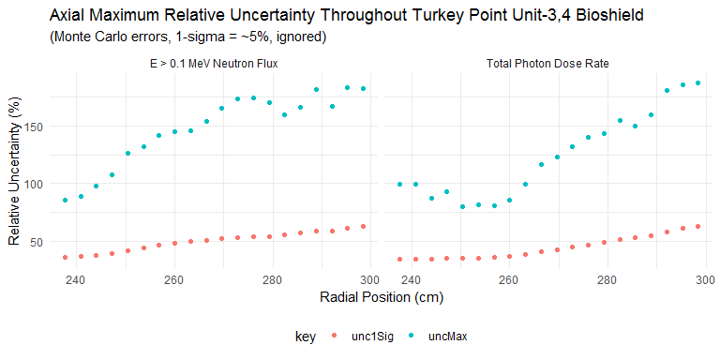

### Penetration Depth Underprediction Due to Lack of Analytic (Epistemic) Uncertainty Treatment of Bioshield Materials

Radiation penetration depths (in centimeters) up to defined thresholds.

|  |  |  |  |  |
| --- | --- | --- | --- | --- |
| type | BE | maxUnc | absDiff | relDiff |
| neutron | 245.6 | 250.3450 | -4.744977 | -0.0193199 |
| photon | 255.2 | 268.8434 | -13.643393 | -0.0534616 |