SCALE-Monaco-MAVRIC/DAKOTA: Distribution Checks

2019-05-06 18:32:27

### Samples = 120

* Parallel batches of 15
* Total wall clock = 7159.99

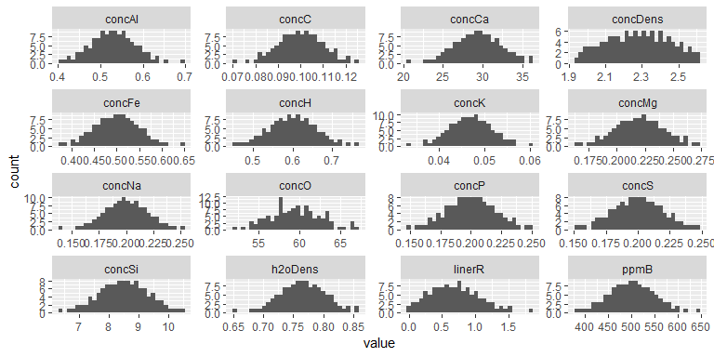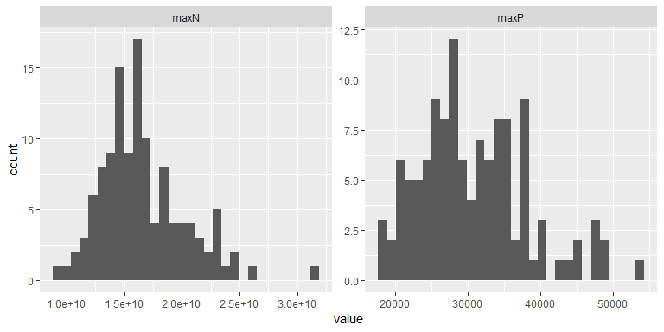

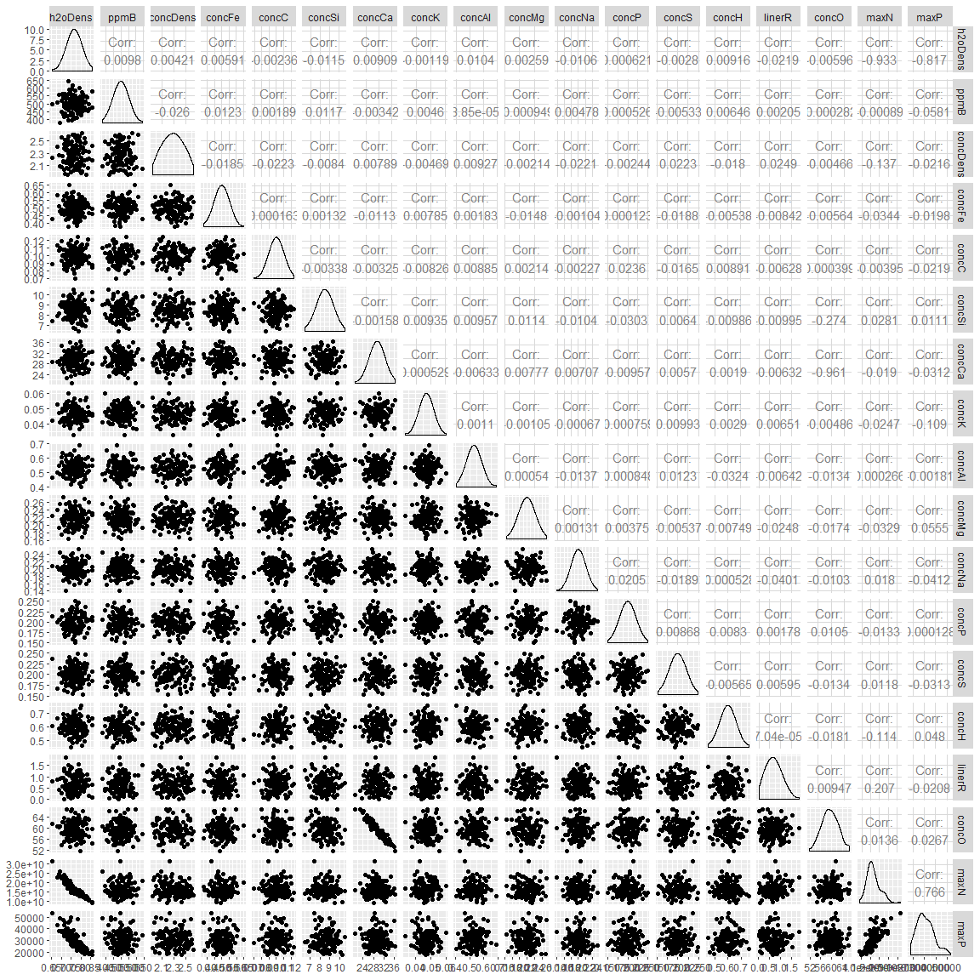

#### Summary

## # A tibble: 18 x 5  
## key average sd min max  
## <chr> <dbl> <dbl> <dbl> <dbl>  
## 1 concAl 5.30e- 1 5.29e-2 4.01e-1 6.89e- 1  
## 2 concC 9.99e- 2 9.95e-3 7.00e-2 1.24e- 1  
## 3 concCa 2.94e+ 1 2.91e+0 2.10e+1 3.64e+ 1  
## 4 concDens 2.28e+ 0 1.70e-1 1.95e+0 2.62e+ 0  
## 5 concFe 5.00e- 1 4.98e-2 3.76e-1 6.48e- 1  
## 6 concH 6.00e- 1 5.95e-2 4.52e-1 7.59e- 1  
## 7 concK 4.70e- 2 4.70e-3 3.30e-2 5.99e- 2  
## 8 concMg 2.20e- 1 2.17e-2 1.65e-1 2.73e- 1  
## 9 concNa 2.00e- 1 2.01e-2 1.40e-1 2.53e- 1  
## 10 concO 5.95e+ 1 3.03e+0 5.19e+1 6.68e+ 1  
## 11 concP 2.00e- 1 1.98e-2 1.49e-1 2.50e- 1  
## 12 concS 2.00e- 1 1.96e-2 1.53e-1 2.49e- 1  
## 13 concSi 8.50e+ 0 8.33e-1 6.42e+0 1.05e+ 1  
## 14 h2oDens 7.66e- 1 3.82e-2 6.54e-1 8.57e- 1  
## 15 linerR 6.93e- 1 3.73e-1 1.58e-2 1.85e+ 0  
## 16 maxN 1.66e+10 3.67e+9 9.23e+9 3.15e+10  
## 17 maxP 3.08e+ 4 7.46e+3 1.77e+4 5.31e+ 4  
## 18 ppmB 5.00e+ 2 4.97e+1 3.80e+2 6.43e+ 2