SCALE-Monaco-MAVRIC/DAKOTA: Distribution Checks

2019-05-06 20:15:23

### Samples = 10

* Max parallel batches of 15

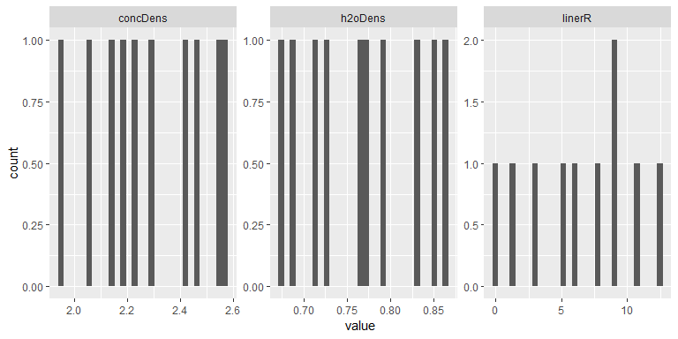

## Warning: Computation failed in `stat_bin()`:  
## `binwidth` must be positive

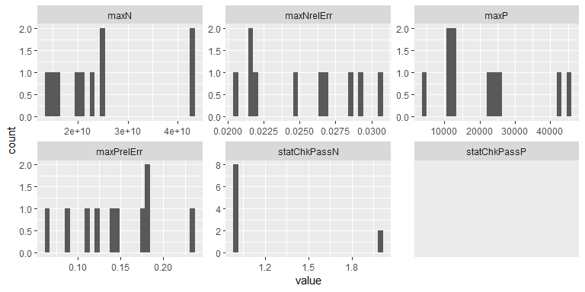

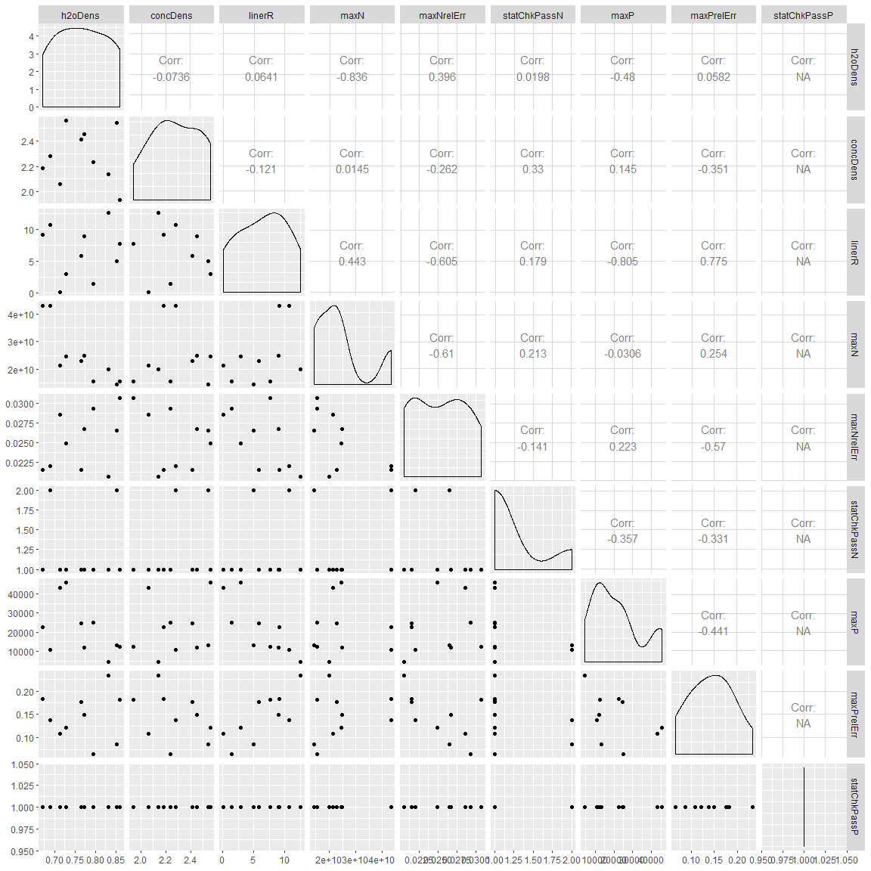

#### Summary

## # A tibble: 9 x 5  
## key average sd min max  
## <chr> <dbl> <dbl> <dbl> <dbl>  
## 1 concDens 2.28e+ 0 2.08e- 1 1.94e+ 0 2.56e+ 0  
## 2 h2oDens 7.68e- 1 6.77e- 2 6.71e- 1 8.61e- 1  
## 3 linerR 6.45e+ 0 4.10e+ 0 1.28e- 1 1.26e+ 1  
## 4 maxN 2.45e+10 1.06e+10 1.43e+10 4.33e+10  
## 5 maxNrelErr 2.52e- 2 3.67e- 3 2.06e- 2 3.07e- 2  
## 6 maxP 2.14e+ 4 1.38e+ 4 4.64e+ 3 4.57e+ 4  
## 7 maxPrelErr 1.44e- 1 5.11e- 2 6.44e- 2 2.34e- 1  
## 8 statChkPassN 1.20e+ 0 4.22e- 1 1.00e+ 0 2.00e+ 0  
## 9 statChkPassP 1.00e+ 0 0. 1.00e+ 0 1.00e+ 0