SCALE-Monaco-MAVRIC/DAKOTA: Distribution Checks

2019-05-08 13:12:26

### Samples = 10

* Max parallel batches of 15

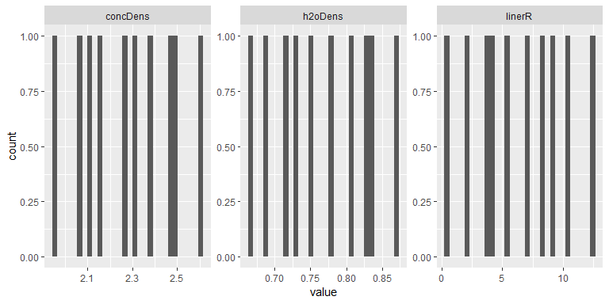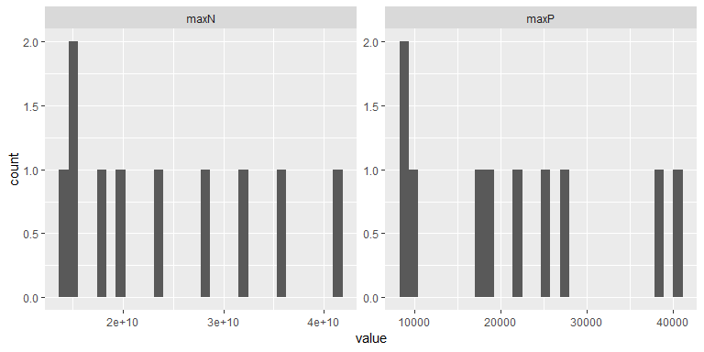

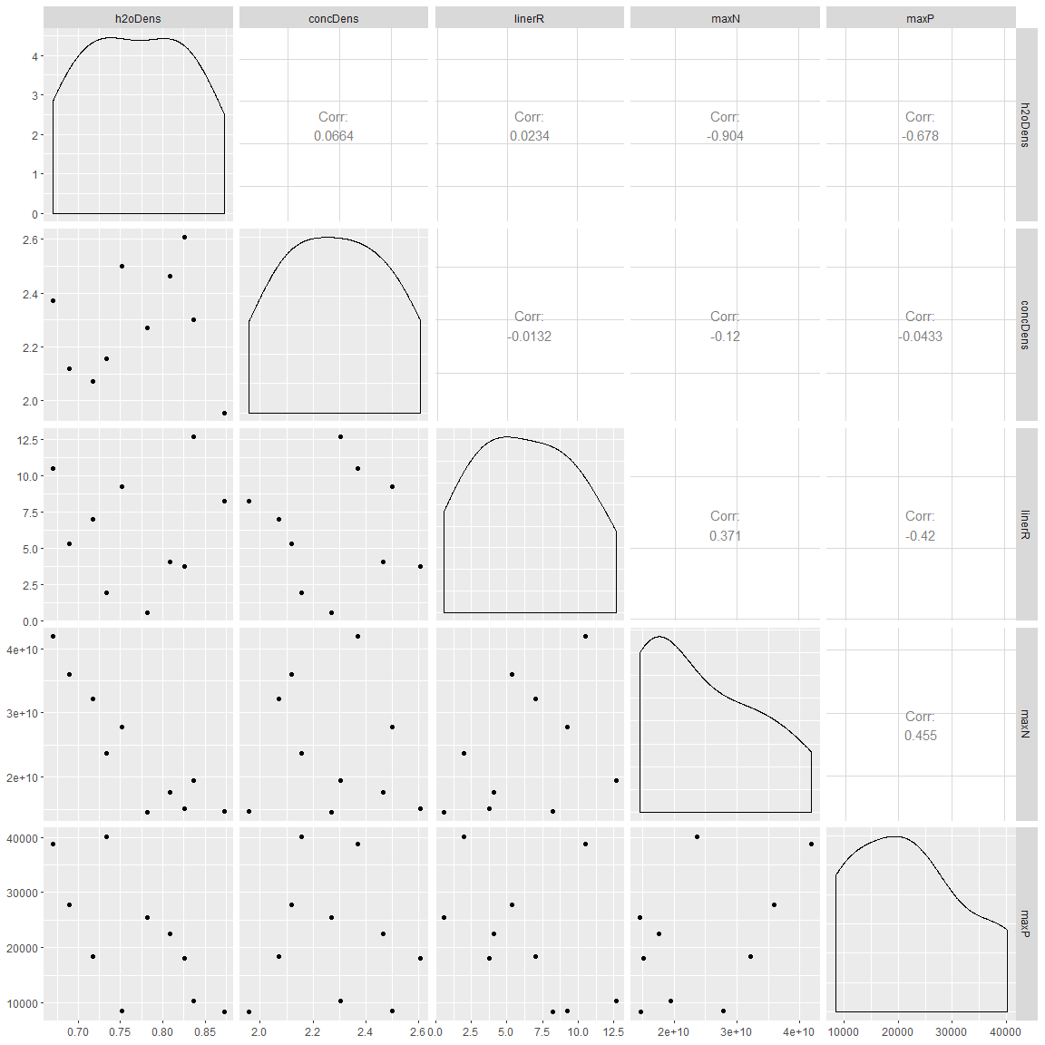

#### Summary

## # A tibble: 5 x 5  
## key average sd min max  
## <chr> <dbl> <dbl> <dbl> <dbl>  
## 1 concDens 2.28e+ 0 2.07e-1 1.96e+ 0 2.61e+ 0  
## 2 h2oDens 7.69e- 1 6.73e-2 6.70e- 1 8.73e- 1  
## 3 linerR 6.33e+ 0 3.87e+0 5.91e- 1 1.26e+ 1  
## 4 maxN 2.43e+10 9.76e+9 1.46e+10 4.19e+10  
## 5 maxP 2.18e+ 4 1.15e+4 8.37e+ 3 4.02e+ 4