SCALE-Monaco-MAVRIC/DAKOTA: Distribution Checks

2019-05-09 05:52:25

### Samples = 160

* Max parallel batches of 15
* Total wall clock = 58137.8

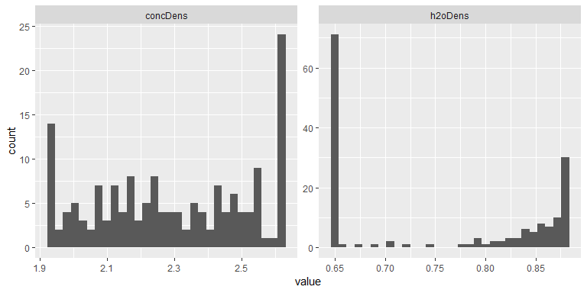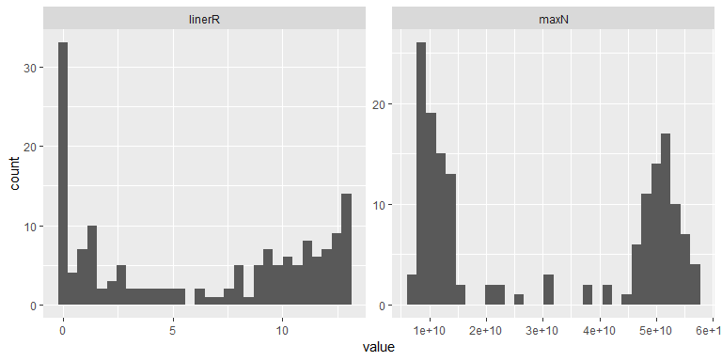

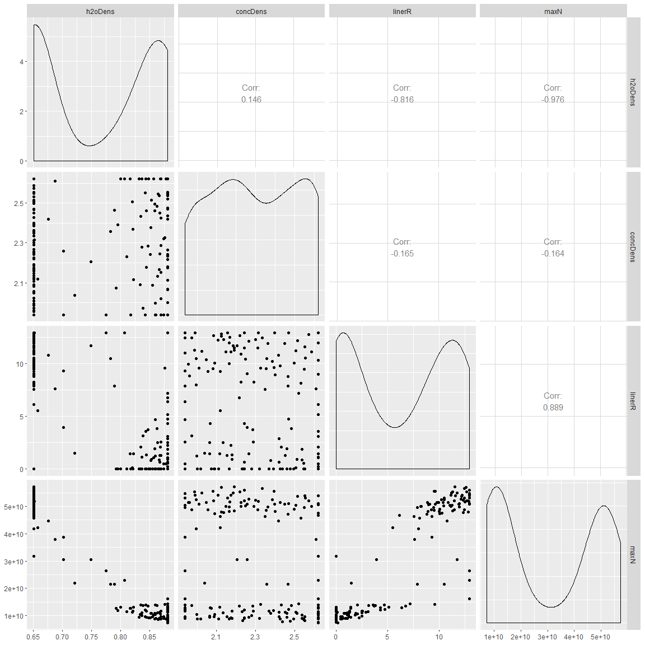

#### Summary

## # A tibble: 4 x 5  
## key average sd min max  
## <chr> <dbl> <dbl> <dbl> <dbl>  
## 1 concDens 2.30e+ 0 2.29e- 1 1.94e+0 2.62e+ 0  
## 2 h2oDens 7.59e- 1 1.04e- 1 6.51e-1 8.81e- 1  
## 3 linerR 6.22e+ 0 5.02e+ 0 3.64e-5 1.29e+ 1  
## 4 maxN 2.99e+10 1.98e+10 7.24e+9 5.72e+10