SCALE-Monaco-MAVRIC/DAKOTA: Distribution Checks

2019-05-17 20:48:01

### Input(s) (Samples = 125)

* Max parallel batches of 15
* Total wall clock = 10540

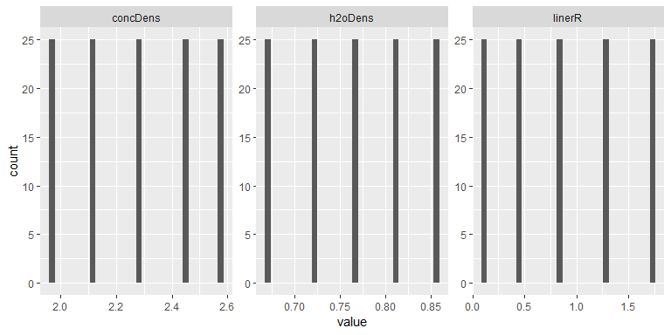

### Output(s)

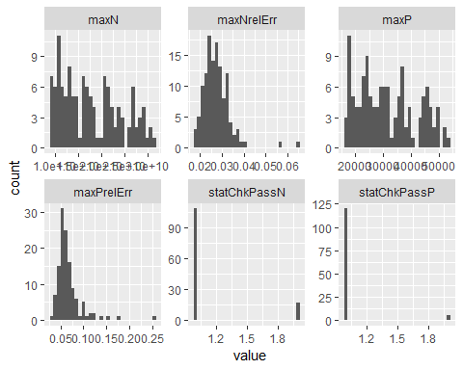

### Correlations

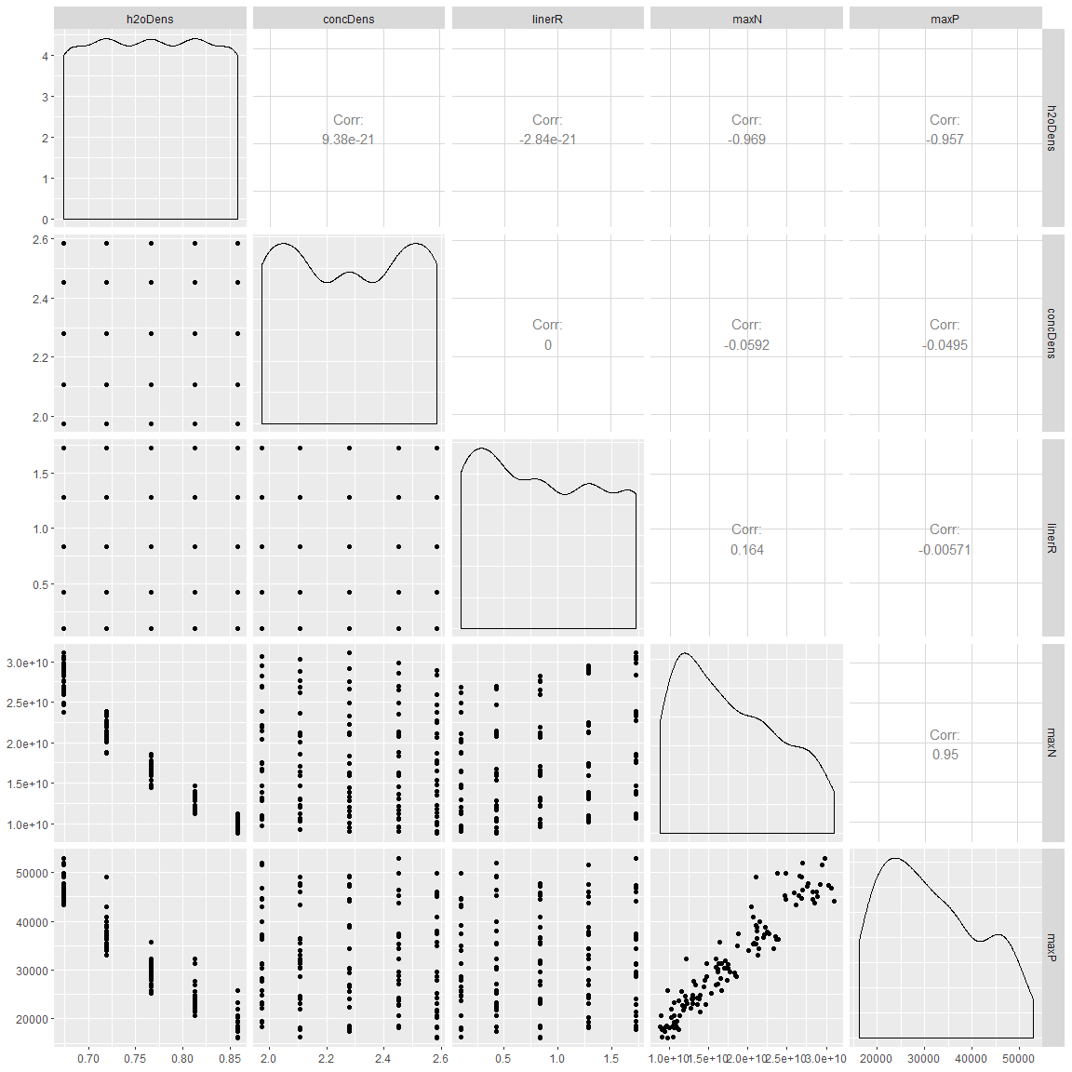

## # A tibble: 4 x 2  
## rowname maxN  
## <chr> <dbl>  
## 1 h2oDens -0.969   
## 2 maxP 0.950   
## 3 linerR 0.164   
## 4 concDens -0.0592

## # A tibble: 4 x 2  
## rowname maxP  
## <chr> <dbl>  
## 1 h2oDens -0.957   
## 2 maxN 0.950   
## 3 concDens -0.0495   
## 4 linerR -0.00571

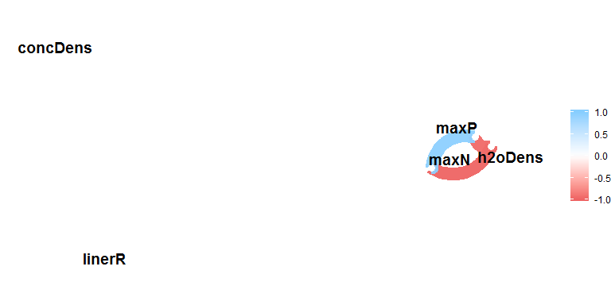

### Summary

## # A tibble: 9 x 5  
## key average sd min max  
## <chr> <dbl> <dbl> <dbl> <dbl>  
## 1 concDens 2.28e+ 0 2.21e-1 1.98e+0 2.58e+ 0  
## 2 h2oDens 7.66e- 1 6.58e-2 6.73e-1 8.59e- 1  
## 3 linerR 8.73e- 1 5.84e-1 9.91e-2 1.72e+ 0  
## 4 maxN 1.77e+10 6.38e+9 8.83e+9 3.10e+10  
## 5 maxNrelErr 2.75e- 2 6.31e-3 1.77e-2 6.47e- 2  
## 6 maxP 3.15e+ 4 1.03e+4 1.61e+4 5.30e+ 4  
## 7 maxPrelErr 6.74e- 2 2.84e-2 3.36e-2 2.56e- 1  
## 8 statChkPassN 1.14e+ 0 3.44e-1 1.00e+0 2.00e+ 0  
## 9 statChkPassP 1.04e+ 0 1.97e-1 1.00e+0 2.00e+ 0