Experiment 03
Basic Networking Devices: Switch and Hub
Name: Amrit UID: 24BCC70009
Aim
To study the basic Layer-1 and Layer-2 networking devices used to build a Local Area Network (LAN) — the Hub and the Switch — to understand their internal working, and to simulate and verify simple LAN connectivity using both devices in Cisco Packet Tracer.
Objectives
- Understand the basic working principle of a Switch.
- Simulate a LAN using a Switch and verify connectivity.
- Understand the basic working principle of a Hub.
- Simulate a LAN using a Hub and verify connectivity.
- Compare the working, advantages, and disadvantages of a Hub versus a Switch.
Part A: Switch
Theory
- A switch is a networking device that connects multiple devices together on a computer network to establish a Local Area Network (LAN).
- Unlike a hub, a switch has memory — it stores a MAC Address Table in its memory.
- The switch uses this MAC Address Table to keep track of which device is connected to which port.
- It is a Layer 2 (Data Link Layer) device used for setting up a LAN.
- A switch has ‘n’ number of ports, called Interfaces / Ports. Every port is assigned a number so that the switch can identify which device is connected to which port, based on the device's MAC address.
MAC Address Table
The switch learns and stores the MAC address of every device connected to it, along with the interface/port number on which that device was learnt, as shown below:
MAC Address | Interface / Port
AA-AA-AA-AA-AA-AA | 1 (PC connected to Port 1 of the switch has this MAC Address)
BB-BB-BB-BB-BB-BB | 19
Topology and Simulation
A single switch (2960-24TT) was used to connect four PCs (PC0, PC1, PC2, PC3) in a star topology, as shown below. A PDU was sent between the PCs to verify LAN connectivity through the switch.
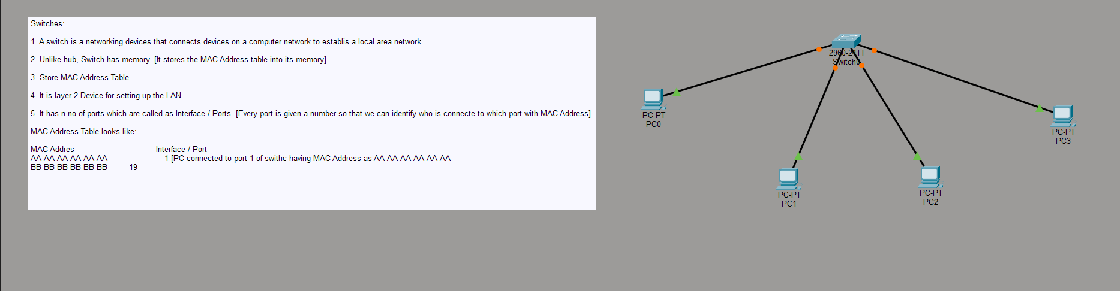
Fig. 3.1 — LAN simulation using a single Switch connecting four PCs
Part B: Hub
Theory
- A hub works at the Physical Layer of the OSI model.
- It is used to set up a LAN.
- A hub has multiple ports.
- A Star topology is developed using a hub.
- When a data packet arrives at one port of the hub, it is copied to all the other ports, so that every device (segment) on the LAN receives every packet.
Procedure
- From the Hub section, choose one Hub, click on it, and check the available ports.
- Take 6 PCs and, using straight-through cables, connect all the PCs to the Hub using the FastEthernet port.
- Assign IP addresses 10.10.10.1 to 10.10.10.6 to PC0 through PC5 respectively.
- Click on Simulation mode in the bottom-right corner, create one data packet (PDU), and set 10.10.10.1 as the Source IP and 10.10.10.5 as the Destination IP to observe how the hub floods the packet to every connected port.
Topology and Simulation
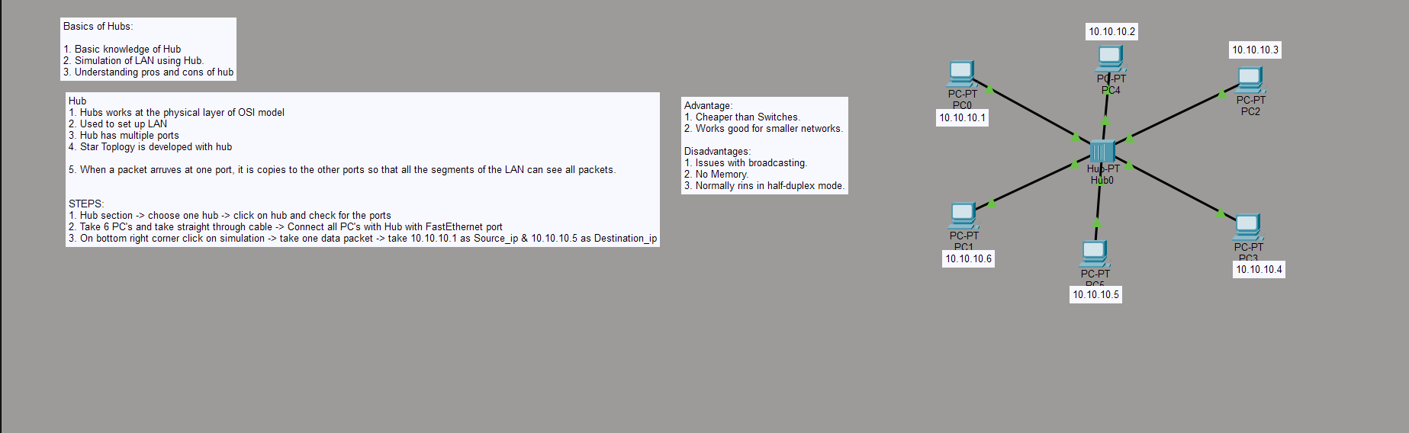
Fig. 3.2 — LAN simulation using a Hub connecting six PCs (10.10.10.1 – 10.10.10.6)
Advantages and Disadvantages of a Hub
Advantages:
- Cheaper than switches.
- Works well for smaller networks.
Disadvantages:
- Issues with excessive broadcasting, since every packet is sent to every port.
- No memory — it cannot learn or store any address table.
- Normally operates in half-duplex mode.
Observation
On sending a PDU through the switch-based LAN (Fig. 3.1), the packet was delivered directly and only to the destination port identified from the MAC address table, resulting in successful, targeted delivery. On sending a PDU through the hub-based LAN (Fig. 3.2), the packet from 10.10.10.1 was broadcast out of every port of the hub, and every PC on the segment received a copy of it, even though only 10.10.10.5 was the intended destination. This clearly demonstrates the key difference between a Layer 1 device (Hub) and a Layer 2 device (Switch).
Learning Outcome
- Understood the working principle and characteristics of a network Switch, including the concept of a MAC Address Table.
- Understood the working principle and characteristics of a network Hub, including how it floods packets to all ports.
- Simulated and verified LAN connectivity using both a Switch and a Hub in Cisco Packet Tracer.
- Compared the advantages and disadvantages of using a Hub versus a Switch in a LAN.
- Gained practical exposure to Layer 1 and Layer 2 networking device behaviour using Cisco Packet Tracer.

