LAB MST
UID-24BCC70009

Question 1-Implement Satic Routing using 4 routers and 8 switches. Use IP from Class A only.
Question 2- Implement 3 vlans hr,admin,finance,and vlan trunking using one switch and 6 pc’s.
Assign Fa0/1 and Fa0/2 to HR. Assign Fa0/3 and Fa0/4 to Admin. Assign Fa0/5 and Fa0/6 to finance. Assign Fa0/24 as Trunk port.

ANS 1----

steps :
take 4 routers, 2 switch and 8 pc.
connect them as shown in figure configure them (configure their ips and that’s all) .
Also write their ip as note infront of them for clearer view.
implement 3 vlan name HR ADMIN Finance and VLAN trunking using one switch and 6 pc
assign fa0/1 and fa0/2 to HR
assign fa0/3 and fa0/4 to admin
assign fa0/5 and fa0/6 to finance
and fa0/24 as trunk port

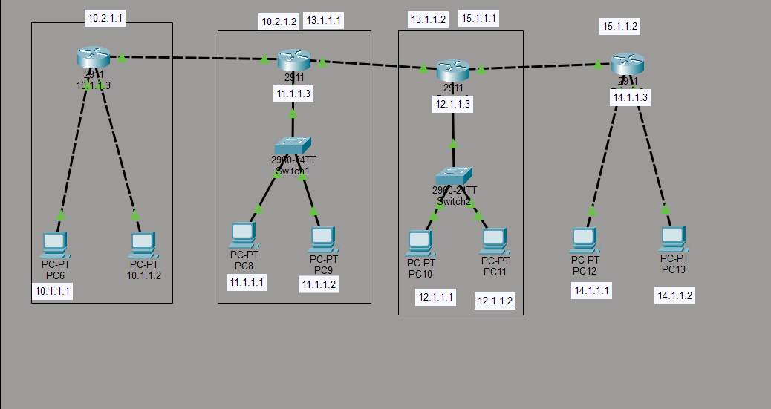

ANS 2----

Steps
take 6 pc and 1 switch connect them as given in figure configure the pc (as shown in diagram )
and then run the command as shown in above screenshots and then vlan and trunking experiment is done .

