Reproduce Key Results in a ML-in-Finance Study

Four experiments on model complexity, generalization, and honest out-of-sample evaluation
DSA5205 Project 1
Ritik Srivastava · A0355860X · ritiksrivastava@u.nus.edu
October 2026

02 · One question, asked four ways
Does giving a financial model more to work with hand it genuine information — or just more room to fit noise?
Task | The question I ask | How I answer it
1 · Ridge | Does seeing more signals help a forecaster? | One fixed simulated market; I only widen the model's view
2 · Lasso | Does betting on a few signals help instead? | The same simulations, with a different assumption
3 · A, B, C | Which model do I trust without the answers? | Nested, chronological selection on unknown datasets
4 · Network | When should a neural network stop learning? | Volatility versus returns, read from the learned weights

The thread that ties them together — what the model sees, then the assumption it imposes, then how its complexity is controlled, and finally an honest verdict measured out of sample.
Source: Kelly, Malamud & Zhou (2024), The Virtue of Complexity in Return Prediction; Montanari & Urbani (2025), Dynamical Decoupling…. Both papers are under docs/.

03 · Everything you see runs from a clean environment
I record from a fresh copy of the source and the six private CSVs, with newly fitted models and visible run outputs.
Setup — Terminal L: python3 -m venv .venv && source .venv/bin/activate && python -m pip install -r requirements.txt && python -m pip install -e . --no-deps
On camera (terminal) | Exact command | Then open / confirm
Task 1 reference (L) | (cd task1 && bash scripts/run_reference.sh) | new aggregates.csv and figures/
Task 4 smoke (R) | bash task4/scripts/setup.sh && (cd task4 && bash scripts/run_smoke.sh) | task4/results/smoke/
Task 2 demo (L) | (cd task2 && bash scripts/run_demo.sh) | pairing and demo results
Task 3 full fresh run (L) | (cd task3 && bash scripts/run_reference.sh) | one final run folder; predictions and validation

Validate + review — Terminal L: use C6–C7 to check the new manifest, prediction hashes and all four metrics. Keep candidate files separate from the submission until reviewed.
Takeaway — pinned versions, fixed seeds, and files I verify on screen. The small demo and smoke runs only prove the code executes; every headline figure comes from the full reference runs.
Source: README.md; recording_commands.md, C1–C7.

Task 1
How does observing more signals change ridge forecast accuracy and timing performance when the underlying simulated market stays fixed?

05 · Task 1 · One fixed world, a widening view
The world stays fixed; I change only how much of it the model is allowed to see.
Each return is built from all 2,000 signals, plus independent noise.
Symbol | Meaning | Value
P | signals in the true process | 2,000
T | training observations | 200
c = P/T | true complexity | 10
P₁ | signals the model actually sees | 100 → 2,000
c_q = P₁/T | observed complexity (what I vary) | 0.5 → 10

Misspecified means the hidden signals still move returns, so the model can never be perfectly right. Dense means the predictive power is spread thinly across many signals, rather than concentrated in a few.
Takeaway — because the market never changes, any shift in performance as c_q grows is about the model's view, not about the world — which is exactly what lets me isolate the effect of complexity.
Source: task1/src/task1/simulation.py — make_simulation, observed_block; 50 replications, ‖β*‖² = 0.2, noise variance 1.

06 · Task 1 · Ridge decides how hard to fit
One dial, z, trades off fitting the training data against keeping the weights small.
L(β) = ‖y − Xβ‖² / T + z · ‖β‖² → β̂(z) = (XᵀX + T z I)⁻¹ Xᵀy
Setting | What it does
larger z | stronger shrinkage, so the fitted weights stay steady
z = 0 (ridgeless) | no penalty; among the many perfect fits it keeps the smallest-weight one
c_q ≈ 1 (interpolation) | about as many features as rows, so the fit can thread every training point
one SVD | gives the whole penalty path cheaply and stays stable where a direct inverse would not

Takeaway — right at interpolation an unregularized fit can chase noise almost without limit, so z is simply the brake that holds it back.
Source: task1/src/task1/ridge.py — fit_ridge_path; at z = 0 it uses the SVD pseudoinverse, never an assumed inverse. Library alpha = T z.

07 · Task 1 · Without a brake, interpolation breaks the fit
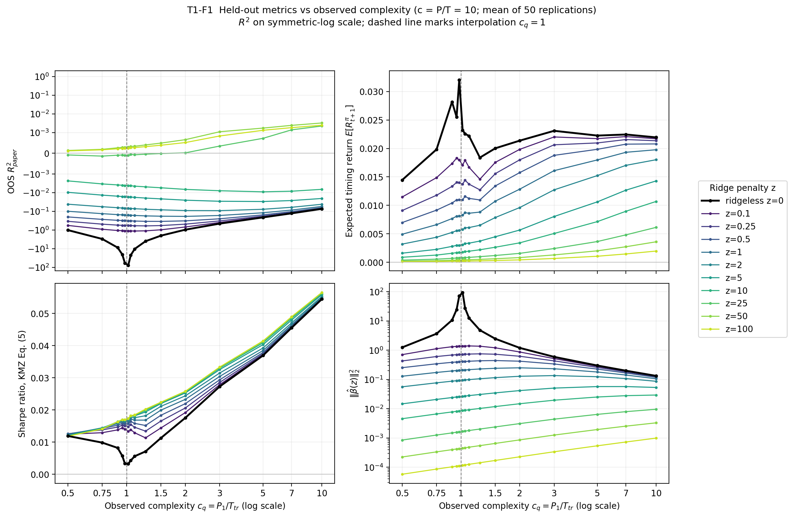
Four metrics against c_q (log x): accuracy, payoff, uncentered Sharpe and weight size. Black = ridgeless; dashed vertical = interpolation.
Takeaway — follow the black curve into c_q = 1: the norm explodes and R² collapses to about −77, yet every regularized (coloured) curve glides straight through — so the hazard is interpolation without shrinkage, not model size.
Source: Task 1 reference, 50 replications; plot_required_metrics; figure_manifest.csv T1-F1.

08 · Task 1 · With the right brake, more signals help
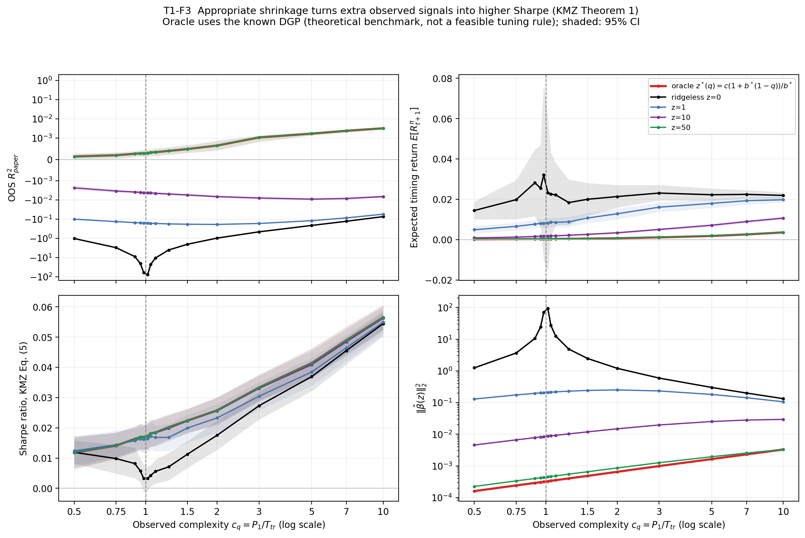
R² top-left; payoff top-right; Sharpe bottom-left; coefficient norm bottom-right. Red = oracle; shaded bands = uncertainty in simulated means.
Takeaway — oracle Sharpe rises from about 0.012 to 0.057 as more signals become visible. It is a parameter-informed benchmark, not a deployable rule or guaranteed finite-sample ceiling.
Source: plot_oracle_comparison; task1/results/assets; figure_manifest.csv T1-F3.

Task 2
On exactly the same dense-signal simulations, does Lasso or another estimator improve on ridge—and does the result survive a larger comparison?

10 · Task 2 · A sparser bet on the same data
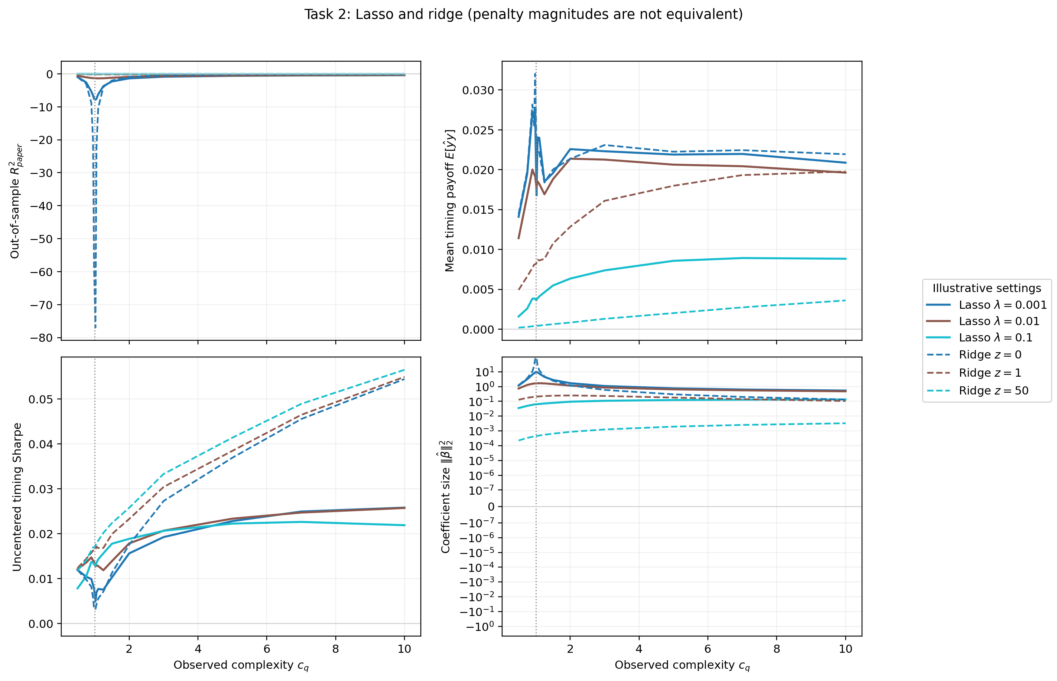
Solid = Lasso; dashed = ridge. Panels show R², payoff, Sharpe and coefficient norm. Penalty numbers use different scales.
Takeaway — ridge retains weak dense signals; Lasso stabilizes the fit but sacrifices timing performance here. At full complexity, SR ≈ 0.057 versus 0.022.
Source: 50-replication paired reference (simulation hashes match); figure_manifest.csv T2-F2.

11 · Task 2 · Does the winner survive more evidence?
I screened nine model specifications, then re-ran only the finalists on 50 replications — because a result that looks good once should have to repeat.
Confirmed model | Mean R² | Mean SR | R² wins / 15 c_q
Ridge z = 50 | 0.00081 | 0.0252 | 15
Ridge-like elastic net | 0.00059 | 0.0237 | 0
Bayesian ridge | −0.0035 | 0.0251 | 0
Lasso λ = 0.1 | −0.0579 | 0.0160 | 0

A Lasso edge that appeared on five replications did not survive fifty. Elastic net, by the way, is simply a blend of ridge and Lasso. Averages run across the 15 complexity values.
Takeaway — match the estimator's built-in assumption to the signal, and confirm anything fragile before trusting it. Ridge wins here because the world is dense and linear — which is precisely the assumption Task 3 can no longer make.
Source: task2/results/assets/model_confirmation/model_ranking.csv.

Task 3
Which forecasting procedure is supported by the labelled data for A, B and C, and how should it predict responses that remain hidden?

13 · Task 3 · Select inside; evaluate outside
One declared search tests 197 configurations without seeing hidden responses.
Dataset | Labelled rows / features | P/N | Outer validation rows
A | 600 / 600 | 1 | 60 per block
B | 240 / 2,400 | 10 | 24 per block
C | 360 / 1,800 | 5 | 36 per block

Dense, sparse, factor and kernel models now include finer penalties, raw/standardized scales, smaller factors and tree alternatives; zero/mean remain benchmarks.
Inner: four folds compare individuals and ensembles by MSE, then choose exposure. Outer: five later blocks evaluate that complete rule.
Five-fold final selection precedes full-data refitting. The completed run is task3_20261006T135535Z_54ad8666f8; reused training labels are not a new audit, and hidden-test performance remains unknown.
Source: protocol.json; extended.py: inventory, search, choose; redesign.py: rolling_folds.
Dataset | Final deployment | Exposure
A | PLS with 2 supervised components | 0.25
B | screened boosting: 100 features, depth 2, 200 iterations | 0.50
C | top-three PCR: raw 5 components at z = 0.001/0.1; standardized 2 at z = 0.001 | 1.00

14 · Task 3 · What the labelled folds selected

PLS uses the response to form compact directions; PCR uses predictor variation without the response. Screened boosting first narrows B's 2,400 features, then fits shallow nonlinear updates.
Takeaway — one model does not fit all three datasets. A and B need exposure shrinkage; only C selects an ensemble.
Source: A/B/C model_card.json and final/choice.json in the completed run.
Dataset | Selection R² | Selection SR | Outer R² | Outer SR
A | 0.0378 | 0.1890 | 0.0203 | 0.1360
B | 0.0295 | 0.1817 | −0.0110 | 0.0653
C | 0.0072 | 0.0782 | −0.0357 | −0.0481

15 · Task 3 · Selection looks stronger than outer evaluation

Selection scores choose the final specification and exposure. Five chronological outer blocks evaluate the complete rule on later labelled rows. Neither table column uses hidden responses.
Takeaway — A has the clearest held-out support. B has positive timing Sharpe but negative accuracy. C's positive selection score does not survive outer evaluation.
Source: summary.csv and review.md. SR is uncentered and not annualized; SRvar is reported in the Task 3 report.

16 · Task 3 · A complete fresh run, not a replay
Read → search → refit → save/reload → predict → validate → review.
Candidate file in the new run folder | Required rows | Required format
A0355860X_predictions_A.csv | 1,000 | UTF-8; t,yhat
A0355860X_predictions_B.csv | 4,000 | UTF-8; t,yhat
A0355860X_predictions_C.csv | 2,000 | UTF-8; t,yhat

The recorded command was bash scripts/run_reference.sh inside task3. The full search made 14,775 candidate-fit attempts across A/B/C, plus selected-member refits.
Validation passed for exact test IDs/order, aligned features, finite predictions and required row counts: 1,000 / 4,000 / 2,000.
Recording: show launch and completion at readable speed, label accelerated waiting, then open review.md, model cards and validation.json.
Source: manifest.json and validation.json for run task3_20261006T135535Z_54ad8666f8.

Task 4
Does a neural network forecasting financial volatility learn economically meaningful structure before it overfits, and what changes when the target is return?

18 · Task 4 · From how-many-inputs to how-long-to-train
The same question, re-asked about training time instead of inputs.
Choice | What it means
two targets | next-week log realized volatility versus excess return
same 44 inputs | 22 absolute-return lags and 22 signed-return lags
subspace H | the HAR directions — 1-, 5- and 22-day averages in both blocks: six directions
the network | two layers, width 256, tanh, small output initialization, 3 seeds
chronological split | train 1926–79, validate 1980–99, test 2000–26

HAR, the heterogeneous autoregressive model, is the standard volatility baseline; the leverage effect — falling prices tending to raise future volatility — makes HAR + leverage an even stronger one. H is an economically motivated proxy for useful structure, not a known truth.
Takeaway — because HAR names the directions that should matter, I can measure how much of what the network learns lands inside H, and so turn an abstract claim into something I can read off the weights.
Source: task4/src/task4/data.py — economic_subspace; Montanari & Urbani (2025).

19 · Task 4 · The score improves before it deteriorates
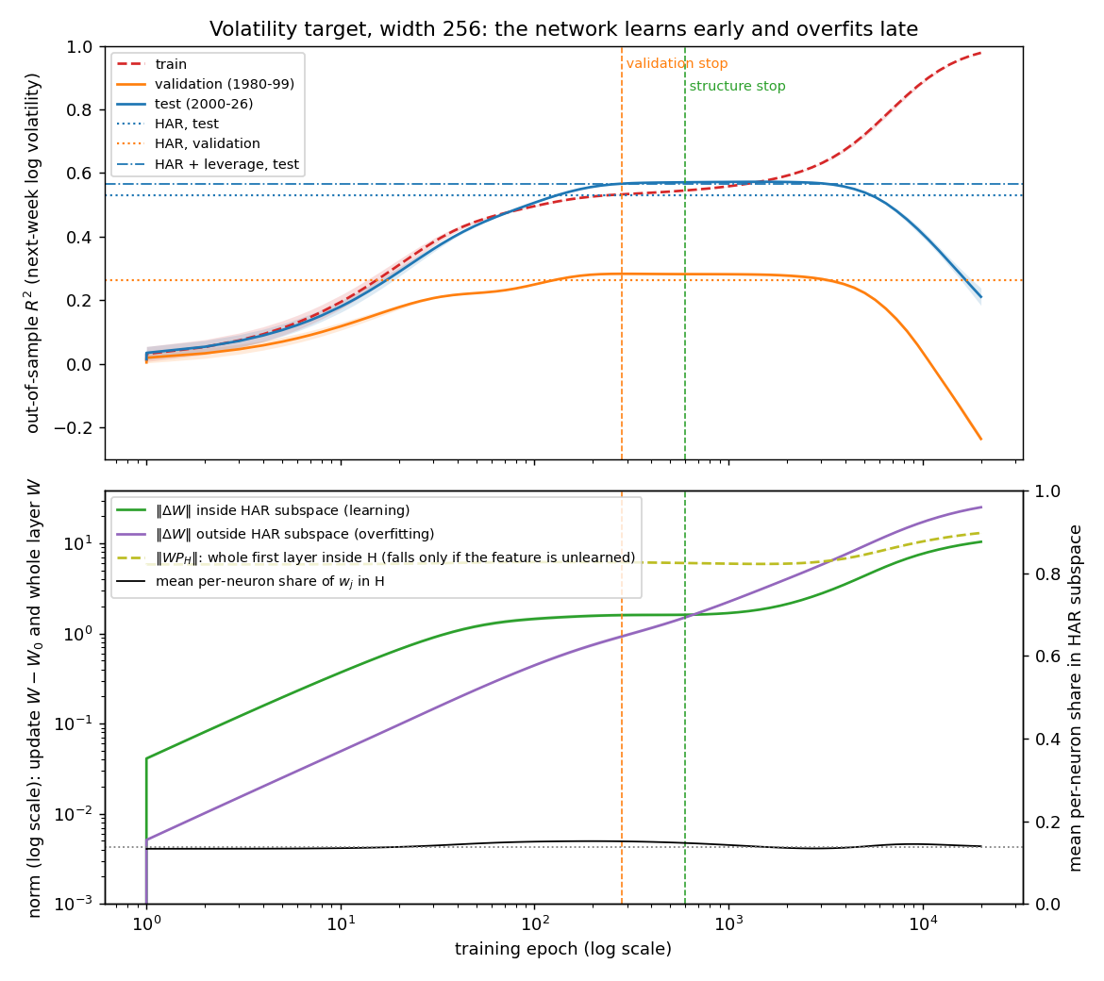
R² against epochs (log scale): red = training, orange = validation, blue = test. Flat lines are HAR benchmarks; vertical lines mark stopping rules.
Interpretation: training keeps improving while validation and test peak, then deteriorate. Select stopping without consulting the test curve.
Source: T4-F1, upper panel; full reference, three-seed mean. The figure retains the original data.

20 · Task 4 · What changes inside the network?
Left axis: update magnitude inside H (green) versus outside H (purple). Right axis: whole-weight share in H (black); dashed projection tracks absolute structure.
Interpretation: early inside-H growth levels off, then outside-H growth dominates. Absolute structure does not disappear: this is dilution, not full unlearning.
Source: T4-F1, lower panel. H is an economic proxy, not a known true signal subspace.

21 · Task 4 · Same network, two very different targets
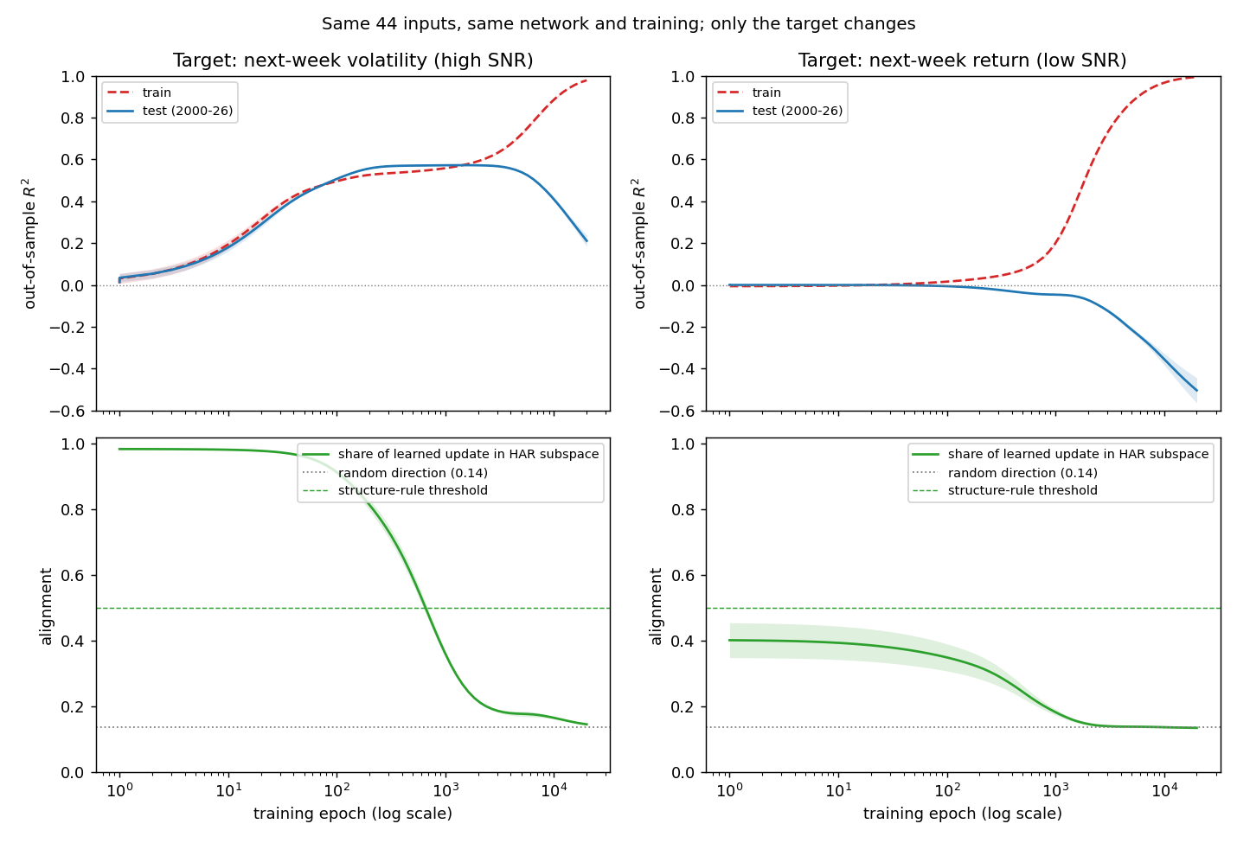
Left = volatility; right = return. Top: training/test R². Bottom: update alignment with H; dotted line = random six-of-44-dimensional share.
Takeaway — volatility stopping R² ≈ 0.57, near HAR + leverage (0.566), without a significant advantage. Returns show no positive validation R² here; the structure threshold remains exploratory.
Source: task4/results/reference; T4-F2, T4-T1.

22 · What the four experiments add up to
One lesson in four forms: complexity helps only when the model's view, its assumptions, and its brakes all fit the signal.
Task | What I take away
1 · Ridge | More signals raised Sharpe — but only with enough shrinkage near interpolation.
2 · Lasso | A sparse assumption discarded a dense signal; the right prior matters more than raw flexibility.
3 · A, B, C | Separate selection from evaluation; retain uncertainty rather than force a favorable sign.
4 · Network | Learning and overfitting ran on different clocks, so when to stop mattered as much as capacity.

Reproducibility — figures retain their reference provenance. The Task 3 predictions have one manifest and are reviewed before they become the submission.
Thank you
Source: reports/figure_manifest.csv; task1–task4 results and submission artifacts.

