
SCALABLE DISTRIBUTED COMPUTING FOR DATA SCIENCE
DSA5208
SINGAPORE RAINFALL ANALYSIS
AND PREDICTION
Spark-based weather-pattern analysis and
30-minute rainfall probability prediction
ANALYSIS PERIOD | 2017–2024
Author | Student ID
Amrit Satpathy | A0355181E
Ritik Srivastava | A0355860X

Dataset: National Environment Agency, Historical Rainfall across Singapore, via data.gov.sg
October 2026

Abstract
This project uses Apache Spark to analyse 48,538,713 cleaned five-minute rainfall readings from 91 monitoring stations across Singapore between 2017 and 2024. It addresses two tasks: describing seasonal, diurnal, interannual and spatial rainfall patterns, and estimating the probability that a station will accumulate more than a user-selected amount of rainfall in the next 30 minutes.
The rainfall summaries show pronounced variation. Mean annual rainfall per station is lowest in 2019 (1,526 mm) and highest in 2022 (2,750 mm). Wet readings peak around 14:00–16:00 Singapore Time, and the raw count of station-days with at least 50 mm of rain peaks in 2021. These findings are observational and remain sensitive to station coverage and missing intervals.
The submitted Spark MLlib Gradient-Boosted Trees pipeline is linked to a saved-model record with 7,997,496 threshold-expanded training rows and 31,872,380 2024 test rows. It reports ROC-AUC 0.924 and PR-AUC 0.584. The reported F1 of 0.984 is MLlib's weighted F1; positive-class precision, recall, F1 and probability calibration are still required before interpreting rare-event detection operationally.
Main systems finding. On one laptop, local[*] is faster than the tested Standalone and Docker layouts. This demonstrates deployment and executor overhead on shared hardware; it is not evidence of multi-machine scale-out. The performance comparison is descriptive because core counts, heap budgets, partition counts and independently sampled row sets differ between configurations.

Research questions and contributions
- A Spark pipeline converts eight annual CSVs into reusable, year-partitioned Parquet and materialised temporal features.
- Task 1 combines annual, monthly, diurnal, spatial and heavy-rain views rather than relying on one aggregate.
- Task 2 uses the rainfall threshold as a model feature and compares a non-linear MLlib model with simpler baselines.
- The deployment study distinguishes single-JVM execution from Standalone executors and Docker workers on the same host.

1. Introduction and objectives
Rainfall at five-minute resolution is temporally clustered: consecutive wet readings can represent the development and passage of a shower, while most station-time observations are dry. This makes recent rainfall, local time and station context useful for short-horizon probability prediction.

1.1 Project tasks
- Task 1 — explore how rainfall changes within a year and across 2017–2024, using appropriate summaries and visualisations.
- Task 2 — estimate P(next-30-minute accumulation > q) for a specified station, prediction time and rainfall threshold q using Spark MLlib.
- Additional study — compare model quality and deployment cost while describing the limits of a single-host distributed experiment.

1.2 Scope and interpretation
The observations come from monitoring stations rather than one island-wide gauge. Station availability changes over time, so per-station normalisation improves comparison but does not fully remove coverage bias. The public source also warns that missing observations can occur and that the data have not undergone the same quality-control procedures as official climate records [1].

2. Dataset and data preparation
Item | Reported value / treatment
Years | 2017–2024 inclusive
Raw size | Approximately 7.8 GB across eight CSV files
Cleaned records | 48,538,713
Distinct stations | 91
Storage | Parquet partitioned by year
Time convention | Asia/Singapore

2.1 Cleaning rules
- Parse timestamps under the Asia/Singapore Spark session time zone and cast rainfall and coordinates to numeric types.
- Remove records with missing station/time/rainfall, negative rainfall, or rainfall above the project screening bound of 60 mm per five minutes.
- Deduplicate (station_id, timestamp), retaining the record with the latest update timestamp.
- Resolve a canonical station name and median coordinates for each station ID.
- Write the cleaned columns to Snappy-compressed Parquet partitioned by year.
Data-quality boundary. The 60 mm screening value is a project rule rather than a documented sensor limit. The final evidence should include counts removed by each rule, cadence gaps, a sensitivity check for this bound and an audit of the reported 786 mm station-day in 2022.

3. Computing architecture
The architecture separates distributed data preparation from model fitting. Spark performs ingestion, validation, aggregation, per-station temporal windows and MLlib training. Small summaries are collected only for plotting. The PyTorch branch receives a bounded sequence sample and runs on one laptop GPU; it is supplementary and is not distributed training. Figures A2–A6 document the logical data plane and the three execution topologies in detail.
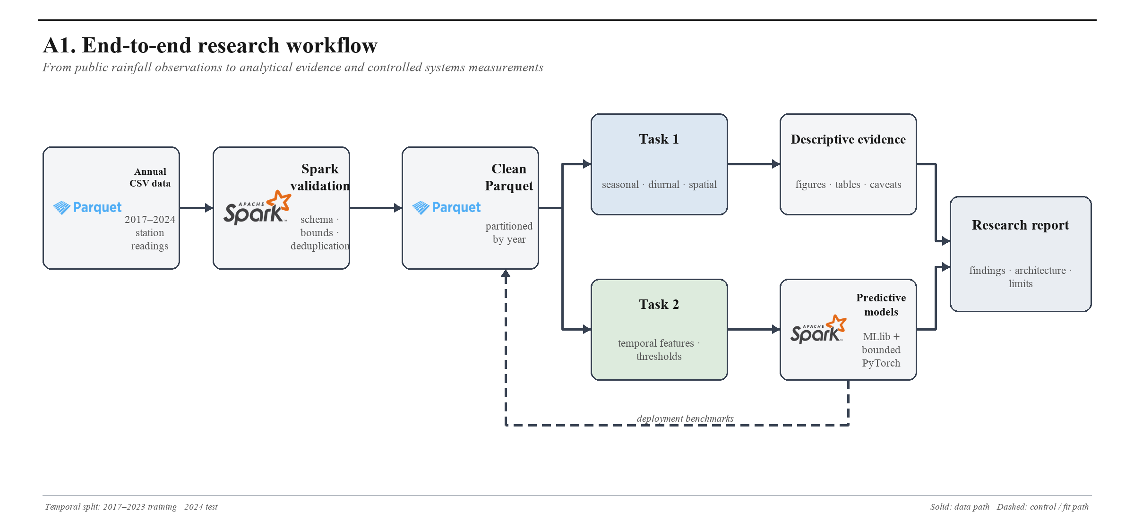
Figure 1. End-to-end analytical workflow from annual rainfall files to descriptive evidence, predictive models and systems measurements.

3.1 Environment and resource configurations
Configuration | Execution | Requested resources | Shuffle partitions
local-all | local[*], one JVM | 16 host threads; 20 GB driver heap | 96
standalone-2x2 | 2 executor processes | 4 total cores; 4 GB driver; 2 × 2 GB executors | 32
standalone-4x2 | 4 executor processes | 8 total cores; 4 GB driver; 4 × 2 GB executors | 64
docker-2w | 2 worker containers | 4 total cores; 2 GB driver; 2 × 1 GB executors | 32
docker-3w | 3 worker containers | 6 total cores; 2 GB driver; 3 × 1 GB executors | 48

Host specification: Windows laptop with WSL2 Ubuntu, 32 GB physical RAM, 24 GB exposed to WSL2, 16 logical CPU cores and 8 GB swap. Software: Python 3.12, OpenJDK 21 and PySpark 3.5.3. Docker workers advertise two cores and 3 GB each; Compose does not impose hard CPU or memory limits. Requested settings should therefore be distinguished from realised runtime allocation.
Meaning of “distributed”. Standalone and Docker use separate Spark executor processes and network shuffle, but do not add physical CPUs, memory channels, storage or network interfaces. They demonstrate deployment mechanics and overhead, not multi-node scalability.

4. Task 1 — rainfall patterns
All large aggregations are performed in Spark and only compact summaries are collected for plotting. Annual and monthly totals are averaged across contributing stations to reduce the direct effect of a changing network. The remaining coverage dependence is reported as a limitation.

4.1 Interannual variation
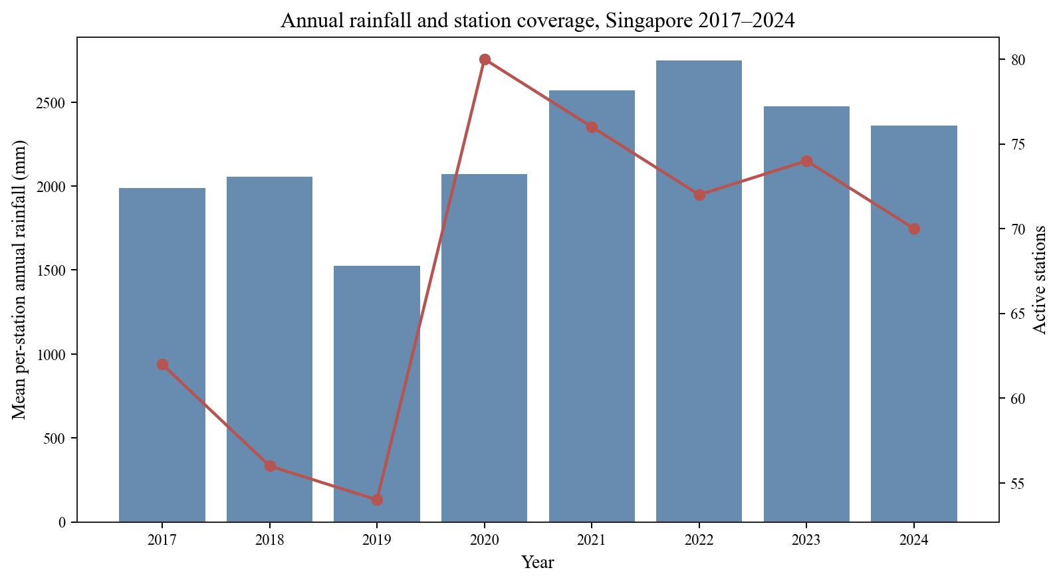
Figure 2. Mean annual rainfall per station with contributing-station count.
Mean annual rainfall per station ranges from 1,526 mm in 2019 to 2,750 mm in 2022, an 80% difference. The contributing network ranges from 54 to 80 stations, so a stable-station cohort and annual completeness rates are needed to test whether the ranking is robust.

4.2 Monthly seasonality
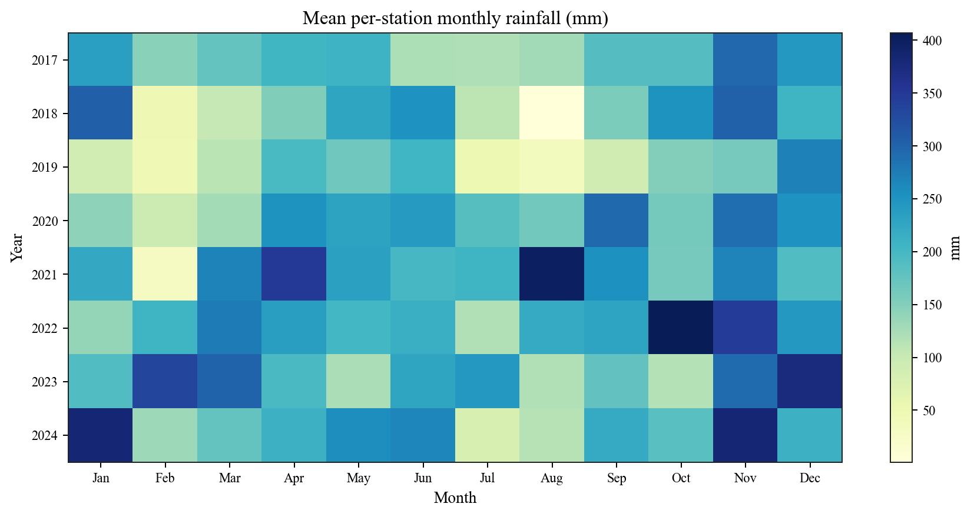
Figure 3. Year-by-month mean rainfall per station.
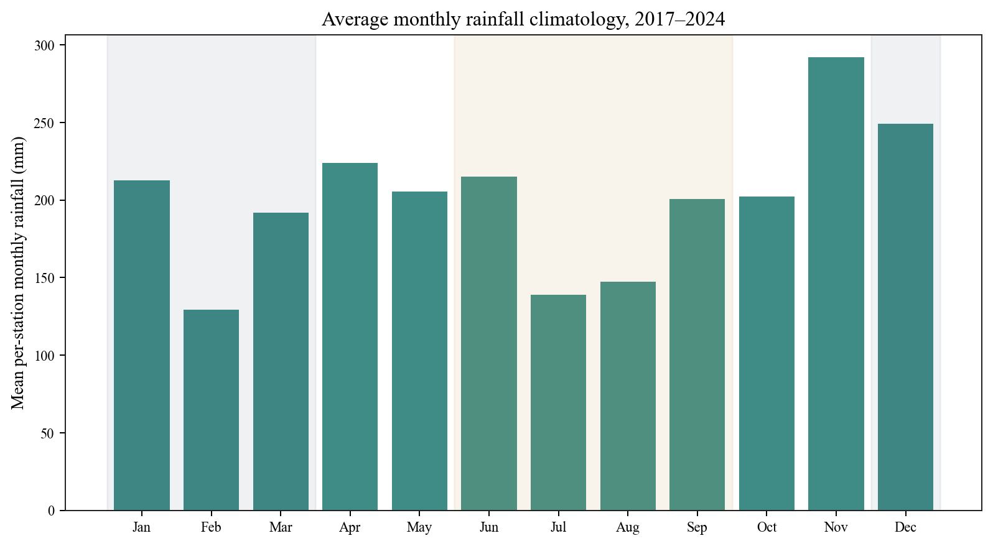
Figure 4. Average monthly rainfall pattern with monsoon context.
The monthly views show a recurring but variable seasonal cycle. Wetter Northeast Monsoon months and inter-monsoon peaks agree broadly with Singapore’s documented climate, while individual years depart from the average [2]. The project data are observational and do not establish a causal meteorological mechanism.

4.3 Diurnal variation
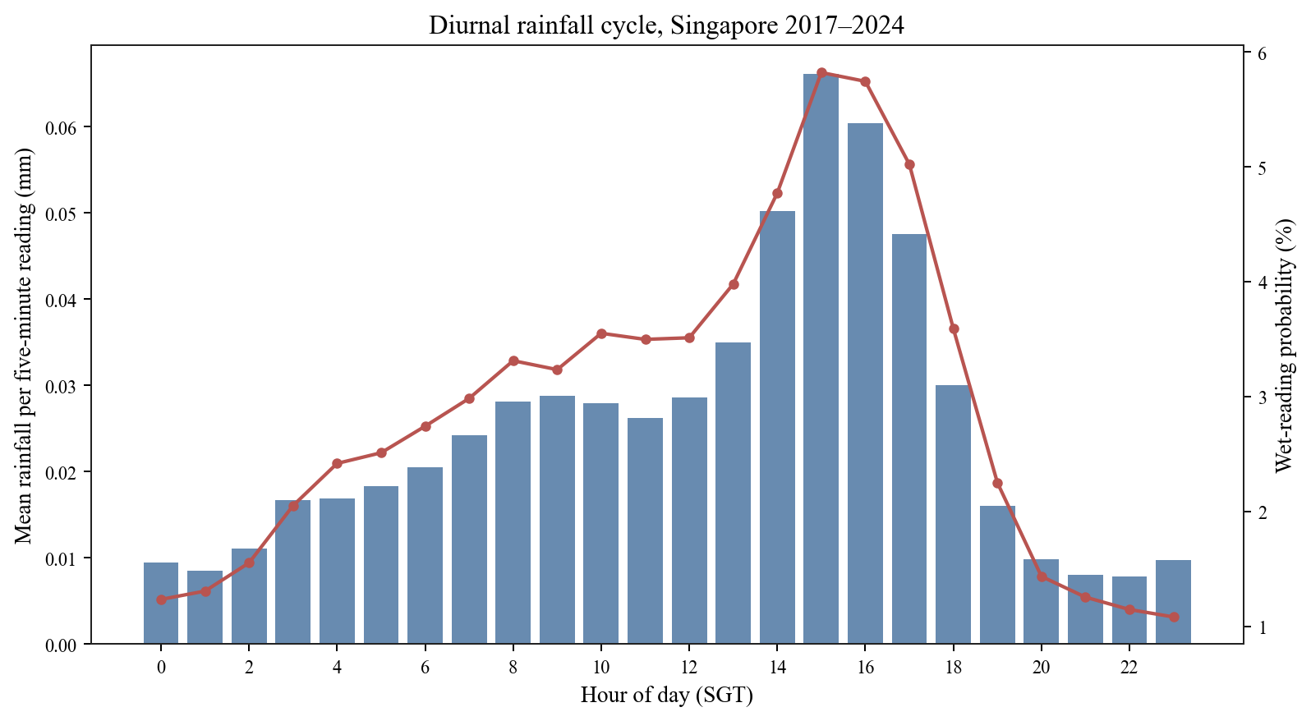
Figure 5. Diurnal rainfall intensity and wet-reading frequency.
Wet-reading frequency rises from about 1.1% at 23:00 to about 5.8% at 15:00 in the reported summary, a roughly 5.3-fold difference. The peak around 14:00–16:00 SGT is consistent with afternoon convection, while seasonal stratification tests whether the pattern persists under different monsoon regimes.
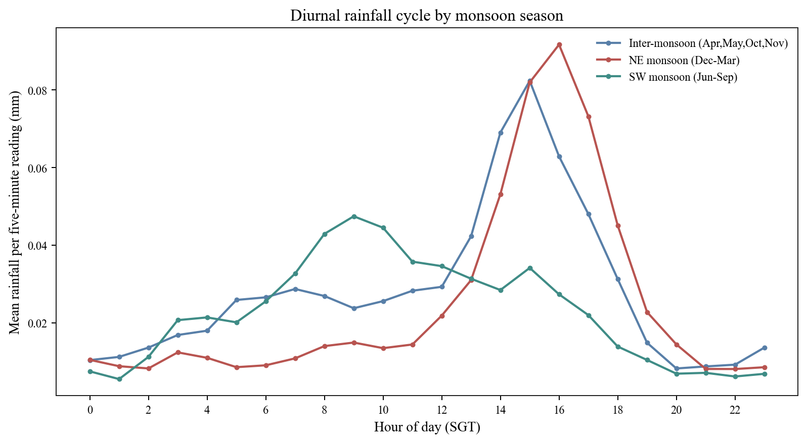
Figure 6. Diurnal rainfall pattern by monsoon season.

4.4 Spatial variation
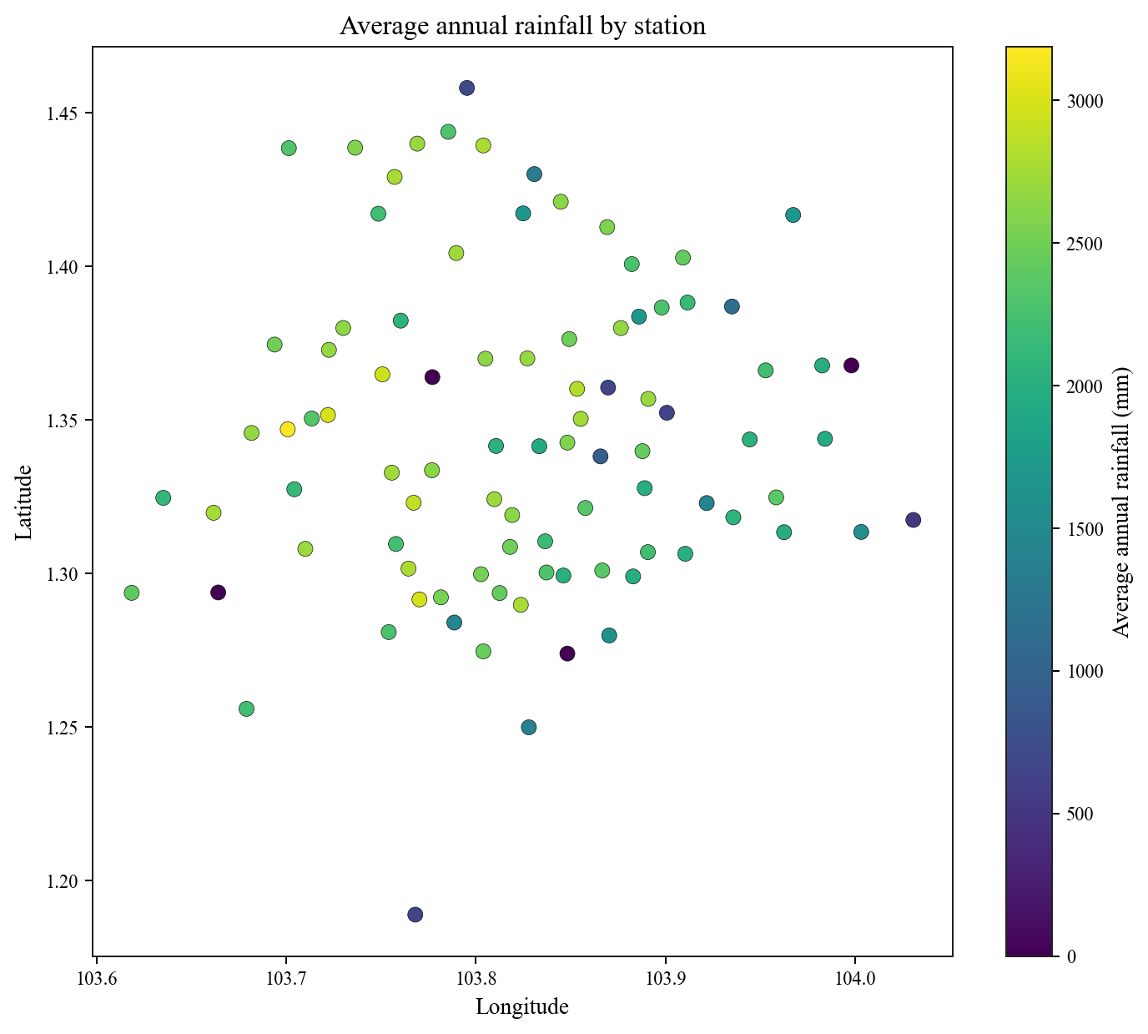
Figure 7. Station locations coloured by average annual rainfall.
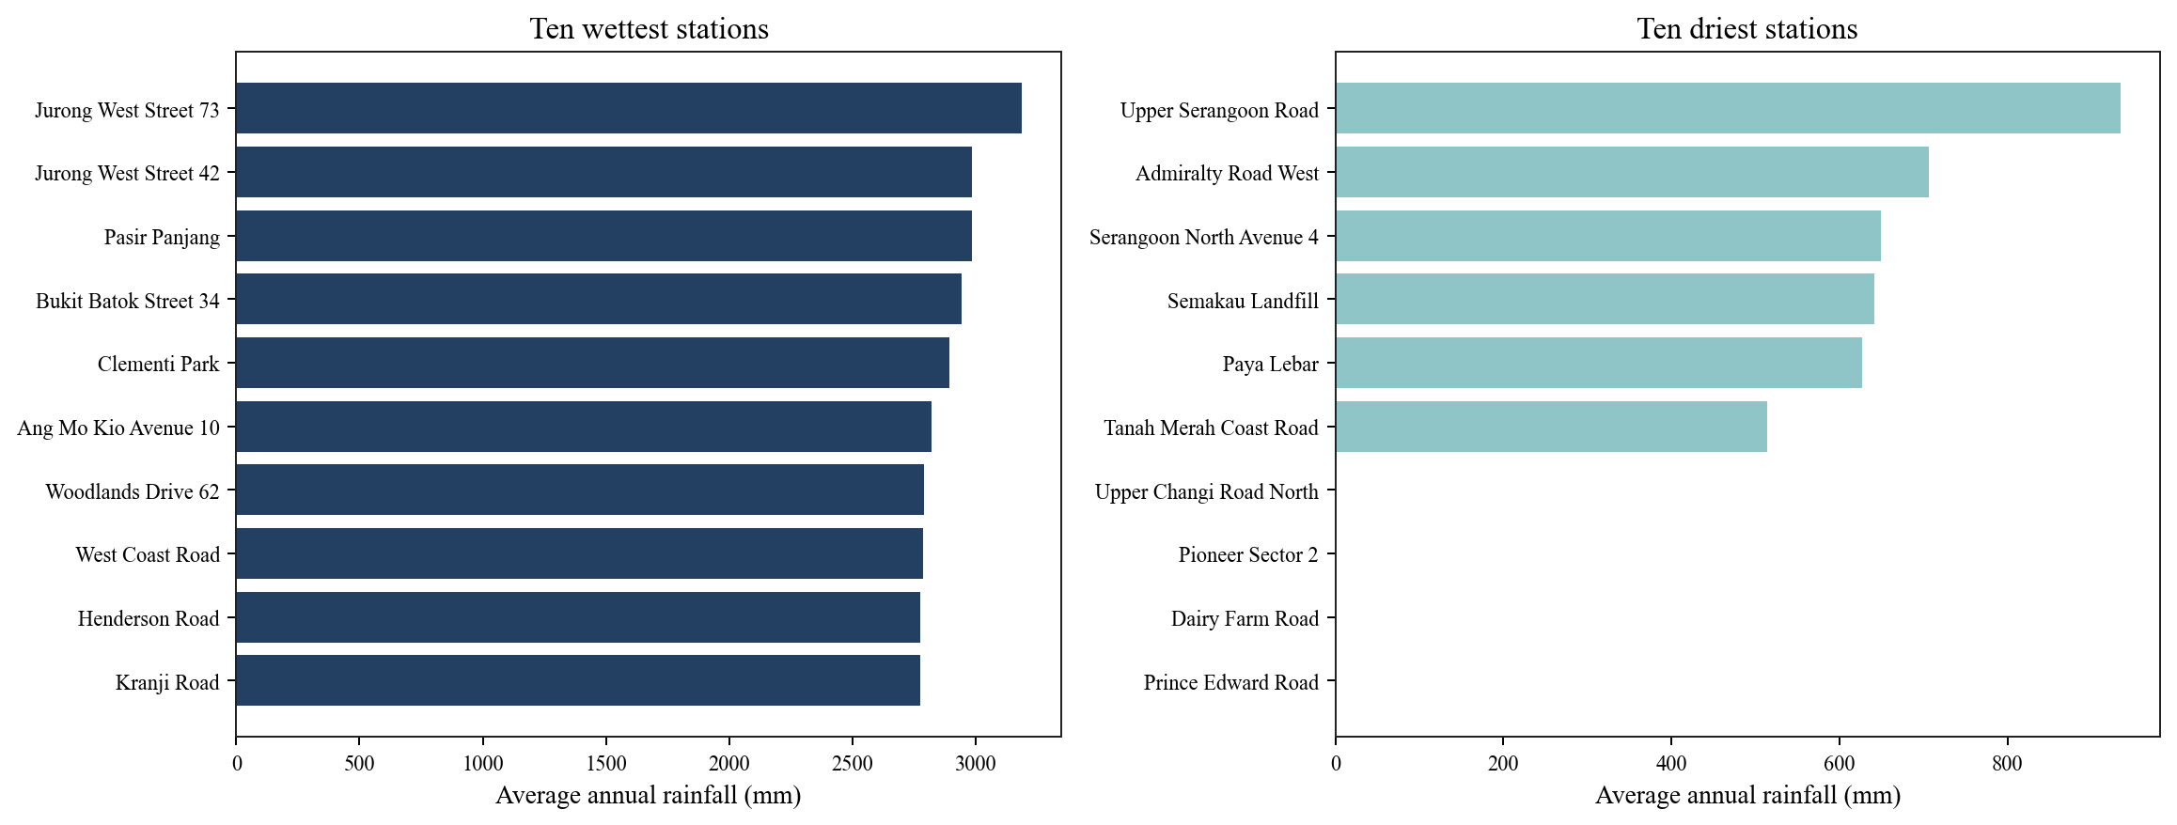
Figure 8. Stations with the highest and lowest reported average annual rainfall.
The map and ranking show spatial heterogeneity, but station rankings should not be treated as climatological differences until each station’s valid observation fraction and period of operation are shown.

4.5 Heavy-rain station-days
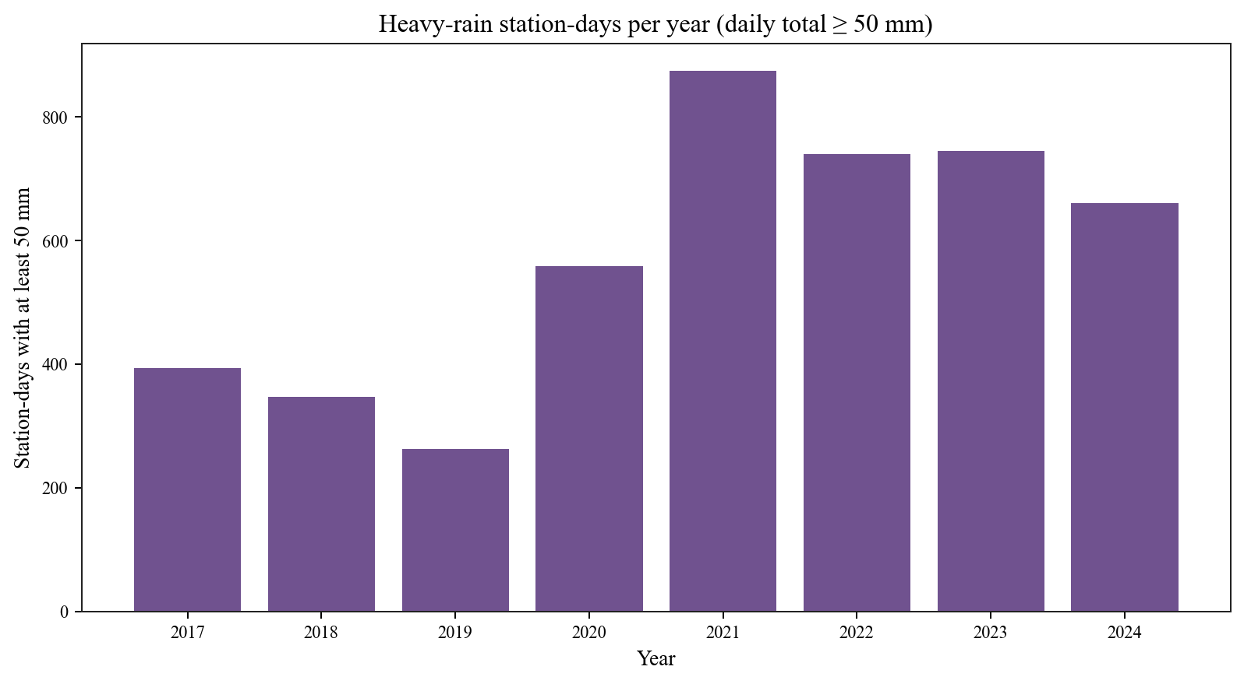
Figure 9. Count of station-days with at least 50 mm of rainfall.
The raw count is lowest in 2019 (263) and highest in 2021 (875). Because more operating stations create more opportunities to record an event, the preferred follow-up measure is heavy station-days per 1,000 eligible station-days under a stated completeness rule.

5. Task 2 — rainfall-probability prediction

5.1 Target and feature contract
For station s, prediction time t and threshold q, the binary target is 1 when the sum of rainfall readings at t+5, t+10, …, t+30 minutes exceeds q. The current reading at t is excluded from the target. Training examples are created for q ∈ {0.2, 1, 2, 5, 10} mm.
Feature family | Features | Purpose
Recent rain | Current and previous reading; rolling 30/60/180-minute sums; minutes since rain | Represent persistence and storm state
Time | Hour/month sine and cosine; weekend; NE/SW monsoon indicators | Represent daily and seasonal cycles
Station | Station index, latitude, longitude | Represent location and station effects
Query | Threshold q in mm | Allow one fitted pipeline to score tested thresholds

Supported-claim boundary. The experiment validates five thresholds. A numeric threshold input does not establish accurate interpolation at unseen thresholds, and a tree model does not guarantee that predicted probability decreases monotonically as q increases.

5.2 Primary Spark MLlib pipeline
The fitted pipeline applies StringIndexer to station identity, VectorAssembler to the full feature set and Spark MLlib Gradient-Boosted Trees. The station index remains categorical, and maxBins is set above the number of stations. Figure A6 shows the shared transformation and fitting path; Appendix B provides one architecture diagram for every evaluated model.
GBT parameter | Value | Reason / implication
maxIter | 40 | Boosting rounds
maxDepth | 5 | Limits tree complexity
stepSize | 0.1 | Shrinkage
maxBins | 128 | Supports at least 91 station categories
subsamplingRate | 0.7 | Row subsampling per tree
cacheNodeIds | true | Trades memory for repeated tree operations
seed | 42 | Fixed estimator randomness

5.3 Temporal evaluation and canonical run
The final saved model is trained on years 2017–2023 and evaluated on 2024. The table below reports the canonical result associated with the submitted pipeline. The separate model-comparison benchmark uses a smaller test sample and is reported independently.
Canonical run | Train rows | 2024 test rows | ROC-AUC | PR-AUC | Accuracy | Weighted F1
Saved GBT pipeline | 7,997,496 | 31,872,380 | 0.924 | 0.584 | 0.986 | 0.984

The 0.984 F1 value is MLlib’s support-weighted F1. With a reported training positive rate near 1.9%, it is dominated by the negative class and must not be read as positive-event F1. ROC-AUC and PR-AUC measure ranking; they do not prove that the predicted probabilities are calibrated.

5.4 Threshold-specific performance
Threshold (mm) | GBT ROC | GBT PR | LogReg ROC | LogReg PR
0.2 | 0.904 | 0.660 | 0.879 | 0.557
1 | 0.905 | 0.577 | 0.874 | 0.500
2 | 0.895 | 0.505 | 0.865 | 0.441
5 | 0.898 | 0.398 | 0.857 | 0.346
10 | 0.905 | 0.302 | 0.861 | 0.253

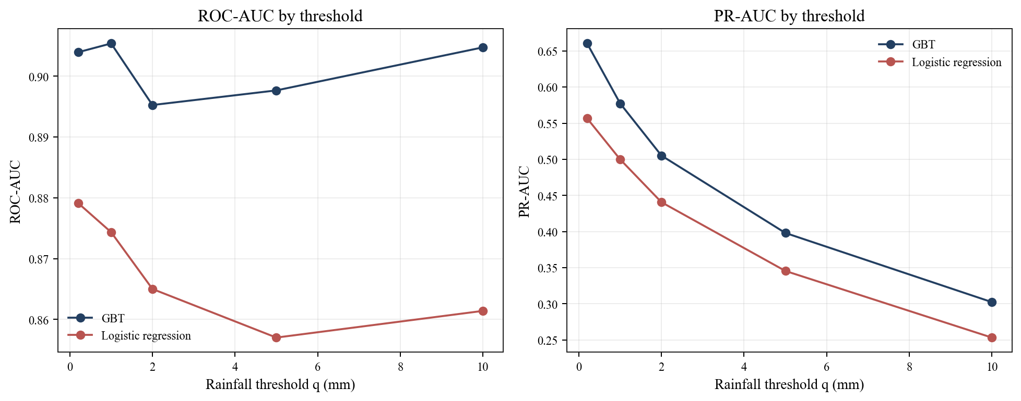
Figure 10. Threshold-specific ranking metrics reported for GBT and logistic regression.
GBT outperforms logistic regression at all five reported thresholds. GBT PR-AUC falls from 0.660 at 0.2 mm to 0.302 at 10 mm, consistent with the increasing rarity and difficulty of higher-accumulation events. Positive prevalence by threshold is required to quantify the baseline level of each PR curve.

5.5 Evaluation still required for probability claims
- Per-threshold positive prevalence, positive-class precision, recall and F1 at a validation-selected cutoff, plus a confusion matrix.
- Brier score or log loss and reliability diagrams with bin counts; calibration fitted on a validation year, not 2024.
- A persistence baseline and a prevalence-only probability baseline.
- Intermediate thresholds such as 0.5, 3 and 7 mm, including the rate of monotonicity violations across q.

6. Model and compute experiments

6.1 Model comparison
The model-comparison benchmark is a separate experiment. The six MLlib models share approximately 8.0 million training rows and 1.59 million test rows. The GPU models use about 401,000 rows per split, different sequence features and a different evaluator; their timing and quality therefore describe practical implementations rather than a controlled algorithm comparison. The model structures are documented independently in Figures M1–M8 so that algorithmic differences are separated from performance claims.
Model | Runtime | Train (s) | Predict (s) | ROC-AUC | PR-AUC
GBT | MLlib CPU | 278.6 | 8.16 | 0.925 | 0.586
Random Forest | MLlib CPU | 173.5 | 8.43 | 0.902 | 0.560
Logistic Regression | MLlib CPU | 27.9 | 4.91 | 0.897 | 0.436
Linear SVC | MLlib CPU | 44.3 | 5.44 | 0.875 | 0.468
MLP | MLlib CPU | 321.1 | 7.95 | 0.921 | 0.557
Factorization Machines | MLlib CPU | 278.3 | 5.51 | 0.814 | 0.196
LSTM | GPU | 75.3 | 0.44 | 0.915 | 0.476
TCN | GPU | 79.9 | 0.36 | 0.915 | 0.473

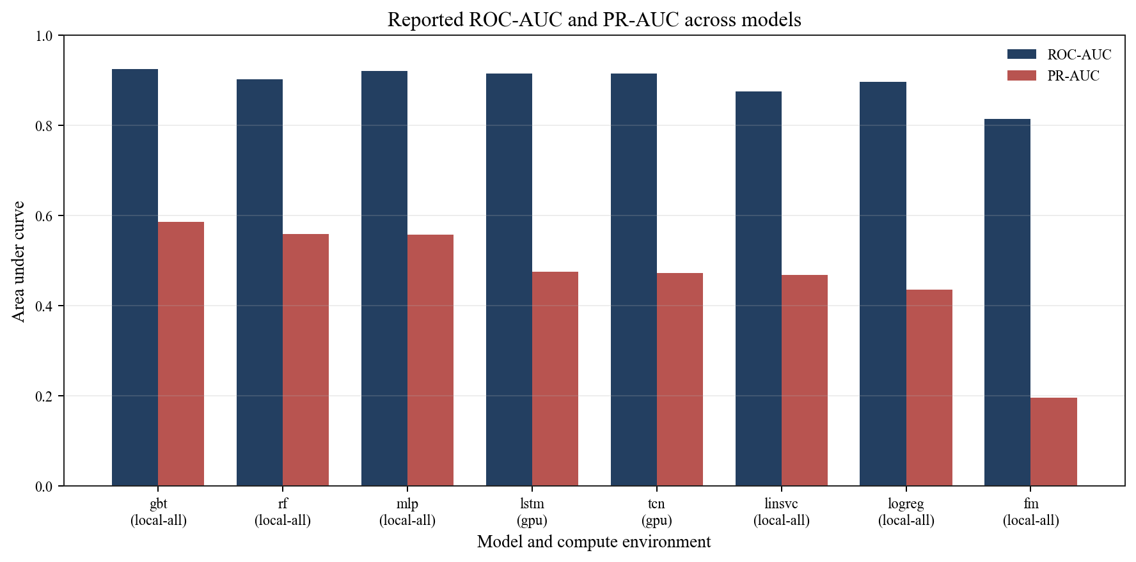
Figure 11. Reported ROC-AUC and PR-AUC across model implementations.
GBT has the highest reported PR-AUC in this experiment. Random Forest and MLP are competitive, while the linear models provide faster baselines. The short GPU inference times are not directly comparable with MLlib because the scored row counts, feature representations and frameworks differ.

6.2 Deployment comparison
Four MLlib models were run across five Spark configurations on approximately one million sampled training rows. The sample counts differ slightly by configuration, and the configurations also change cores, heap budgets and shuffle partitions. The timings are therefore descriptive observations rather than a controlled estimate of deployment overhead. Figure A7 specifies the matched-resource protocol needed for a causal deployment comparison.
Configuration | GBT train rows | GBT (s) | RF (s) | LogReg (s) | LinSVC (s)
local-all | 999,587 | 64.0 | 42.4 | 13.4 | 27.0
standalone-2x2 | 1,000,314 | 108.9 | 75.6 | 23.5 | 41.5
standalone-4x2 | 1,000,771 | 86.2 | 51.2 | 19.9 | 36.6
docker-2w | 1,000,314 | 101.8 | 71.7 | 21.6 | 46.2
docker-3w | 1,000,771 | 82.4 | 59.4 | 20.2 | 39.1

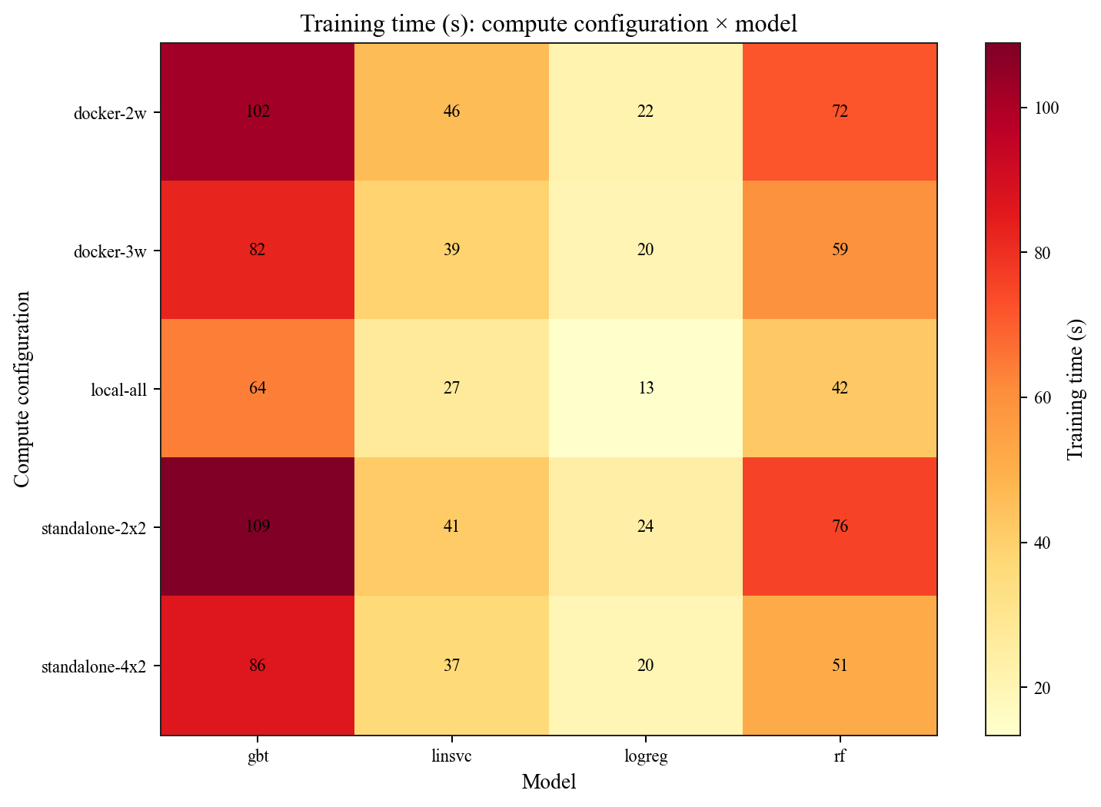
Figure 12. Training time by deployment configuration; resources are not held constant.
Local execution is fastest in the reported table. Within each cluster family, more allocated cores reduce GBT training time. These results are compatible with executor, serialization and container overhead on a shared host, but the current design cannot isolate those causes. Quality metrics remain similar because deployment changes execution, not the learning objective.

6.3 Stronger experiment design
Experiment | Controlled design | Report output
Matched deployment overhead | Same frozen row IDs, four cores, memory budget, partitions and GBT; local[4] vs 2×2 Standalone vs 2×2 Docker | Median and range over ≥3 measured runs; stage time, shuffle, spill, GC
Parallel scaling | Fixed data/model; local[1/2/4/8], then executor layouts with fixed total cores | Speedup S(p), efficiency E(p), throughput and p95 task time
Feature reuse break-even | Recompute features per fit versus materialise once and reuse for 1, 3 and 6 fits | End-to-end elapsed time and measured break-even number of fits

7. Threats to validity and proposed extensions
The following items are the most consequential unresolved risks found during report review. They are stated explicitly because correcting prose alone cannot establish that the current metrics are unaffected.
Priority | Risk | Implication / required check
P0 | Temporal window boundaries | Confirm that rolling 30 minutes contains the intended six five-minute totals; rangeBetween(-1800,0) can include seven grid points.
P0 | Cadence integrity | A previous row is not necessarily t−5 minutes. Verify exact offsets for lag sequences and future labels when observations are missing.
P0 | Temporal split boundary | Ensure training rows near year-end do not use 2024 observations in their target windows.
P0 | Training/inference parity | Training can search up to 24 h for last rain; inference currently loads six hours. Compare offline and online features for identical queries.
P1 | Run traceability | Assign immutable run IDs to data, feature version, sample membership, model, metrics and figures.
P1 | Probability validation | Add calibration, positive-class metrics and unseen-threshold tests before operational claims.

Interpretation. These are static implementation risks, not proof that the reported ranking metrics are wrong. If any check changes feature values or labels, regenerate the saved model, all predictive tables and all figures from one versioned run.

7.1 Proposed temporal-partitioning experiment
A strong extension is to compare the corrected station-wide temporal window with station-month blocks that include boundary “halo” data. Each monthly block must include at least 180 minutes of prior context, 30 minutes of future context and sufficient last-wet state, then emit only rows owned by its core month. The optimised output must match the reference output exactly before runtime is compared.
- Correctness: identical keys, feature values and labels, including month/year boundaries and missing-slot cases.
- Systems evidence: runtime, shuffle read/write, spill, task-duration distribution and executor utilisation.
- Honest outcome: overlap may cost more than added parallelism; no speed-up is still a useful finding when explained.

8. Limitations and conclusion
The analysis is limited by changing station coverage, incomplete rule-level cleaning counts, a project-selected high-reading cutoff, sampled training, unresolved probability calibration and single-host compute experiments. Deep-model comparisons use smaller datasets and different feature representations. The saved model’s evaluator reports weighted rather than positive-class F1.
Within those limits, the project demonstrates a coherent Spark workflow from large raw CSV files to reusable Parquet, distributed temporal processing, MLlib training and report-ready summaries. The strongest empirical weather findings are the wet 2021–2022 period, dry 2019, an afternoon wet-reading peak and spatial heterogeneity. The strongest predictive result is GBT’s PR-AUC advantage over the logistic baseline at each tested threshold. The strongest systems finding is that extra executor/container layers do not compensate for reduced cores and shared-host overhead in the reported setups.

9. AI usage declaration
The authors used OpenAI Codex (GPT-6) to review the report structure, improve expression and formatting, analyse methodological and presentation gaps, and create and refine architecture diagrams. The authors are responsible for the content and quality of the submitted work.

References
[1] National Environment Agency. Historical Rainfall across Singapore datasets, 2017–2024. data.gov.sg. Source link
[2] Meteorological Service Singapore. Climate of Singapore. Source link
[3] Apache Spark. MLlib classification and regression documentation, Spark 3.5.3. Source link
[4] Apache Spark. BinaryClassificationMetrics API, Spark 3.5.3. Source link
[5] Apache Spark. Monitoring and instrumentation, Spark 3.5 series. Source link
[6] Apache Spark. SQL performance tuning and Adaptive Query Execution, Spark 3.5 series. Source link
[7] AI assistance statement. The authors used OpenAI Codex (GPT-6) to review the report structure, improve expression and formatting, analyse methodological and presentation gaps, and create and refine architecture diagrams. The authors are responsible for the content and quality of the submitted work.

Appendix A. Distributed systems architecture
This appendix makes the execution boundaries explicit. Solid arrows show primary data or task flow; dashed arrows show scheduling, shuffle, fitting or instrumentation. The Standalone and Docker layouts remain within one physical laptop and therefore demonstrate process-level distribution rather than multi-machine scale-out.
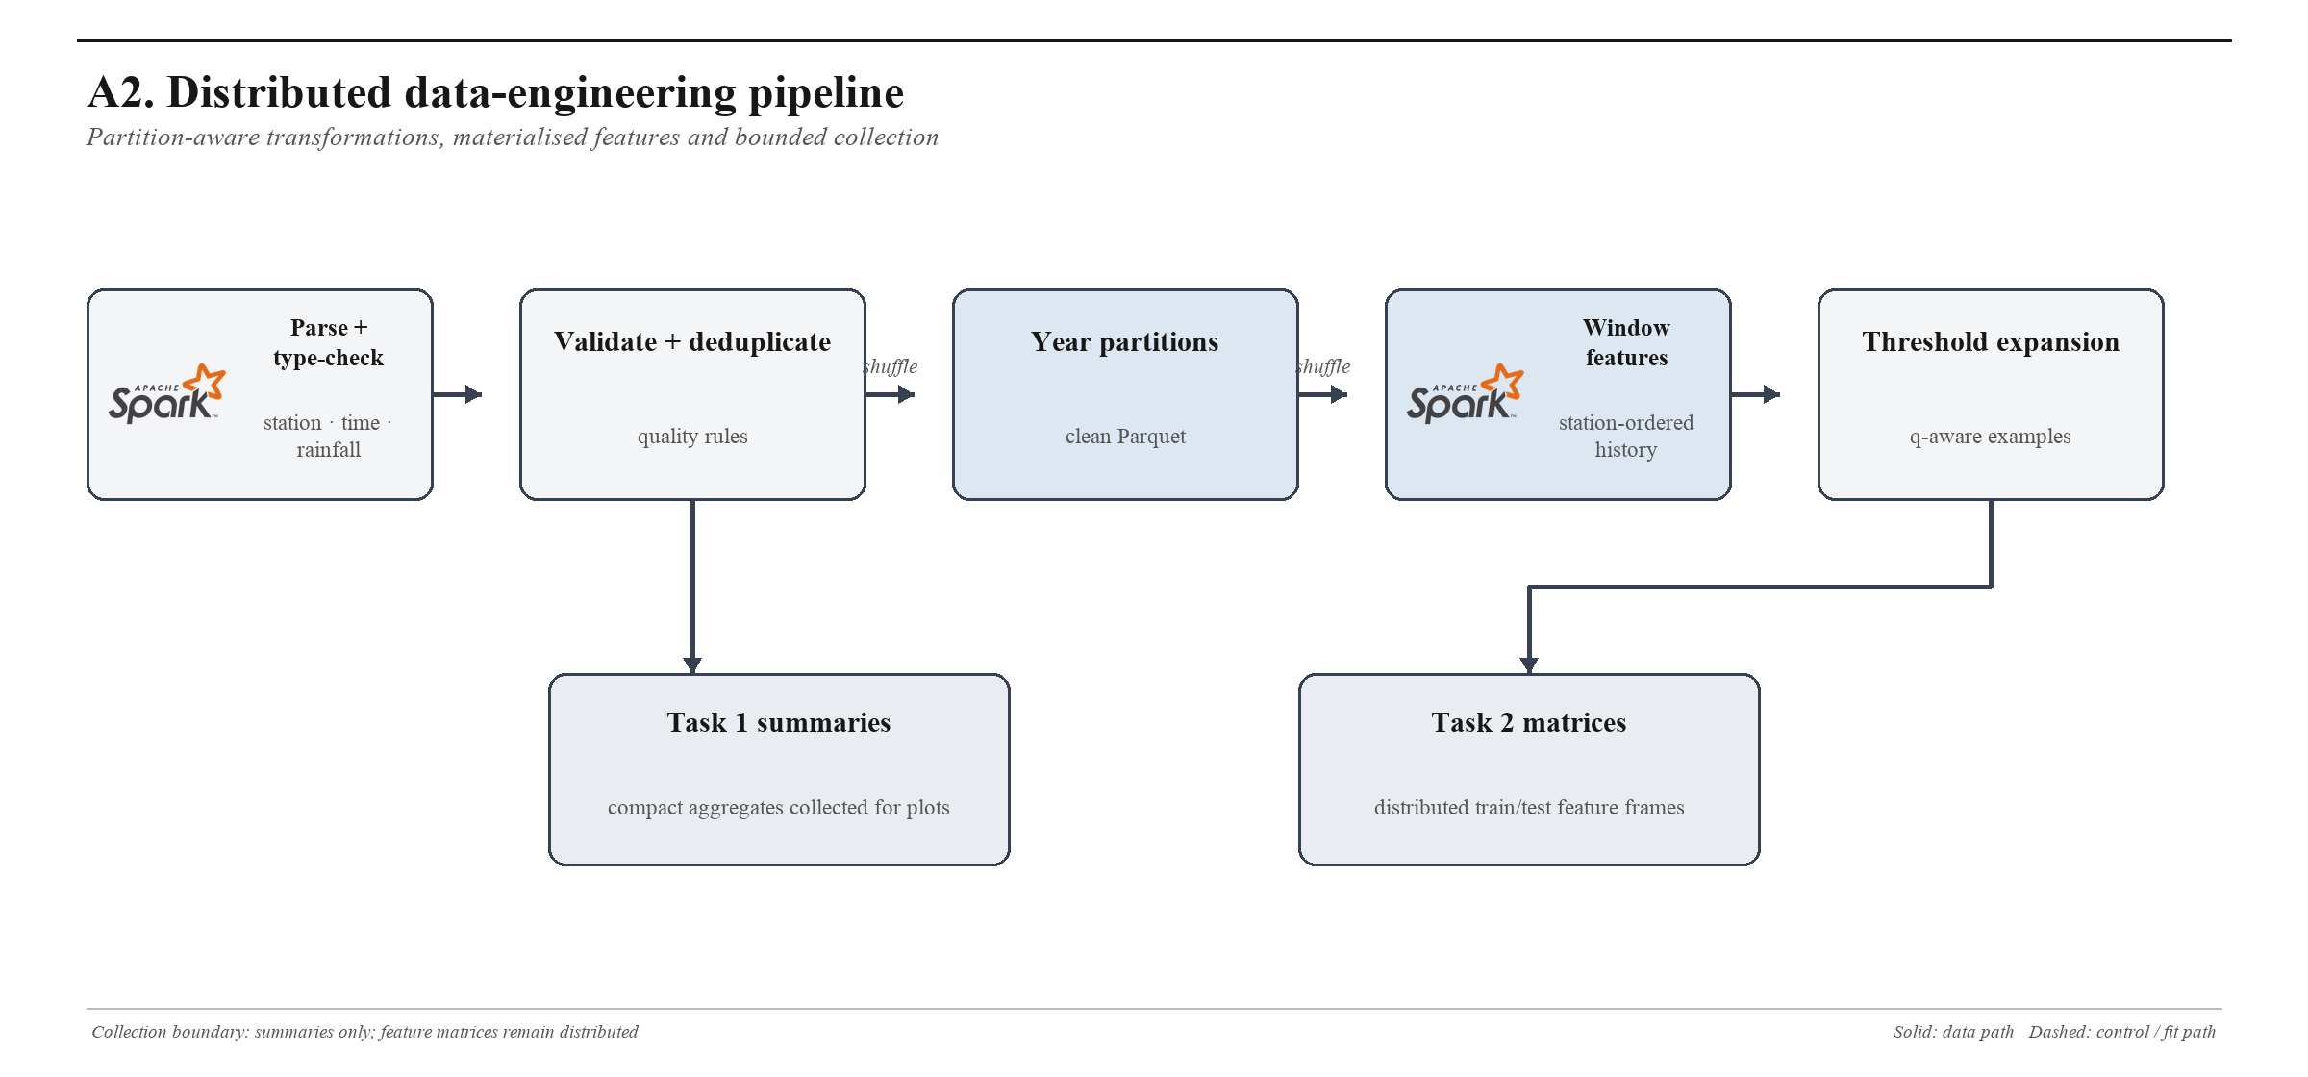
Figure A2. Distributed data-engineering path, including partitioning, shuffle boundaries and feature materialisation.
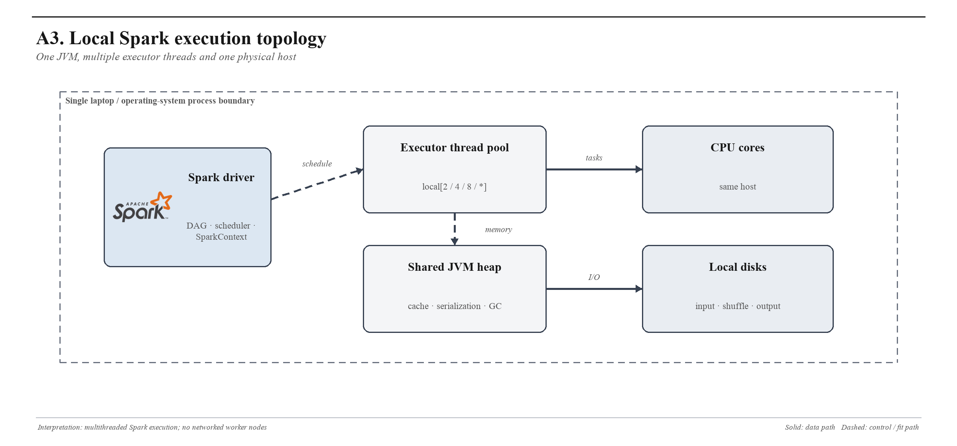
Figure A3. Local Spark uses executor threads inside the driver JVM and shares one host resource pool.

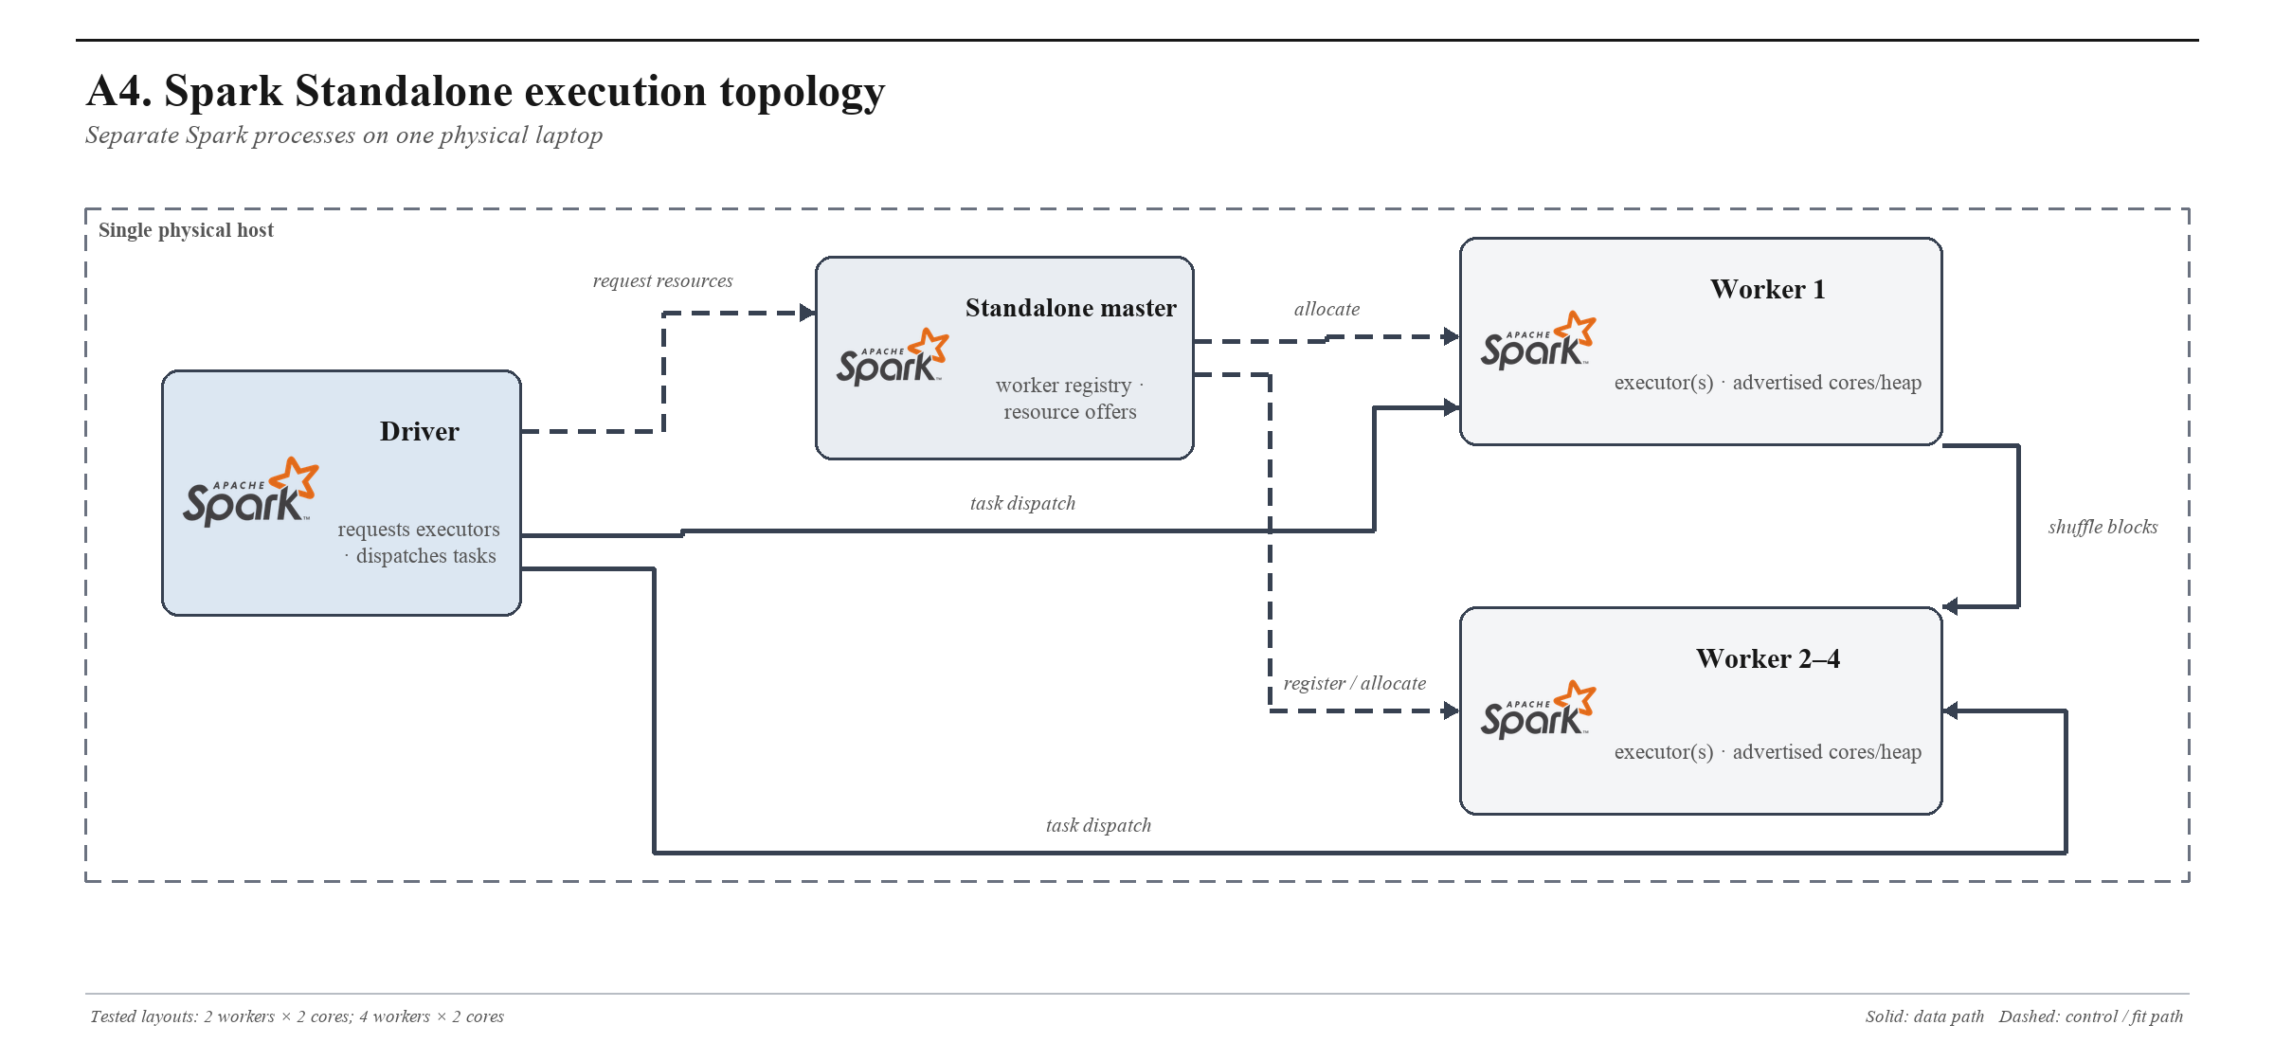
Figure A4. Spark Standalone separates the master, driver and executor JVMs while retaining a shared physical-host boundary.
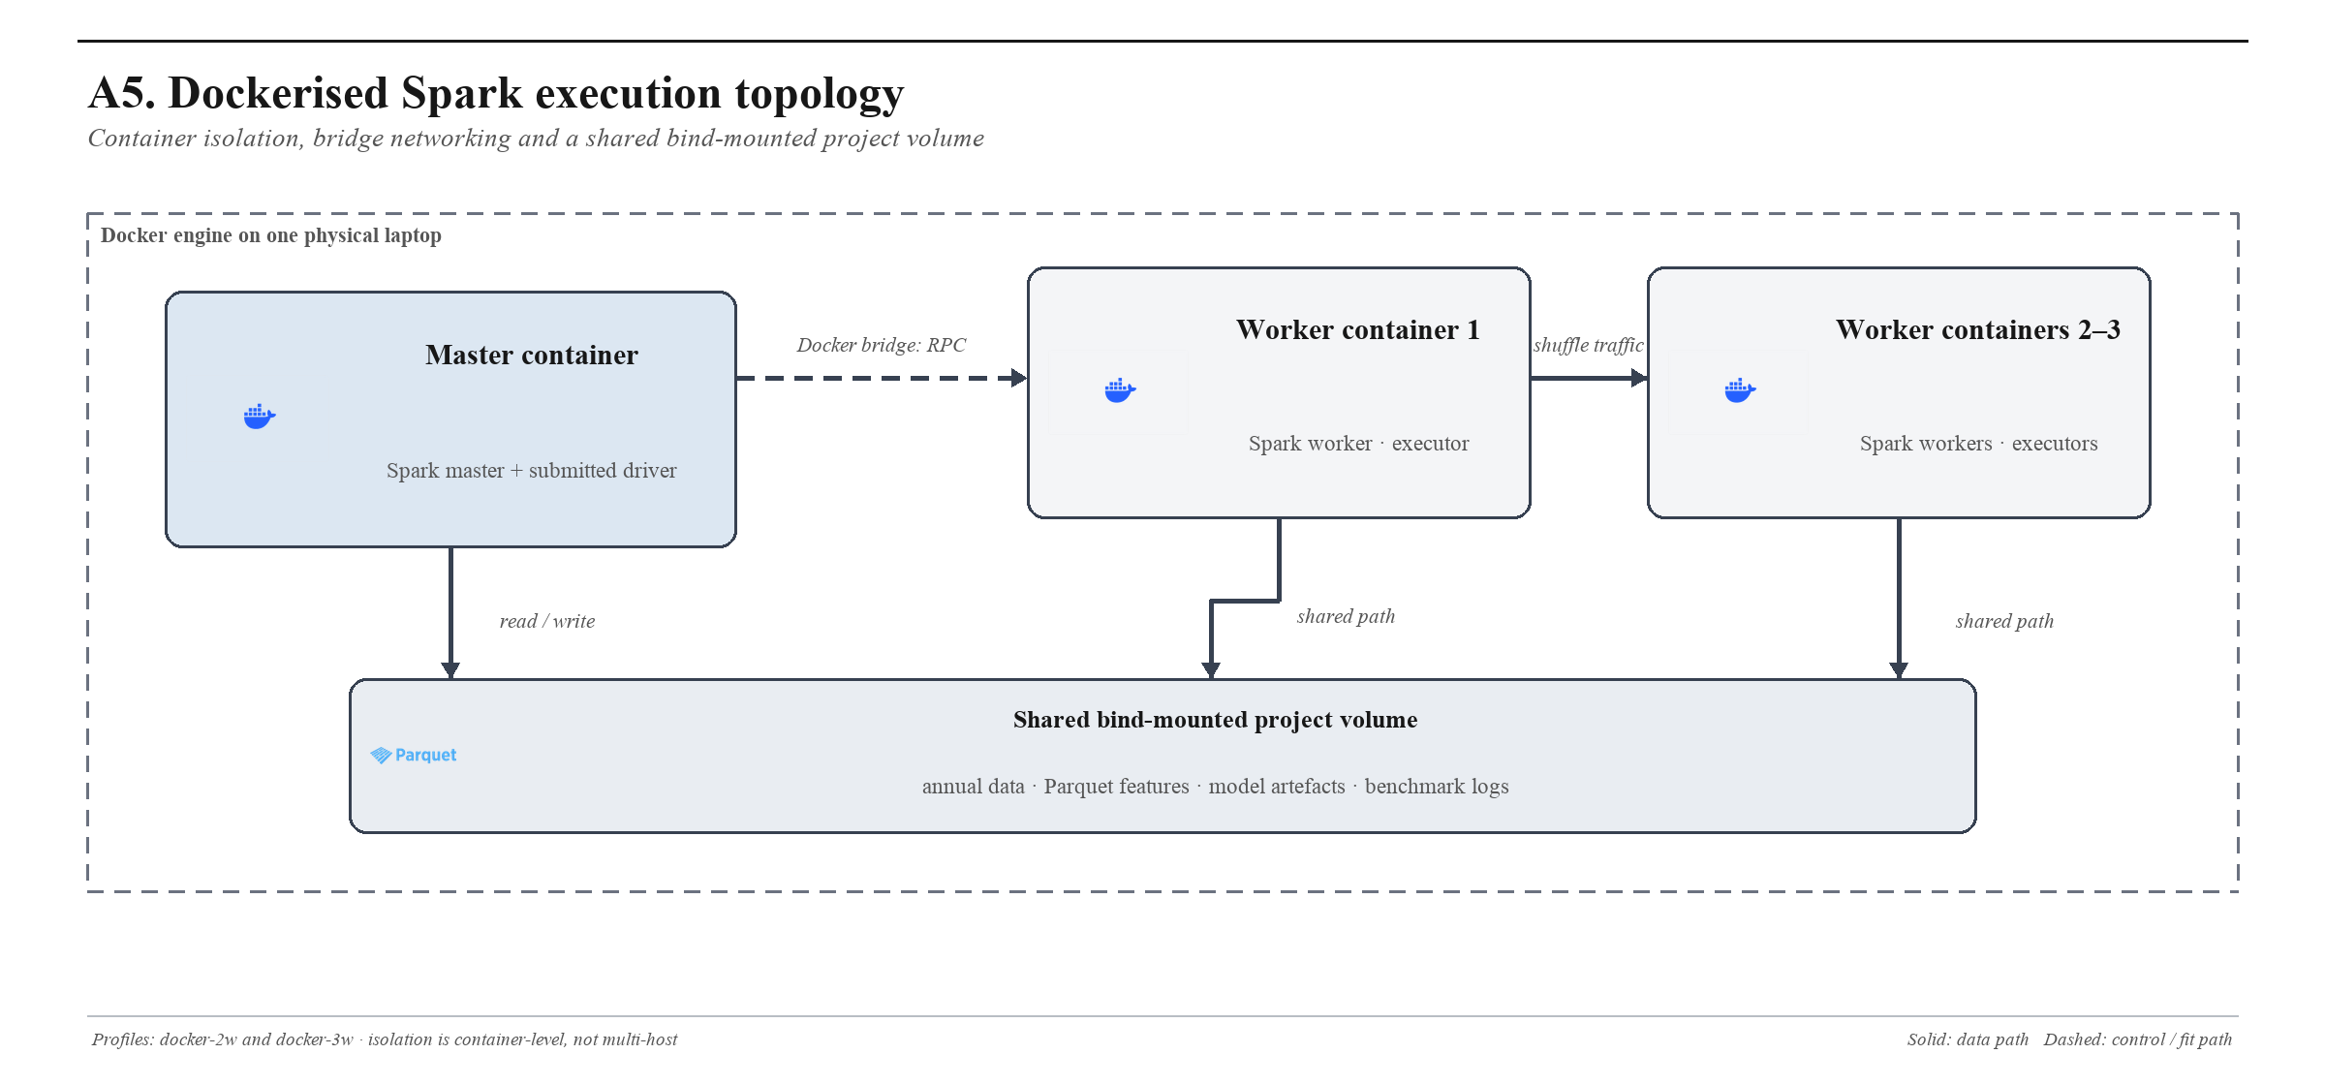
Figure A5. Docker Spark isolates the master and workers as containers connected by a bridge network and shared bind mount.

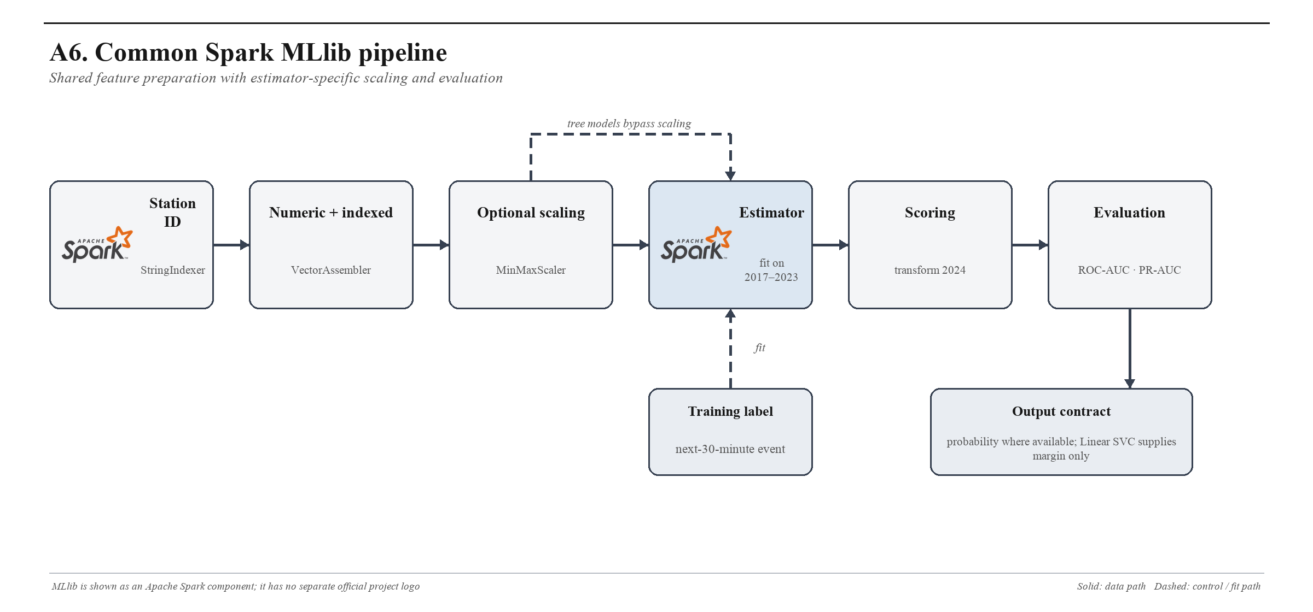
Figure A6. Common MLlib transformation, fitting and evaluation path used by the six Spark classifiers.
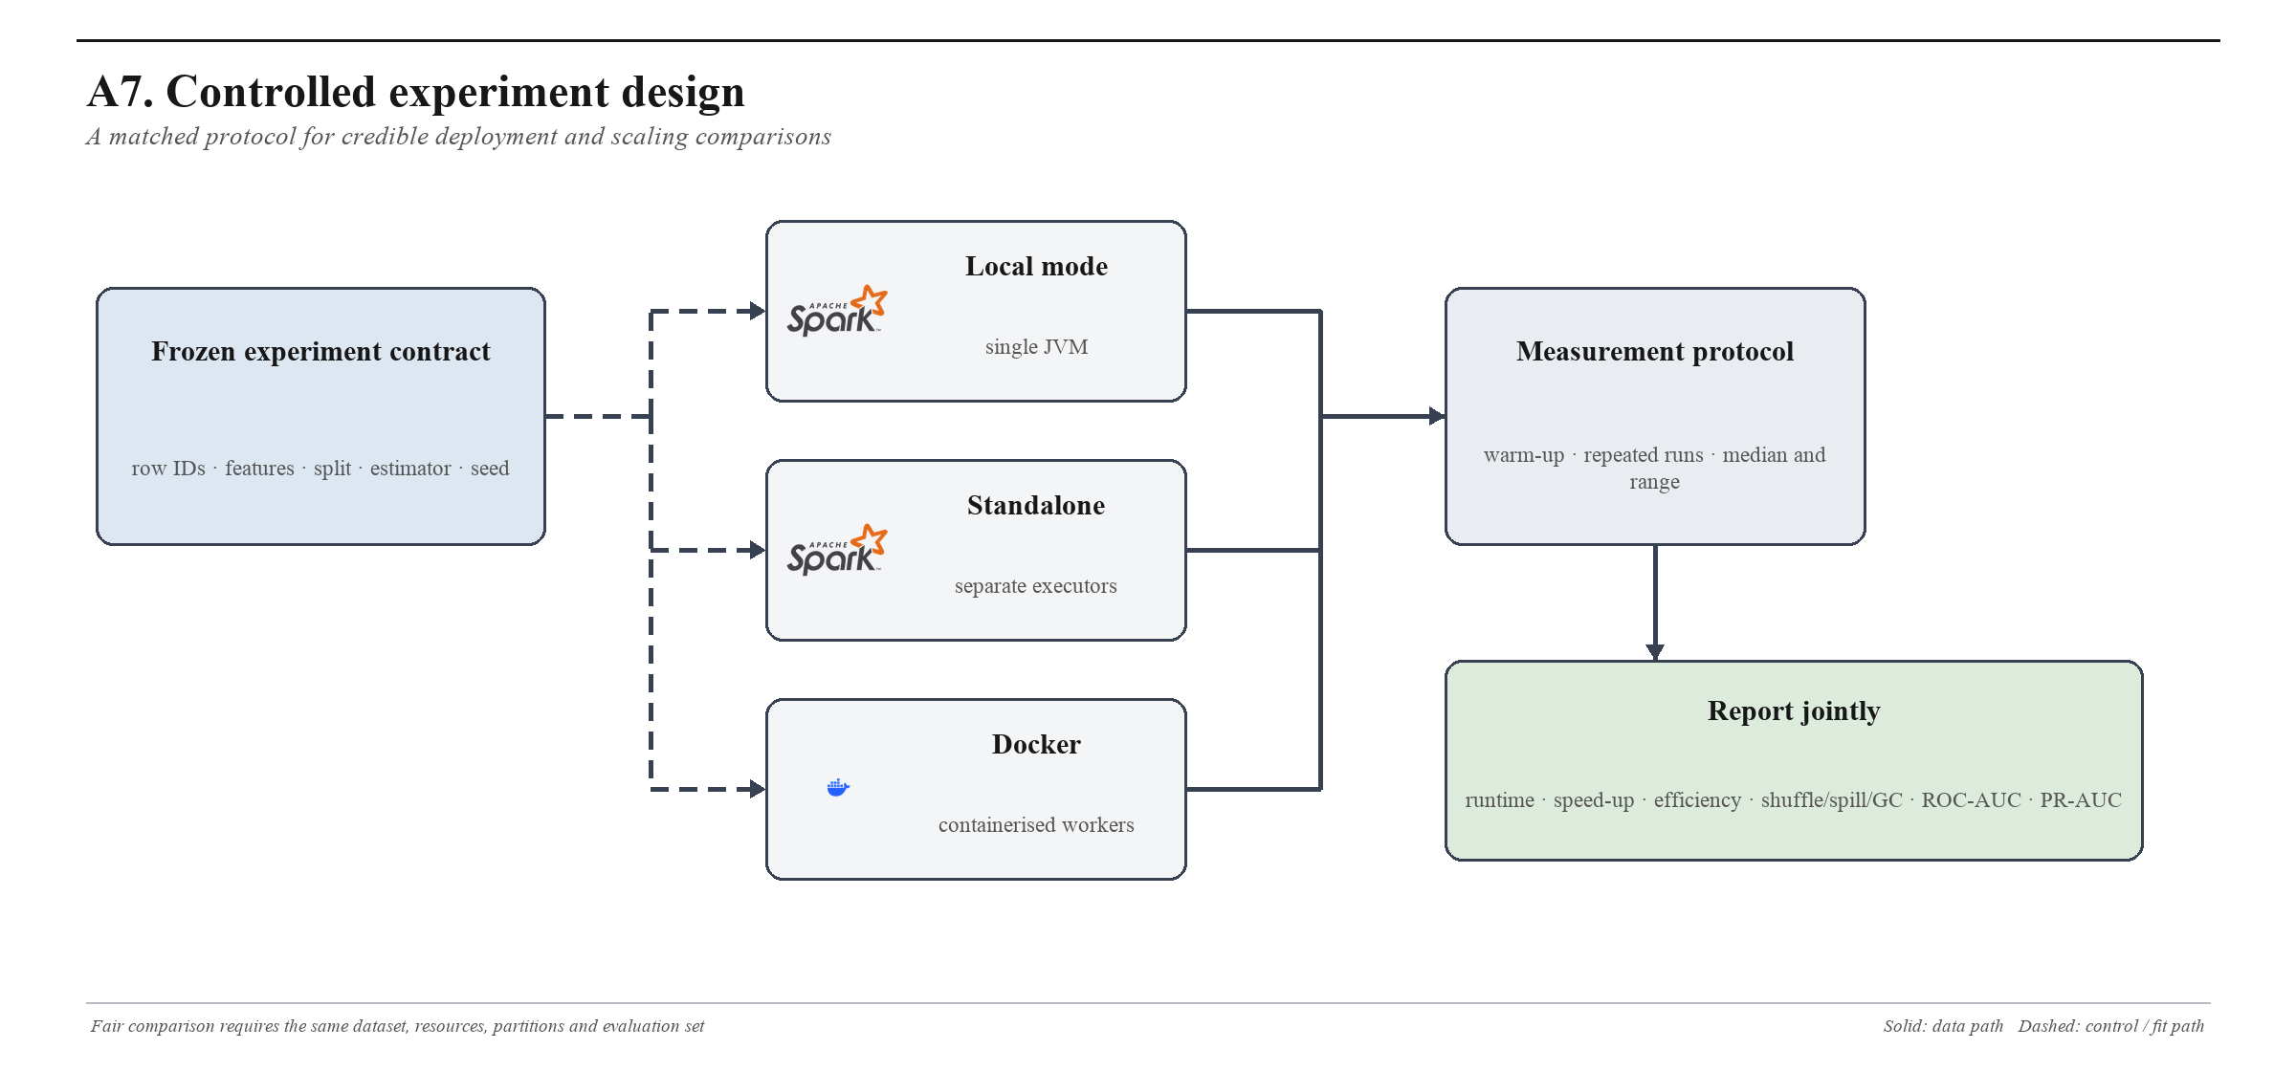
Figure A7. Proposed matched-resource protocol for comparing local, Standalone and Docker execution.

Appendix B. Model architecture atlas
Each evaluated model is shown separately because its computational assumptions differ. These figures document the implemented structure and experimental role; they do not substitute for the common evaluation tables in Section 6.
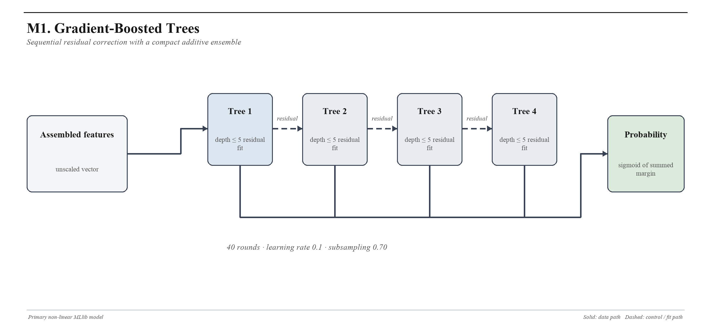
Figure M1. Gradient-Boosted Trees: sequential residual fitting and additive probability score.
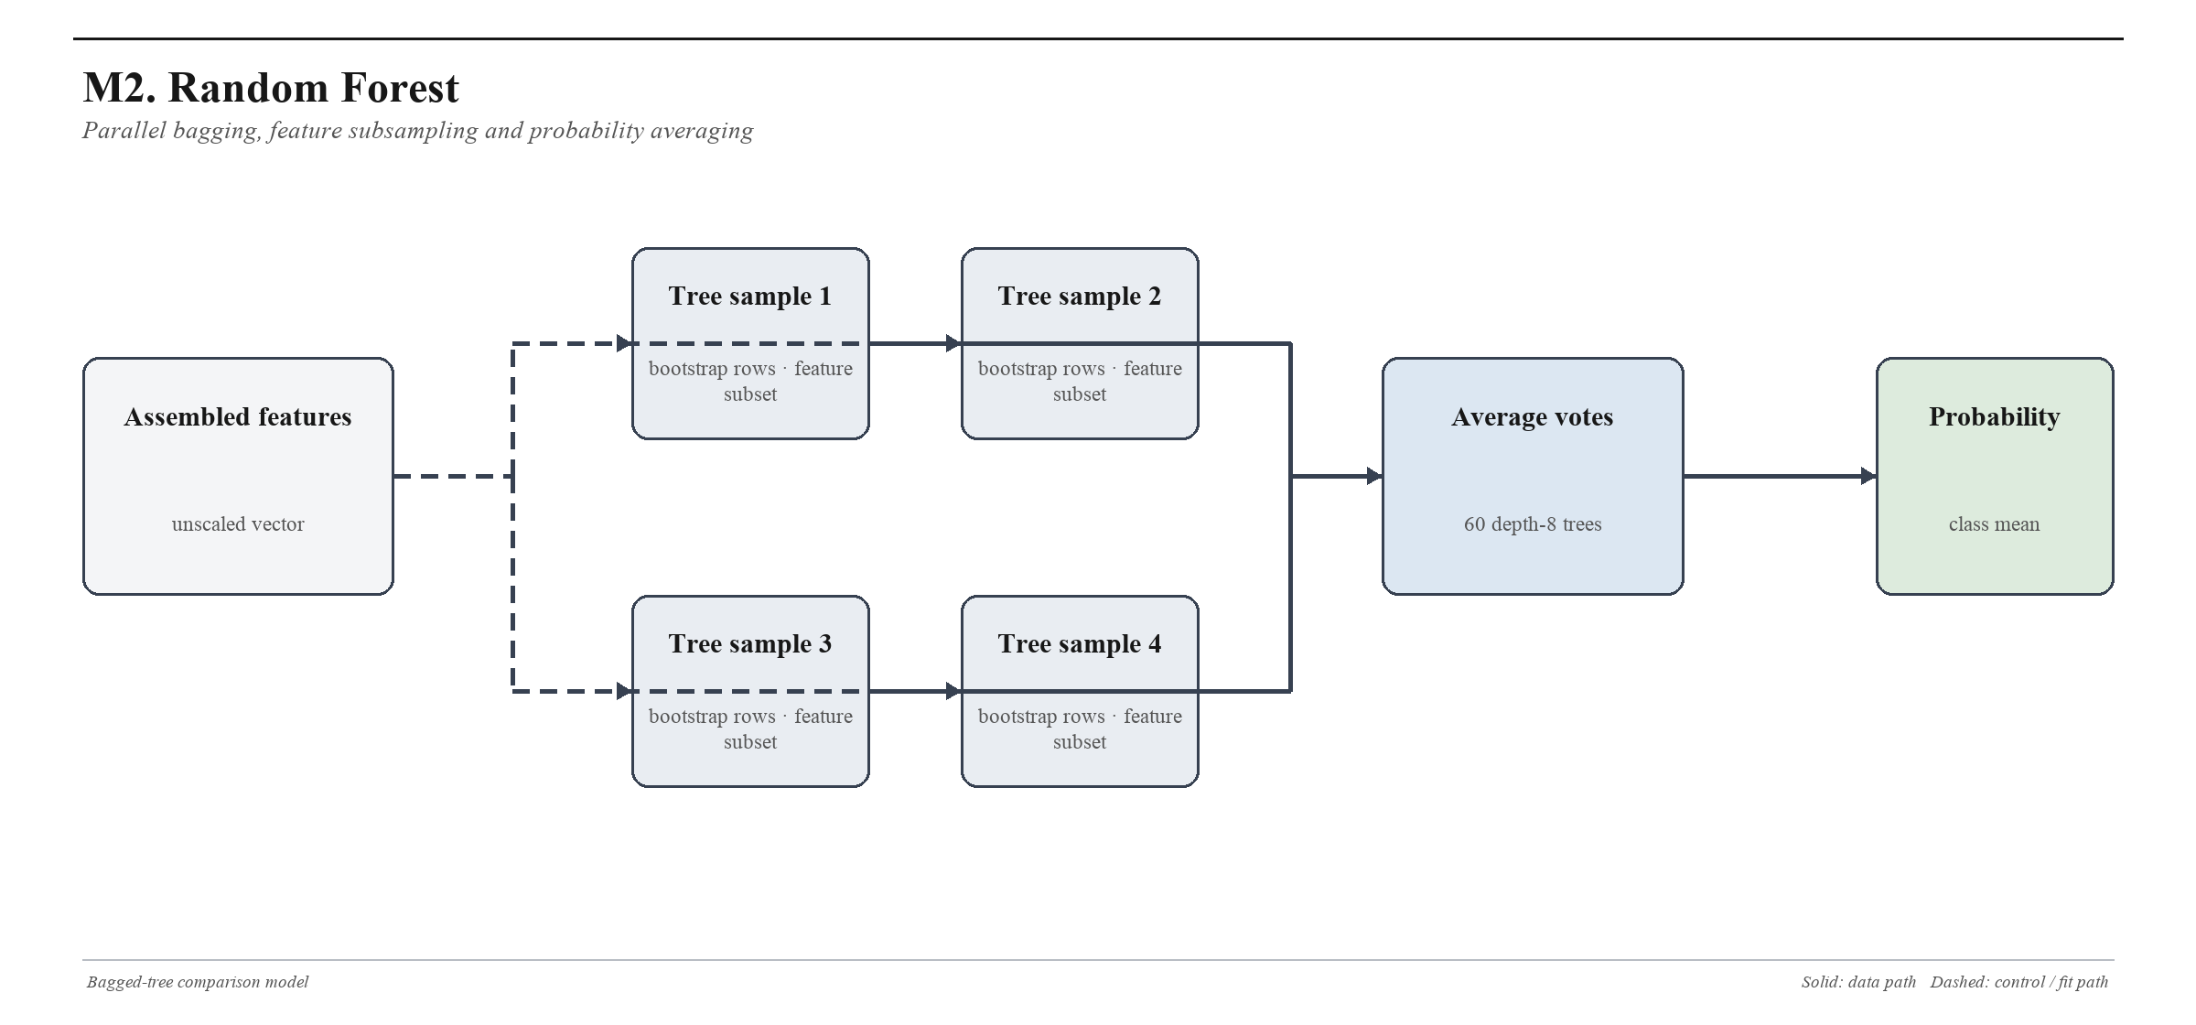
Figure M2. Random Forest: independent bagged trees followed by vote or probability averaging.

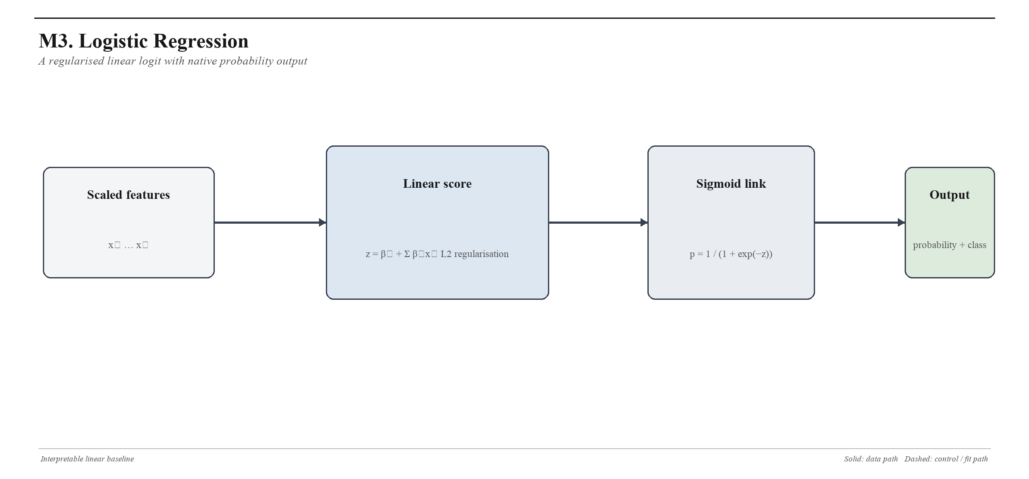
Figure M3. Logistic regression: scaled linear score with L2 regularisation and sigmoid probability.
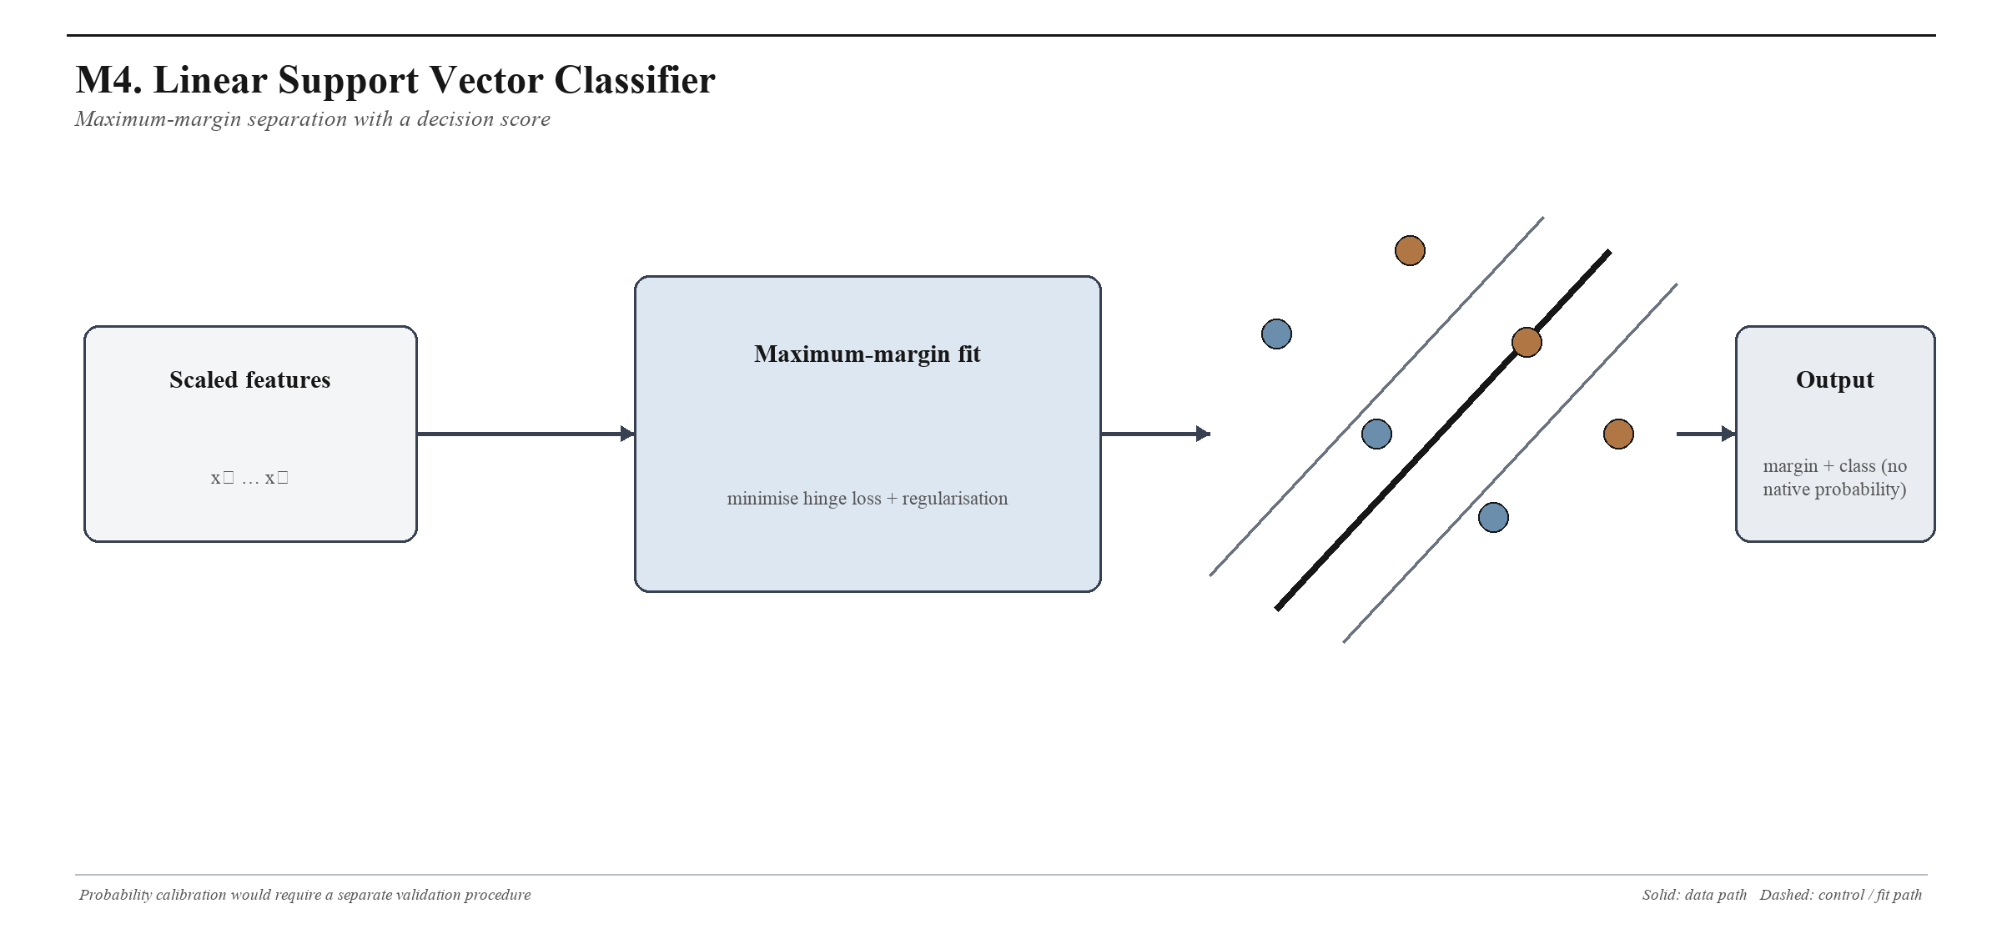
Figure M4. Linear SVC: scaled maximum-margin classifier that yields a ranking margin rather than a native probability.

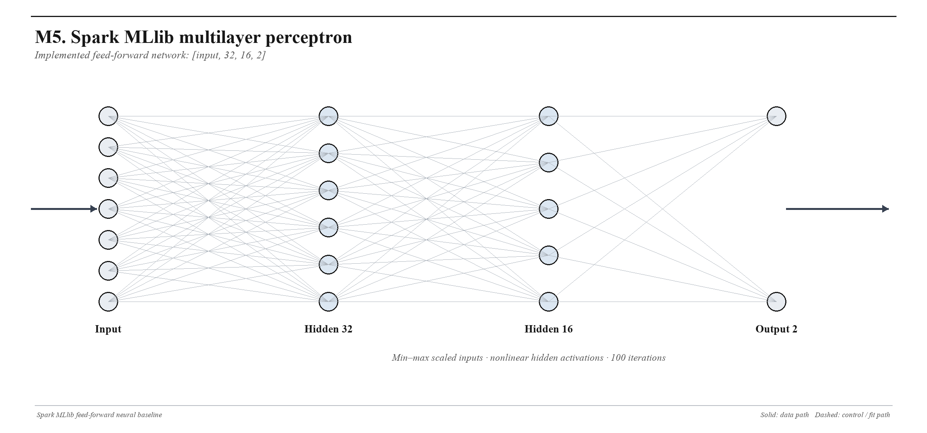
Figure M5. Spark MLlib multilayer perceptron with 32- and 16-unit hidden layers.
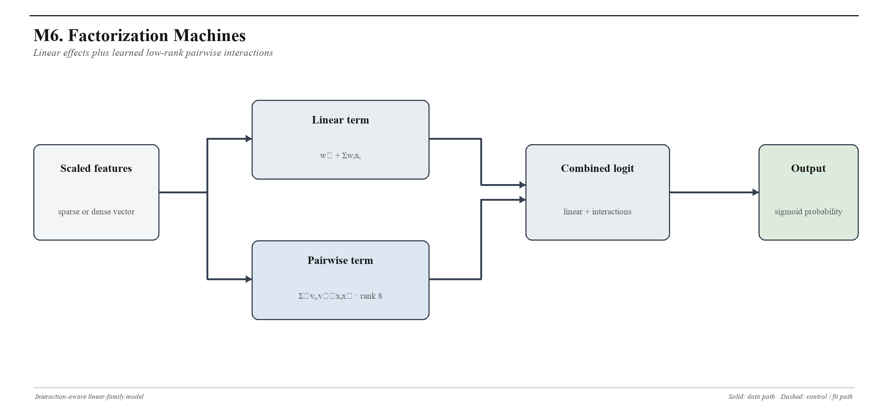
Figure M6. Factorization Machines combine linear effects with learned rank-8 pairwise interactions.

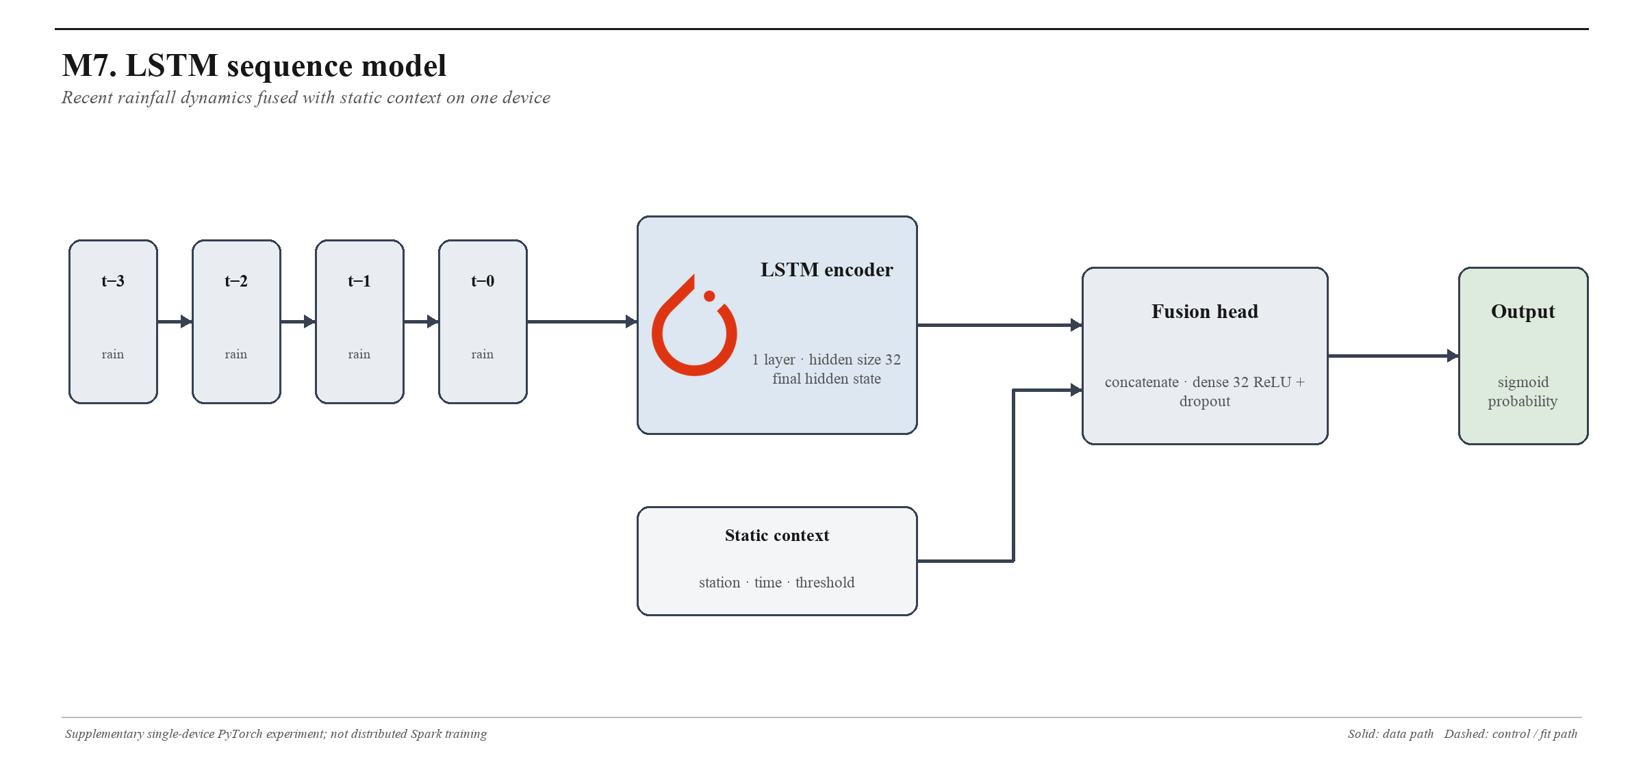
Figure M7. LSTM sequence model with static-context fusion and a dense PyTorch classification head.
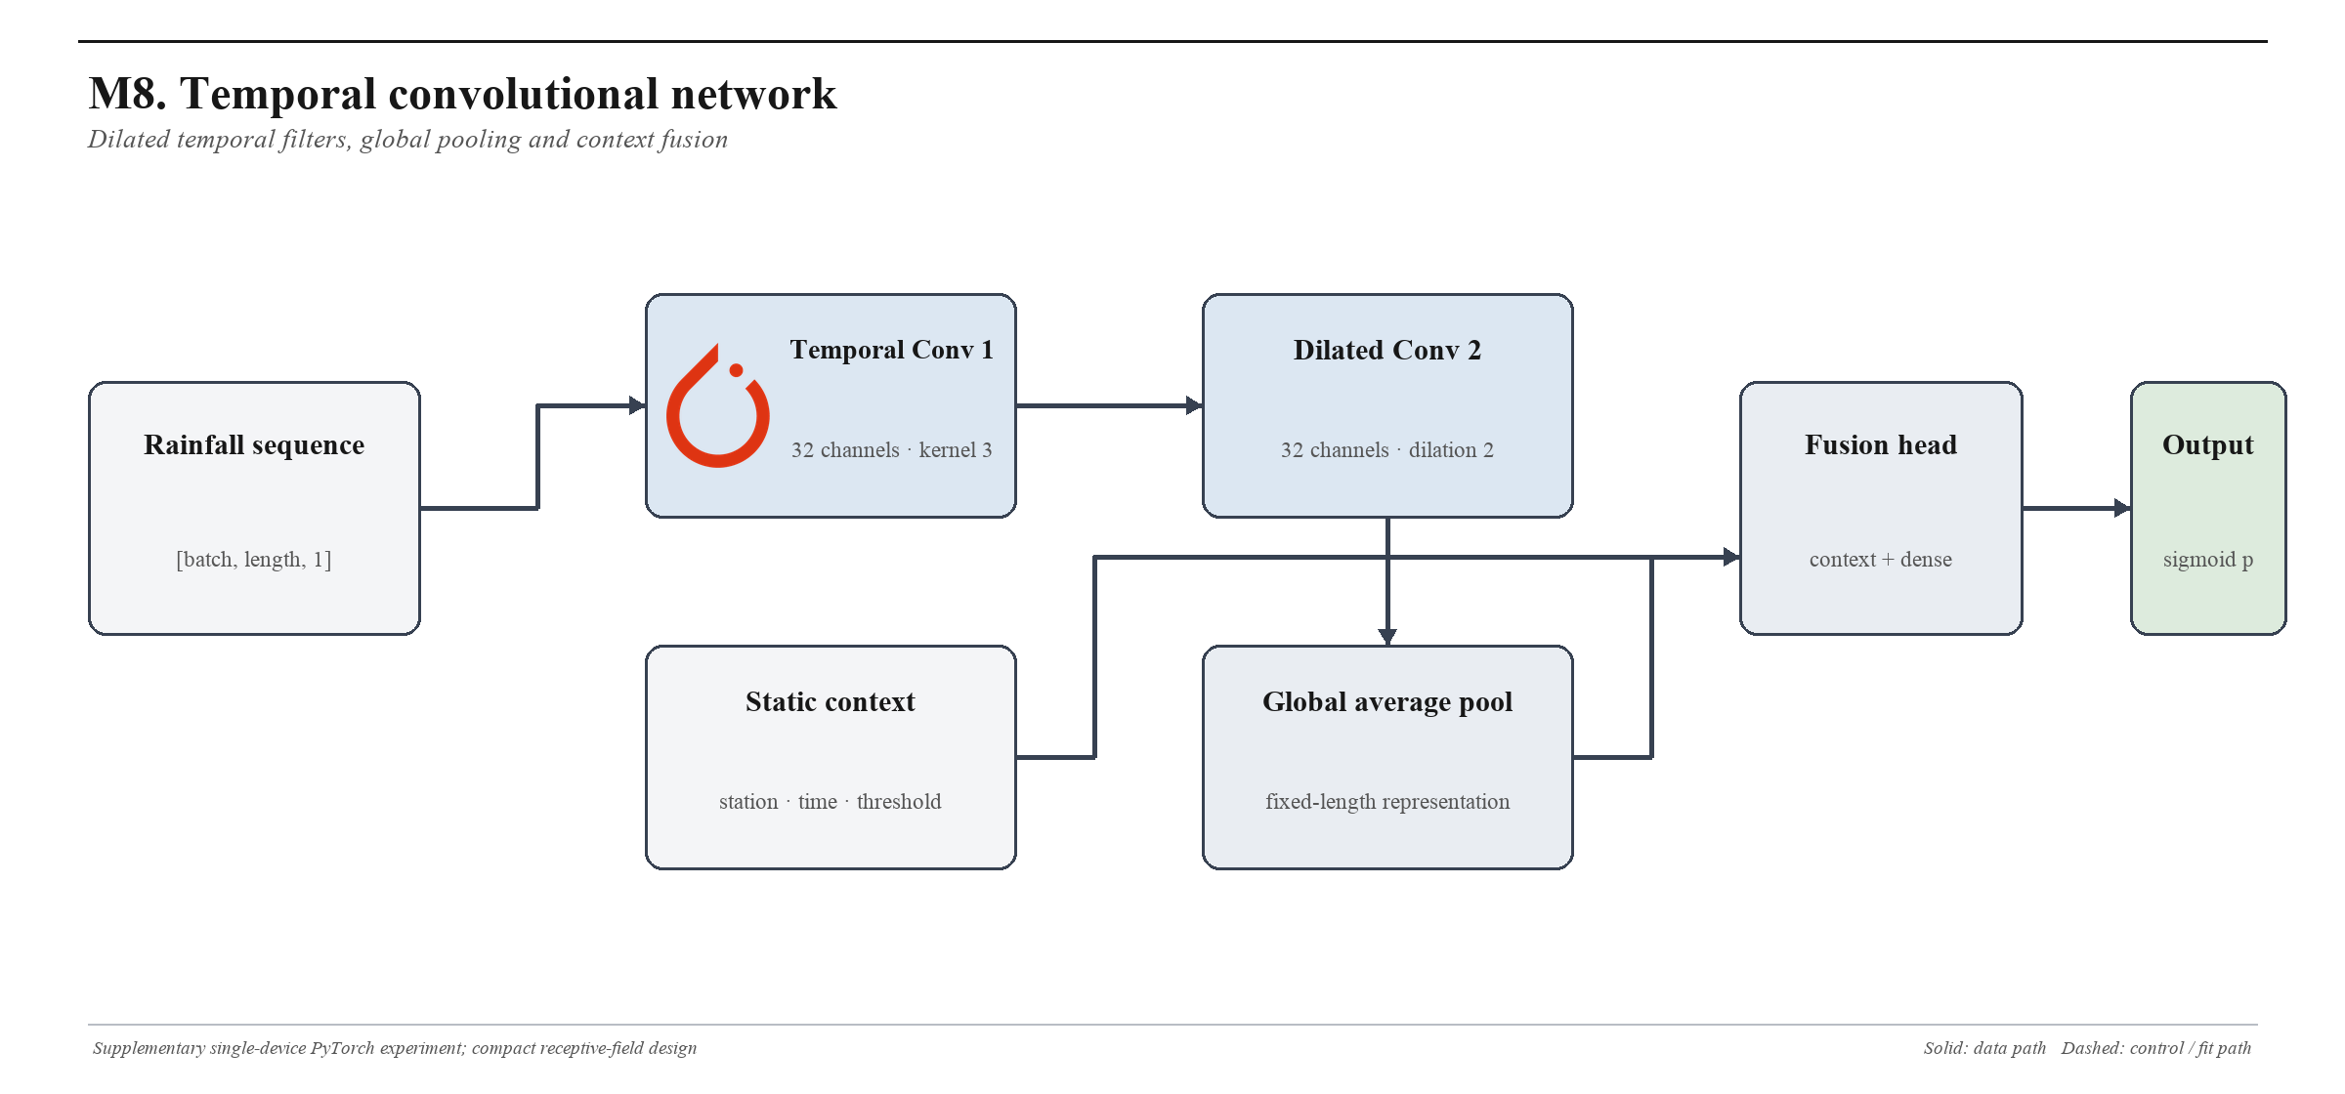
Figure M8. Temporal CNN with standard and dilated convolutions, global pooling and static-context fusion.

