Day0_ChickenWeights
Amrit Singh
2025-08-21
library(tidyverse)
## ── Attaching core tidyverse packages ──────────────────────── tidyverse 2.0.0 ──
## ✔ dplyr 1.1.4 ✔ readr 2.1.5
## ✔ forcats 1.0.0 ✔ stringr 1.5.1
## ✔ ggplot2 3.5.2 ✔ tibble 3.3.0
## ✔ lubridate 1.9.4 ✔ tidyr 1.3.1
## ✔ purrr 1.1.0
## ── Conflicts ────────────────────────────────────────── tidyverse_conflicts() ──
## ✖ dplyr::filter() masks stats::filter()
## ✖ dplyr::lag() masks stats::lag()
## ℹ Use the conflicted package (<http://conflicted.r-lib.org/>) to force all conflicts to become errors
data("ChickWeight")
head(ChickWeight)
## weight Time Chick Diet
## 1 42 0 1 1
## 2 51 2 1 1
## 3 59 4 1 1
## 4 64 6 1 1
## 5 76 8 1 1
## 6 93 10 1 1
total_chickens <- ChickWeight %>% summarise(n = n_distinct(Chick))
total_chickens
## n
## 1 50
# Summary Exercises
# 1) Average weight on Day 18 (any diet)
avg_day18 <- ChickWeight %>%
filter(Time == 18) %>%
summarise(avg_weight = mean(weight))
avg_day18
## avg_weight
## 1 190.1915
# 2) Total number of chickens per diet
chicks_per_diet <- ChickWeight %>%
group_by(Diet) %>%
summarise(total_chicks = n_distinct(Chick), .groups = "drop")
chicks_per_diet
## # A tibble: 4 × 2
## Diet total_chicks
## <fct> <int>
## 1 1 20
## 2 2 10
## 3 3 10
## 4 4 10
# 3) Standard deviation of weights on Day 0 and Day 21
sd_day0 <- ChickWeight %>% filter(Time == 0) %>% summarise(std_dev = sd(weight))
sd_day21 <- ChickWeight %>% filter(Time == 21) %>% summarise(std_dev = sd(weight))
sd_day0; sd_day21
## std_dev
## 1 1.132272
## std_dev
## 1 71.51027
# 4) For Day 21, mean and SD grouped by Diet (labels: mean_weight, std_dev)
day21_by_diet <- ChickWeight %>%
filter(Time == 21) %>%
group_by(Diet) %>%
summarise(mean_weight = mean(weight),
std_dev = sd(weight),
.groups = "drop")
day21_by_diet
## # A tibble: 4 × 3
## Diet mean_weight std_dev
## <fct> <dbl> <dbl>
## 1 1 178. 58.7
## 2 2 215. 78.1
## 3 3 270. 71.6
## 4 4 239. 43.3
# Visualization Exercises
# 1) Filter weights on Day 14 for Diet 3; save as wt_day14_diet3
wt_day14_diet3 <- ChickWeight %>%
filter(Time == 14, Diet == 3)
# Dot plot (Counts of points binned along x)
ggplot(wt_day14_diet3, aes(x = weight)) +
geom_dotplot(binwidth = 10) +
labs(title = "Weights of Chickens on Diet 3, on Day 14",
x = "Weight (grams)",
y = "Count")
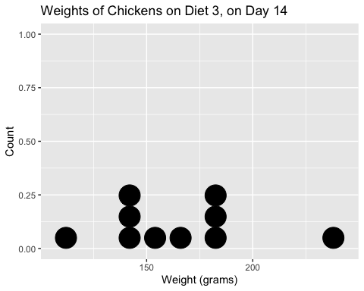
# 2) Histogram of chicken weights on Day 0, any diet
ggplot(ChickWeight %>% filter(Time == 0), aes(x = weight)) +
geom_histogram(binwidth = 1, fill = "skyblue", color = "black") +
labs(title = "Chicken Weights on Day 0",
x = "Weight (grams)",
y = "Number of Chickens")
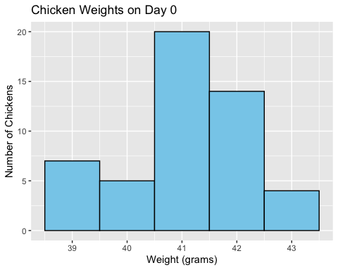
# 3) Boxplots of Day 21 weights grouped by Diet
ggplot(ChickWeight %>% filter(Time == 21),
aes(x = factor(Diet, levels = c("1","2","3","4")),
y = weight,
fill = factor(Diet))) +
geom_boxplot() +
scale_fill_manual(values = c("pink", "green", "skyblue", "purple"),
labels = c("Diet 1", "Diet 2", "Diet 3", "Diet 4"),
name = "Diet") +
labs(title = "Comparison of Chicken Diets",
x = "Diet",
y = "Weight (grams)")
