Day 1
Amrit Singh
2025-08-26
library(readr)
library(mosaic)
## Registered S3 method overwritten by 'mosaic':
## method from
## fortify.SpatialPolygonsDataFrame ggplot2
##
## The 'mosaic' package masks several functions from core packages in order to add
## additional features. The original behavior of these functions should not be affected by this.
##
## Attaching package: 'mosaic'
## The following objects are masked from 'package:dplyr':
##
## count, do, tally
## The following object is masked from 'package:Matrix':
##
## mean
## The following object is masked from 'package:ggplot2':
##
## stat
## The following objects are masked from 'package:stats':
##
## binom.test, cor, cor.test, cov, fivenum, IQR, median, prop.test,
## quantile, sd, t.test, var
## The following objects are masked from 'package:base':
##
## max, mean, min, prod, range, sample, sum
library(tidyverse)
## ── Attaching core tidyverse packages ──────────────────────── tidyverse 2.0.0 ──
## ✔ forcats 1.0.0 ✔ stringr 1.5.1
## ✔ lubridate 1.9.4 ✔ tibble 3.3.0
## ✔ purrr 1.1.0 ✔ tidyr 1.3.1
## ── Conflicts ────────────────────────────────────────── tidyverse_conflicts() ──
## ✖ mosaic::count() masks dplyr::count()
## ✖ purrr::cross() masks mosaic::cross()
## ✖ mosaic::do() masks dplyr::do()
## ✖ tidyr::expand() masks Matrix::expand()
## ✖ dplyr::filter() masks stats::filter()
## ✖ dplyr::lag() masks stats::lag()
## ✖ tidyr::pack() masks Matrix::pack()
## ✖ mosaic::stat() masks ggplot2::stat()
## ✖ mosaic::tally() masks dplyr::tally()
## ✖ tidyr::unpack() masks Matrix::unpack()
## ℹ Use the conflicted package (<http://conflicted.r-lib.org/>) to force all conflicts to become errors
Handwriting <- read_csv("Day 1/Handwriting.csv")
## Rows: 204 Columns: 8
## ── Column specification ────────────────────────────────────────────────────────
## Delimiter: ","
## dbl (8): Individual, Gender, Survey1, Survey2, FemaleID, MaleID, Both, DIFF
##
## ℹ Use `spec()` to retrieve the full column specification for this data.
## ℹ Specify the column types or set `show_col_types = FALSE` to quiet this message.
Survey2 <- na.omit(Handwriting$Survey2)
head(Handwriting)
## # A tibble: 6 × 8
## Individual Gender Survey1 Survey2 FemaleID MaleID Both DIFF
## <dbl> <dbl> <dbl> <dbl> <dbl> <dbl> <dbl> <dbl>
## 1 1 1 72 68 75 69.2 68 4
## 2 2 0 56 68 41.7 69.2 48 -12
## 3 3 1 68 48 75 61.5 36 20
## 4 4 1 80 80 83.3 76.9 76 0
## 5 5 1 76 72 83.3 69.2 68 4
## 6 6 1 76 60 75 76.9 60 16
# 1) Histogram of Survey2
hist(Survey2,
breaks = 10,
main = "Survey 2 Histogram",
xlab = "Percentage Correct")
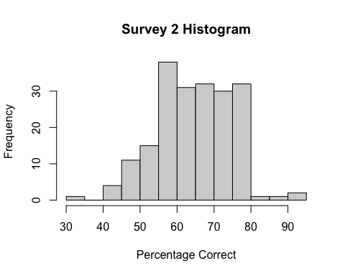
# 2) Summary of Survey2
summary(Survey2)
## Min. 1st Qu. Median Mean 3rd Qu. Max.
## 32.00 60.00 64.00 65.03 72.00 92.00
# 3) Residual diagnostics for Survey2
residuals <- Survey2 - mean(Survey2)
stripchart(residuals, method = "stack",
pch = 16, main = "Residuals Dotplot",
xlab = "Residual values", at = 0,
offset = 0.3, cex = 0.5)
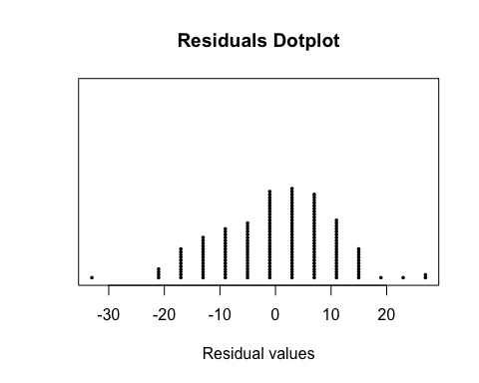
qqnorm(residuals, main = "The normal probability plot",
xlab = "Score value", ylab = "Residual values", pch = 16)
qqline(residuals, col = "blue", lwd = 4)
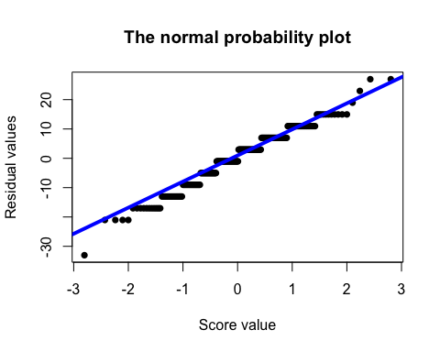
# 4) One-sample t-test: is mean(Survey2) > 50
t.test(Survey2, mu = 50, alternative = "greater")
##
## One Sample t-test
##
## data: Survey2
## t = 21.161, df = 197, p-value < 2.2e-16
## alternative hypothesis: true mean is greater than 50
## 95 percent confidence interval:
## 63.85649 Inf
## sample estimates:
## mean of x
## 65.0303
# Clean rows needed for gender comparisons
# (Assumes Gender coded 0/1; label for nicer output)
Handwriting2 <- Handwriting |>
dplyr::filter(!is.na(Survey2), !is.na(Gender)) |>
dplyr::mutate(Gender = factor(Gender,
levels = c(0, 1),
labels = c("Male", "Female")))
# 5) Boxplot by Gender
boxplot(Survey2 ~ Gender, data = Handwriting2,
main = "Gender Comparison (Guessing Ability)",
ylab = "Percentage Correct")
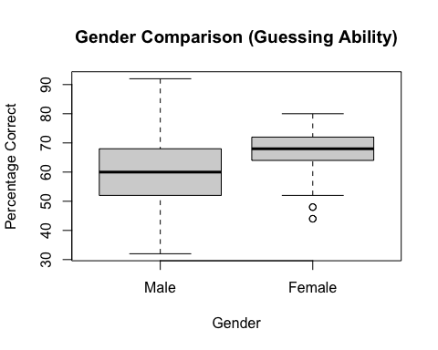
# 6) Group means by Gender
aggregate(Survey2 ~ Gender, data = Handwriting2, FUN = mean)
## Gender Survey2
## 1 Male 61.75281
## 2 Female 67.70642
# 7) Residual diagnostics from a simple linear model Survey2 ~ Gender
residuals_gender <- lm(Survey2 ~ Gender, data = Handwriting2)$residuals
stripchart(residuals_gender, method = "stack", pch = 20,
main = "Dotplot of Residuals (by Gender model)",
xlab = "Residual values", at = 0,
offset = 0.5, cex = 0.5)
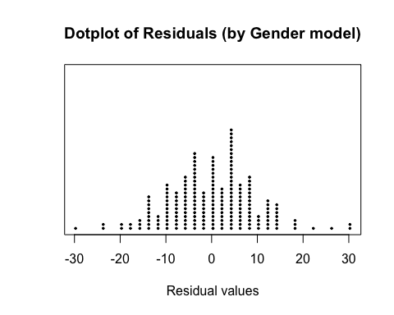
qqnorm(residuals_gender, main = "The normal probability plot (by Gender model)",
xlab = "Score values", ylab = "Residual values", pch = 20)
qqline(residuals_gender, col = "blue", lwd = 4)
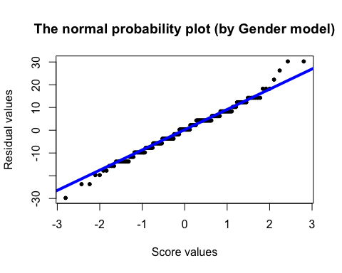
# 8) Two-sample (Welch) t-test between genders
t.test(Survey2 ~ Gender, data = Handwriting2)
##
## Welch Two Sample t-test
##
## data: Survey2 by Gender
## t = -4.2057, df = 152.27, p-value = 4.427e-05
## alternative hypothesis: true difference in means between group Male and group Female is not equal to 0
## 95 percent confidence interval:
## -8.750406 -3.156820
## sample estimates:
## mean in group Male mean in group Female
## 61.75281 67.70642

