Day11
Amrit Singh
2025-10-21
library(readr)
library(MASS)
CountyHealth <- read_csv("CountyHealth.csv")
## Rows: 53 Columns: 4
## ── Column specification ────────────────────────────────────────────────────────
## Delimiter: ","
## chr (1): County
## dbl (3): MDs, Hospitals, Beds
##
## ℹ Use `spec()` to retrieve the full column specification for this data.
## ℹ Specify the column types or set `show_col_types = FALSE` to quiet this message.
CountyHealth$TsqrtMDs <- sqrt(CountyHealth$MDs)
FirstYearGPA <- read_csv("FirstYearGPA.csv")
## Rows: 220 Columns: 10
## ── Column specification ────────────────────────────────────────────────────────
## Delimiter: ","
## dbl (10): GPA, HSGPA, SATV, SATM, Male, HU, SS, FirstGen, White, CollegeBound
##
## ℹ Use `spec()` to retrieve the full column specification for this data.
## ℹ Specify the column types or set `show_col_types = FALSE` to quiet this message.
HighPeaks <- read_csv("HighPeaks.csv")
## Rows: 46 Columns: 6
## ── Column specification ────────────────────────────────────────────────────────
## Delimiter: ","
## chr (1): Peak
## dbl (5): Elevation, Difficulty, Ascent, Length, Time
##
## ℹ Use `spec()` to retrieve the full column specification for this data.
## ℹ Specify the column types or set `show_col_types = FALSE` to quiet this message.
ReligionGDP <- read_csv("ReligionGDP.csv")
## Rows: 44 Columns: 9
## ── Column specification ────────────────────────────────────────────────────────
## Delimiter: ","
## chr (1): Country
## dbl (8): Religiosity, GDP, Africa, EastEurope, MiddleEast, Asia, WestEurope,...
##
## ℹ Use `spec()` to retrieve the full column specification for this data.
## ℹ Specify the column types or set `show_col_types = FALSE` to quiet this message.
#8
#a)
train_CH <- CountyHealth[1:35, ]
model_CH <- lm(TsqrtMDs ~ Hospitals, data = train_CH)
summary(model_CH)
##
## Call:
## lm(formula = TsqrtMDs ~ Hospitals, data = train_CH)
##
## Residuals:
## Min 1Q Median 3Q Max
## -18.582 -6.362 -2.918 8.277 23.170
##
## Coefficients:
## Estimate Std. Error t value Pr(>|t|)
## (Intercept) -3.1695 2.6915 -1.178 0.247
## Hospitals 6.7853 0.5284 12.841 2.19e-14 ***
## ---
## Signif. codes: 0 '***' 0.001 '**' 0.01 '*' 0.05 '.' 0.1 ' ' 1
##
## Residual standard error: 9.627 on 33 degrees of freedom
## Multiple R-squared: 0.8332, Adjusted R-squared: 0.8282
## F-statistic: 164.9 on 1 and 33 DF, p-value: 2.194e-14
# LSRL is sqrtMDs = -3.1695 + 6.7853Hospitals
#b)
test_CH <- CountyHealth[36:nrow(CountyHealth), ]
pred_CH <- predict(model_CH, newdata = test_CH)
pred_CH
## 1 2 3 4 5 6 7 8
## 64.68383 23.97183 17.18649 17.18649 17.18649 30.75716 10.40116 10.40116
## 9 10 11 12 13 14 15 16
## 71.46916 23.97183 10.40116 10.40116 44.32783 10.40116 10.40116 10.40116
## 17 18
## 10.40116 10.40116
cor(test_CH$TsqrtMDs, pred_CH)
## [1] 0.9531439
# r = 0.9531439 and predictions are shown in code
#c)
shrinkage_CH <- summary(model_CH)$r.squared - (cor(test_CH$TsqrtMDs, pred_CH))^2
shrinkage_CH
## [1] -0.0752451
# Shrinkage = -0.0752451. This value ^2 is very close to the R^2 value which tells us that the model works as well for any sample as it did for the training sample.
#9
#a)
train_GPA <- FirstYearGPA[1:150, ]
model_GPA <- lm(GPA ~ HSGPA + HU + White, data = train_GPA)
summary(model_GPA)
##
## Call:
## lm(formula = GPA ~ HSGPA + HU + White, data = train_GPA)
##
## Residuals:
## Min 1Q Median 3Q Max
## -1.09844 -0.23079 0.03517 0.23600 0.82933
##
## Coefficients:
## Estimate Std. Error t value Pr(>|t|)
## (Intercept) 1.147478 0.311524 3.683 0.000323 ***
## HSGPA 0.466053 0.088393 5.273 4.75e-07 ***
## HU 0.015328 0.004091 3.747 0.000257 ***
## White 0.199174 0.076152 2.615 0.009846 **
## ---
## Signif. codes: 0 '***' 0.001 '**' 0.01 '*' 0.05 '.' 0.1 ' ' 1
##
## Residual standard error: 0.3773 on 146 degrees of freedom
## Multiple R-squared: 0.2842, Adjusted R-squared: 0.2695
## F-statistic: 19.32 on 3 and 146 DF, p-value: 1.319e-10
# The least squares regression line is given by GPA = 1.1475 + 0.46605(HSGPA) + 0.015328(HU) + 0.19917(White). All predictors are statistically significant since their p-values are below 0.05. The estimated standard deviation of the errors is 0.377, and the model explains 28.42% of the variation in GPA (R^2 = 0.2842).
#b)
test_GPA <- FirstYearGPA[151:219, ]
pred_GPA <- predict(model_GPA, newdata = test_GPA)
pred_GPA
## 1 2 3 4 5 6 7 8
## 3.152561 3.040603 2.960027 2.730315 2.944078 3.268243 3.604737 3.245045
## 9 10 11 12 13 14 15 16
## 3.410132 3.061938 2.901408 3.073537 3.014712 2.904827 3.065147 3.413655
## 17 18 19 20 21 22 23 24
## 3.061895 3.092490 2.990063 3.045884 3.201649 3.466889 3.354205 2.957334
## 25 26 27 28 29 30 31 32
## 2.718183 2.578471 3.191812 3.288337 3.151835 3.002475 2.926162 2.550298
## 33 34 35 36 37 38 39 40
## 3.306568 3.192433 2.954020 3.324895 3.017908 2.965929 2.780842 2.575170
## 41 42 43 44 45 46 47 48
## 2.759209 3.317013 2.960027 3.181870 3.187047 3.022686 2.640300 3.277669
## 49 50 51 52 53 54 55 56
## 3.394287 2.882145 3.195629 3.192223 2.963844 2.962720 2.894557 3.014607
## 57 58 59 60 61 62 63 64
## 2.437825 2.681637 3.257576 3.210957 3.252399 2.740256 3.245771 3.257060
## 65 66 67 68 69
## 3.089176 3.122512 2.945009 2.970695 2.810164
errors_GPA <- test_GPA$GPA - pred_GPA
errors_GPA
## 1 2 3 4 5
## 0.1774394377 0.7093971450 0.7199727824 -0.5703145067 -0.4140782175
## 6 7 8 9 10
## -0.0382432643 -0.2047372186 -0.6550454987 0.3798684276 0.4580618768
## 11 12 13 14 15
## 0.1985923190 0.2664629939 -0.2747119553 0.2351734504 -0.7751471876
## 16 17 18 19 20
## -0.2536553431 -0.0018953044 -0.3524895565 -0.3600627205 0.0141157790
## 21 22 23 24 25
## 0.7683507724 -0.7868886116 0.2257948302 0.6026659164 -0.0881825223
## 26 27 28 29 30
## -0.6084714179 0.4681877699 0.2216631324 -0.0818348277 0.1975249313
## 31 32 33 34 35
## -0.3461618179 -0.6202984124 0.2034320264 -0.4424330626 0.1059798830
## 36 37 38 39 40
## -0.4148954015 -0.4579081385 -0.3659294161 -0.3708417600 -0.0751703326
## 41 42 43 44 45
## 0.1907910433 -0.5770129223 -0.1300272176 0.0181296694 0.4429532055
## 46 47 48 49 50
## -0.5626864554 0.3596999810 0.2423307665 -0.2842874743 -0.1221447143
## 51 52 53 54 55
## 0.1743707542 -0.6322232584 -0.5838442333 0.7272796483 -0.7945570625
## 56 57 58 59 60
## 0.1053929468 -0.1978247748 -0.4516368696 0.4624243698 0.4690425865
## 61 62 63 64 65
## 0.4176008337 -0.2202564063 0.0842287668 0.0529403002 0.0408244100
## 66 67 68 69
## -0.2425121782 -0.2950094662 -0.0006948518 -0.1901644095
#c)
mean(errors_GPA)
## [1] -0.05947226
sd(errors_GPA)
## [1] 0.4065554
# The residuals have a mean of -0.0595, which is approximately zero, and a standard deviation of 0.4066, closely matching the model’s estimated error standard deviation of 0.377.
#d)
cor(test_GPA$GPA, pred_GPA)
## [1] 0.5960115
# The r = 0.596
#e)
shrinkage_GPA <- summary(model_GPA)$r.squared - (cor(test_GPA$GPA, pred_GPA))^2
shrinkage_GPA
## [1] -0.07103228
# It works well since the shrinkage is negative
#11
#a)
ReligionGDP$logGDP <- log(ReligionGDP$GDP)
plot(logGDP ~ Religiosity, data = ReligionGDP, xlab="Religiosity", ylab="log(GDP)")
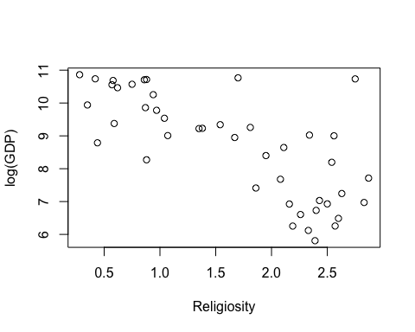
#b)
model_rel1 <- lm(logGDP ~ Religiosity, data = ReligionGDP)
summary(model_rel1)
##
## Call:
## lm(formula = logGDP ~ Religiosity, data = ReligionGDP)
##
## Residuals:
## Min 1Q Median 3Q Max
## -1.8387 -0.8108 0.1272 0.5833 3.5923
##
## Coefficients:
## Estimate Std. Error t value Pr(>|t|)
## (Intercept) 10.9961 0.3656 30.079 < 2e-16 ***
## Religiosity -1.4013 0.2001 -7.005 1.43e-08 ***
## ---
## Signif. codes: 0 '***' 0.001 '**' 0.01 '*' 0.05 '.' 0.1 ' ' 1
##
## Residual standard error: 1.085 on 42 degrees of freedom
## Multiple R-squared: 0.5388, Adjusted R-squared: 0.5278
## F-statistic: 49.06 on 1 and 42 DF, p-value: 1.432e-08
# 53.88%
#c)
# The coefficient is -1.40, indicating that for each one-unit increase in Religiosity, logGDP is expected to decrease by 1.40.
#d.)
studres_rel1 <- studres(model_rel1)
plot(predict(model_rel1), studres_rel1, xlab="Predicted", ylab="Studentized Residuals")
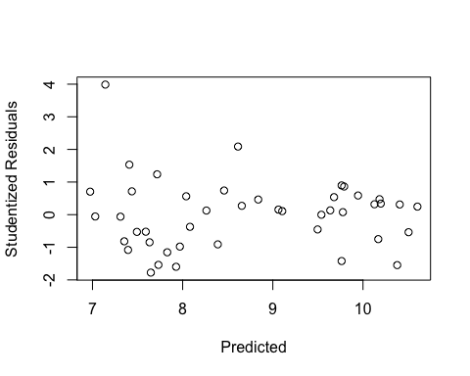
studres_rel1[ReligionGDP$Country == "Kuwait"]
## 25
## 3.986899
# The magnitude is 3.986
#e.)
model_rel2 <- lm(logGDP ~ Religiosity + EastEurope + MiddleEast + Asia + WestEurope + Americas, data = ReligionGDP)
summary(model_rel2)
##
## Call:
## lm(formula = logGDP ~ Religiosity + EastEurope + MiddleEast +
## Asia + WestEurope + Americas, data = ReligionGDP)
##
## Residuals:
## Min 1Q Median 3Q Max
## -1.5274 -0.5720 -0.0760 0.5457 2.3395
##
## Coefficients:
## Estimate Std. Error t value Pr(>|t|)
## (Intercept) 9.2019 0.7452 12.348 1.09e-14 ***
## Religiosity -0.9979 0.2852 -3.498 0.00124 **
## EastEurope 0.7901 0.6709 1.178 0.24639
## MiddleEast 1.9374 0.4797 4.039 0.00026 ***
## Asia 0.9856 0.4556 2.163 0.03706 *
## WestEurope 2.0538 0.6975 2.944 0.00556 **
## Americas 1.5937 0.4778 3.336 0.00195 **
## ---
## Signif. codes: 0 '***' 0.001 '**' 0.01 '*' 0.05 '.' 0.1 ' ' 1
##
## Residual standard error: 0.8947 on 37 degrees of freedom
## Multiple R-squared: 0.7235, Adjusted R-squared: 0.6787
## F-statistic: 16.14 on 6 and 37 DF, p-value: 5.095e-09
# 72.35%
#f.)
# The coefficient of -0.9979 indicates that, after controlling for region, a one-unit increase in Religiosity is associated with a 0.9979 decrease in logGDP.
#g.)
anova(model_rel1, model_rel2)
## Analysis of Variance Table
##
## Model 1: logGDP ~ Religiosity
## Model 2: logGDP ~ Religiosity + EastEurope + MiddleEast + Asia + WestEurope +
## Americas
## Res.Df RSS Df Sum of Sq F Pr(>F)
## 1 42 49.405
## 2 37 29.615 5 19.79 4.9449 0.001448 **
## ---
## Signif. codes: 0 '***' 0.001 '**' 0.01 '*' 0.05 '.' 0.1 ' ' 1
# It does help because the p-value 0.001448 is less than 0.05.
#h.)
studres_rel2 <- studres(model_rel2)
plot(predict(model_rel2), studres_rel2, xlab="Predicted", ylab="Studentized Residuals")
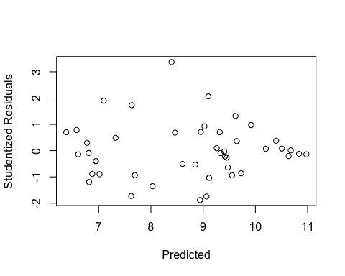
studres_rel2[ReligionGDP$Country == "Kuwait"]
## 25
## 3.369879
# The magnitude is 3.3699
#12 a.)
model_hp <- lm(Time ~ Length + Elevation + Ascent + Difficulty, data = HighPeaks)
summary(model_hp)
##
## Call:
## lm(formula = Time ~ Length + Elevation + Ascent + Difficulty,
## data = HighPeaks)
##
## Residuals:
## Min 1Q Median 3Q Max
## -1.77942 -0.81216 -0.08647 0.68962 3.06736
##
## Coefficients:
## Estimate Std. Error t value Pr(>|t|)
## (Intercept) 5.9567864 2.2307630 2.670 0.01082 *
## Length 0.4440084 0.0812523 5.465 2.49e-06 ***
## Elevation -0.0016703 0.0005183 -3.223 0.00249 **
## Ascent 0.0006011 0.0003310 1.816 0.07669 .
## Difficulty 0.8654527 0.2285275 3.787 0.00049 ***
## ---
## Signif. codes: 0 '***' 0.001 '**' 0.01 '*' 0.05 '.' 0.1 ' ' 1
##
## Residual standard error: 1.171 on 41 degrees of freedom
## Multiple R-squared: 0.8401, Adjusted R-squared: 0.8245
## F-statistic: 53.84 on 4 and 41 DF, p-value: 8.738e-16
model_hp2 <- lm(Time ~ Length + Elevation + Difficulty, data = HighPeaks)
summary(model_hp2)
##
## Call:
## lm(formula = Time ~ Length + Elevation + Difficulty, data = HighPeaks)
##
## Residuals:
## Min 1Q Median 3Q Max
## -2.1264 -0.7673 -0.1459 0.6920 3.1487
##
## Coefficients:
## Estimate Std. Error t value Pr(>|t|)
## (Intercept) 6.0130843 2.2907487 2.625 0.012035 *
## Length 0.4892337 0.0794289 6.159 2.34e-07 ***
## Elevation -0.0013986 0.0005096 -2.744 0.008884 **
## Difficulty 0.8728118 0.2346585 3.719 0.000586 ***
## ---
## Signif. codes: 0 '***' 0.001 '**' 0.01 '*' 0.05 '.' 0.1 ' ' 1
##
## Residual standard error: 1.202 on 42 degrees of freedom
## Multiple R-squared: 0.8272, Adjusted R-squared: 0.8149
## F-statistic: 67.02 on 3 and 42 DF, p-value: 4.681e-16
# I would model Time as: Time = Constant + B1(Length) + B2(Elevation) + B3(Ascent) + B4(Difficulty).
#b.)
par(mfrow=c(2,2))
plot(model_hp)
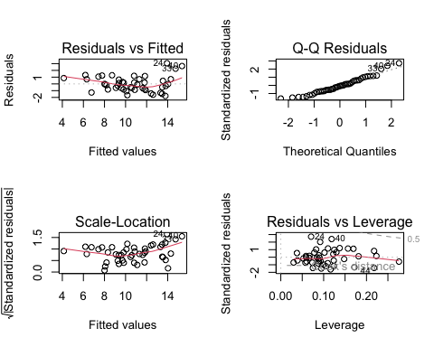
# Linearity and Equal Variance: The Residual vs. Fitted Plot shows a uniform scatter on both sides, indicating these assumptions are satisfied.
# Normality: The QQ Plot appears relatively linear, suggesting that the normality assumption is met.
#c)
studres_hp <- rstudent(model_hp)
HighPeaks$studres <- studres_hp
HighPeaks[abs(HighPeaks$studres) > 2, ]
## # A tibble: 3 × 7
## Peak Elevation Difficulty Ascent Length Time studres
## <chr> <dbl> <dbl> <dbl> <dbl> <dbl> <dbl>
## 1 Seward Mtn. 4361 7 3490 16 17 2.96
## 2 Mt. Donaldson 4140 7 3490 17 17 2.10
## 3 Mt. Emmons 4040 7 3490 18 18 2.56
# Seward, Donaldson, and Emmons appear to be outliers, as their climb times are significantly longer than the model’s predictions.
#d.)
lev_hp <- hatvalues(model_hp)
cooks_hp <- cooks.distance(model_hp)
threshold_leverage <- 2 * (4 + 1) / nrow(HighPeaks)
flag_leverage <- lev_hp > threshold_leverage
flag_max_cook <- cooks_hp == max(cooks_hp)
flag <- flag_leverage | flag_max_cook
HighPeaks$Leverage <- lev_hp
HighPeaks$CooksD <- cooks_hp
HighPeaks[flag, c("Peak", "Leverage", "CooksD")]
## # A tibble: 5 × 3
## Peak Leverage CooksD
## <chr> <dbl> <dbl>
## 1 Mt. Marcy 0.223 0.00152
## 2 Cascade Mtn. 0.218 0.0384
## 3 Mt. Emmons 0.119 0.156
## 4 Cliff Mtn. 0.218 0.112
## 5 Nye Mtn. 0.276 0.0260
# Nye has the highest leverage at 0.276, while Emmons has the largest Cook’s Distance value of 0.156. Based on the 2(k+1)/n criterion, Nye, Marcy, Cascade, and Cliff are considered influential, but since no Cook’s Distance exceeds 0.5, none are deemed highly influential overall.

