Day15
Amrit Singh
2025-11-10
library(dplyr)
##
## Attaching package: 'dplyr'
## The following objects are masked from 'package:stats':
##
## filter, lag
## The following objects are masked from 'package:base':
##
## intersect, setdiff, setequal, union
library(ggplot2)
library(readr)
births <- read_csv("NCBirths.csv")
## Rows: 1450 Columns: 15
## ── Column specification ────────────────────────────────────────────────────────
## Delimiter: ","
## chr (2): HispMom, MomRace
## dbl (13): ID, Plural, Sex, MomAge, Weeks, Marital, RaceMom, Gained, Smoke, B...
##
## ℹ Use `spec()` to retrieve the full column specification for this data.
## ℹ Specify the column types or set `show_col_types = FALSE` to quiet this message.
mouse <- read_csv("MouseBrain.csv")
## Rows: 48 Columns: 3
## ── Column specification ────────────────────────────────────────────────────────
## Delimiter: ","
## chr (2): Sex, Genotype
## dbl (1): Contacts
##
## ℹ Use `spec()` to retrieve the full column specification for this data.
## ℹ Specify the column types or set `show_col_types = FALSE` to quiet this message.
amyloid <- read_csv("Amyloid.csv")
## Rows: 57 Columns: 2
## ── Column specification ────────────────────────────────────────────────────────
## Delimiter: ","
## chr (1): Group
## dbl (1): Abeta
##
## ℹ Use `spec()` to retrieve the full column specification for this data.
## ℹ Specify the column types or set `show_col_types = FALSE` to quiet this message.
meniscus <- read_csv("Meniscus.csv")
## Rows: 18 Columns: 4
## ── Column specification ────────────────────────────────────────────────────────
## Delimiter: ","
## dbl (4): Method, FailureLoad, Displacement, Stiffness
##
## ℹ Use `spec()` to retrieve the full column specification for this data.
## ℹ Specify the column types or set `show_col_types = FALSE` to quiet this message.
#5.6: b. The error terms aren’t all positive. ANOVA assumes that the errors are independent, roughly normally distributed, and have a common standard deviation.
#5.7: d. Check model assumptions using a normal probability plot of residuals and a residuals-versus-fits plot.
#5.11
# a. Randomly assigning mothers to racial or ethnic groups isn’t possible, so no causal conclusion can be drawn—only correlation.
# b. If the sample was randomly selected from 2004 North Carolina births, inferences can be made to that population, assuming ANOVA conditions are met.
#5.12
# a. Since the study was observational rather than experimental, confounding variables couldn’t be controlled. Personality traits like risk-taking or thrill-seeking could affect both music preference and speeding behavior.
# b. Because the participants were all from one large high school, results can only be generalized to similar student populations, not all teens or drivers.
#5.14: Incorrect, Incorrect, Incorrect, Correct
#5.22
# a. No. Residuals show deviations from each group’s mean, and their total must be zero. If all residuals were positive, the sum would exceed zero, which is impossible.
# b. Yes. This can occur if one residual is negative enough to offset several positive ones, keeping the total at zero.
# c. Yes. A residual reflects distance from the group mean, not relative ranking. So one person may have a higher raw score but a smaller residual if it’s closer to the mean.
# d. Yes. Residuals are calculated within each group’s mean. Even if one group’s average is higher, a member can still have a smaller residual relative to that mean.
#5.27: The “Mixed” genotype group has the highest average contacts, “Minus” the lowest, with similar variability across groups. ANOVA assumptions appear valid, showing average contact counts differ as Mixed > Plus > Minus.
#5.31
# The three groups are: No cognitive impairment, Mild cognitive impairment, Mild-to-moderate Alzheimer’s disease
# B-amyloid levels tend to increase with greater cognitive decline. The boxplots show higher centers and wider spreads for the Alzheimer’s group, indicating different population means. Because the variable is quantitative, groups are independent, and spreads are similar, ANOVA is appropriate.
#5.33
# MS(Occupation) = 2749 / 4 = 687.25
# MS(Error) = 195149 / 968 = 201.4
# F = 687.25 / 201.4 ≈ 3.41
#5.38
# Null: Mean stiffness is the same for all three repair methods (μVertical=μArrow=μFastFix)
# Alternative: At least one mean stiffness differs.
# Independence: Each knee randomly assigned, so groups are independent.
# Normality: Residuals appear approximately normal.
# Equal variances: Group spreads are similar.
# Result: With p = 0.947 > 0.05, there’s no evidence that average stiffness differs among the three techniques.
#5.40
# Null: Mean displacement is equal for all three methods (μVertical=μArrow=μFastFix).
# Alternative: At least one differs.
# Independence: Independence ensured by random assignment.
# Normality: Residuals roughly normal.
# Equal variances: Variances similar across groups.
# Result: With p-value = 0.842 is far above 0.05, so there’s no significant evidence of mean displacement differences among methods.
by_race <- births %>%
group_by(MomRace) %>%
summarise(n = n(),
mean_bw = mean(BirthWeightGm, na.rm = TRUE),
sd_bw = sd(BirthWeightGm, na.rm = TRUE)) %>%
arrange(MomRace)
by_race
## # A tibble: 4 × 4
## MomRace n mean_bw sd_bw
## <chr> <int> <dbl> <dbl>
## 1 black 332 3134. 663.
## 2 hispanic 164 3360. 515.
## 3 other 48 3321. 499.
## 4 white 906 3342. 638.
fit <- aov(BirthWeightGm ~ MomRace, data = births)
summary(fit)
## Df Sum Sq Mean Sq F value Pr(>F)
## MomRace 3 11254022 3751341 9.528 3.12e-06 ***
## Residuals 1446 569302160 393708
## ---
## Signif. codes: 0 '***' 0.001 '**' 0.01 '*' 0.05 '.' 0.1 ' ' 1
plot(fit, which = 1)
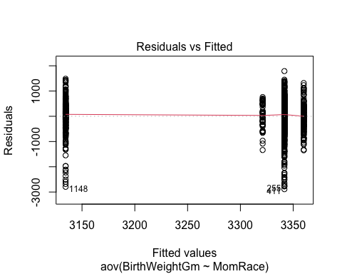
qqnorm(residuals(fit)); qqline(residuals(fit))
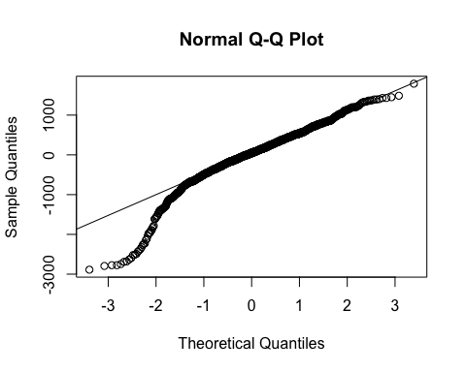
desc <- mouse %>%
group_by(Genotype) %>%
summarise(n = n(),
mean = mean(Contacts),
sd = sd(Contacts),
median = median(Contacts),
min = min(Contacts),
max = max(Contacts),
.groups = "drop")
desc
## # A tibble: 3 × 7
## Genotype n mean sd median min max
## <chr> <int> <dbl> <dbl> <dbl> <dbl> <dbl>
## 1 Minus 10 12.7 4.52 13.5 2 18
## 2 Mixed 19 19.3 4.79 19 12 29
## 3 Plus 19 17.5 5.46 17 5 26
ggplot(mouse, aes(x = Genotype, y = Contacts, fill = Genotype)) +
geom_boxplot(width = 0.7) +
labs(y = "Serotonin contacts", x = "Genotype") +
theme_minimal() +
theme(legend.position = "none")
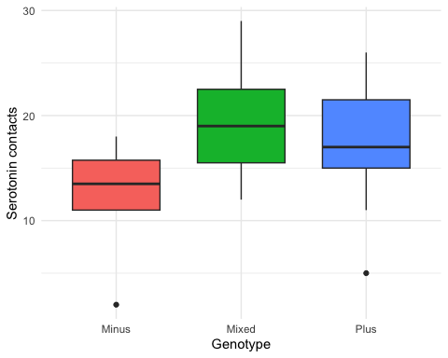
fit <- aov(Contacts ~ Genotype, data = mouse)
summary(fit)
## Df Sum Sq Mean Sq F value Pr(>F)
## Genotype 2 285.4 142.70 5.66 0.00642 **
## Residuals 45 1134.5 25.21
## ---
## Signif. codes: 0 '***' 0.001 '**' 0.01 '*' 0.05 '.' 0.1 ' ' 1
par(mfrow = c(1, 2))
plot(fit, which = 1)
qqnorm(residuals(fit)); qqline(residuals(fit))
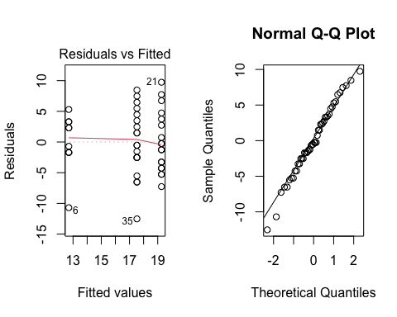
amyloid %>%
group_by(Group) %>%
summarise(n = n(),
mean_Abeta = mean(Abeta, na.rm = TRUE),
sd_Abeta = sd(Abeta, na.rm = TRUE))
## # A tibble: 3 × 4
## Group n mean_Abeta sd_Abeta
## <chr> <int> <dbl> <dbl>
## 1 MCI 21 341. 406.
## 2 NCI 19 336. 436.
## 3 mAD 17 761. 427.
ggplot(amyloid, aes(x = Group, y = Abeta, fill = Group)) +
geom_boxplot() +
labs(x = "Cognitive Group", y = "Abeta (pmol/g)") +
theme_minimal()
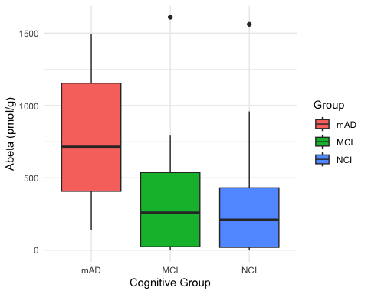
glimpse(meniscus)
## Rows: 18
## Columns: 4
## $ Method <dbl> 1, 1, 1, 1, 1, 1, 2, 2, 2, 2, 2, 2, 3, 3, 3, 3, 3, 3
## $ FailureLoad <dbl> 97.3, 106.4, 118.2, 99.7, 106.5, 84.2, 44.9, 46.1, 59.3, …
## $ Displacement <dbl> 16.9, 20.2, 20.1, 15.7, 13.9, 14.9, 7.9, 12.5, 15.5, 10.2…
## $ Stiffness <dbl> 8.3, 7.2, 6.3, 7.3, 8.7, 8.7, 4.7, 6.1, 5.0, 5.8, 6.6, 8.…
meniscus %>%
group_by(Method) %>%
summarise(n = n(),
mean_stiff = mean(Stiffness, na.rm = TRUE),
sd_stiff = sd(Stiffness, na.rm = TRUE))
## # A tibble: 3 × 4
## Method n mean_stiff sd_stiff
## <dbl> <int> <dbl> <dbl>
## 1 1 6 7.75 0.971
## 2 2 6 6.1 1.33
## 3 3 6 7.7 0.693
ggplot(meniscus, aes(x = Method, y = Stiffness, fill = Method)) + geom_boxplot() + theme_minimal()
## Warning: Continuous x aesthetic
## ℹ did you forget `aes(group = ...)`?
## Warning: The following aesthetics were dropped during statistical transformation: fill.
## ℹ This can happen when ggplot fails to infer the correct grouping structure in
## the data.
## ℹ Did you forget to specify a `group` aesthetic or to convert a numerical
## variable into a factor?
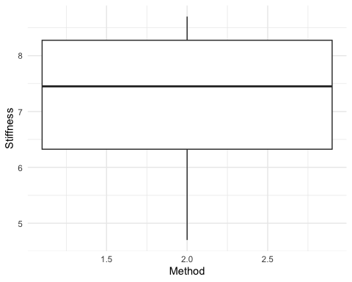
fit_stiff <- aov(Stiffness ~ Method, data = meniscus)
summary(fit_stiff)
## Df Sum Sq Mean Sq F value Pr(>F)
## Method 1 0.008 0.0075 0.005 0.947
## Residuals 16 26.478 1.6548
meniscus %>%
group_by(Method) %>%
summarise(n = n(),
mean_disp = mean(Displacement, na.rm = TRUE),
sd_disp = sd(Displacement, na.rm = TRUE))
## # A tibble: 3 × 4
## Method n mean_disp sd_disp
## <dbl> <int> <dbl> <dbl>
## 1 1 6 17.0 2.67
## 2 2 6 11.4 2.88
## 3 3 6 17.5 4.47
ggplot(meniscus, aes(x = Method, y = Displacement, fill = Method)) +
geom_boxplot() +
labs(x = "Repair method", y = "Displacement") +
theme_minimal() +
theme(legend.position = "none")
## Warning: Continuous x aesthetic
## ℹ did you forget `aes(group = ...)`?
## The following aesthetics were dropped during statistical transformation: fill.
## ℹ This can happen when ggplot fails to infer the correct grouping structure in
## the data.
## ℹ Did you forget to specify a `group` aesthetic or to convert a numerical
## variable into a factor?
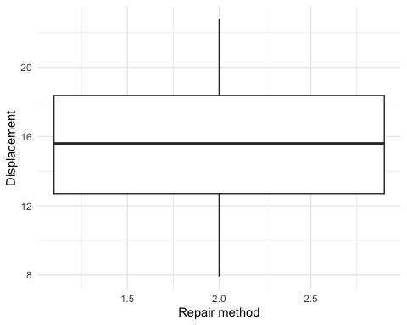
fit_disp <- aov(Displacement ~ Method, data = meniscus)
summary(fit_disp)
## Df Sum Sq Mean Sq F value Pr(>F)
## Method 1 0.8 0.801 0.041 0.842
## Residuals 16 312.8 19.547

