Day16
Amrit Singh
2025-11-14
library(readr)
library(ggplot2)
library(dplyr)
##
## Attaching package: 'dplyr'
## The following objects are masked from 'package:stats':
##
## filter, lag
## The following objects are masked from 'package:base':
##
## intersect, setdiff, setequal, union
library(car)
## Loading required package: carData
##
## Attaching package: 'car'
## The following object is masked from 'package:dplyr':
##
## recode
library(mosaic)
## Registered S3 method overwritten by 'mosaic':
## method from
## fortify.SpatialPolygonsDataFrame ggplot2
##
## The 'mosaic' package masks several functions from core packages in order to add
## additional features. The original behavior of these functions should not be affected by this.
##
## Attaching package: 'mosaic'
## The following object is masked from 'package:Matrix':
##
## mean
## The following objects are masked from 'package:car':
##
## deltaMethod, logit
## The following objects are masked from 'package:dplyr':
##
## count, do, tally
## The following object is masked from 'package:ggplot2':
##
## stat
## The following objects are masked from 'package:stats':
##
## binom.test, cor, cor.test, cov, fivenum, IQR, median, prop.test,
## quantile, sd, t.test, var
## The following objects are masked from 'package:base':
##
## max, mean, min, prod, range, sample, sum
Meniscus <- read_csv("Meniscus.csv")
## Rows: 18 Columns: 4
## ── Column specification ────────────────────────────────────────────────────────
## Delimiter: ","
## dbl (4): Method, FailureLoad, Displacement, Stiffness
##
## ℹ Use `spec()` to retrieve the full column specification for this data.
## ℹ Specify the column types or set `show_col_types = FALSE` to quiet this message.
oil <- read_csv("OilDeapsorbtion.csv")
## Rows: 40 Columns: 4
## ── Column specification ────────────────────────────────────────────────────────
## Delimiter: ","
## dbl (4): salt, Ultra, Oil, diff
##
## ℹ Use `spec()` to retrieve the full column specification for this data.
## ℹ Specify the column types or set `show_col_types = FALSE` to quiet this message.
#53:
# a.)
oil$Oil <- factor(oil$Oil)
stripchart(diff~ Oil, data = oil,
method = "stack",
pch = 19,
xlab = "Difference (Experimental - Control)",
main = "Dotplot of Difference by Oil Level")
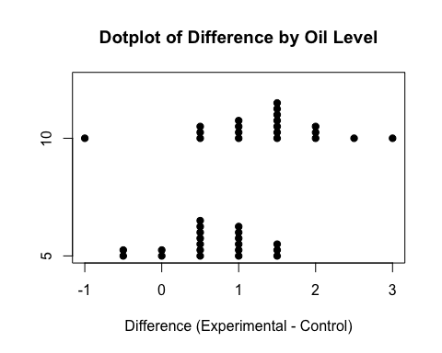
favstats(diff~ Oil, data = oil)
## Oil min Q1 median Q3 max mean sd n missing
## 1 5 -0.5 0.5 0.5 1.000 1.5 0.650 0.5871429 20 0
## 2 10 -1.0 1.0 1.5 1.625 3.0 1.325 0.8472090 20 0
# From the dotplot, there is a difference in the amount of oil de-adsorbed between the experimental and control.
# b.)
model_oil <- aov(diff~ factor(Oil), data = oil)
t.test(diff~ Oil, data = oil, var.equal = TRUE)
##
## Two Sample t-test
##
## data: diff by Oil
## t = -2.9286, df = 38, p-value = 0.005728
## alternative hypothesis: true difference in means between group 5 and group 10 is not equal to 0
## 95 percent confidence interval:
## -1.1415998 -0.2084002
## sample estimates:
## mean in group 5 mean in group 10
## 0.650 1.325
# P-value is 0.006 which is less than 0.05. Therefore, we reject H0 and evidence shows that there is a difference.
# c.)
anova_oil <- aov(diff ~ factor(Oil), data = oil)
par(mfrow = c(2, 2))
plot(anova_oil)
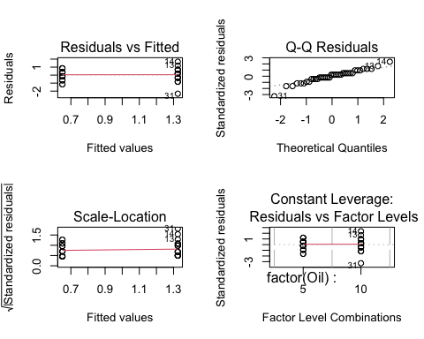
par(mfrow = c(1, 1))
summary(anova_oil)
## Df Sum Sq Mean Sq F value Pr(>F)
## factor(Oil) 1 4.556 4.556 8.576 0.00573 **
## Residuals 38 20.188 0.531
## ---
## Signif. codes: 0 '***' 0.001 '**' 0.01 '*' 0.05 '.' 0.1 ' ' 1
# Residuals are normally and equal, QQ-Plot is linear so conditions are met. P is 0.006 so we reject H0.
# d.)
# The conclusions are the same
#55:
# a.)
oil$Ultra <- factor(oil$Ultra)
stripchart(diff ~ Ultra, data = oil,
method = "stack",
pch = 19,
xlab = "Difference (Experimental - Control)",
main = "Dotplot of Difference by Ultrasound Duration")
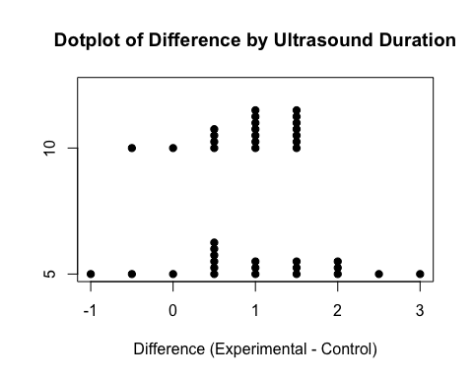
favstats(diff ~ Ultra, data = oil)
## Ultra min Q1 median Q3 max mean sd n missing
## 1 5 -1.0 0.5 1 1.625 3.0 1.025 0.9930681 20 0
## 2 10 -0.5 0.5 1 1.500 1.5 0.950 0.5596051 20 0
# There isn't much difference based off of how long the sand is in the ultrasound.
# b.)
t.test(diff ~ Ultra, data = oil, var.equal = TRUE)
##
## Two Sample t-test
##
## data: diff by Ultra
## t = 0.29425, df = 38, p-value = 0.7702
## alternative hypothesis: true difference in means between group 5 and group 10 is not equal to 0
## 95 percent confidence interval:
## -0.4409907 0.5909907
## sample estimates:
## mean in group 5 mean in group 10
## 1.025 0.950
# P is 0.77 which is less than 0.05. So we fail to reject H0. Evidence suggests that there is no difference.
# c.)
anova_ultra <- aov(diff ~ factor(Ultra), data = oil)
par(mfrow = c(2, 2))
plot(anova_ultra)
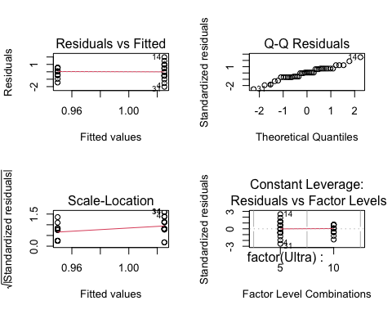
par(mfrow = c(1, 1))
summary(anova_ultra)
## Df Sum Sq Mean Sq F value Pr(>F)
## factor(Ultra) 1 0.056 0.0562 0.087 0.77
## Residuals 38 24.688 0.6497
# Residuals are normally and equal, QQ-Plot is linear so conditions are met. P is 0.770 so we fail to reject.
# d.)
# The conclusions are the same
#57:
# a.)
# H0: aa = af = av = 0
# Ha: At least one ak = 0
# b.)
model_fail <- aov(FailureLoad ~ factor(Method), data = Meniscus)
par(mfrow = c(2, 2))
plot(model_fail)
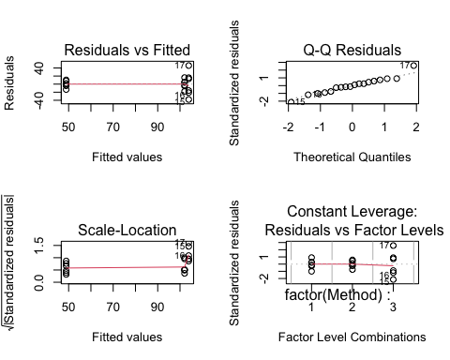
par(mfrow = c(1, 1))
# The residuals are normally distributed but don't seem equal

