Day17
Amrit Singh
2025-11-14
library(readr)
library(tidyverse)
## ── Attaching core tidyverse packages ──────────────────────── tidyverse 2.0.0 ──
## ✔ dplyr 1.1.4 ✔ purrr 1.1.0
## ✔ forcats 1.0.0 ✔ stringr 1.5.1
## ✔ ggplot2 3.5.2 ✔ tibble 3.3.0
## ✔ lubridate 1.9.4 ✔ tidyr 1.3.1
## ── Conflicts ────────────────────────────────────────── tidyverse_conflicts() ──
## ✖ dplyr::filter() masks stats::filter()
## ✖ dplyr::lag() masks stats::lag()
## ℹ Use the conflicted package (<http://conflicted.r-lib.org/>) to force all conflicts to become errors
hawks <- read_csv("Hawks.csv")
## Rows: 908 Columns: 19
## ── Column specification ────────────────────────────────────────────────────────
## Delimiter: ","
## chr (5): CaptureTime, BandNumber, Species, Age, Sex
## dbl (13): Month, Day, Year, Wing, Weight, Culmen, Hallux, Tail, StandardTai...
## time (1): ReleaseTime
##
## ℹ Use `spec()` to retrieve the full column specification for this data.
## ℹ Specify the column types or set `show_col_types = FALSE` to quiet this message.
# 8) c
# 10
# a.) If the spread of the data increases with the mean
# b.) A power transformation could fix the variance
# 32
# a.)
hawks_filtered <- hawks %>%
filter(Species %in% c("RT", "SS", "CH")) %>%
filter(Weight > 0)
hawks_filtered %>%
ggplot(aes(x = Weight, y = Species)) +
geom_jitter(height = 0.2) +
theme_minimal()
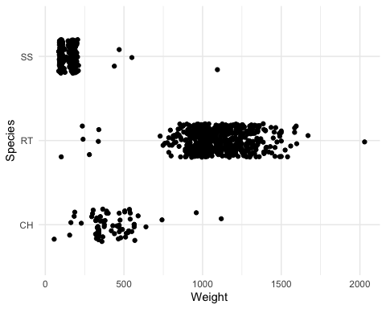
# The SS doplot is right skewed and has little variability. Also, there are outliers in all three groups
# b.)
hawks_filtered %>%
group_by(Species) %>%
summarize(SD = sd(Weight))
## # A tibble: 3 × 2
## Species SD
## <chr> <dbl>
## 1 CH 162.
## 2 RT 189.
## 3 SS 80.7
# The standard deviations are different across the species, so there is a concern about using ANOVA.
# 43
# a.)
hawk_summary <- hawks_filtered %>%
group_by(Species) %>%
summarize(average = mean(Weight), s = sd(Weight))
log_summary <- hawk_summary %>%
mutate(log_avg = log(average), log_s = log(s))
plot(log_summary$log_avg, log_summary$log_s,
main = "Log(SD) vs Log(Average)",
xlab = "log(average weight)",
ylab = "log(standard deviation)",
pch = 19)
abline(lm(log_s~ log_avg, data = log_summary))
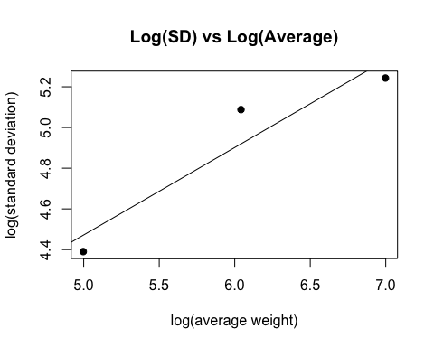
# The points form roughly a straight line
# b.)
slope <- coef(lm(log_s~ log_avg, data = log_summary))[2]
slope
## log_avg
## 0.4298342
# The slope is approximately 0.5.
# c.)
p <- 1- slope
p
## log_avg
## 0.5701658
# The transformation suggested is raising Weight to the 0.5th power
# 49
# a.)
hawks_filtered <- hawks_filtered %>%
mutate(Weight_trans = Weight^0.5)
hawks_filtered %>%
group_by(Species) %>%
summarize(mean_trans = mean(Weight_trans), sd_trans = sd(Weight_trans))
## # A tibble: 3 × 3
## Species mean_trans sd_trans
## <chr> <dbl> <dbl>
## 1 CH 20.1 3.86
## 2 RT 32.9 3.06
## 3 SS 11.9 2.42
# After the transformation, the sample means and standard deviations are more similar across species.
# b.)
hawks_filtered %>%
ggplot(aes(x = Species, y = Weight_trans)) +
geom_boxplot()
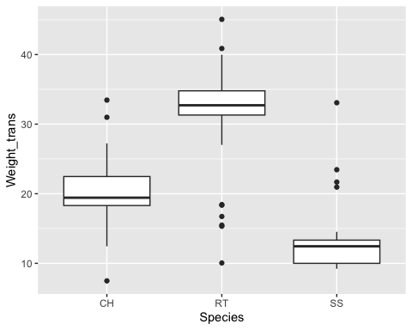
# The boxplots show that the weights are highest for RT and smallest for SS.
# c.)
# Even though the standard deviations are somewhat similar, they are still skewed.

