Day18
Amrit Singh
2025-11-19
library(tidyverse)
## ── Attaching core tidyverse packages ──────────────────────── tidyverse 2.0.0 ──
## ✔ dplyr 1.1.4 ✔ readr 2.1.5
## ✔ forcats 1.0.0 ✔ stringr 1.5.1
## ✔ ggplot2 3.5.2 ✔ tibble 3.3.0
## ✔ lubridate 1.9.4 ✔ tidyr 1.3.1
## ✔ purrr 1.1.0
## ── Conflicts ────────────────────────────────────────── tidyverse_conflicts() ──
## ✖ dplyr::filter() masks stats::filter()
## ✖ dplyr::lag() masks stats::lag()
## ℹ Use the conflicted package (<http://conflicted.r-lib.org/>) to force all conflicts to become errors
library(ggplot2)
library(car)
## Loading required package: carData
##
## Attaching package: 'car'
##
## The following object is masked from 'package:dplyr':
##
## recode
##
## The following object is masked from 'package:purrr':
##
## some
library(agricolae)
fantasy <- read.csv("FantasyBaseball.csv")
metro <- read.csv("MetroCommutes.csv")
fantasy$Person <- as.factor(fantasy$Person)
fantasy$Round <- as.factor(fantasy$Round)
metro$City <- metro$city
metro$Time <- metro$time
metro$City <- as.factor(metro$City)
# 5.64
metro_clean <- metro %>% filter(!is.na(Time) & Time > 0)
metro_clean$LogCommute <- log(metro_clean$Time)
log_model_metro <- aov(LogCommute ~ City, data = metro_clean)
summary(log_model_metro)
## Df Sum Sq Mean Sq F value Pr(>F)
## City 3 34.2 11.402 18.17 1.24e-11 ***
## Residuals 1994 1251.3 0.628
## ---
## Signif. codes: 0 '***' 0.001 '**' 0.01 '*' 0.05 '.' 0.1 ' ' 1
LSD.test(log_model_metro, "City", p.adj = "none")$groups
## LogCommute groups
## Washington 3.220030 a
## Houston 2.975064 b
## Boston 2.954324 bc
## Minneapolis 2.867528 c
# Fisher's LSD = 0.091
# 5.65
metro$SqrtCommute <- sqrt(metro$Time)
sqrt_model_metro <- aov(SqrtCommute ~ City, data = metro)
summary(sqrt_model_metro)
## Df Sum Sq Mean Sq F value Pr(>F)
## City 3 186 62.04 20.99 2.17e-13 ***
## Residuals 1996 5899 2.96
## ---
## Signif. codes: 0 '***' 0.001 '**' 0.01 '*' 0.05 '.' 0.1 ' ' 1
LSD.test(sqrt_model_metro, "City", p.adj = "none")$groups
## SqrtCommute groups
## Washington 5.320662 a
## Boston 4.758917 b
## Houston 4.730243 b
## Minneapolis 4.488544 c
# Fisher's LSD = 0.213
# 5.66 a)
boxplot(Time ~ Person, data = fantasy,
main = "Selection Times by Participant",
ylab = "Time (seconds)")
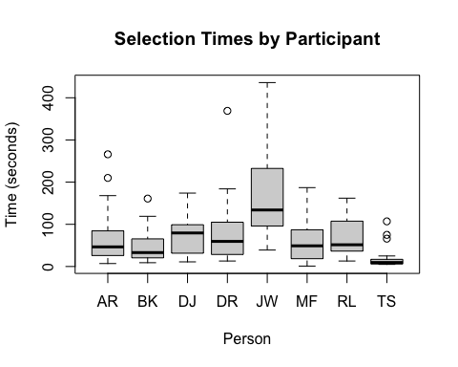
summary_stats <- fantasy %>%
group_by(Person) %>%
summarise(mean = mean(Time), sd = sd(Time),
min = min(Time), max = max(Time))
summary_stats
## # A tibble: 8 × 5
## Person mean sd min max
## <fct> <dbl> <dbl> <int> <int>
## 1 AR 68.3 66.9 7 266
## 2 BK 48.0 39.3 9 161
## 3 DJ 69.6 41.6 11 174
## 4 DR 80.1 75.8 13 369
## 5 JW 164. 104. 39 436
## 6 MF 63.8 56.0 1 187
## 7 RL 67.1 44.6 13 162
## 8 TS 19.3 25.8 5 107
summary_stats %>% filter(mean == max(mean))
## # A tibble: 1 × 5
## Person mean sd min max
## <fct> <dbl> <dbl> <int> <int>
## 1 JW 164. 104. 39 436
summary_stats %>% filter(mean == min(mean))
## # A tibble: 1 × 5
## Person mean sd min max
## <fct> <dbl> <dbl> <int> <int>
## 1 TS 19.3 25.8 5 107
# Boxplots show that the distributions are right skewed. JW is slower and TS is the fastest.
# b)
anova_model <- aov(Time ~ Person, data = fantasy)
summary(anova_model)
## Df Sum Sq Mean Sq F value Pr(>F)
## Person 7 287196 41028 10.89 1.79e-11 ***
## Residuals 184 693126 3767
## ---
## Signif. codes: 0 '***' 0.001 '**' 0.01 '*' 0.05 '.' 0.1 ' ' 1
# From the ANOVA table, we can conclude that one of the participants has a different mean selection time
# c)
LSD.test(anova_model, "Person", p.adj = "none")$groups
## Time groups
## JW 163.87500 a
## DR 80.12500 b
## DJ 69.62500 b
## AR 68.29167 b
## RL 67.12500 b
## MF 63.83333 b
## BK 47.95833 bc
## TS 19.33333 c
# JW is a lot slower then everyone else and TS is significantly faster than everyone other than BK.
# 5.67 a)
qqPlot(anova_model, main = "Q-Q Plot of Residuals")
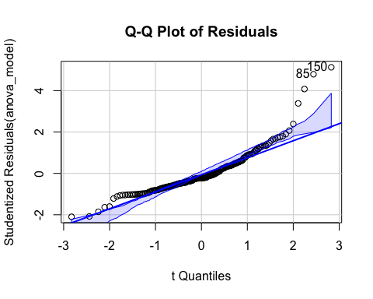
## [1] 85 150
# Not linear -> ANOVA model not appropriate without transformations
# 5.67 b)
fantasy$LogTime <- log(fantasy$Time)
boxplot(LogTime ~ Person, data = fantasy,
main = "Log(Selection Times) by Participant",
ylab = "Log(Time)")
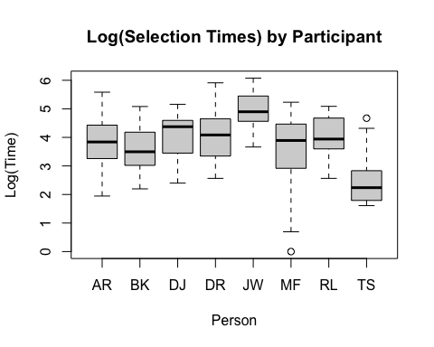
log_anova_model <- aov(LogTime ~ Person, data = fantasy)
summary(log_anova_model)
## Df Sum Sq Mean Sq F value Pr(>F)
## Person 7 78.75 11.250 12.99 1.54e-13 ***
## Residuals 184 159.37 0.866
## ---
## Signif. codes: 0 '***' 0.001 '**' 0.01 '*' 0.05 '.' 0.1 ' ' 1
LSD.test(log_anova_model, "Person", p.adj = "none")$groups
## LogTime groups
## JW 4.903026 a
## DR 4.046958 b
## DJ 4.022507 bc
## RL 3.987541 bc
## AR 3.779757 bc
## BK 3.554379 bc
## MF 3.502555 c
## TS 2.468851 d
# From the ANOVA table, we see that there is a significant difference in ln
# 5.69
round_anova_model <- aov(LogTime ~ Round, data = fantasy)
par(mfrow = c(2, 2))
qqnorm(resid(round_anova_model), main = "Normal Q-Q Plot")
qqline(resid(round_anova_model))
plot(fitted(round_anova_model), resid(round_anova_model),
xlab = "Fitted Value", ylab = "Residual",
main = "Residuals vs Fitted")
abline(h = 0, lty = 2)
hist(resid(round_anova_model), breaks = 20,
main = "Histogram of Residuals", xlab = "Residual")
plot(resid(round_anova_model), type = "b",
xlab = "Observation Order", ylab = "Residual",
main = "Residuals vs Order")
abline(h = 0, lty = 2)
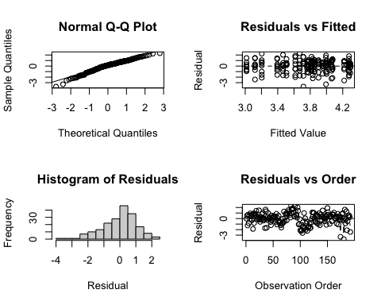
par(mfrow = c(1, 1))
summary(round_anova_model)
## Df Sum Sq Mean Sq F value Pr(>F)
## Round 23 23.82 1.036 0.812 0.713
## Residuals 168 214.30 1.276
# Conditions are met so proceed with ANOVA test. Since p is > 0.05, we don't have enough evidence to reject the hypothesis.

