Day2_WeightLoss
Amrit Singh
2025-08-31
library(readr)
library(mosaic)
## Registered S3 method overwritten by 'mosaic':
## method from
## fortify.SpatialPolygonsDataFrame ggplot2
##
## The 'mosaic' package masks several functions from core packages in order to add
## additional features. The original behavior of these functions should not be affected by this.
##
## Attaching package: 'mosaic'
## The following objects are masked from 'package:dplyr':
##
## count, do, tally
## The following object is masked from 'package:Matrix':
##
## mean
## The following object is masked from 'package:ggplot2':
##
## stat
## The following objects are masked from 'package:stats':
##
## binom.test, cor, cor.test, cov, fivenum, IQR, median, prop.test,
## quantile, sd, t.test, var
## The following objects are masked from 'package:base':
##
## max, mean, min, prod, range, sample, sum
library(tidyverse)
## ── Attaching core tidyverse packages ──────────────────────── tidyverse 2.0.0 ──
## ✔ forcats 1.0.0 ✔ stringr 1.5.1
## ✔ lubridate 1.9.4 ✔ tibble 3.3.0
## ✔ purrr 1.1.0 ✔ tidyr 1.3.1
## ── Conflicts ────────────────────────────────────────── tidyverse_conflicts() ──
## ✖ mosaic::count() masks dplyr::count()
## ✖ purrr::cross() masks mosaic::cross()
## ✖ mosaic::do() masks dplyr::do()
## ✖ tidyr::expand() masks Matrix::expand()
## ✖ dplyr::filter() masks stats::filter()
## ✖ dplyr::lag() masks stats::lag()
## ✖ tidyr::pack() masks Matrix::pack()
## ✖ mosaic::stat() masks ggplot2::stat()
## ✖ mosaic::tally() masks dplyr::tally()
## ✖ tidyr::unpack() masks Matrix::unpack()
## ℹ Use the conflicted package (<http://conflicted.r-lib.org/>) to force all conflicts to become errors
library(Stat2Data)
# Problem 23: Weight Loss Incentive
WeightLossIncentive7 <- read_csv("WeightLossIncentive7.csv")
## Rows: 33 Columns: 2
## ── Column specification ────────────────────────────────────────────────────────
## Delimiter: ","
## chr (1): Group
## dbl (1): Month7Loss
##
## ℹ Use `spec()` to retrieve the full column specification for this data.
## ℹ Specify the column types or set `show_col_types = FALSE` to quiet this message.
head(WeightLossIncentive7)
## # A tibble: 6 × 2
## Group Month7Loss
## <chr> <dbl>
## 1 Control -2
## 2 Control 7
## 3 Control 19.5
## 4 Control -0.5
## 5 Control -1.5
## 6 Control -10
sapply(WeightLossIncentive7$Month7Loss, mean, na.rm=TRUE)
## [1] -2.0 7.0 19.5 -0.5 -1.5 -10.0 0.5 5.0 8.5 18.0 16.0 -9.0
## [13] 4.5 23.5 5.5 6.5 -9.5 1.5 11.5 20.0 -22.0 2.0 7.5 16.5
## [25] 19.0 18.0 -1.0 5.5 24.5 9.5 10.0 -8.5 4.5
mean_loss <- mean(WeightLossIncentive7$Month7Loss, na.rm = TRUE)
summary <- WeightLossIncentive7 %>%
group_by(Group) %>%
summarize(
mean_Loss = mean(Month7Loss, na.rm = TRUE),
std_dev = sd(Month7Loss, na.rm = TRUE),
N = sum(!is.na(Month7Loss))
)
print(summary)
## # A tibble: 2 × 4
## Group mean_Loss std_dev N
## <chr> <dbl> <dbl> <int>
## 1 Control 4.64 9.84 18
## 2 Incentive 7.8 12.1 15
cont <- WeightLossIncentive7$Month7Loss[WeightLossIncentive7$Group == "Control"]
inc <- WeightLossIncentive7$Month7Loss[WeightLossIncentive7$Group == "Incentive"]
hist(cont, breaks = 15, main = "Month7Loss - Histogram- Cont",
xlab = "Pounds of weight lost", col = "lightblue")
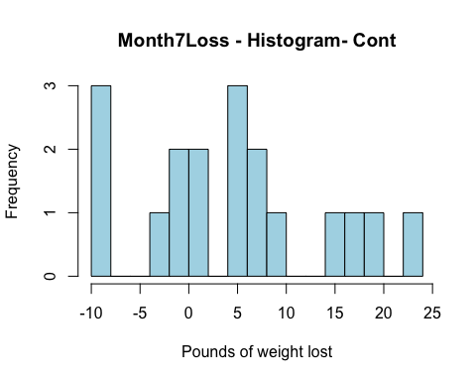
hist(inc, breaks = 15, main = "Month7Loss - Histogram - Incent",
xlab = "Pounds of weight lost", col = "lightgreen")
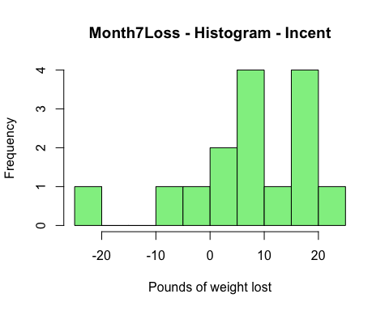
mean_cont <- mean(cont, na.rm = TRUE)
mean_inc <- mean(inc, na.rm = TRUE)
print(mean_cont)
## [1] 4.638889
print(mean_inc)
## [1] 7.8
residuals_cont <- cont - mean_cont
residuals_inc <- inc - mean_inc
stripchart(residuals_cont, method = "stack", pch = 16,
main = "Control - Dotplot - Residuals", xlab = "Residual value",
at = 0, offset = 0.45, cex = 2, col = "lightblue")
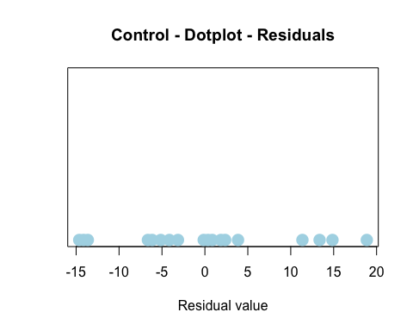
stripchart(residuals_inc, method = "stack", pch = 16,
main = "Incentive - Dotplot - Residuals", xlab = "Residual value",
at = 0, offset = 0.45, cex = 2, col = "lightgreen")
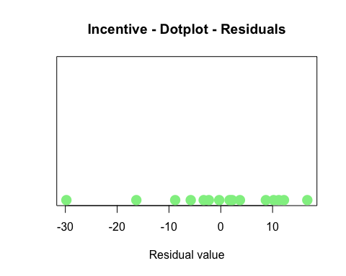
t_Test_Results <- t.test(Month7Loss ~ Group, data = WeightLossIncentive7, alternative = "less")
print(t_Test_Results)
##
## Welch Two Sample t-test
##
## data: Month7Loss by Group
## t = -0.8144, df = 26.994, p-value = 0.2113
## alternative hypothesis: true difference in means between group Control and group Incentive is less than 0
## 95 percent confidence interval:
## -Inf 3.450298
## sample estimates:
## mean in group Control mean in group Incentive
## 4.638889 7.800000
#Choice: For this analysis, the independent variable is whether a monetary incentive was provided or not and the dependent variable is the weight change over a span of seven months. The model takes the form weight change = mean effect + random error.
#Fit: The model for estimation suggests that the participants in the control group lost on average 4.64 pounds, whereas the participants in the incentive group lost on average 7.8 pounds, with both instances incorporating random variation.
#Fit: The estimated model shows that those in the control group lost a mean of 4.64 four pounds, while those in the incentive group lost a mean of 7.8 pounds, with random variation present in both instances.
#Use: In accordance with the model, the impact of the monetary incentive wears off after the first four months, and a declining effect is evident.
# Problem 26: Marathon Short vs Long
Marathon_data <- read_csv("Marathon.csv")
## Rows: 1127 Columns: 9
## ── Column specification ────────────────────────────────────────────────────────
## Delimiter: ","
## chr (3): Date, Time, ShoeBrand
## dbl (5): Miles, TimeMin, PaceMin, Short, After2004
## time (1): Pace
##
## ℹ Use `spec()` to retrieve the full column specification for this data.
## ℹ Specify the column types or set `show_col_types = FALSE` to quiet this message.
head(Marathon_data)
## # A tibble: 6 × 9
## Date Miles Time Pace ShoeBrand TimeMin PaceMin Short After2004
## <chr> <dbl> <chr> <time> <chr> <dbl> <dbl> <dbl> <dbl>
## 1 1/1/2002 5 38:31:00 07:42:12 <NA> 38.5 7.70 1 0
## 2 1/3/2002 5 41:05:00 08:13:00 <NA> 41.1 8.22 1 0
## 3 1/5/2002 4 31:21:00 07:50:15 <NA> 31.4 7.84 1 0
## 4 1/6/2002 6 53:52:00 08:58:40 <NA> 53.9 8.98 0 0
## 5 1/8/2002 4.5 40:19:00 08:57:33 <NA> 40.3 8.96 1 0
## 6 1/9/2002 5 39:51:00 07:58:12 <NA> 39.8 7.97 1 0
Marathon_data %>%
group_by(Short) %>%
select(PaceMin) %>%
summarize(average = mean(PaceMin, na.rm=TRUE),
std_dev = sd(PaceMin, na.rm=TRUE))
## Adding missing grouping variables: `Short`
## # A tibble: 2 × 3
## Short average std_dev
## <dbl> <dbl> <dbl>
## 1 0 8.16 0.486
## 2 1 7.96 0.478
stripchart(PaceMin ~ Short, data = Marathon_data,
main = "pace vs distance in Marathon",
xlab = "Pace traveled", ylab = "Distance traveled",
method = "stack", offset = 0.45, pch = 16, col = "lightblue")
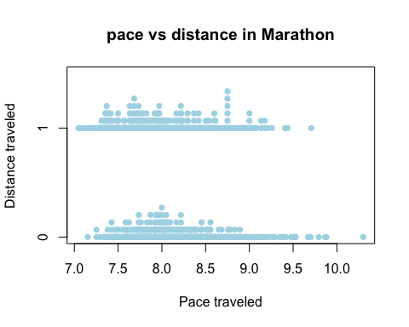
Marathon_t_Test <- t.test(PaceMin ~ Short, data = Marathon_data)
print(Marathon_t_Test)
##
## Welch Two Sample t-test
##
## data: PaceMin by Short
## t = 6.6991, df = 962.52, p-value = 3.563e-11
## alternative hypothesis: true difference in means between group 0 and group 1 is not equal to 0
## 95 percent confidence interval:
## 0.1389206 0.2540322
## sample estimates:
## mean in group 0 mean in group 1
## 8.157665 7.961188
#Choice: The independent variable in the study is running distance, whereas the dependent variable is running pace. The model is of the type where pace is equal to the average effect plus random error.
#Fit: The model estimated that runners in the long-distance group had an average pace of 8.16 per mile, whereas those in the incentive group had an average pace of 7.96 per mile, with further variation explained by error.
#Assess: The dot plots indicate that the data is nearly normally distributed. With a p-value almost zero, smaller than zero point zero five, there is strong statistical evidence that there is a significant difference in speed between the two groups.
#Use: The model suggests that there is a dramatic difference in running speed between short and long distances, and hence distance does make a measurable impact on speed.

# Problem 27: Marathon Before vs After 2004
Marathon_data <- read_csv("Marathon.csv")
## Rows: 1127 Columns: 9
## ── Column specification ────────────────────────────────────────────────────────
## Delimiter: ","
## chr (3): Date, Time, ShoeBrand
## dbl (5): Miles, TimeMin, PaceMin, Short, After2004
## time (1): Pace
##
## ℹ Use `spec()` to retrieve the full column specification for this data.
## ℹ Specify the column types or set `show_col_types = FALSE` to quiet this message.
Marathon_data %>%
group_by(After2004) %>%
summarize(
average = mean(PaceMin, na.rm=TRUE),
std_dev = sd(PaceMin, na.rm=TRUE)
)
## # A tibble: 2 × 3
## After2004 average std_dev
## <dbl> <dbl> <dbl>
## 1 0 7.91 0.446
## 2 1 8.41 0.406
stripchart(PaceMin ~ After2004, data = Marathon_data,
main = "pace vs time period graph",
xlab = "pace time", ylab = "Time variable - After 2004",
method = "stack", offset=0.45, pch = 16, col = "lightblue")
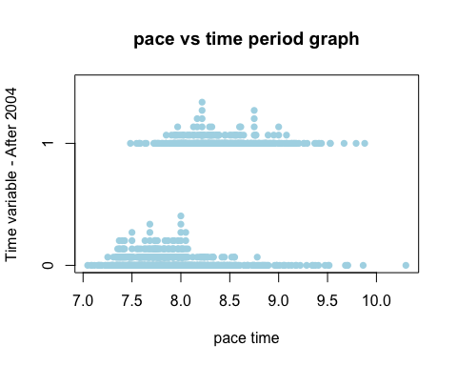
t_Test <- t.test(PaceMin ~ After2004, data = Marathon_data)
print(t_Test)
##
## Welch Two Sample t-test
##
## data: PaceMin by After2004
## t = -18.715, df = 813.19, p-value < 2.2e-16
## alternative hypothesis: true difference in means between group 0 and group 1 is not equal to 0
## 95 percent confidence interval:
## -0.5488239 -0.4446252
## sample estimates:
## mean in group 0 mean in group 1
## 7.914414 8.411139
Marathon_data %>%
group_by(After2004) %>%
summarize(
average = mean(Miles, na.rm=TRUE),
std_dev = sd(Miles, na.rm=TRUE)
)
## # A tibble: 2 × 3
## After2004 average std_dev
## <dbl> <dbl> <dbl>
## 1 0 7.49 4.07
## 2 1 6.63 3.14
stripchart(Miles ~ After2004, data = Marathon_data,
main = "miles vs time period data",
xlab = "Miles", ylab = "Time after 2004",
method = "stack", offset=0.45, pch = 16, col = "lightblue")
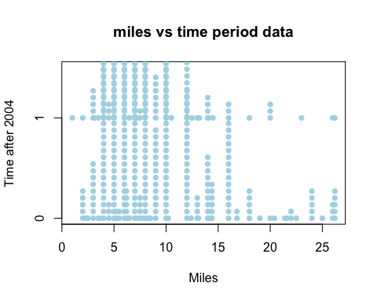
T_Test_data <- t.test(Miles ~ After2004, data = Marathon_data)
print(T_Test_data)
##
## Welch Two Sample t-test
##
## data: Miles by After2004
## t = 3.9261, df = 937.03, p-value = 9.265e-05
## alternative hypothesis: true difference in means between group 0 and group 1 is not equal to 0
## 95 percent confidence interval:
## 0.4318012 1.2949073
## sample estimates:
## mean in group 0 mean in group 1
## 7.492154 6.628800
#Choice: The explanatory variable in this study is time period, while the response variable is running speed. The model follows the structure where speed equals the average effect plus random error.
#Fit: The estimated mean pace before 2004 was 7.91 minutes per mile, while after 2004, it increased to 8.41 minutes per mile, with slight variations due to random error.
#Assess: The dot plots indicate that the data follows a normal distribution. With a p-value close to zero, which is below 0.05, there is strong statistical evidence that pace differs significantly between the two time periods.
#Use: The model clearly demonstrates a shift in running speed before and after 2004, showing that pace trends changed over time.

# Problem 30
Marathon_data <- read_csv("Marathon.csv")
## Rows: 1127 Columns: 9
## ── Column specification ────────────────────────────────────────────────────────
## Delimiter: ","
## chr (3): Date, Time, ShoeBrand
## dbl (5): Miles, TimeMin, PaceMin, Short, After2004
## time (1): Pace
##
## ℹ Use `spec()` to retrieve the full column specification for this data.
## ℹ Specify the column types or set `show_col_types = FALSE` to quiet this message.
summary_stats <- Marathon_data %>%
group_by(Short) %>%
summarize(
avg_pace = mean(Pace, na.rm=TRUE),
sd_pace = sd(Pace, na.rm=TRUE)
) %>%
filter(Short %in% c(0,1))
avg1 <- summary_stats$avg_pace[summary_stats$Short == 0]
sd1 <- summary_stats$sd_pace[summary_stats$Short == 0]
avg2 <- summary_stats$avg_pace[summary_stats$Short == 1]
sd2 <- summary_stats$sd_pace[summary_stats$Short == 1]
pooled_sd <- sqrt((sd1^2 + sd2^2)/2)
effect_size <- abs(avg1 - avg2)/pooled_sd
effect_size
## Time difference of 0.4074827 secs
#An effect size of 0.41, however, indicates a moderate difference between mean running speed with long training runs versus short training runs, and therefore, training distance does have some measurable effect on running speed.
# Problem 31
Marathon_data <- read_csv("Marathon.csv")
## Rows: 1127 Columns: 9
## ── Column specification ────────────────────────────────────────────────────────
## Delimiter: ","
## chr (3): Date, Time, ShoeBrand
## dbl (5): Miles, TimeMin, PaceMin, Short, After2004
## time (1): Pace
##
## ℹ Use `spec()` to retrieve the full column specification for this data.
## ℹ Specify the column types or set `show_col_types = FALSE` to quiet this message.
Handwriting <- read_csv("Handwriting.csv")
## Rows: 204 Columns: 8
## ── Column specification ────────────────────────────────────────────────────────
## Delimiter: ","
## dbl (8): Individual, Gender, Survey1, Survey2, FemaleID, MaleID, Both, DIFF
##
## ℹ Use `spec()` to retrieve the full column specification for this data.
## ℹ Specify the column types or set `show_col_types = FALSE` to quiet this message.
head(Handwriting)
## # A tibble: 6 × 8
## Individual Gender Survey1 Survey2 FemaleID MaleID Both DIFF
## <dbl> <dbl> <dbl> <dbl> <dbl> <dbl> <dbl> <dbl>
## 1 1 1 72 68 75 69.2 68 4
## 2 2 0 56 68 41.7 69.2 48 -12
## 3 3 1 68 48 75 61.5 36 20
## 4 4 1 80 80 83.3 76.9 76 0
## 5 5 1 76 72 83.3 69.2 68 4
## 6 6 1 76 60 75 76.9 60 16
summary_stats <- Marathon_data %>%
group_by(After2004) %>%
summarize(
avg_miles = mean(Miles, na.rm=TRUE),
sd_miles = sd(Miles, na.rm=TRUE)
) %>%
filter(After2004 %in% c(0,1))
avg1 <- summary_stats$avg_miles[summary_stats$After2004 == 0]
sd1 <- summary_stats$sd_miles[summary_stats$After2004 == 0]
avg2 <- summary_stats$avg_miles[summary_stats$After2004 == 1]
sd2 <- summary_stats$sd_miles[summary_stats$After2004 == 1]
pooled_sd <- sqrt((sd1^2 + sd2^2)/2)
effect_size <- abs(avg1 - avg2)/pooled_sd
effect_size
## [1] 0.237376
#The effect size is 0.24, indicating a relatively small difference. This suggests that the average miles per day for training before and after 2004 did not differ significantly.

