Day20
Amrit Singh
2025-12-06
library(readr)
library(tidyverse)
## ── Attaching core tidyverse packages ──────────────────────── tidyverse 2.0.0 ──
## ✔ dplyr 1.1.4 ✔ purrr 1.1.0
## ✔ forcats 1.0.0 ✔ stringr 1.5.1
## ✔ ggplot2 3.5.2 ✔ tibble 3.3.0
## ✔ lubridate 1.9.4 ✔ tidyr 1.3.1
## ── Conflicts ────────────────────────────────────────── tidyverse_conflicts() ──
## ✖ dplyr::filter() masks stats::filter()
## ✖ dplyr::lag() masks stats::lag()
## ℹ Use the conflicted package (<http://conflicted.r-lib.org/>) to force all conflicts to become errors
library(tidyr)
# 6.7)
# a) If the F-ratio is close to 1, the group differences are likely just due to random variance.
# b) If the F-ratio is around 10, that's unusually large, meaning random chance likely isn’t responsible and at least one mean stands out.
#6.9)
# a) The df for 1s factor = K-1 = 4-1 = 3
# b) The df for 2nd factor = J-1 = 5-1 = 4
# c) The residual df = (K-1)(J-1) = (4-1)*(5-1) = 12
# 6.11)
# a) Large
# b) Less
# 6.12)
# a) Smaller
# b) More
#6.32)
# a)
contraceptives <- read.csv("Contraceptives.csv")
library(tidyr)
contra_wide <- contraceptives %>%
select(ID, Treatment, EE.AUC) %>%
pivot_wider(
names_from = Treatment,
values_from = EE.AUC
)
head(contra_wide)
## # A tibble: 6 × 3
## ID Placebo Drug
## <int> <dbl> <dbl>
## 1 1 2623 3745.
## 2 2 2511 3756.
## 3 3 2228. 2480
## 4 4 3177. 2987.
## 5 5 3177. 3858.
## 6 6 4494. 4642.
ggplot(contra_wide, aes(x = Placebo, y = Drug)) +
geom_point() +
geom_smooth(method = "lm", se = FALSE, color = "red") +
labs(
title = "Anscombe Plot: New Drug vs Placebo",
x = "Placebo EE",
y = "New Drug EE"
)
## `geom_smooth()` using formula = 'y ~ x'
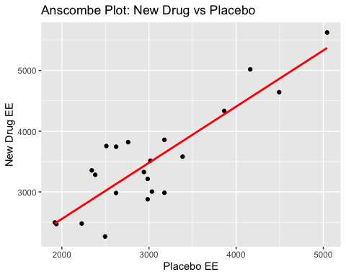
model_contra <- lm(Drug ~ Placebo, data = contra_wide)
summary(model_contra)$coefficients
## Estimate Std. Error t value Pr(>|t|)
## (Intercept) 707.1479475 371.5038022 1.903474 7.147044e-02
## Placebo 0.9243411 0.1197347 7.719907 2.012610e-07
# b) No transformation because the slope is close to 1.
# 6.34
river <- read.csv("RiverIron.csv")
head(river)
## River Site Iron LogIron
## 1 Grasse Upstream 944 2.9750
## 2 Grasse MidStream 525 2.7202
## 3 Grasse DownStream 327 2.5145
## 4 Oswegatchie Upstream 860 2.9345
## 5 Oswegatchie MidStream 229 2.3598
## 6 Oswegatchie DownStream 130 2.1139
river_wide <- river %>%
select(River, Site, Iron) %>%
pivot_wider(
names_from = Site,
values_from = Iron
)
river_wide
## # A tibble: 4 × 4
## River Upstream MidStream DownStream
## <chr> <int> <int> <int>
## 1 Grasse 944 525 327
## 2 Oswegatchie 860 229 130
## 3 Raquette 108 36 30
## 4 St. Regis 751 568 350
ggplot(river_wide, aes(x = MidStream, y = DownStream)) +
geom_point(size = 3) +
geom_smooth(method = "lm", se = FALSE, color = "brown") +
labs(
title = "Iron_DownStream vs Iron_MidStream",
x = "Iron_MidStream",
y = "Iron_DownStream"
)
## `geom_smooth()` using formula = 'y ~ x'
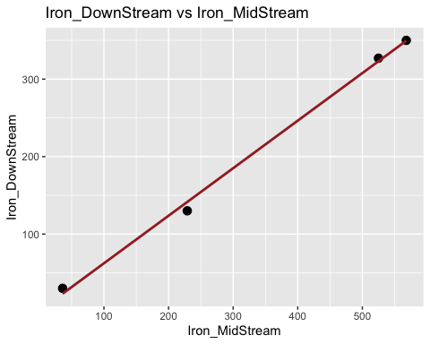
ggplot(river_wide, aes(x = Upstream, y = MidStream)) +
geom_point(size = 3) +
geom_smooth(method = "lm", se = FALSE, color = "brown") +
labs(
title = "Iron_MidStream vs Iron_UpStream",
x = "Iron_UpStream",
y = "Iron_MidStream"
)
## `geom_smooth()` using formula = 'y ~ x'
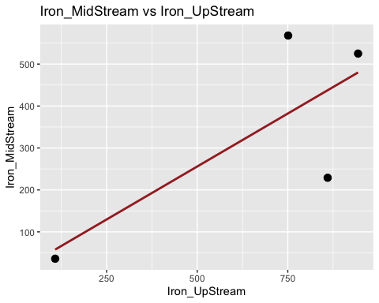
ggplot(river_wide, aes(x = Upstream, y = MidStream)) +
geom_point(size = 3) +
geom_smooth(method = "lm", se = FALSE, color = "brown") +
labs(
title = "Iron_MidStream vs Iron_UpStream",
x = "Iron_UpStream",
y = "Iron_MidStream"
)
## `geom_smooth()` using formula = 'y ~ x'
ggplot(river_wide, aes(x = Upstream, y = DownStream)) +
geom_point(size = 3) +
geom_smooth(method = "lm", se = FALSE, color = "brown") +
labs(
title = "Iron_DownStream vs Iron_UpStream",
x = "Iron_UpStream",
y = "Iron_DownStream"
)
## `geom_smooth()` using formula = 'y ~ x'
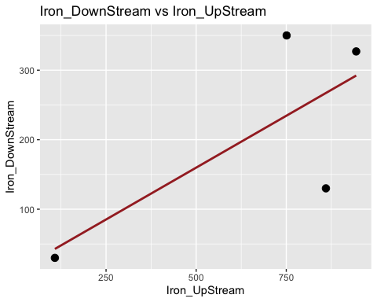
library(broom)
model1 <- lm(DownStream ~ MidStream, data = river_wide)
model2 <- lm(MidStream ~ Upstream, data = river_wide)
model3 <- lm(DownStream ~ Upstream, data = river_wide)
slopes <- c(
slope_Down_vs_Mid = coef(model1)[2],
slope_Mid_vs_Up = coef(model2)[2],
slope_Down_vs_Up = coef(model3)[2]
)
slopes
## slope_Down_vs_Mid.MidStream slope_Mid_vs_Up.Upstream
## 0.6135982 0.5049667
## slope_Down_vs_Up.Upstream
## 0.2983683
# A transformation could be good here because they're all different values than 1.

