Day22
Amrit Singh
2025-12-13
library(tidyverse)
## ── Attaching core tidyverse packages ──────────────────────── tidyverse 2.0.0 ──
## ✔ dplyr 1.1.4 ✔ readr 2.1.5
## ✔ forcats 1.0.0 ✔ stringr 1.5.1
## ✔ ggplot2 3.5.2 ✔ tibble 3.3.0
## ✔ lubridate 1.9.4 ✔ tidyr 1.3.1
## ✔ purrr 1.1.0
## ── Conflicts ────────────────────────────────────────── tidyverse_conflicts() ──
## ✖ dplyr::filter() masks stats::filter()
## ✖ dplyr::lag() masks stats::lag()
## ℹ Use the conflicted package (<http://conflicted.r-lib.org/>) to force all conflicts to become errors
library(car)
## Loading required package: carData
##
## Attaching package: 'car'
##
## The following object is masked from 'package:dplyr':
##
## recode
##
## The following object is masked from 'package:purrr':
##
## some
## 6.36
Alfalfa <- read.csv("Alfalfa.csv")
Alfalfa$Row <- as.factor(Alfalfa$Row)
Alfalfa$Acid <- as.factor(Alfalfa$Acid)
# a)
Alfalfa %>%
group_by(Row) %>%
summarize(mean = mean(Ht4))
## # A tibble: 5 × 2
## Row mean
## <fct> <dbl>
## 1 a 1.16
## 2 b 1.57
## 3 c 1.25
## 4 d 2.26
## 5 e 2.46
Alfalfa %>%
group_by(Acid) %>%
summarize(mean = mean(Ht4))
## # A tibble: 3 × 2
## Acid mean
## <fct> <dbl>
## 1 1.5HCl 1.47
## 2 3.0HCl 1.08
## 3 water 2.67
mean(Alfalfa$Ht4)
## [1] 1.74
sd(Alfalfa$Ht4)
## [1] 1.105396
# b)
model_636 <- aov(Ht4 ~ Acid + Row, data = Alfalfa)
summary(model_636)
## Df Sum Sq Mean Sq F value Pr(>F)
## Acid 2 6.852 3.426 4.513 0.0487 *
## Row 4 4.183 1.046 1.378 0.3235
## Residuals 8 6.072 0.759
## ---
## Signif. codes: 0 '***' 0.001 '**' 0.01 '*' 0.05 '.' 0.1 ' ' 1
# c)
qqPlot(model_636, main = "Normal Q-Q Plot")
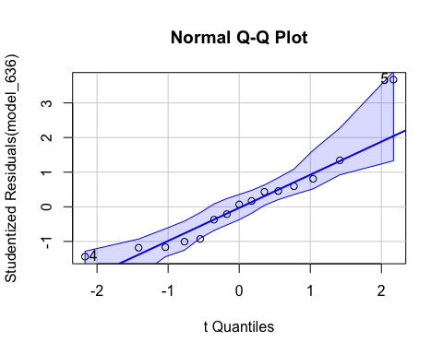
## [1] 4 5
plot(fitted(model_636), resid(model_636),
xlab = "Fitted Value",
ylab = "Residual",
main = "Residuals vs Fitted")
abline(h = 0, lty = 2)
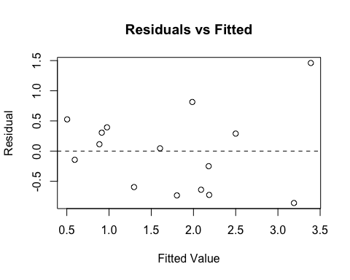
# Normal probability plot shows that normality is reasonable.
# Because the residuals vs. fitted plot displays a fairly even band, equal variance is reasonable.
# d)
# Because the p-value for acid is significant, there is evidence that growth differs by acid treatment.
# e)
# Because the p-value for row is not significant, differences across rows are probably due to randomness.
## 6.37
MSE <- summary(model_636)[[1]]["Residuals","Mean Sq"]
MSE
## [1] 0.759055
df_error <- summary(model_636)[[1]]["Residuals","Df"]
n <- 5
t_star <- qt(0.975, df_error)
ME <- t_star * sqrt(2 * MSE / n)
ME
## [1] 1.270652
means <- Alfalfa %>%
group_by(Acid) %>%
summarize(mean = mean(Ht4))
means
## # A tibble: 3 × 2
## Acid mean
## <fct> <dbl>
## 1 1.5HCl 1.47
## 2 3.0HCl 1.08
## 3 water 2.67
means$mean[1] - means$mean[2]
## [1] 0.382
means$mean[1] - means$mean[3]
## [1] -1.204
means$mean[2] - means$mean[3]
## [1] -1.586
# Only the Water minus 3.0 HCl interval doesn't have 0.
# Therefore, there is a significant difference between Water and 3.0 HCl.
# The others are not significant.
## 6.41
MentalHealth <- read.csv("MentalHealth.csv")
MentalHealth$Month <- as.factor(MentalHealth$Month)
MentalHealth$Moon <- as.factor(MentalHealth$Moon)
ggplot(MentalHealth, aes(x = Moon, y = Admission)) + geom_boxplot() + ggtitle("Admissions by Moon Phase")
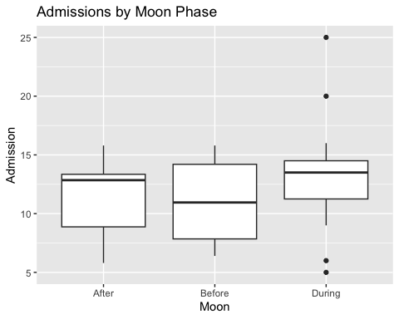
ggplot(MentalHealth, aes(x = Month, y = Admission)) + geom_boxplot() + ggtitle("Admissions by Month")
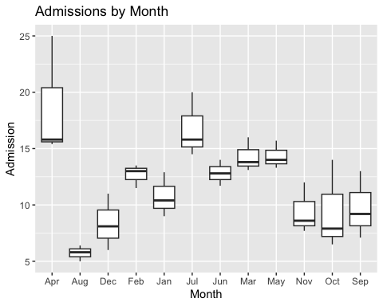
# Possible moon effect --> higher admissions during the full moon.
# Month affects admissions --> higher values in spring/early summer.
model_641 <- aov(Admission ~ Month + Moon, data = MentalHealth)
summary(model_641)
## Df Sum Sq Mean Sq F value Pr(>F)
## Month 11 455.6 41.42 7.129 5.08e-05 ***
## Moon 2 41.5 20.76 3.573 0.0453 *
## Residuals 22 127.8 5.81
## ---
## Signif. codes: 0 '***' 0.001 '**' 0.01 '*' 0.05 '.' 0.1 ' ' 1
qqPlot(model_641, main = "Normal Q-Q Plot")
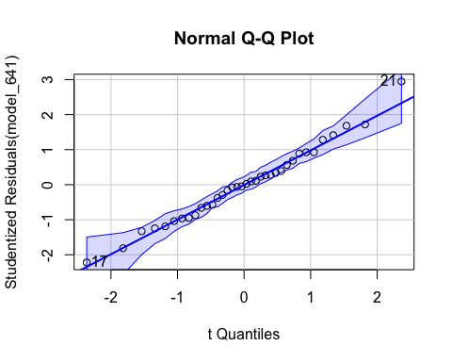
## [1] 17 21
plot(fitted(model_641), resid(model_641),
xlab = "Fitted Value",
ylab = "Residual",
main = "Residuals vs Fitted")
abline(h = 0, lty = 2)
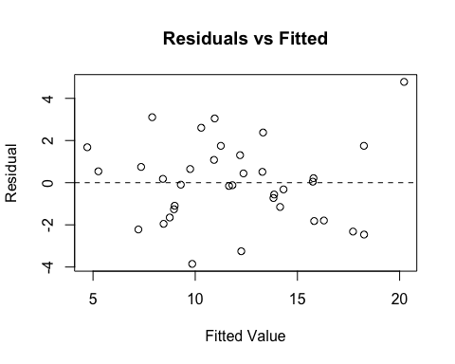
# Normal plot is linear --> residual plot shows no strong pattern.
# Reasonable conditions for ANOVA
# Month and Moon are both significant.
# Month is more significant --> boxplots
# Interaction can't be tested.

