day4part2
Amrit Singh
2025-09-10
library(tidyverse)
## ── Attaching core tidyverse packages ──────────────────────── tidyverse 2.0.0 ──
## ✔ dplyr 1.1.4 ✔ readr 2.1.5
## ✔ forcats 1.0.0 ✔ stringr 1.5.1
## ✔ ggplot2 3.5.2 ✔ tibble 3.3.0
## ✔ lubridate 1.9.4 ✔ tidyr 1.3.1
## ✔ purrr 1.1.0
## ── Conflicts ────────────────────────────────────────── tidyverse_conflicts() ──
## ✖ dplyr::filter() masks stats::filter()
## ✖ dplyr::lag() masks stats::lag()
## ℹ Use the conflicted package (<http://conflicted.r-lib.org/>) to force all conflicts to become errors
library(ggplot2)
library(readr)
# Load data
Caterpillars <- read_csv("Caterpillars.csv")
## Rows: 267 Columns: 18
## ── Column specification ────────────────────────────────────────────────────────
## Delimiter: ","
## chr (3): ActiveFeeding, Fgp, Mgp
## dbl (15): Instar, Mass, LogMass, Intake, LogIntake, WetFrass, LogWetFrass, D...
##
## ℹ Use `spec()` to retrieve the full column specification for this data.
## ℹ Specify the column types or set `show_col_types = FALSE` to quiet this message.
BaseballTimes2017 <- read_csv("BaseballTimes2017.csv")
## Rows: 14 Columns: 7
## ── Column specification ────────────────────────────────────────────────────────
## Delimiter: ","
## chr (2): Game, League
## dbl (5): Runs, Margin, Pitchers, Attendance, Time
##
## ℹ Use `spec()` to retrieve the full column specification for this data.
## ℹ Specify the column types or set `show_col_types = FALSE` to quiet this message.
# Quick peek
head(Caterpillars)
## # A tibble: 6 × 18
## Instar ActiveFeeding Fgp Mgp Mass LogMass Intake LogIntake WetFrass
## <dbl> <chr> <chr> <chr> <dbl> <dbl> <dbl> <dbl> <dbl>
## 1 1 Y Y Y 0.00206 -2.69 0.165 -0.782 0.000241
## 2 1 Y N N 0.00519 -2.28 0.201 -0.697 0.000063
## 3 2 N Y N 0.00560 -2.25 0.189 -0.723 0.00140
## 4 2 Y N N 0.0193 -1.71 0.283 -0.548 0.00204
## 5 2 N Y Y 0.0293 -1.53 0.260 -0.586 0.00538
## 6 3 Y Y N 0.0626 -1.20 0.328 -0.484 0.0295
## # ℹ 9 more variables: LogWetFrass <dbl>, DryFrass <dbl>, LogDryFrass <dbl>,
## # Cassim <dbl>, LogCassim <dbl>, Nfrass <dbl>, LogNfrass <dbl>, Nassim <dbl>,
## # LogNassim <dbl>
head(BaseballTimes2017)
## # A tibble: 6 × 7
## Game League Runs Margin Pitchers Attendance Time
## <chr> <chr> <dbl> <dbl> <dbl> <dbl> <dbl>
## 1 CHC-ARI NL 11 5 10 39131 203
## 2 KCR-CHW AL 9 3 7 18137 169
## 3 MIN-DET AL 13 5 10 29733 201
## 4 SDP-LAD NL 7 1 6 52898 179
## 5 COL-MIA NL 9 3 10 20096 204
## 6 CIN-MIL NL 21 1 10 34517 235
# Remove NAs once up front
caterpillars <- Caterpillars %>% drop_na()
bball <- BaseballTimes2017
# 1.30 Caterpillar N assimilation vs mass
# (a) Nassim vs Mass
ggplot(caterpillars, aes(x = Mass, y = Nassim)) +
geom_point() +
geom_smooth(method = "lm", se = FALSE) +
labs(title = "Nassim vs Mass", x = "Mass", y = "Nassim")
## `geom_smooth()` using formula = 'y ~ x'
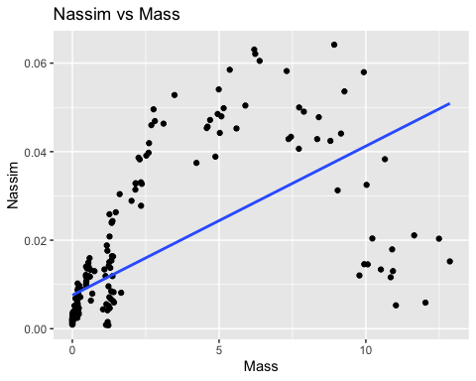
# #There's a clear curve in the data, so a straight-line model wouldn't be a good fit.
# (b) LogNassim vs LogMass
caterpillars <- caterpillars %>%
mutate(LogMass = log10(Mass),
LogNassim = log10(Nassim))
ggplot(caterpillars, aes(x = LogMass, y = LogNassim)) +
geom_point() +
geom_smooth(method = "lm", se = FALSE) +
labs(title = "LogNassim vs LogMass", x = "log10(Mass)", y = "log10(Nassim)")
## `geom_smooth()` using formula = 'y ~ x'
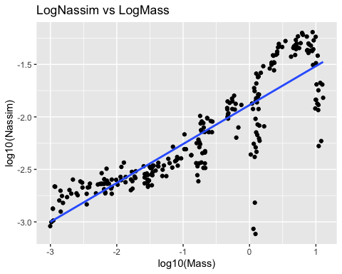
#The relationship is clearly positive, looking much more linear, though there's still a bit of curvature.
# (c) Fit linear model on preferred scale (logs)
m_nassim <- lm(LogNassim ~ LogMass, data = caterpillars)
summary(m_nassim)
##
## Call:
## lm(formula = LogNassim ~ LogMass, data = caterpillars)
##
## Residuals:
## Min 1Q Median 3Q Max
## -1.26089 -0.11558 0.02162 0.16725 0.41862
##
## Coefficients:
## Estimate Std. Error t value Pr(>|t|)
## (Intercept) -1.88738 0.01841 -102.53 <2e-16 ***
## LogMass 0.37096 0.01332 27.85 <2e-16 ***
## ---
## Signif. codes: 0 '***' 0.001 '**' 0.01 '*' 0.05 '.' 0.1 ' ' 1
##
## Residual standard error: 0.2501 on 251 degrees of freedom
## Multiple R-squared: 0.7555, Adjusted R-squared: 0.7545
## F-statistic: 775.6 on 1 and 251 DF, p-value: < 2.2e-16
coef(m_nassim) # Prediction equation on log scale
## (Intercept) LogMass
## -1.8873772 0.3709587
# I’d go with the log model since it follows a straighter pattern overall. - #Predicted LogNassim = -1.89 + 0.371 × LogMass
# (d) Add grouping by Instar to chosen plot
ggplot(caterpillars, aes(x = LogMass, y = LogNassim, color = factor(Instar))) +
geom_point() +
geom_smooth(method = "lm", se = FALSE) +
labs(title = "LogNassim vs LogMass by Instar",
x = "log10(Mass)", y = "log10(Nassim)", color = "Instar")
## `geom_smooth()` using formula = 'y ~ x'
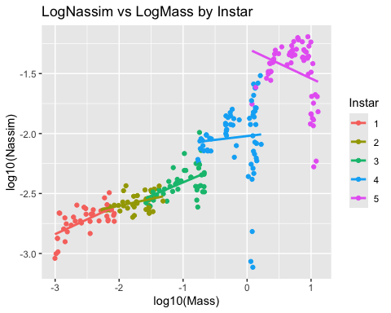
#The first three Instar groups show a pretty clear linear trend, but there’s still some curvature in the 4th and 5th groups.
# (e) Group by Free-growth period (Fgp)
ggplot(caterpillars, aes(x = LogMass, y = LogNassim, color = Fgp)) +
geom_point() +
geom_smooth(method = "lm", se = FALSE) +
labs(title = "LogNassim vs LogMass by Fgp",
x = "log10(Mass)", y = "log10(Nassim)")
## `geom_smooth()` using formula = 'y ~ x'
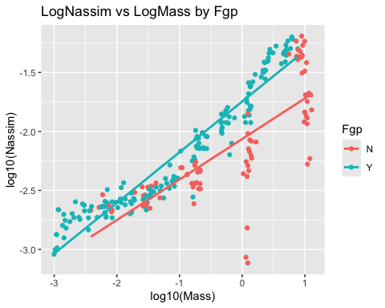
#There definitely seems to be a stronger linear trend when the caterpillars are in a free-growth period.
# 1.32 Mass predicting Intake (reverse roles)
# (a) Intake vs Mass
ggplot(caterpillars, aes(x = Mass, y = Intake)) +
geom_point() +
geom_smooth(method = "lm", se = FALSE) +
labs(title = "Intake vs Mass", x = "Mass", y = "Intake")
## `geom_smooth()` using formula = 'y ~ x'
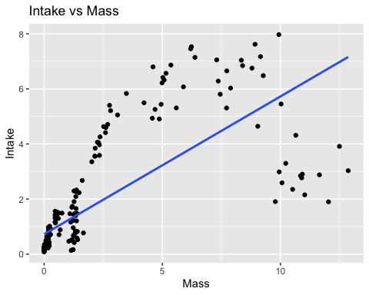
# There's a noticeable curve in the data, so a linear model wouldn’t be a good fit here.
# (b) LogIntake vs LogMass
caterpillars <- caterpillars %>%
mutate(LogIntake = log10(Intake))
ggplot(caterpillars, aes(x = LogMass, y = LogIntake)) +
geom_point() +
geom_smooth(method = "lm", se = FALSE) +
labs(title = "LogIntake vs LogMass", x = "log10(Mass)", y = "log10(Intake)")
## `geom_smooth()` using formula = 'y ~ x'
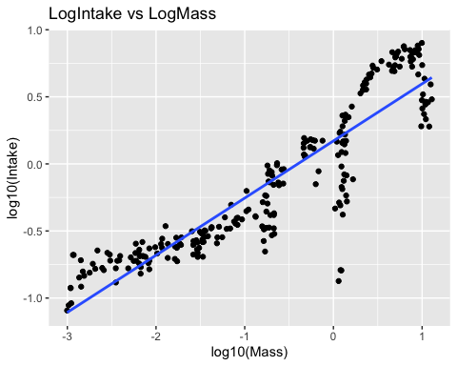
# There’s a strong positive trend with much less curvature, though a slight curve is still present.
# (c) Fit linear model on preferred (log) scale
m_intake <- lm(LogIntake ~ LogMass, data = caterpillars)
summary(m_intake)
##
## Call:
## lm(formula = LogIntake ~ LogMass, data = caterpillars)
##
## Residuals:
## Min 1Q Median 3Q Max
## -1.06945 -0.12480 0.02579 0.16657 0.40080
##
## Coefficients:
## Estimate Std. Error t value Pr(>|t|)
## (Intercept) 0.17120 0.01755 9.752 <2e-16 ***
## LogMass 0.42591 0.01270 33.528 <2e-16 ***
## ---
## Signif. codes: 0 '***' 0.001 '**' 0.01 '*' 0.05 '.' 0.1 ' ' 1
##
## Residual standard error: 0.2386 on 251 degrees of freedom
## Multiple R-squared: 0.8175, Adjusted R-squared: 0.8167
## F-statistic: 1124 on 1 and 251 DF, p-value: < 2.2e-16
coef(m_intake)
## (Intercept) LogMass
## 0.1711959 0.4259131
# I’d go with the second model since it’s a lot less curved and works better for linear regression.
# (d) Add Instar groups
ggplot(caterpillars, aes(x = LogMass, y = LogIntake, color = factor(Instar))) +
geom_point() +
geom_smooth(method = "lm", se = FALSE) +
labs(title = "LogIntake vs LogMass by Instar",
x = "log10(Mass)", y = "log10(Intake)", color = "Instar")
## `geom_smooth()` using formula = 'y ~ x'
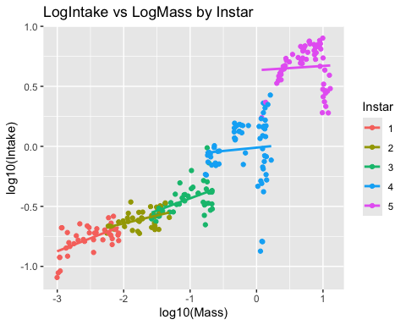
# A linear model works well for the first three groups, but there's noticeable curvature in the last two.
# 1.45 MLB game times (choose/fit/assess)
# (a) Distribution of Time
ggplot(bball, aes(x = Time)) +
geom_histogram(binwidth = 7) +
labs(title = "Histogram of Game Time", x = "Time (minutes)", y = "Count")
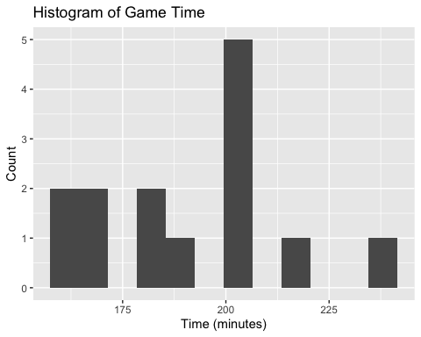
summary(bball$Time)
## Min. 1st Qu. Median Mean 3rd Qu. Max.
## 161.0 171.5 194.5 191.6 203.8 235.0
# The distribution looks roughly symmetric and follows a normal pattern.
# (b) Scatterplots: Time vs predictors
preds <- c("Runs", "Margin", "Pitchers", "Attendance")
for (v in preds) {
print(
ggplot(bball, aes(x = .data[[v]], y = Time)) +
geom_point() +
geom_smooth(method = "lm", se = FALSE) +
labs(title = paste("Time vs", v), x = v, y = "Time (minutes)")
)
}
## `geom_smooth()` using formula = 'y ~ x'
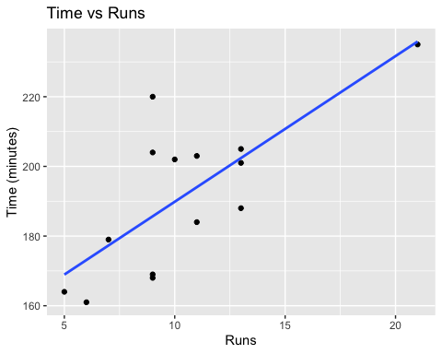
## `geom_smooth()` using formula = 'y ~ x'
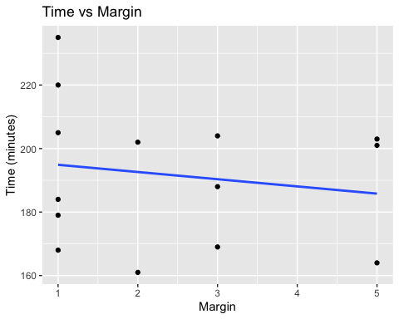
## `geom_smooth()` using formula = 'y ~ x'
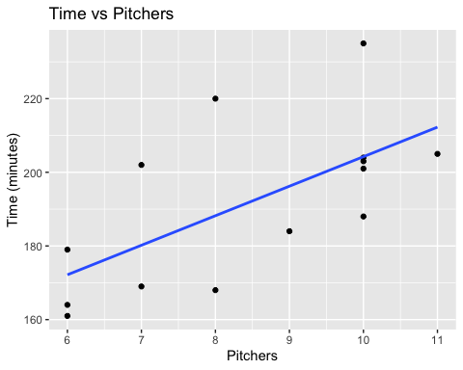
## `geom_smooth()` using formula = 'y ~ x'
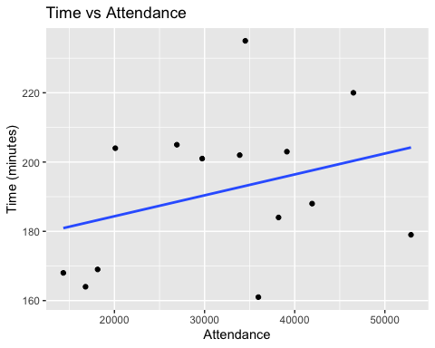
# The strongest linear relationship seems to be between time and runs, followed by time and pitchers.
# (c) Choose best predictor (use Runs) and fit model
mod_time_runs <- lm(Time ~ Runs, data = bball)
summary(mod_time_runs)
##
## Call:
## lm(formula = Time ~ Runs, data = bball)
##
## Residuals:
## Min 1Q Median 3Q Max
## -17.670 -11.604 -1.117 7.378 34.330
##
## Coefficients:
## Estimate Std. Error t value Pr(>|t|)
## (Intercept) 148.043 11.995 12.342 3.53e-08 ***
## Runs 4.181 1.081 3.868 0.00224 **
## ---
## Signif. codes: 0 '***' 0.001 '**' 0.01 '*' 0.05 '.' 0.1 ' ' 1
##
## Residual standard error: 15.34 on 12 degrees of freedom
## Multiple R-squared: 0.5549, Adjusted R-squared: 0.5178
## F-statistic: 14.96 on 1 and 12 DF, p-value: 0.002237
coef(mod_time_runs)
## (Intercept) Runs
## 148.042553 4.180851
# Residual/diagnostic plots
res_df <- tibble(Fitted = fitted(mod_time_runs), Resid = resid(mod_time_runs))
ggplot(res_df, aes(x = Fitted, y = Resid)) +
geom_point() +
geom_hline(yintercept = 0, linetype = 2) +
labs(title = "Residuals vs Fitted (Time ~ Runs)")
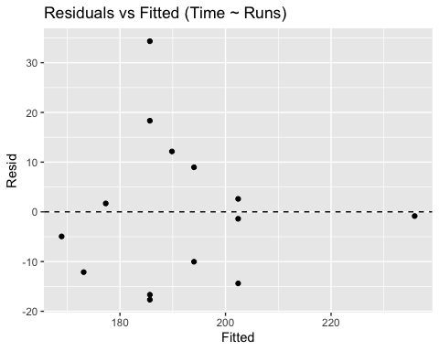
ggplot(tibble(Resid = resid(mod_time_runs)), aes(sample = Resid)) +
stat_qq() + stat_qq_line() +
labs(title = "Q-Q Plot of Residuals")
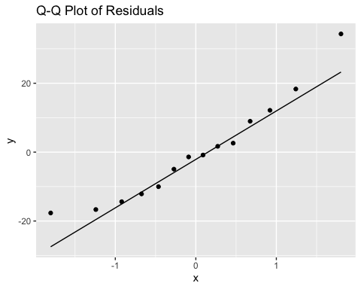
#The equation comes out to Predicted Time = 148 + 4.18 × Runs. This means that for every extra run scored, the game time increases by roughly 4.18 minutes.
# 1.46 Outliers/influential points (CIN–MIL)
# (a) Mark the CIN-MIL point on Time vs Runs
cin_mil <- bball %>% filter(Game == "CIN-MIL")
ggplot(bball, aes(x = Runs, y = Time)) +
geom_point() +
geom_smooth(method = "lm", se = FALSE) +
geom_point(data = cin_mil, color = "red", size = 4) +
geom_text(data = cin_mil, aes(label = Game), vjust = -1) +
labs(title = "Time vs Runs with CIN-MIL highlighted")
## `geom_smooth()` using formula = 'y ~ x'
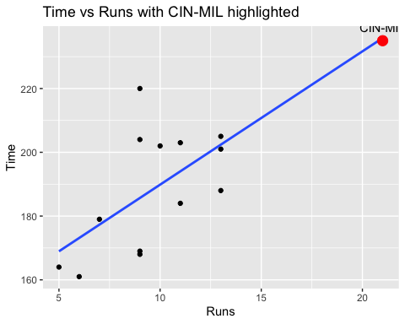
#46A - #This point is distant from the main cluster but aligns with the overall trend, so it likely won’t have a major effect on the regression line.
# (b) Omit CIN-MIL and refit
bball_no_cinmil <- bball %>% filter(Game != "CIN-MIL")
mod_time_runs_no <- lm(Time ~ Runs, data = bball_no_cinmil)
summary(mod_time_runs_no)
##
## Call:
## lm(formula = Time ~ Runs, data = bball_no_cinmil)
##
## Residuals:
## Min 1Q Median 3Q Max
## -17.662 -11.766 -1.858 8.740 34.338
##
## Coefficients:
## Estimate Std. Error t value Pr(>|t|)
## (Intercept) 146.972 17.673 8.316 4.51e-06 ***
## Runs 4.299 1.779 2.416 0.0342 *
## ---
## Signif. codes: 0 '***' 0.001 '**' 0.01 '*' 0.05 '.' 0.1 ' ' 1
##
## Residual standard error: 16.02 on 11 degrees of freedom
## Multiple R-squared: 0.3468, Adjusted R-squared: 0.2874
## F-statistic: 5.839 on 1 and 11 DF, p-value: 0.03422
coef(mod_time_runs_no)
## (Intercept) Runs
## 146.972486 4.298861
#46B - #The updated equation, Time = 146.97 + 4.3 × Runs, is nearly identical to the previous 148 + 4.18 × Runs, indicating that removing the point didn’t significantly affect the model.
# (c) With CIN-MIL removed, check Time vs all other predictors
num_vars <- c("Runs","Margin","Pitchers","Attendance")
for (v in num_vars) {
print(
ggplot(bball_no_cinmil, aes(x = .data[[v]], y = Time)) +
geom_point() +
geom_smooth(method = "lm", se = FALSE) +
labs(title = paste("Time vs", v, "(CIN-MIL removed)"),
x = v, y = "Time (minutes)")
)
}
## `geom_smooth()` using formula = 'y ~ x'
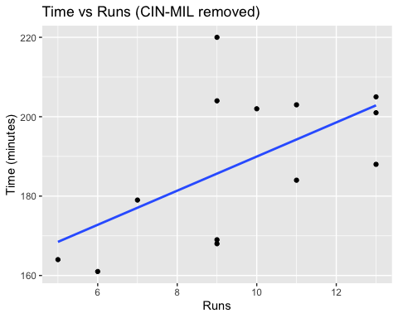
## `geom_smooth()` using formula = 'y ~ x'
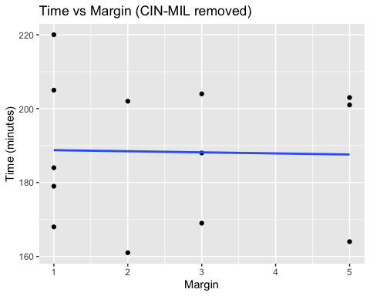
## `geom_smooth()` using formula = 'y ~ x'
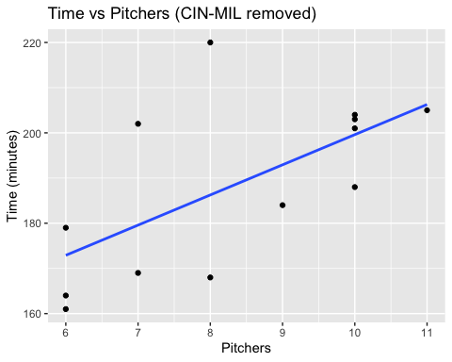
## `geom_smooth()` using formula = 'y ~ x'
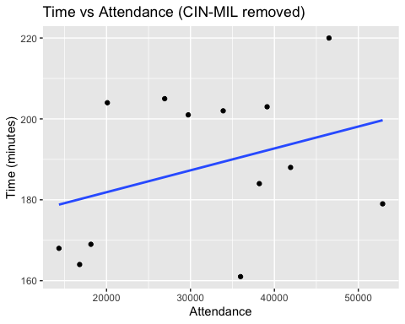
#Time is closely linked to both runs and the number of pitchers. However, after taking out the CIN-MIL game, the relationship between time and runs became less strictly linear, now resembling the weaker linear trend seen between time and pitchers.

