Day5
Amrit Singh
2025-09-15
library(Stat2Data)
library(tidyverse)
## ── Attaching core tidyverse packages ──────────────────────── tidyverse 2.0.0 ──
## ✔ dplyr 1.1.4 ✔ readr 2.1.5
## ✔ forcats 1.0.0 ✔ stringr 1.5.1
## ✔ ggplot2 3.5.2 ✔ tibble 3.3.0
## ✔ lubridate 1.9.4 ✔ tidyr 1.3.1
## ✔ purrr 1.1.0
## ── Conflicts ────────────────────────────────────────── tidyverse_conflicts() ──
## ✖ dplyr::filter() masks stats::filter()
## ✖ dplyr::lag() masks stats::lag()
## ℹ Use the conflicted package (<http://conflicted.r-lib.org/>) to force all conflicts to become errors
library(ggplot2)
library(dplyr)
library(effectsize)
# Chapter 2 exercises Page 77-81: #2, 3, 4, 11 (no code) #13, 15, 17, 19
#2 TRUE
#3 TRUE
#4 FALSE
# The variability due to error can never be smaller than the variation it'll usually be larger
#11a
#B1 = 0
#the test statistic is 15.5/3.4 = 4.56
#with a degree of freedom of 38, we found the p value of 0.00005. This gives us evidence to reject the null hypothesis and conclude that the slope is positive
#11b
#with a 38 d.f. the t critical value for 95% confidence level is 2.024.
#15.5+-6.88 = (8.62,22.38)
#13
BrainpH <- read_csv("BrainpH.csv")
## Rows: 54 Columns: 5
## ── Column specification ────────────────────────────────────────────────────────
## Delimiter: ","
## chr (3): Sex, Ethnicity, DeathType
## dbl (2): pH, Age
##
## ℹ Use `spec()` to retrieve the full column specification for this data.
## ℹ Specify the column types or set `show_col_types = FALSE` to quiet this message.
head(BrainpH)
## # A tibble: 6 × 5
## pH Sex Ethnicity Age DeathType
## <dbl> <chr> <chr> <dbl> <chr>
## 1 7.13 M Caucasian 64 Cardiac
## 2 6.5 M Caucasian 63 Cardiac
## 3 6.4 M AfricanAmerican 59 Cardiac
## 4 6.53 M Caucasian 52 Cardiac
## 5 6.58 M Caucasian 58 Cardiac
## 6 6.63 M Caucasian 78 Other
plot(BrainpH$pH~BrainpH$Age,
main= "scatterplot of relationship between pH and age",
xlab= "Age",
ylab= "pH")
reg = lm(BrainpH$pH~BrainpH$Age)
abline(reg, col = "blue")
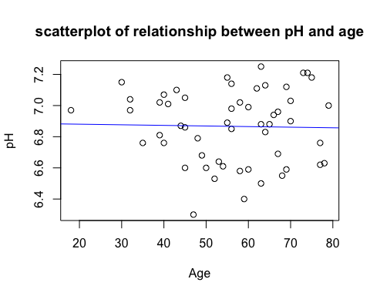
summary(reg)
##
## Call:
## lm(formula = BrainpH$pH ~ BrainpH$Age)
##
## Residuals:
## Min 1Q Median 3Q Max
## -0.56976 -0.21781 0.02032 0.16801 0.38649
##
## Coefficients:
## Estimate Std. Error t value Pr(>|t|)
## (Intercept) 6.8881113 0.1321194 52.13 <2e-16 ***
## BrainpH$Age -0.0003905 0.0022944 -0.17 0.866
## ---
## Signif. codes: 0 '***' 0.001 '**' 0.01 '*' 0.05 '.' 0.1 ' ' 1
##
## Residual standard error: 0.235 on 52 degrees of freedom
## Multiple R-squared: 0.0005566, Adjusted R-squared: -0.01866
## F-statistic: 0.02896 on 1 and 52 DF, p-value: 0.8655
# Because the p-value is big, we fail to reject null that there is no linear relationship between age and pH
#15
Cereal <- read_csv("Cereal.csv")
## Rows: 36 Columns: 4
## ── Column specification ────────────────────────────────────────────────────────
## Delimiter: ","
## chr (1): Cereal
## dbl (3): Calories, Sugar, Fiber
##
## ℹ Use `spec()` to retrieve the full column specification for this data.
## ℹ Specify the column types or set `show_col_types = FALSE` to quiet this message.
plot(Cereal$Calories~Cereal$Sugar)
reg = lm(Cereal$Calories~Cereal$Sugar)
abline(reg, col = "purple4")
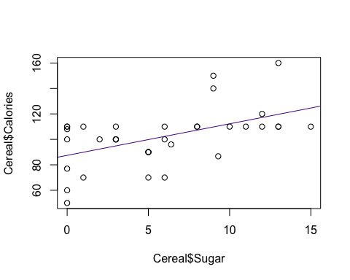
summary(reg)
##
## Call:
## lm(formula = Cereal$Calories ~ Cereal$Sugar)
##
## Residuals:
## Min 1Q Median 3Q Max
## -37.428 -9.832 0.245 8.909 40.322
##
## Coefficients:
## Estimate Std. Error t value Pr(>|t|)
## (Intercept) 87.4277 5.1627 16.935 <2e-16 ***
## Cereal$Sugar 2.4808 0.7074 3.507 0.0013 **
## ---
## Signif. codes: 0 '***' 0.001 '**' 0.01 '*' 0.05 '.' 0.1 ' ' 1
##
## Residual standard error: 19.27 on 34 degrees of freedom
## Multiple R-squared: 0.2656, Adjusted R-squared: 0.244
## F-statistic: 12.3 on 1 and 34 DF, p-value: 0.001296
#p-value is small --> reject null and say that positive relationship exists between calories and sugar
confint(reg, level = 0.95)
## 2.5 % 97.5 %
## (Intercept) 76.935859 97.919521
## Cereal$Sugar 1.043205 3.918421
#95% confident that the true average increase in calories per increase in sugar falls between 1.04 and 3.92
#17
Dementia <- read_csv("LewyDLBad.csv")
## Rows: 20 Columns: 3
## ── Column specification ────────────────────────────────────────────────────────
## Delimiter: ","
## chr (1): group
## dbl (2): APC, MMSE
##
## ℹ Use `spec()` to retrieve the full column specification for this data.
## ℹ Specify the column types or set `show_col_types = FALSE` to quiet this message.
plot(Dementia$MMSE~Dementia$APC)
reg = lm(MMSE~APC, data = Dementia)
abline(reg, col = "green3")
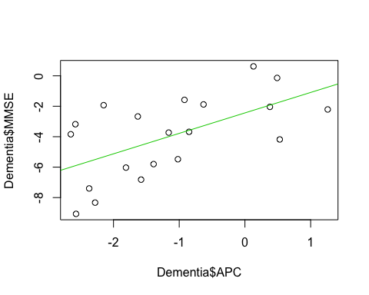
summary(reg)
##
## Call:
## lm(formula = MMSE ~ APC, data = Dementia)
##
## Residuals:
## Min 1Q Median 3Q Max
## -3.1791 -1.6991 -0.1081 1.9911 3.3963
##
## Coefficients:
## Estimate Std. Error t value Pr(>|t|)
## (Intercept) -2.4359 0.6858 -3.552 0.00228 **
## APC 1.3444 0.4225 3.182 0.00516 **
## ---
## Signif. codes: 0 '***' 0.001 '**' 0.01 '*' 0.05 '.' 0.1 ' ' 1
##
## Residual standard error: 2.184 on 18 degrees of freedom
## Multiple R-squared: 0.36, Adjusted R-squared: 0.3245
## F-statistic: 10.13 on 1 and 18 DF, p-value: 0.005161
#r-squared is like 0.36 which is not good --> so not strong correlation
resid <- resid(reg)
plot(fitted(reg), resid)
abline(0,0)
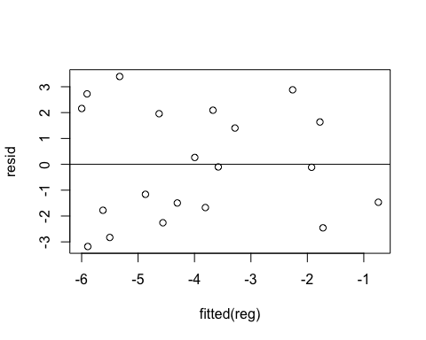
#estimated slope = 1.3444, standard error = 0.4225
confint(reg, level = 0.9)
## 5 % 95 %
## (Intercept) -3.6251781 -1.246683
## APC 0.6117672 2.076951
#Interval does not contain zero, p-value less than 0.1
#19
Rails <- read_csv("RailsTrails.csv")
## Rows: 104 Columns: 30
## ── Column specification ────────────────────────────────────────────────────────
## Delimiter: ","
## chr (6): acregroup, bedgroup, distgroup, garagegroup, sfgroup, streetname
## dbl (24): housenum, acre, adj1998, adj2007, adj2011, bedrooms, bikescore, di...
##
## ℹ Use `spec()` to retrieve the full column specification for this data.
## ℹ Specify the column types or set `show_col_types = FALSE` to quiet this message.
plot(adj2007~distance, data = Rails)
reg = lm(adj2007~distance, data = Rails)
abline(reg, col = "pink3")
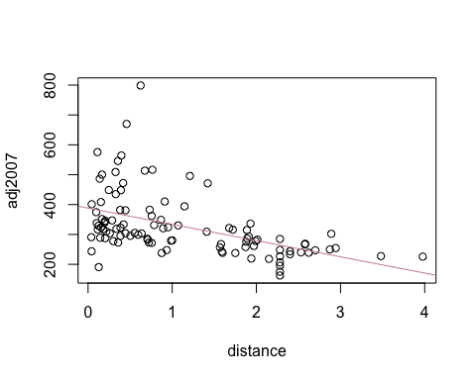
summary(reg)
##
## Call:
## lm(formula = adj2007 ~ distance, data = Rails)
##
## Residuals:
## Min 1Q Median 3Q Max
## -190.55 -58.19 -17.48 25.22 444.41
##
## Coefficients:
## Estimate Std. Error t value Pr(>|t|)
## (Intercept) 388.204 14.052 27.626 < 2e-16 ***
## distance -54.427 9.659 -5.635 1.56e-07 ***
## ---
## Signif. codes: 0 '***' 0.001 '**' 0.01 '*' 0.05 '.' 0.1 ' ' 1
##
## Residual standard error: 92.13 on 102 degrees of freedom
## Multiple R-squared: 0.2374, Adjusted R-squared: 0.2299
## F-statistic: 31.75 on 1 and 102 DF, p-value: 1.562e-07
#r-squared is like 0.237 which is very low so not strong correlation
#adj2007 = 388-54.427(distance)
confint(reg, level = 0.9)
## 5 % 95 %
## (Intercept) 364.87844 411.52913
## distance -70.46056 -38.39384
#90% confident mean price increase is in between 38 and 70 grand
resid <- resid(reg)
plot(fitted(reg), resid)
abline(0,0)
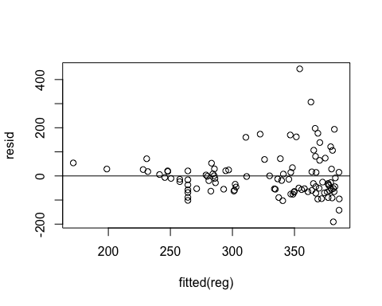
#Lack of constance variance

