Day6Part2
Amrit Singh
2025-09-22
library(tidyverse)
## ── Attaching core tidyverse packages ──────────────────────── tidyverse 2.0.0 ──
## ✔ dplyr 1.1.4 ✔ readr 2.1.5
## ✔ forcats 1.0.0 ✔ stringr 1.5.1
## ✔ ggplot2 3.5.2 ✔ tibble 3.3.0
## ✔ lubridate 1.9.4 ✔ tidyr 1.3.1
## ✔ purrr 1.1.0
## ── Conflicts ────────────────────────────────────────── tidyverse_conflicts() ──
## ✖ dplyr::filter() masks stats::filter()
## ✖ dplyr::lag() masks stats::lag()
## ℹ Use the conflicted package (<http://conflicted.r-lib.org/>) to force all conflicts to become errors
library(readr)
# 2.44
TextPrices <- read_csv("TextPrices.csv")
## Rows: 30 Columns: 2
## ── Column specification ────────────────────────────────────────────────────────
## Delimiter: ","
## dbl (2): Pages, Price
##
## ℹ Use `spec()` to retrieve the full column specification for this data.
## ℹ Specify the column types or set `show_col_types = FALSE` to quiet this message.
model_textbooks <- lm(Price ~ Pages, data = TextPrices)
predict(model_textbooks, newdata = data.frame(Pages = 450),
interval = "confidence", level = 0.95)
## fit lwr upr
## 1 62.87549 51.73074 74.02024
# a. The 95% confidence interval for the mean cost of a 450-page textbook ranges from about $51.73 to $74.02, indicating strong confidence that the true average price of such books lies within this interval.
predict(model_textbooks, newdata = data.frame(Pages = 450),
interval = "prediction", level = 0.95)
## fit lwr upr
## 1 62.87549 0.9035981 124.8474
# b. For an individual 450-page textbook, the 95% prediction interval spans about $0.90 to $124.85, reflecting the larger spread in single prices versus the mean.
# c. Both intervals share the same midpoint (~$62.88), as they center on the regression model’s predicted value.
# d. The prediction interval is noticeably wider than the confidence interval because it incorporates individual price variation, not just uncertainty in the average.
# e. The narrowest prediction interval occurs near the dataset’s mean page count (~464.5), where variation from distance to the average is minimized.
# f. The 95% prediction interval for a 1500-page textbook is about $143.36 to $291.78. But since 1500 pages lies far outside the data’s observed range, this is extrapolation, and the model’s reliability here is questionable.
# 2.47
RailsTrails <- read_csv("RailsTrails.csv")
## Rows: 104 Columns: 30
## ── Column specification ────────────────────────────────────────────────────────
## Delimiter: ","
## chr (6): acregroup, bedgroup, distgroup, garagegroup, sfgroup, streetname
## dbl (24): housenum, acre, adj1998, adj2007, adj2011, bedrooms, bikescore, di...
##
## ℹ Use `spec()` to retrieve the full column specification for this data.
## ℹ Specify the column types or set `show_col_types = FALSE` to quiet this message.
model_rails <- lm(adj2007 ~ distance, data = RailsTrails)
predict(model_rails, newdata = data.frame(distance = 0.5))
## 1
## 360.9902
# a. A house half a mile from the trail is predicted to sell for ~$360,990.
predict(model_rails, newdata = data.frame(distance = 0.5),
interval = "prediction", level = 0.90)
## fit lwr upr
## 1 360.9902 207.0166 514.9638
# b. The 90% prediction interval ranges from about $207,017 to $514,964, indicating that most homes half a mile away are expected to fall within this price bracket.
plot(model_rails, which = 1)
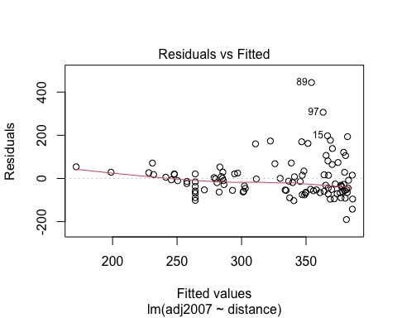
# c. The residual plot shows unequal variance, suggesting the constant variance assumption is violated, which reduces the reliability of the intervals in (a) and (b).
model_log <- lm(log(adj2007) ~ log(distance), data = RailsTrails)
predict(model_log, newdata = data.frame(distance = 0.5),
interval = "prediction", level = 0.90)
## fit lwr upr
## 1 5.784329 5.355955 6.212704
# d. With a log transformation, the 90% prediction interval is (5.36, 6.21) in log-dollars, or roughly $211,866 to $499,049 after conversion. This interval is narrower, meaning the logged model provides more precise predictions.
plot(model_log, which = 1)
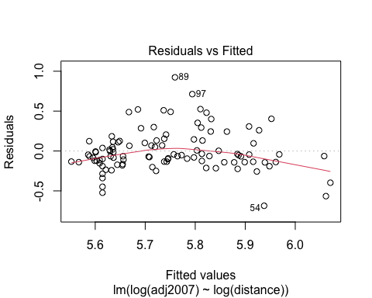
# e. The log-transformed model shows much more stable variance, so assumptions are met better. The interval back on the dollar scale is narrower, reflecting the improved model fit.
# 2.54
BaseballTimes2017 <- read_csv("BaseballTimes2017.csv")
## Rows: 14 Columns: 7
## ── Column specification ────────────────────────────────────────────────────────
## Delimiter: ","
## chr (2): Game, League
## dbl (5): Runs, Margin, Pitchers, Attendance, Time
##
## ℹ Use `spec()` to retrieve the full column specification for this data.
## ℹ Specify the column types or set `show_col_types = FALSE` to quiet this message.
numeric_data <- BaseballTimes2017 %>% select(where(is.numeric))
cor(numeric_data)
## Runs Margin Pitchers Attendance Time
## Runs 1.0000000 -0.17757535 0.72718414 0.12518965 0.7449071
## Margin -0.1775754 1.00000000 0.06525924 -0.28254013 -0.1647079
## Pitchers 0.7271841 0.06525924 1.00000000 -0.02221478 0.6478162
## Attendance 0.1251897 -0.28254013 -0.02221478 1.00000000 0.3187164
## Time 0.7449071 -0.16470790 0.64781618 0.31871640 1.0000000
# a. The predictor with the strongest correlation to game length is Runs (r ≈ 0.745).
model_runs <- lm(Time ~ Runs, data = BaseballTimes2017)
summary(model_runs)
##
## Call:
## lm(formula = Time ~ Runs, data = BaseballTimes2017)
##
## Residuals:
## Min 1Q Median 3Q Max
## -17.670 -11.604 -1.117 7.378 34.330
##
## Coefficients:
## Estimate Std. Error t value Pr(>|t|)
## (Intercept) 148.043 11.995 12.342 3.53e-08 ***
## Runs 4.181 1.081 3.868 0.00224 **
## ---
## Signif. codes: 0 '***' 0.001 '**' 0.01 '*' 0.05 '.' 0.1 ' ' 1
##
## Residual standard error: 15.34 on 12 degrees of freedom
## Multiple R-squared: 0.5549, Adjusted R-squared: 0.5178
## F-statistic: 14.96 on 1 and 12 DF, p-value: 0.002237
# b. The fitted regression model is Time = 148.04 + 4.18 × Runs, meaning each additional run increases average game time by about 4.2 minutes.
# c. With p ≈ 0.002, we reject the null hypothesis, concluding that runs have a significant effect on game duration.
plot(model_runs, which = 1)
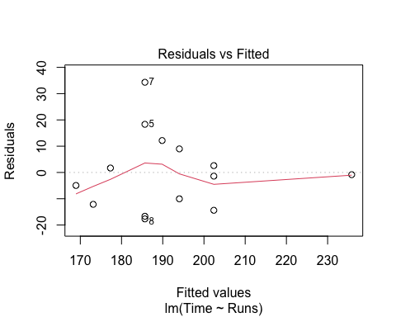
plot(model_runs, which = 2)
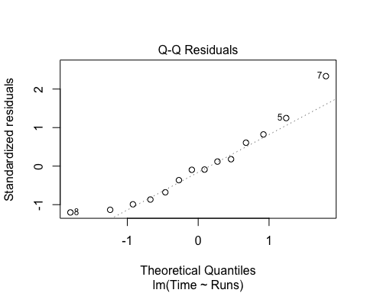
# d. The residuals vs fitted plot shows no major pattern, which is good. The Q–Q plot suggests slight right-skew in the residuals. Despite this imperfection, the small p-value provides strong evidence of a correlation.

