Day8
Amrit Singh
2025-09-30
library(readr)
library(ggplot2)
CountyHealth <- read_csv("CountyHealth.csv")
## Rows: 53 Columns: 4
## ── Column specification ────────────────────────────────────────────────────────
## Delimiter: ","
## chr (1): County
## dbl (3): MDs, Hospitals, Beds
##
## ℹ Use `spec()` to retrieve the full column specification for this data.
## ℹ Specify the column types or set `show_col_types = FALSE` to quiet this message.
FishEggs <- read_csv("FishEggs.csv")
## Rows: 35 Columns: 4
## ── Column specification ────────────────────────────────────────────────────────
## Delimiter: ","
## chr (1): Month
## dbl (3): Age, PctDM, Sept
##
## ℹ Use `spec()` to retrieve the full column specification for this data.
## ℹ Specify the column types or set `show_col_types = FALSE` to quiet this message.
Fluorescence <- read_csv("Fluorescence.csv")
## Rows: 51 Columns: 2
## ── Column specification ────────────────────────────────────────────────────────
## Delimiter: ","
## dbl (2): Calcium, ProteinProp
##
## ℹ Use `spec()` to retrieve the full column specification for this data.
## ℹ Specify the column types or set `show_col_types = FALSE` to quiet this message.
Pollster <- read_csv("Pollster08.csv")
## Rows: 102 Columns: 11
## ── Column specification ────────────────────────────────────────────────────────
## Delimiter: ","
## chr (4): PollTaker, PollDates, MidDate, Pop
## dbl (7): Days, n, McCain, Obama, Margin, Charlie, Meltdown
##
## ℹ Use `spec()` to retrieve the full column specification for this data.
## ℹ Specify the column types or set `show_col_types = FALSE` to quiet this message.
#10:
#a. Negative, since newer cars generally have less mileage.
#b. Negative, because as mileage increases, the car’s value decreases.
#11:
#a. He’d choose a dealership with negative residuals, meaning the predicted value exceeds the listed price, making it a bargain.
#b. Price = b1·Year + b2·Mileage + b0 + error.
#c. Likely negative, since higher year/mileage lowers value, while lower year/mileage raises it.
#13:
#a. Arsenic = b0 + b1·Year + b2·Miles + b3·(Year × Miles) + error.
#b. Lead = b0 + b1·Year + b2·Iclean + b3·(Year × Iclean) + error.
#c. Titanium = b0 + b1·Miles + b2·Miles² + error.
#d. Sulfide = b0 + b1·Year + b2·Miles + b3·Depth + b4·(Year × Miles) + b5·(Year × Depth) + b6·(Miles × Depth) + error.
#15:
#a. 198 – 3 – 1 = 194 degrees of freedom.
#b. 198 – 3 – 1 = 194 degrees of freedom.
#a. 198 – 2 – 1 = 195 degrees of freedom.
#b. 198 – 6 – 1 = 191 degrees of freedom.
# 3.34)
# a)
model1 <- lm(PctDM ~ Age, data = FishEggs)
summary(model1)
##
## Call:
## lm(formula = PctDM ~ Age, data = FishEggs)
##
## Residuals:
## Min 1Q Median 3Q Max
## -2.9091 -0.8471 0.3822 1.0271 2.1409
##
## Coefficients:
## Estimate Std. Error t value Pr(>|t|)
## (Intercept) 38.70206 0.86783 44.596 <2e-16 ***
## Age -0.21033 0.07313 -2.876 0.007 **
## ---
## Signif. codes: 0 '***' 0.001 '**' 0.01 '*' 0.05 '.' 0.1 ' ' 1
##
## Residual standard error: 1.426 on 33 degrees of freedom
## Multiple R-squared: 0.2004, Adjusted R-squared: 0.1762
## F-statistic: 8.272 on 1 and 33 DF, p-value: 0.007001
# LRSL: PctDM = 38.702 - 0.2103Age
# For every one year increase in age, PctDM decreases by 0.2103.
# b)
summary(model1)$r.squared
## [1] 0.2004315
# r^2 = 0.2004 so 20% of variability in the model is explained by the LSRL.
# c)
summary(model1)$coefficients
## Estimate Std. Error t value Pr(>|t|)
## (Intercept) 38.7020617 0.86783471 44.596121 4.503099e-31
## Age -0.2103312 0.07312934 -2.876154 7.001273e-03
# p = 0.007, so there is a significant relationship between age and pctdm.
# d)
residuals_plot <- ggplot(data = FishEggs, aes(x = fitted(model1), y = residuals(model1))) +
geom_point() +
geom_hline(yintercept = 0, linetype = "dashed") +
labs(title = "Residuals vs Fitted Values")
print(residuals_plot)
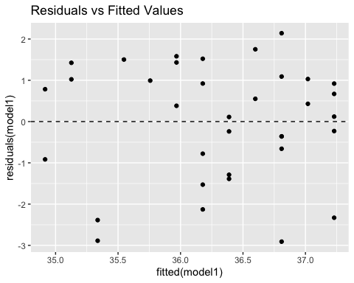
# No patterns in the residual plot.
# e)
residuals_plot2 <- ggplot(data = FishEggs, aes(x = fitted(model1), y = residuals(model1), color = factor(Month), shape = factor(Month))) +
geom_point(size = 3) +
geom_hline(yintercept = 0, linetype = "dashed") +
labs(title = "Residuals vs Fitted Values by Month", color = "Month", shape = "Month") +
scale_color_manual(values = c("blue", "red")) +
scale_shape_manual(values = c(16, 17))
print(residuals_plot2)
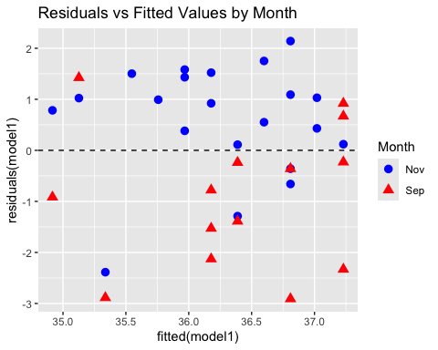
# September seems to have negative residuals while Novemeber seems to have negative residuals.
model2 <- lm(PctDM ~ Age * Month, data = FishEggs)
summary(model2)
##
## Call:
## lm(formula = PctDM ~ Age * Month, data = FishEggs)
##
## Residuals:
## Min 1Q Median 3Q Max
## -2.9559 -0.5576 0.2305 0.7522 2.5029
##
## Coefficients:
## Estimate Std. Error t value Pr(>|t|)
## (Intercept) 39.39733 1.07376 36.691 <2e-16 ***
## Age -0.21821 0.08942 -2.440 0.0206 *
## MonthSep -1.27623 1.51190 -0.844 0.4051
## Age:MonthSep -0.02144 0.12782 -0.168 0.8679
## ---
## Signif. codes: 0 '***' 0.001 '**' 0.01 '*' 0.05 '.' 0.1 ' ' 1
##
## Residual standard error: 1.242 on 31 degrees of freedom
## Multiple R-squared: 0.4303, Adjusted R-squared: 0.3752
## F-statistic: 7.806 on 3 and 31 DF, p-value: 0.000505
# Fitted model is pctdm = 39.40 - 0.218Age - 1.276Sept - 0.0214Age*Sept
# f)
model3 <- lm(PctDM ~ Age + Month, data = FishEggs)
summary(model3)
##
## Call:
## lm(formula = PctDM ~ Age + Month, data = FishEggs)
##
## Residuals:
## Min 1Q Median 3Q Max
## -2.9100 -0.5869 0.2974 0.7599 2.4380
##
## Coefficients:
## Estimate Std. Error t value Pr(>|t|)
## (Intercept) 39.51922 0.77827 50.778 < 2e-16 ***
## Age -0.22870 0.06292 -3.635 0.000965 ***
## MonthSep -1.51929 0.42342 -3.588 0.001096 **
## ---
## Signif. codes: 0 '***' 0.001 '**' 0.01 '*' 0.05 '.' 0.1 ' ' 1
##
## Residual standard error: 1.223 on 32 degrees of freedom
## Multiple R-squared: 0.4298, Adjusted R-squared: 0.3942
## F-statistic: 12.06 on 2 and 32 DF, p-value: 0.0001248
# Both effects are significant in this model
# g)
summary(model3)$r.squared
## [1] 0.4298313
# r^2 = 0.4298, so 42.98% of the variability is explained by the model.
#h)
residuals_plot3 <- ggplot(data = FishEggs, aes(x = fitted(model3), y = residuals(model3), color = factor(Month), shape = factor(Month))) +
geom_point(size = 3) +
geom_hline(yintercept = 0, linetype = "dashed") +
labs(title = "Residuals vs Fitted Values by Month (Updated Model)", color = "Month", shape = "Month") +
scale_color_manual(values = c("blue", "red")) +
scale_shape_manual(values = c(16, 17))
print(residuals_plot3)
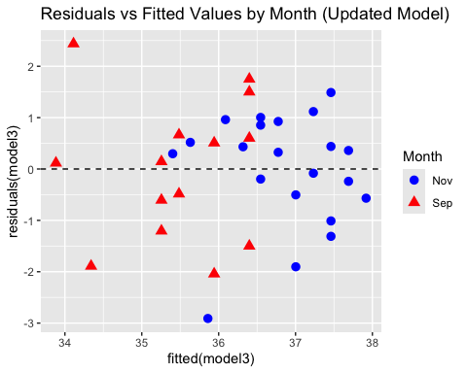
# Now, both months seems to have positive and negative values
# 3.41
# a)
Fluorescence$CalciumSq <- Fluorescence$Calcium^2
model4 <- lm(ProteinProp ~ Calcium + CalciumSq, data = Fluorescence)
summary(model4)
##
## Call:
## lm(formula = ProteinProp ~ Calcium + CalciumSq, data = Fluorescence)
##
## Residuals:
## Min 1Q Median 3Q Max
## -0.19782 -0.05926 -0.01287 0.06304 0.26462
##
## Coefficients:
## Estimate Std. Error t value Pr(>|t|)
## (Intercept) 0.479926 0.317905 1.510 0.13769
## Calcium -0.253189 0.084103 -3.010 0.00415 **
## CalciumSq -0.027788 0.005425 -5.122 5.31e-06 ***
## ---
## Signif. codes: 0 '***' 0.001 '**' 0.01 '*' 0.05 '.' 0.1 ' ' 1
##
## Residual standard error: 0.09738 on 48 degrees of freedom
## Multiple R-squared: 0.8941, Adjusted R-squared: 0.8897
## F-statistic: 202.7 on 2 and 48 DF, p-value: < 2.2e-16
# ProteinProp = 0.479926 - 0.2532Calcium - 0.0278Calcium^2
# b)
scatter_plot1 <- ggplot(data = Fluorescence, aes(x = Calcium, y = ProteinProp)) +
geom_point() +
stat_smooth(method = "lm", formula = y ~ poly(x, 2)) +
labs(title = "Quadratic Regression Curve")
print(scatter_plot1)
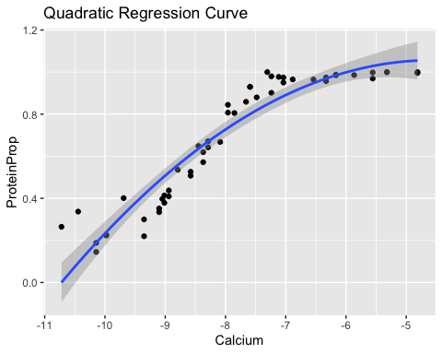
# c)
plot(model4)
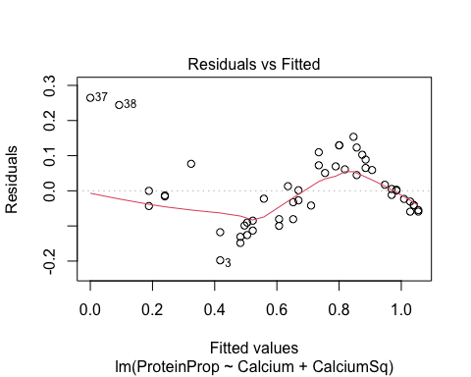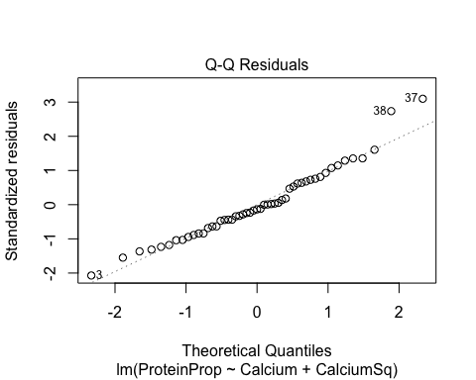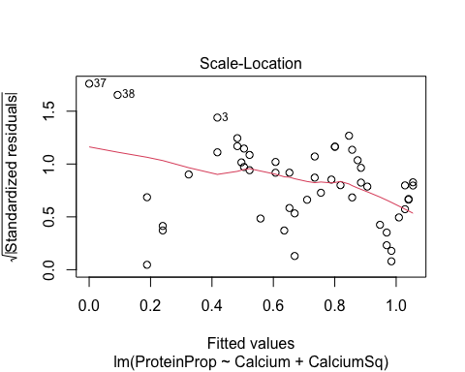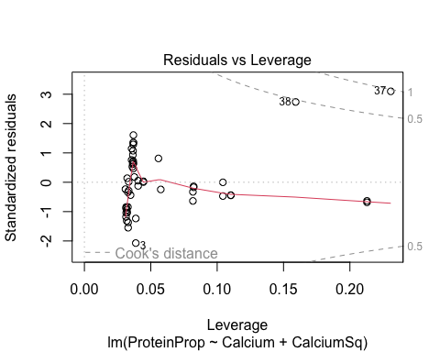
# L - Scatterplot is somewhat linear but shows curvature.
# I - We can assume independence.
# N - QQPlot is linear so normal condition is checked.
# E - There is equal variance in the residual plot
# R - We can assume random
# Z - Residual plot seems to have equal residuals on both sides.
# d)
summary(model4)$coefficients
## Estimate Std. Error t value Pr(>|t|)
## (Intercept) 0.47992559 0.31790509 1.509651 1.376878e-01
## Calcium -0.25318895 0.08410292 -3.010466 4.150025e-03
## CalciumSq -0.02778755 0.00542489 -5.122233 5.309813e-06
# Since the p-value is ~ 0, the Calcium^2 term is significant
# e)
summary(model4)$r.squared
## [1] 0.8941312
# r^2 = 0.8941312, so 89.4% of variation explained by the model.
# 3.42
# a)
Fluorescence$CalciumCube <- Fluorescence$Calcium^3
model5 <- lm(ProteinProp ~ Calcium + CalciumSq + CalciumCube, data = Fluorescence)
summary(model5)
##
## Call:
## lm(formula = ProteinProp ~ Calcium + CalciumSq + CalciumCube,
## data = Fluorescence)
##
## Residuals:
## Min 1Q Median 3Q Max
## -0.14031 -0.05528 -0.01859 0.05267 0.13583
##
## Coefficients:
## Estimate Std. Error t value Pr(>|t|)
## (Intercept) -6.523761 1.088885 -5.991 2.78e-07 ***
## Calcium -3.138442 0.442570 -7.091 5.94e-09 ***
## CalciumSq -0.411335 0.058399 -7.043 7.02e-09 ***
## CalciumCube -0.016515 0.002509 -6.583 3.51e-08 ***
## ---
## Signif. codes: 0 '***' 0.001 '**' 0.01 '*' 0.05 '.' 0.1 ' ' 1
##
## Residual standard error: 0.07099 on 47 degrees of freedom
## Multiple R-squared: 0.9449, Adjusted R-squared: 0.9414
## F-statistic: 268.8 on 3 and 47 DF, p-value: < 2.2e-16
# ProteinProp = -6.52 - 3.14Calcium - 0.411Calcium^2 - 0.0165Calcium^3
# b)
scatter_plot2 <- ggplot(data = Fluorescence, aes(x = Calcium, y = ProteinProp)) +
geom_point() +
stat_smooth(method = "lm", formula = y ~ poly(x, 3)) +
labs(title = "Cubic Regression Curve")
print(scatter_plot2)
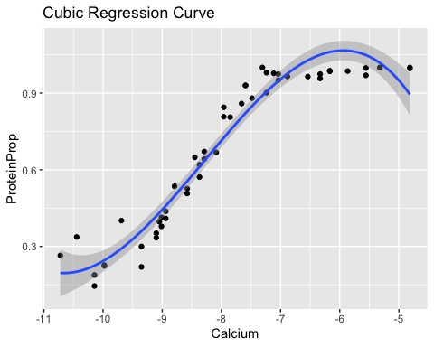
# c)
plot(model5)
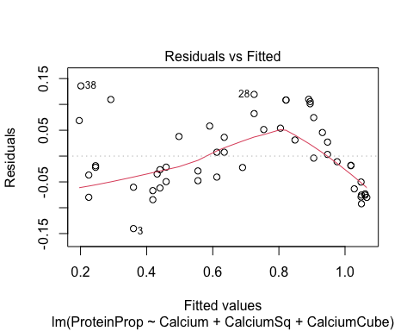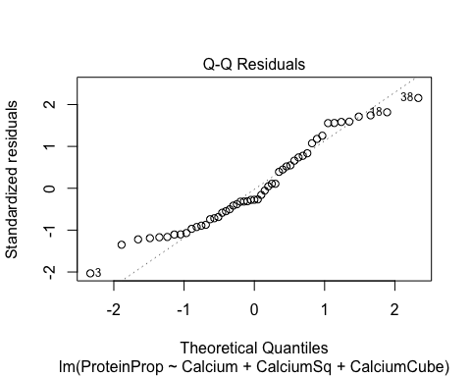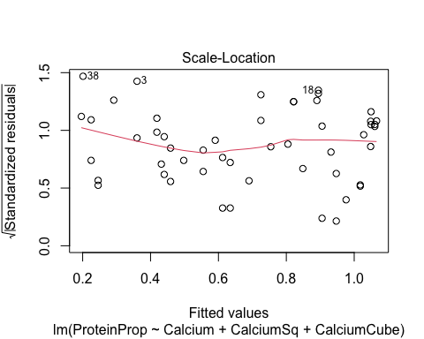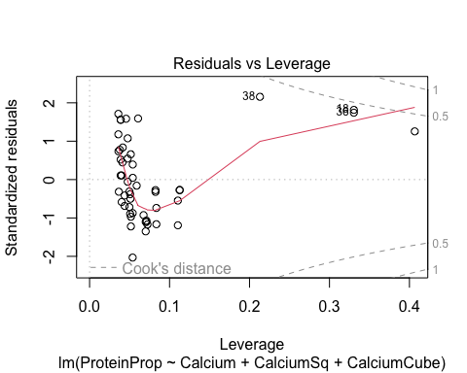
# L - Scatterplot is somewhat linear but shows curvature.
# I - We can assume independence.
# N - QQPlot has some curvature at the start and end so normal condition isn't checked.
# E - There seems to be some patterns in the residual plot.
# R - We can assume random
# Z - Residual plot doesn't seem to be centered at zero.
# d)
summary(model5)$coefficients
## Estimate Std. Error t value Pr(>|t|)
## (Intercept) -6.5237609 1.088884714 -5.991232 2.775151e-07
## Calcium -3.1384417 0.442569618 -7.091408 5.940760e-09
## CalciumSq -0.4113352 0.058399304 -7.043495 7.021984e-09
## CalciumCube -0.0165154 0.002508877 -6.582784 3.514368e-08
# p ~ 0, so the Calcium^3 term is significant
# e)
summary(model5)$r.squared
## [1] 0.9449168
# r^2 = 0.9449168, so 94.49% of the variability is explained by the model
# 3.43
# a)
model6 <- lm(Margin ~ Days + I(Days^2), data = Pollster)
summary(model6)
##
## Call:
## lm(formula = Margin ~ Days + I(Days^2), data = Pollster)
##
## Residuals:
## Min 1Q Median 3Q Max
## -10.7496 -2.0461 -0.1227 1.9297 6.8969
##
## Coefficients:
## Estimate Std. Error t value Pr(>|t|)
## (Intercept) 4.477958 1.095676 4.087 8.89e-05 ***
## Days -0.604426 0.138598 -4.361 3.18e-05 ***
## I(Days^2) 0.021129 0.003776 5.595 1.97e-07 ***
## ---
## Signif. codes: 0 '***' 0.001 '**' 0.01 '*' 0.05 '.' 0.1 ' ' 1
##
## Residual standard error: 3.014 on 99 degrees of freedom
## Multiple R-squared: 0.3495, Adjusted R-squared: 0.3363
## F-statistic: 26.59 on 2 and 99 DF, p-value: 5.711e-10
SSE1 <- sum(residuals(model6)^2)
# Margin = 4.478 - 0.6044Dqys + 0.0211Days^2. r^2 = 0.3495, SSE = 899
# b)
model7 <- lm(Margin ~ Days * Charlie, data = Pollster)
summary(model7)
##
## Call:
## lm(formula = Margin ~ Days * Charlie, data = Pollster)
##
## Residuals:
## Min 1Q Median 3Q Max
## -10.1803 -1.7702 0.1641 1.7862 5.8089
##
## Coefficients:
## Estimate Std. Error t value Pr(>|t|)
## (Intercept) 5.5656 1.0885 5.113 1.57e-06 ***
## Days -0.5984 0.1206 -4.960 2.96e-06 ***
## Charlie -10.1117 1.9251 -5.253 8.74e-07 ***
## Days:Charlie 0.9207 0.1364 6.752 1.04e-09 ***
## ---
## Signif. codes: 0 '***' 0.001 '**' 0.01 '*' 0.05 '.' 0.1 ' ' 1
##
## Residual standard error: 2.868 on 98 degrees of freedom
## Multiple R-squared: 0.417, Adjusted R-squared: 0.3992
## F-statistic: 23.37 on 3 and 98 DF, p-value: 1.712e-11
# c)
model8 <- lm(Margin ~ Days * Meltdown, data = Pollster)
summary(model8)
##
## Call:
## lm(formula = Margin ~ Days * Meltdown, data = Pollster)
##
## Residuals:
## Min 1Q Median 3Q Max
## -11.0863 -1.8292 0.0351 1.6849 6.2133
##
## Coefficients:
## Estimate Std. Error t value Pr(>|t|)
## (Intercept) 3.2725 0.9933 3.295 0.00137 **
## Days -0.2429 0.0863 -2.815 0.00590 **
## Meltdown -8.5701 2.9390 -2.916 0.00439 **
## Days:Meltdown 0.5917 0.1343 4.406 2.7e-05 ***
## ---
## Signif. codes: 0 '***' 0.001 '**' 0.01 '*' 0.05 '.' 0.1 ' ' 1
##
## Residual standard error: 3.088 on 98 degrees of freedom
## Multiple R-squared: 0.3239, Adjusted R-squared: 0.3032
## F-statistic: 15.65 on 3 and 98 DF, p-value: 2.162e-08
SSE3 <- sum(residuals(model8)^2)
# Margin = 3.273 - 0.2429Days - 8.57Meltdown + 0.5917Days*Meltdown. r^2 = 0.324, SSE = 934.
# d)
# The model in part b has the largest r^2 value and the smallest SSE value, so that would be the best
# 3.44)
# a)
CountyHealth$SqrtMDs <- sqrt(CountyHealth$MDs)
cor(CountyHealth[, c("SqrtMDs", "Hospitals", "Beds")])
## SqrtMDs Hospitals Beds
## SqrtMDs 1.0000000 0.9231113 0.9492056
## Hospitals 0.9231113 1.0000000 0.9094098
## Beds 0.9492056 0.9094098 1.0000000
# Beds has a strong correlation with sqrtmds than hospital does so it would be a stronger predictor by itself.
# b)
model9 <- lm(SqrtMDs ~ Hospitals, data = CountyHealth)
summary(model9)$r.squared
## [1] 0.8521344
model10 <- lm(SqrtMDs ~ Beds, data = CountyHealth)
summary(model10)$r.squared
## [1] 0.9009912
# r^2 for hospitals is 0.852 (85.2%), and it is 0.901 (90.1%) for beds. These values say what the portion of the variable of sqrtmds explained by the beds or hospitals is.
# c)
model11 <- lm(SqrtMDs ~ Hospitals + Beds, data = CountyHealth)
summary(model11)$r.squared
## [1] 0.9217304
# r^2 = 0.9217, so 92.17% of variability is explained by the model.
# 3.44d.)
summary(model9)$coefficients
## Estimate Std. Error t value Pr(>|t|)
## (Intercept) -2.753326 1.9849642 -1.387091 1.714465e-01
## Hospitals 6.876364 0.4011006 17.143741 8.146525e-23
summary(model10)$coefficients
## Estimate Std. Error t value Pr(>|t|)
## (Intercept) 8.49311335 1.2241621018 6.937899 6.822168e-09
## Beds 0.01841663 0.0008548731 21.543111 2.867169e-27
# Both p-values ~ 0, so both are significant
# 3.44e.)
summary(model11)$coefficients
## Estimate Std. Error t value Pr(>|t|)
## (Intercept) 3.58080929 1.740615629 2.057209 4.490083e-02
## Hospitals 2.57935412 0.708640665 3.639862 6.462279e-04
## Beds 0.01230699 0.001845742 6.667771 1.986656e-08
# In multiple regression model, both p-values are also ~ 0, so both variables are significant.

