

**SDM College of Engineering and Technology**

**Department of Computer Science & Engineering**

**CTA Activity REPORT**

**On**

**______________________________________**

**Web Technology - 18UCSO707**

**__________________________________________________**

|  |  |  |  |  |
| --- | --- | --- | --- | --- |
| **Activity. No** | **Title** | **Max.**  **Marks** | **Marks**  **Scored** | **Out of 10 M** |
| 1 | Designing of static web pages | 10 |  |  |
| 2 | Implementation of CSS and JavaScript | 10 |  |
| 3 |  | 10 |  |
| 4 | (It is an optional activity, it is applicable only to those who attempt this activity, Others can remove this) | 10 |  |
| 5 |  |  |  |
| **Total Marks** | | 50 |  |

**Note: The total scored mark will be scaled down to 10M.**

**Submitted**

**By**

**Name:** Amrit Kumar Singh,Ankit Kumar **USN:** 2SD20CS014, 2SD20CS017

**VII Semester, `A` Division Academic Year:2023-24**

**Course Teacher**

**Prathap Kumar M.K.**

**Contents**

|  |  |  |
| --- | --- | --- |
| **Sl. No** | **Problem Definition** | **Page No** |
| **1** | **Activity-1: Designing of static web pages** | **3** |
| **2** | **Activity-2 Implementation of CSS and JavaScript** | **9** |

**Activity – 1**

**(Designing of static web pages)**

1. **Problem statement**

**Students face technical & coding related problems all the time. Our proposal is a website where students and teacher can post their problems and give solutions.**

**Development of static web pages for the identified problem statement.**

**Implementation:**

1. Designing of Web page(s) using HTML/XHTML/HTML5.
2. Creation of XML file for the identified problem statement
3. Creation of DTD file for the identified problem statement
4. Creation of XSD file for the identified problem statement

**Solution:**

1. **HTML Source Code**

<!DOCTYPE html>

<html lang="en">

<head>

<meta charset="UTF-8">

<meta name="viewport" content="width=device-width, initial-scale=1.0">

<title>SDMCET QUERY</title>

<link rel="stylesheet" href="styles.css">

</head>

<body>

<header>

<h1>SDMCET QUERY</h1>

<nav>

<ul>

<li><a class="header-item" href="#home">Home</a></li>

<li><a class="header-item" href="#about">About Us</a></li>

<li><a class="header-item" href="#contact">Contact</a></li>

</ul>

</nav>

</header>

<main>

<section class="question-section">

<h2>Ask a Question</h2>

<textarea id="question" placeholder="Ask your question here"></textarea>

<button id="ask-button">Ask</button>

</section>

<section class="question-list">

<h2>Recent Questions</h2>

<ul id="question-list">

<!-- Questions and answers will be dynamically added here -->

<li>

<h3>Question Title</h3>

<p>Question content goes here...</p>

<button class="answer-button">Answer</button>

</li>

<!-- Repeat for more questions -->

</ul>

</section>

</main>

<footer>

<p>&copy; 2023 SDMCET </p>

</footer>

<script src="script.js"></script>

</body>

</html>

1. **XML Source Code.**

<queries xmlns:xsi="http://www.w3.org/2001/XMLSchema-instance"

xsi:noNamespaceSchemaLocation="queries.xsd">

<query>

<description> Question or Problem goes here </description>

<author>Person who posted the query</author>

<date> Posted On </date>

<tags>

<tag>Related Keyword</tag>

<tag>Related Keyword</tag>

<tag>Related Keyword</tag>

<tag>Related Keyword</tag>

</tags>

<answers>

<answer>

<description>Solution Submitted</description>

<author>Posted by</author>

<date>Posted on </date>

</answer>

<answer>

<description>Solution Submitted</description>

<author>Posted by</author>

<date>posted on </date>

</answer>

</answers>

</query>

<query>

<description> Question or Problem goes here </description>

<author>Person who posted the query</author>

<date> Posted On </date>

<tags>

<tag>Related Keyword</tag>

<tag>Related Keyword</tag>

<tag>Related Keyword</tag>

<tag>Related Keyword</tag>

</tags>

<answers>

<answer>

<description>Solution Submitted</description>

<author>Posted by</author>

<date>posted on </date>

</answer>

<answer>

<description>SOluton Submitted</description>

<author>POsted by</author>

<date>posted on </date>

</answer>

</answers>

</query>

</queries>

1. **DTD Source Code**

<!ELEMENT queries (query+)>

<!ELEMENT query (description,author,date,tags,answers)>

<!ELEMENT description (#PCDATA)>

<!ELEMENT author (#PCDATA)>

<!ELEMENT date (#PCDATA)>

<!ELEMENT tags (tag+)>

<!ELEMENT tag (#PCDATA)>

<!ELEMENT answers (answer+)>

<!ELEMENT answer (description,author,date)>

1. **XSD Source Code**

<?xml version="1.0" encoding="UTF-8"?>

<xs:schema xmlns:xs="http://www.w3.org/2001/XMLSchema">

<xs:element name="queries">

<xs:complexType>

<xs:sequence>

<xs:element name="query" maxOccurs="unbounded">

<xs:complexType>

<xs:sequence>

<xs:element name="description" type="xs:string" />

<xs:element name="author" type="xs:string" />

<xs:element name="date" type="xs:string" />

<xs:element name="tags">

<xs:complexType>

<xs:sequence>

<xs:element name="tag" maxOccurs="unbounded"

type="xs:string" />

</xs:sequence>

</xs:complexType>

</xs:element>

<xs:element name="answers">

<xs:complexType>

<xs:sequence>

<xs:element name="answer" maxOccurs="unbounded">

<xs:complexType>

<xs:sequence>

<xs:element name="description" type="xs:string" />

<xs:element name="author" type="xs:string" />

<xs:element name="date" type="xs:string" />

</xs:sequence>

</xs:complexType>

</xs:element>

</xs:sequence>

</xs:complexType>

</xs:element>

</xs:sequence>

</xs:complexType>

</xs:element>

</xs:sequence>

</xs:complexType>

</xs:element>

</xs:schema>

**Results:**

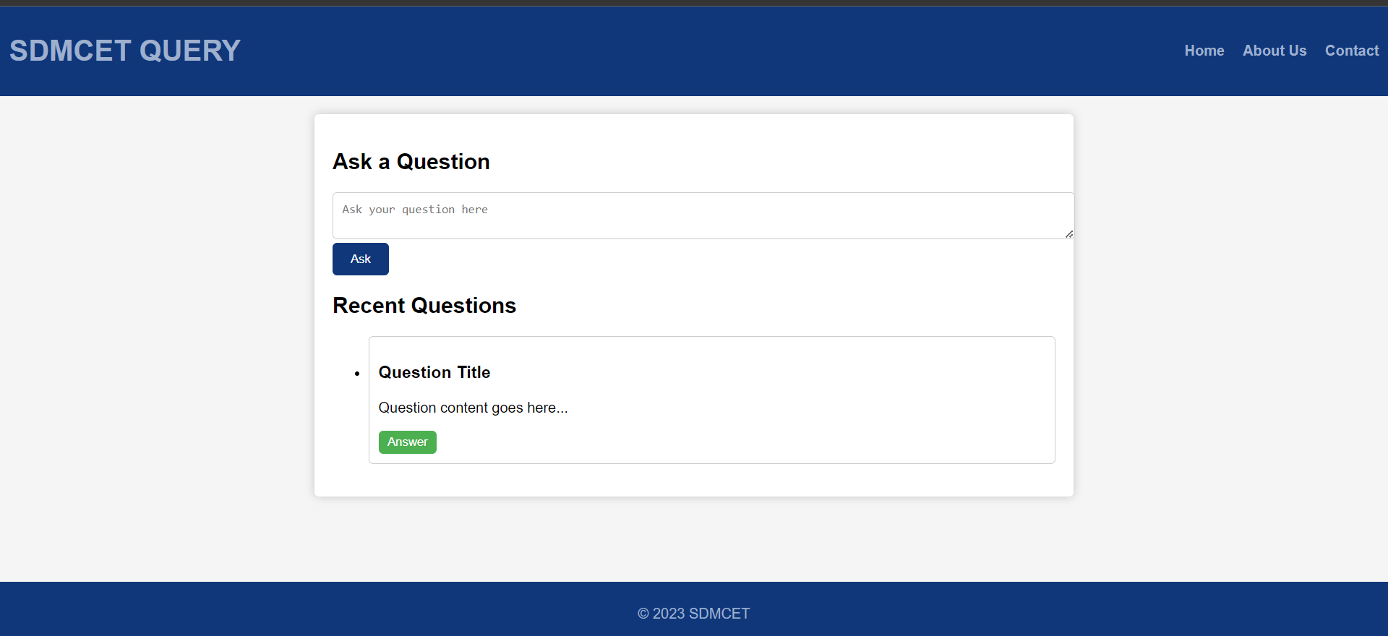

**Activity-2**

**(Implementation of CSS & JavaScript)**

1. **Problem statement**

**Integration of CSS and JavaScript to activity-1**

**Solution:**

**Index.html**

<!DOCTYPE html>

<html lang="en">

<head>

<meta charset="UTF-8">

<meta name="viewport" content="width=device-width, initial-scale=1.0">

<title>SDMCET QUERY</title>

<link rel="stylesheet" href="styles.css">

</head>

<body>

<header>

<h1>SDMCET QUERY</h1>

<nav>

<ul>

<li><a class="header-item" href="home.html">Home</a></li>

<li><a class="header-item" href="aboutUs.html">About Us</a></li>

<li><a class="header-item" href="contactUs.html">Contact</a></li>

</ul>

</nav>

</header>

<main>

<section class="question-section">

<h2>Ask a Question</h2>

<textarea id="question" placeholder="Ask your question here"></textarea>

<button id="ask-button">Ask</button>

</section>

<section class="question-list">

<h2>Recent Questions</h2>

<ul id="question-list">

<!-- Questions and answers will be dynamically added here -->

<li>

<h3>Question Title</h3>

<p>Question content goes here...</p>

<button class="answer-button">Answer</button>

</li>

<!-- Repeat for more questions -->

</ul>

</section>

</main>

<footer>

<p>&copy; 2023 SDMCET </p>

</footer>

<script src="app.js"></script>

</body>

</html>

**Home.html**

<!DOCTYPE html>

<html lang="en">

<head>

<meta charset="UTF-8">

<meta name="viewport" content="width=device-width, initial-scale=1.0">

<title>SDMCET QUERY</title>

<link rel="stylesheet" href="styles.css">

</head>

<body>

<header>

<h1>Welcome to SDMCET QUERY</h1>

<nav>

<ul>

<li><a class="header-item" href="home.html">Home</a></li>

<li><a class="header-item" href="aboutUs.html">About Us</a></li>

<li><a class="header-item" href="contactUs.html">Contact</a></li>

</ul>

</nav>

</header>

<main>

<section id="home">

<h2>Welcome</h2>

<p>Welcome to SDMCET QUERY, a platform where you can ask questions and get answers from the SDMCET community. Feel free to ask any questions or browse through the recent questions asked by others.</p>

<a href="index.html">Ask a Question</a>

</section>

<!-- Rest of your code -->

</main>

<footer>

<p>&copy; 2023 SDMCET </p>

</footer>

<script src="app.js"></script>

</body>

</html>

**AboutUs.html**

<!DOCTYPE html>

<html lang="en">

<head>

<meta charset="UTF-8">

<meta name="viewport" content="width=device-width, initial-scale=1.0">

<title>About - SDMCET QUERY</title>

<link rel="stylesheet" href="styles.css">

</head>

<body>

<header>

<h1>About SDMCET QUERY</h1>

<nav>

<ul>

<li><a class="header-item" href="home.html">Home</a></li>

<li><a class="header-item" href="about.html">About Us</a></li>

<li><a class="header-item" href="contactUs.html">Contact</a></li>

</ul>

</nav>

</header>

<main>

<section id="about">

<h2>About Us</h2>

<p>SDMCET QUERY is a platform created for the SDMCET community to ask questions and get answers. Our mission is to foster a collaborative learning environment where everyone can share their knowledge and learn from others.</p>

<p>We believe that everyone has something valuable to contribute, and we encourage all members of the SDMCET community to participate. Whether you have a question about coursework, campus life, or anything else related to SDMCET, don't hesitate to ask!</p>

</section>

</main>

<footer>

<p>&copy; 2023 SDMCET </p>

</footer>

<script src="app.js"></script>

</body>

</html>

**App.js**

document.getElementById('ask-button').addEventListener('click', function() {

var question = document.getElementById('question').value;

if (question.trim() !== '') {

var questionList = document.getElementById('question-list');

var newQuestion = document.createElement('li');

newQuestion.innerHTML = `

<h3>${question}</h3>

<button class="answer-button">Answer</button>

`;

questionList.prepend(newQuestion);

document.getElementById('question').value = '';

} else {

alert('Please enter a question');

}

});

document.getElementById('question-list').addEventListener('click', function(e) {

if (e.target && e.target.nodeName == 'BUTTON' && e.target.className == 'answer-button') {

var answer = prompt('Please enter your answer');

if (answer.trim() !== '') {

var answerParagraph = document.createElement('p');

answerParagraph.textContent = answer;

e.target.parentElement.appendChild(answerParagraph);

e.target.remove();

} else {

alert('Please enter an answer');

}

}

});

**Style.css**

body {

font-family: Arial, sans-serif;

margin: 0;

padding: 0;

background-color: #f5f5f5;

}

header {

display: flex;

justify-content: space-between;

align-items: center;

background-color: #10377A;

color: #fff;

padding: 10px;

}

h1 {

color: #9FAFCE;

}

.header-item {

color: #9FAFCE;

}

nav ul {

list-style-type: none;

padding: 0;

display: flex;

justify-content: flex-end; /* Align the navigation to the right */

}

nav ul li a {

margin-left: 20px;

}

nav ul li:first-child {

margin-left: 0; /* Remove margin from the first list item */

}

nav ul li a {

text-decoration: none;

color: #fff;

font-weight: bold;

}

main {

max-width: 800px;

margin: 20px auto;

padding: 20px;

background-color: #fff;

border-radius: 5px;

box-shadow: 0 0 10px rgba(0, 0, 0, 0.2);

}

.question-section {

margin-bottom: 20px;

}

textarea {

width: 100%;

padding: 10px;

border: 1px solid #ccc;

border-radius: 5px;

}

button {

padding: 10px 20px;

background-color: #10377A;

color: #fff;

border: none;

border-radius: 5px;

cursor: pointer;

}

.question-list {

list-style: none;

}

.question-list li {

border: 1px solid #ccc;

border-radius: 5px;

padding: 10px;

margin-bottom: 10px;

background-color: #fff;

}

.answer-button {

background-color: #4caf50;

color: #fff;

border: none;

border-radius: 5px;

cursor: pointer;

padding: 5px 10px;

}

footer {

background-color: #10377A;

color: #9FAFCE;

text-align: center;

padding: 10px 0;

position: absolute;

bottom: 0;

width: 100%;

}

.contact-container {

display: flex;

justify-content: space-between;

}

.contact-container section {

width: 45%; /* Adjust as needed */

}

**Results:**

