<?xml version="1.0" encoding="utf-8"?>

<!-- Main application to demonstrate TitleWindow layout container. -->

<mx:Application xmlns:mx="http://www.adobe.com/2006/mxml">

<mx:Script>

<![CDATA[

import mx.managers.PopUpManager;

import mx.containers.TitleWindow;

import flash.geom.Point;

private var point1:Point = new Point();

// Open the TitleWindow container.

// Cast the return value of the createPopUp() method

// to SimpleTitleWindowExample, the name of the

// component containing the TitleWindow container.

private function showWindow():void {

var login:SimpleTitleWindowExample=SimpleTitleWindowExample(PopUpManager.createPopUp( this, SimpleTitleWindowExample , true));

// Calculate position of TitleWindow in Application's coordinates.

// Position it 25 pixels down and to the right of the Button control.

point1.x=0;

point1.y=0;

point1=myButton.localToGlobal(point1);

login.x=point1.x+25;

login.y=point1.y+25;

// Pass a reference to the TextInput control

// to the TitleWindow container so that the

// TitleWindow container can return data to the main application.

login.loginName=returnedName;

}

]]>

</mx:Script>

<mx:Panel title="TitleWindow Container Example" height="75%" width="75%"

paddingTop="10" paddingLeft="10" paddingRight="10" paddingBottom="10">

<mx:Button id="myButton" label="Click to open the TitleWindow container"

click="showWindow();"/>

<mx:Text id="returnedName" text="" width="100%"/>

</mx:Panel>

</mx:Application>

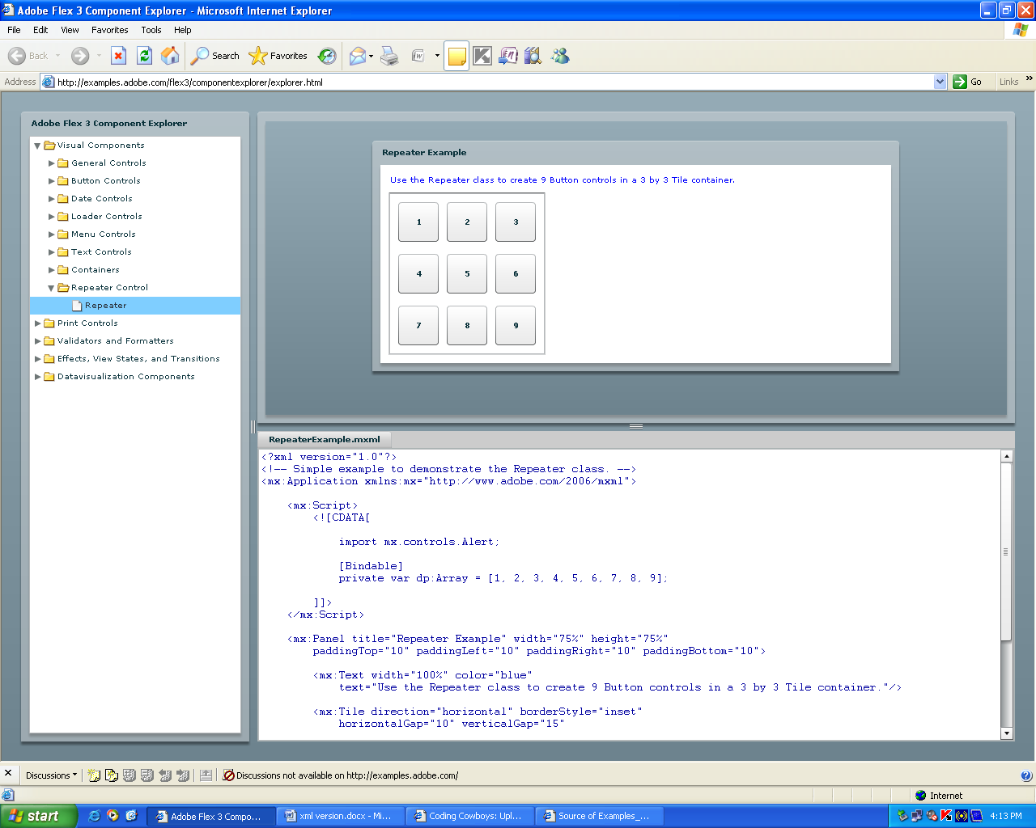

<?xml version="1.0"?>

<!-- Simple example to demonstrate the Repeater class. -->

<mx:Application xmlns:mx="http://www.adobe.com/2006/mxml">

<mx:Script>

<![CDATA[

import mx.controls.Alert;

[Bindable]

private var dp:Array = [1, 2, 3, 4, 5, 6, 7, 8, 9];

]]>

</mx:Script>

<mx:Panel title="Repeater Example" width="75%" height="75%"

paddingTop="10" paddingLeft="10" paddingRight="10" paddingBottom="10">

<mx:Text width="100%" color="blue"

text="Use the Repeater class to create 9 Button controls in a 3 by 3 Tile container."/>

<mx:Tile direction="horizontal" borderStyle="inset"

horizontalGap="10" verticalGap="15"

paddingLeft="10" paddingTop="10" paddingBottom="10" paddingRight="10">

<mx:Repeater id="rp" dataProvider="{dp}">

<mx:Button height="49" width="50"

label="{String(rp.currentItem)}"

click="Alert.show(String(event.currentTarget.getRepeaterItem()) + ' pressed')"/>

</mx:Repeater>

</mx:Tile>

</mx:Panel>

</mx:Application>

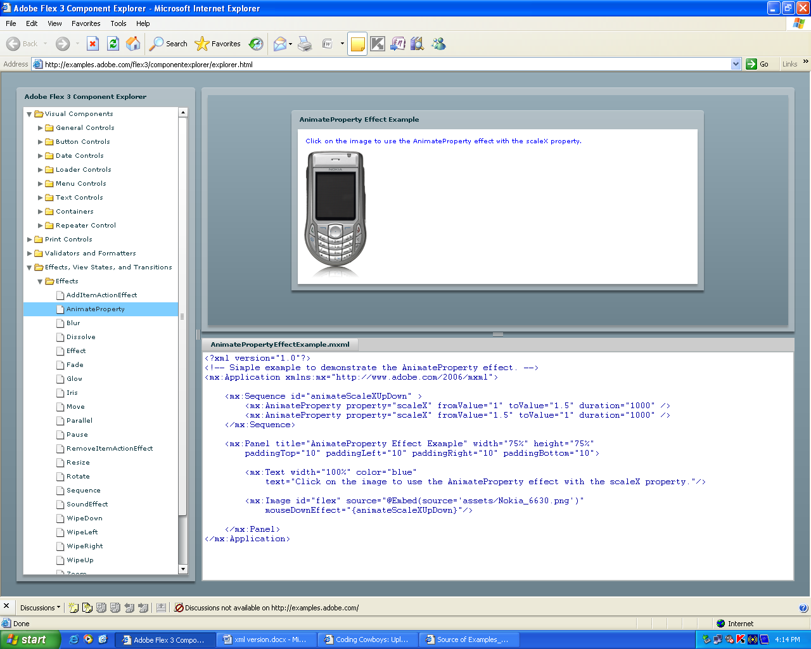

<?xml version="1.0"?>

<!-- Simple example to demonstrate the AnimateProperty effect. -->

<mx:Application xmlns:mx="http://www.adobe.com/2006/mxml">

<mx:Sequence id="animateScaleXUpDown" >

<mx:AnimateProperty property="scaleX" fromValue="1" toValue="1.5" duration="1000" />

<mx:AnimateProperty property="scaleX" fromValue="1.5" toValue="1" duration="1000" />

</mx:Sequence>

<mx:Panel title="AnimateProperty Effect Example" width="75%" height="75%"

paddingTop="10" paddingLeft="10" paddingRight="10" paddingBottom="10">

<mx:Text width="100%" color="blue"

text="Click on the image to use the AnimateProperty effect with the scaleX property."/>

<mx:Image id="flex" source="@Embed(source='assets/Nokia_6630.png')"

mouseDownEffect="{animateScaleXUpDown}"/>

</mx:Panel>

</mx:Application>

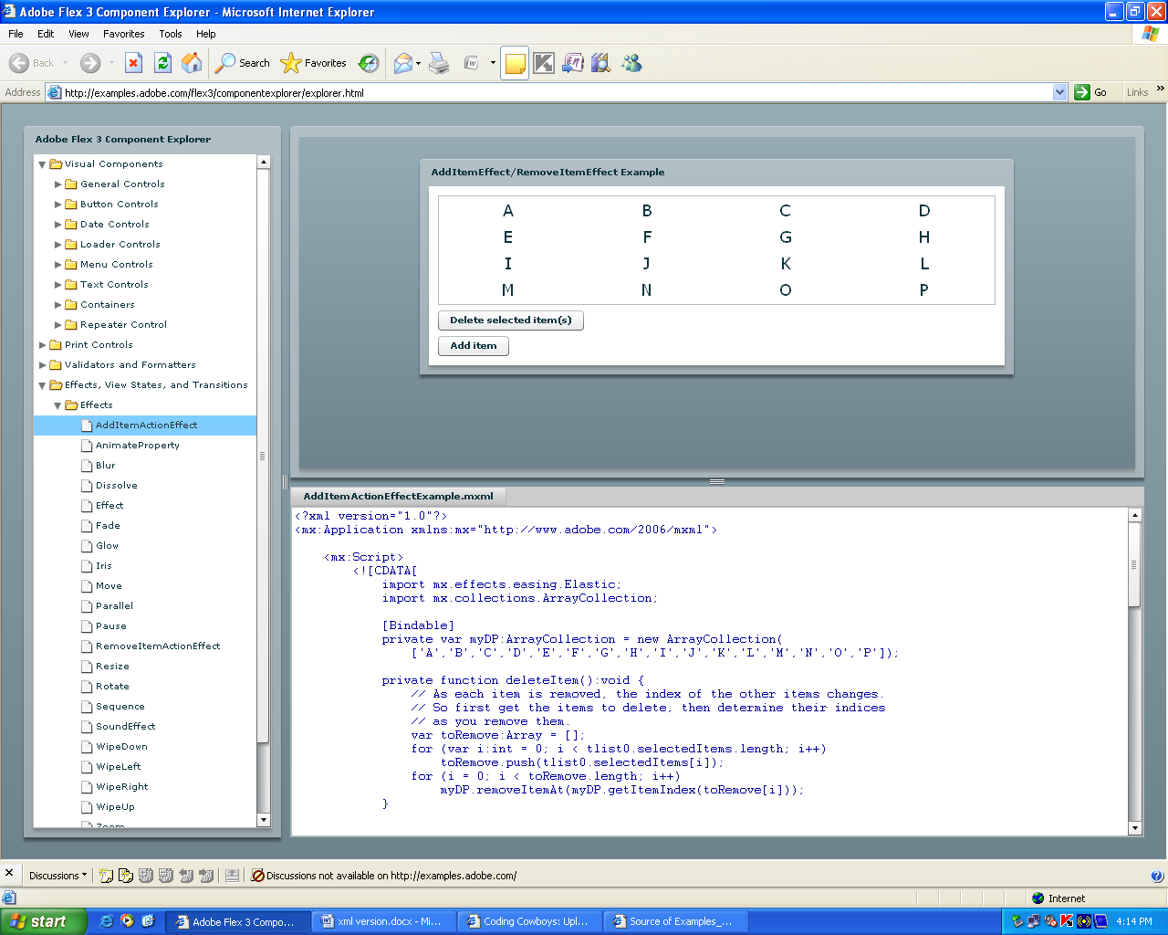

<?xml version="1.0"?>

<mx:Application xmlns:mx="http://www.adobe.com/2006/mxml">

<mx:Script>

<![CDATA[

import mx.effects.easing.Elastic;

import mx.collections.ArrayCollection;

[Bindable]