PS-4
Amrita Nath
2026-02-19
Consider the Credit data in the ISLR library. Choose balance as the response and Age, Limit and Rating as the predictors.
library(ISLR)
library(car)
## Loading required package: carData
library(stargazer)
##
## Please cite as:
## Hlavac, Marek (2022). stargazer: Well-Formatted Regression and Summary Statistics Tables.
## R package version 5.2.3. https://CRAN.R-project.org/package=stargazer
attach(Credit)
df=Credit[,c(3,4,6,12)]
head(df)
## Limit Rating Age Balance
## 1 3606 283 34 333
## 2 6645 483 82 903
## 3 7075 514 71 580
## 4 9504 681 36 964
## 5 4897 357 68 331
## 6 8047 569 77 1151
- Make a scatter plot of (i) Age versus Limit and (ii) Rating Versus Limit. Comment on the scatter plot
par(mfrow=c(1,2))
plot(Limit,Rating,main="Scatterplot of Rating vs Limit")
plot(Limit,Age,main="Scatterplot of Age vs Limit")
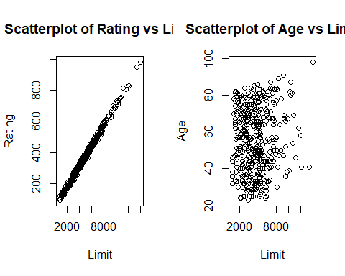 Interpretation
From the scatterplot ,we observe that there is a positive strong positive linear correlation between Rating and Limit.This suggests that including both variables in a regression model may cause severe multicollinearity.
From the scatterplot, there seems to be no linear relationship between Limit and Age.
- Run three separate regressions: (i) Balance on Age and Limit (ii) Balance on Age, Rating and Limit (iii) Balance on Rating and Limit. Present all the regression output in a single table using stargazer. What is the marked differ ence that you can observe from the output
fit1=lm(Balance~Age+Limit)
fit2=lm(Balance~Rating+Age+Limit)
fit3=lm(Balance~Rating+Limit)
library(stargazer)
stargazer(fit1,fit2,fit3,type="text",out="f2.txt")
##
## ==============================================================================================
## Dependent variable:
## --------------------------------------------------------------------------
## Balance
## (1) (2) (3)
## ----------------------------------------------------------------------------------------------
## Rating 2.310** 2.202**
## (0.940) (0.952)
##
## Age -2.291*** -2.346***
## (0.672) (0.669)
##
## Limit 0.173*** 0.019 0.025
## (0.005) (0.063) (0.064)
##
## Constant -173.411*** -259.518*** -377.537***
## (43.828) (55.882) (45.254)
##
## ----------------------------------------------------------------------------------------------
## Observations 400 400 400
## R2 0.750 0.754 0.746
## Adjusted R2 0.749 0.752 0.745
## Residual Std. Error 230.532 (df = 397) 229.080 (df = 396) 232.320 (df = 397)
## F Statistic 594.988*** (df = 2; 397) 403.718*** (df = 3; 396) 582.820*** (df = 2; 397)
## ==============================================================================================
## Note: *p<0.1; **p<0.05; ***p<0.01
Interpretation
• In model (1), Limit is highly significant (0.173***).
• In model (2), when Rating is added, Limit becomes statistically insignificant (0.019, not significant).
• In model (3), Limit remains insignificant.
At the same time, Rating is significant when included (in models 2 and 3).
This indicates that Rating absorbs the explanatory power of Limit. From the earlier scatterplot, Rating and Limit are almost perfectly linearly related, so this is a clear case of multicollinearity. When both are included, the model cannot separately identify their individual effects.
- Calculate the variance inflation factor (VIF) and comment on multicollinearity
library(car)
vif(fit1)
## Age Limit
## 1.010283 1.010283
vif(fit2)
## Rating Age Limit
## 160.668301 1.011385 160.592880
vif(fit3)
## Rating Limit
## 160.4933 160.4933
Interpretation
The VIF results clearly confirm the presence of multicollinearity.
In fit1, the VIF values for Age and Limit are approximately 1, which indicates no multicollinearity. This means the predictors in that model are essentially independent of each other.
However, in fit2 and fit3, the VIF values for Rating and Limit are extremely large (around 160). A VIF above 10 is considered problematic, so values around 160 indicate severe multicollinearity. This happens because Rating and Limit are almost perfectly linearly related.The VIF results clearly confirm the presence of multicollinearity.
In fit1, the VIF values for Age and Limit are approximately 1, which indicates no multicollinearity. This means the predictors in that model are essentially independent of each other.
However, in fit2 and fit3, the VIF values for Rating and Limit are extremely large. A VIF above 10 is already considered problematic, so values around 160 indicate severe multicollinearity. This happens because Rating and Limit are almost perfectly linearly related.
Consequently, when both Rating and Limit are included in the model, they compete to explain the same variation in Balance, leading to unstable coefficient estimates and inflated standard errors. This explains why Limit becomes insignificant once Rating is added.
Overall, the VIF results strongly support the earlier conclusion that Rating and Limit should not be included together in the same regression model.
2 Problem to demonstrate the detection of outlier, leverage and influential points
Attach “Boston” data from MASS library in R. Select median value of owner occupied homes, as the response and per capita crime rate, nitrogen oxides concentration, proportion of blacks and percentage of lower status of the population as predictors. The objective is to fit a multiple linear regression model of the response on the predictors. With reference to this problem, detect outliers,leverage points and influential points if any
rm(list=ls())
library(MASS)
attach(Boston)
df=data.frame(medv,crim,black,nox,lstat)
head(df)
## medv crim black nox lstat
## 1 24.0 0.00632 396.90 0.538 4.98
## 2 21.6 0.02731 396.90 0.469 9.14
## 3 34.7 0.02729 392.83 0.469 4.03
## 4 33.4 0.03237 394.63 0.458 2.94
## 5 36.2 0.06905 396.90 0.458 5.33
## 6 28.7 0.02985 394.12 0.458 5.21
model=lm(medv~.,data=df)
summary(model)
##
## Call:
## lm(formula = medv ~ ., data = df)
##
## Residuals:
## Min 1Q Median 3Q Max
## -15.564 -4.004 -1.504 2.178 24.608
##
## Coefficients:
## Estimate Std. Error t value Pr(>|t|)
## (Intercept) 30.053584 2.170839 13.844 <2e-16 ***
## crim -0.059424 0.037755 -1.574 0.116
## black 0.006785 0.003408 1.991 0.047 *
## nox 3.415809 3.056602 1.118 0.264
## lstat -0.918431 0.050167 -18.307 <2e-16 ***
## ---
## Signif. codes: 0 '***' 0.001 '**' 0.01 '*' 0.05 '.' 0.1 ' ' 1
##
## Residual standard error: 6.183 on 501 degrees of freedom
## Multiple R-squared: 0.5517, Adjusted R-squared: 0.5481
## F-statistic: 154.1 on 4 and 501 DF, p-value: < 2.2e-16
Fitted Model:
$$\hat{medv}=30.0536-0.059424 crim+0.006785 black+3.415809 nox-0.918431 lstat$$
Residual Plot
plot(model$fitted.values, resid(model),
xlab="Fitted Values",
ylab="Residuals",
main="Residuals vs Fitted")
abline(h=0,col="red",lwd=2)
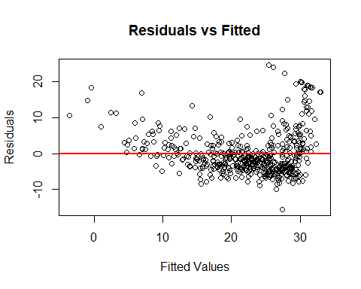 Comment We can observe from the residual plot that outliers are present both in the positive and negative direction but the residual plot is not sufficient to predict the presence of influential or leverage points.
####To find Potential Outliers:
We find out the standardized residuals from the fitted model. A point is declared as a potential outlier if its standradized residual is greater than 2 or less than -2.
std.res=rstandard(model)
outliers=which(abs(std.res)>2)
outliers
## 99 162 163 164 167 187 196 204 205 215 225 226 229 234 257 258 262 263 268 281
## 99 162 163 164 167 187 196 204 205 215 225 226 229 234 257 258 262 263 268 281
## 283 284 369 370 371 372 373 375 410 413 506
## 283 284 369 370 371 372 373 375 410 413 506
length(outliers)
## [1] 31
We observe 31 data points which can be potential outliers.

To find Leverge points
We obtain the diagonal elements of the Hat matrix. Then we obtain the cutoff point L=3*(p+1)/n where p is the number of predictors and n is number of rows. If the hat values exceed the leverage value then the points are called potential leverages.
lev=hatvalues(model)
n=nrow(df) #number of rows
p=4 #number of predictors
cutoff=3*(p+1)/n
cutoff
## [1] 0.02964427
leverage=which(lev>cutoff)
leverage
## 49 103 142 156 157 160 375 381 399 405 406 411 413 415 416 417 419 424 425 426
## 49 103 142 156 157 160 375 381 399 405 406 411 413 415 416 417 419 424 425 426
## 427 428 438 439 451 455 457 458 467
## 427 428 438 439 451 455 457 458 467
length(leverage)
## [1] 29
There are 29 potential leverage points.

To find Influential points
We find out the Cook’s distance Di which is a function of standardized residuals and elements of hat matrix. If for a data point Di>1, we can say that point is influential point.
di=cooks.distance(model)
influential=which(di>1)
length(influential)
## [1] 0
Conclusion In this model no value of Di exceeds one. So we can conclude that there exists no influential point.

