Problem Statement
Problem Definition:
Class 9 Biology introduces abstract and microscopic concepts such as cell structure, tissues, diversity in living organisms, and life processes. Students often struggle to visualize and conceptually connect these ideas, which results in misconceptions, surface learning, and rote memorization instead of deep understanding.

Stakeholder-wise Impact Analysis
1. Biology Teacher
Impact:
- Faces difficulty in explaining invisible or microscopic concepts without sufficient visual or experiential tools.
- Needs to spend extra instructional time on concept clarification and misconception correction.
- Increased pressure to balance conceptual teaching with syllabus completion and exam preparation.
- May experience teaching fatigue or frustration if learning outcomes are not achieved despite effort.
Nature of Impact:
High impact – direct responsibility for addressing the learning challenge.

2. Students
Impact:
- Difficulty in visualizing and understanding abstract biological processes.
- Development of misconceptions (e.g., confusing cell organelle functions, tissue types).
- Dependence on rote learning, leading to poor retention and application.
- Reduced interest, confidence, and performance in Biology and Science overall.
Nature of Impact:
Very high impact – primary affected group.

3. Curriculum Developers (CBSE / NCERT)
Impact:
- Curriculum may be perceived as conceptually dense or age-inappropriate for some learners.
- Learning outcomes may not be uniformly achieved across diverse classrooms.
- Feedback from schools may require revision of content sequencing, illustrations, or pedagogy guidelines.
- Necessitates alignment with competency-based education and NEP 2020 goals.
Nature of Impact:
Moderate impact – indirect but systemic responsibility.

4. School Academic Heads
Impact:
- Responsible for ensuring academic performance and curriculum implementation quality.
- Need to arrange teacher training, teaching aids, labs, and digital resources.
- May face pressure from management or parents if results decline.
- Required to support instructional innovation and remedial strategies.
Nature of Impact:
High impact – managerial and support role.

Stakeholder Impact Chart
Stakeholder | Level of Impact | Type of Impact | Key Concerns
Students | Very High | Academic, cognitive, emotional | Misconceptions, rote learning, low confidence
Biology Teacher | High | Instructional, professional | Teaching abstract concepts, time pressure
School Academic Heads | High | Administrative, academic | Learning outcomes, teacher support, results
Curriculum Developers (CBSE/NCERT) | Moderate | Systemic, curricular | Content load, sequencing, pedagogy design

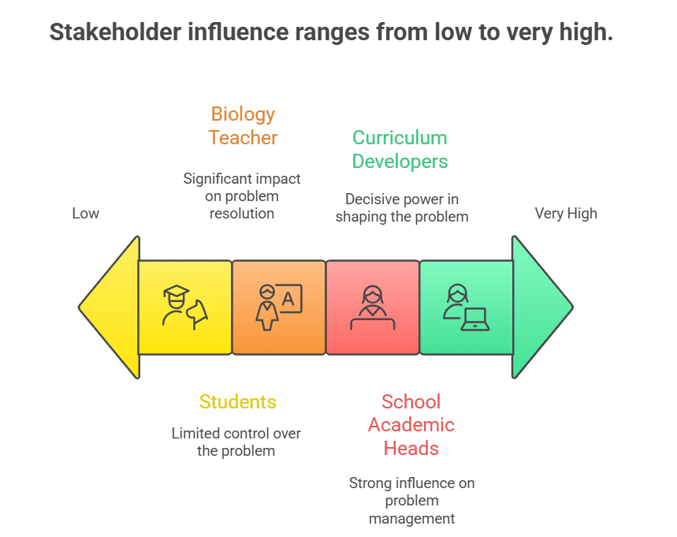
Stakeholder Impact Matrix (Influence vs Impact)
Stakeholder | Influence on Problem | Impact of Problem
Students | Low | Very High
Biology Teacher | High | High
School Academic Heads | High | High
Curriculum Developers | Very High | Moderate

Key Insight (One-line Conclusion)
The challenge of abstract concepts in Class 9 Biology most strongly impacts students, while teachers and academic heads act as critical change agents, and curriculum developers hold long-term systemic influence.

If you want, I can next:
- Add mitigation strategies mapped to each stakeholder
- Convert this into a CBSE-style case study
- Create a visual stakeholder map diagram for presentation

