**PRACTICAL NO 1**

**Understanding the working of NIC cards, Ethernet/Fast ethernet/ Gigabit Ethernet.**

**DIAGRAM:**

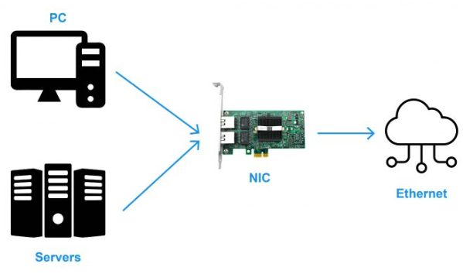

**WHAT IS NIC?**

A network interface card (NIC) is a hardware component, typically a circuit board or chip, installed on a computer so it can connect to a network. Modern NICs provide functionality to computers, such as support for [input/output](https://www.techtarget.com/whatis/definition/input-output-I-O) interrupt, [direct-memory access](https://www.techtarget.com/whatis/definition/Direct-Memory-Access-DMA) interfaces, data transmission, network traffic engineering and partitioning.

A NIC provides a computer with a dedicated, full-time connection to a network. It implements the [physical layer](https://www.techtarget.com/searchnetworking/definition/physical-layer) circuitry necessary for communicating with a data link layer standard, such as Ethernet or Wi-Fi. Each card represents a device and can prepare, transmit and control the flow of data on the network.

The NIC uses the Open System Interconnection ([OSI](https://www.techtarget.com/searchnetworking/definition/OSI)) model to send signals at the physical layer, transmit data packets at the network layer and operate as an interface at the [TCP/IP](https://www.techtarget.com/searchnetworking/definition/TCP-IP) layer.

**PURPOSE OF NIC:**

A NIC provides a computer with a dedicated, full-time connection to a network. It implements the physical layer circuitry necessary for communicating with a data link layer standard, such as Ethernet or Wi-Fi. Each card represents a device and can prepare, transmit and control the flow of data on the network.

**ADVANTAGES OF NIC:**

* As compared to the wireless network card, NIC provides a secure, faster, and more reliable connection.
* NIC allows us to share bulk data among many users.
* It helps us to connect peripheral devices using many ports of NIC.
* Communication speed is high.
* Network Interface cards are not expensive.

**DISADVANTAGES OF NIC:**

* NIC is inconvenient as compared to the wireless card.
* For wired NIC, a hard-wired connection is required.
* NIC needs a proper configuration to work efficiently.
* NIC cards are not secure, so the data inside NIC is not safe.

**TYPES OF NIC:**

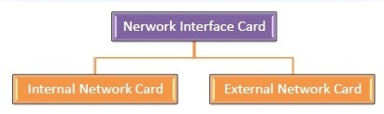

**DISCRIPTION:**

**Internal Network Card:** A network interface card (NIC) is a hardware component without which a computer cannot be connected over a network. It is a circuit board installed in a computer that provides a dedicated network connection to the computer. It is also called network interface controller, network adapter, or LAN adapter.

**External Network Card:** External network cards are of two types: Wireless and USB based. Wireless network card needs to be inserted into the motherboard, however no network cable is required to connect to the network. They are useful while traveling or accessing a wireless signal.

**HOW DOES NIC WORKS?**

Operating as an interface, a NIC card can transmit signals at the physical layer and deliver data packets at the network layer.

 Irrespective of location, the NIC card acts as a middleman between a computer, or server, and a data network.

When a user requests a web page, the LAN card gets data from the user device, sends it to the server via the Internet, and gets the required data back from the Internet to display for users.

**HOW DOES NIC TRNASMITTING THE DATA?**

A NIC (network interface controller) card, also known as a network adaptor or network interface card, is a circuit board that is installed on a computer to connect to the network.

The NIC uses the Open System Interconnection (OSI) model to send signals at the physical layer, transmit data packets at the network layer and operate as an interface at the TCP/IP layer. The NIC performs different functions for different layers of the OSI model.

**WHAT ARE COMPONENTS OF NIC?**

Components of NICs include the following:

Speed. All NICs have a speed rating in terms of megabits per second (Mbps) that determines the card's performance in a network. If the network's bandwidth is lower than the NIC or multiple computers connect with the same controller, the labeled speed decreases. The average Ethernet NICs come in 10 Mbps, 100 Mbps, 1000 Mbps and 1 gigabits per second varieties.

Driver. The required software that passes data between the computer's [operating system](https://www.techtarget.com/whatis/definition/operating-system-OS) and the NIC. When a NIC is installed on a computer, the corresponding driver software is also downloaded. Drivers must stay updated and uncorrupted to ensure optimal performance from the NIC.

* **MAC address.** Unique, unchangeable [media access control addresses](https://www.techtarget.com/searchnetworking/definition/MAC-address), also known as physical network addresses, are assigned to NICs. MAC addresses deliver Ethernet packets to the computer.
* **LED indicator.** Most NICs have an LED indicator integrated into the connector to notify the user when the network connects and data transmission occurs.
* **Router.** A router is sometimes needed to enable communication between a computer and other devices. In this case, the NIC connects to the router which is connected to the internet.

**ETHERNET**

**DIAGRAM:**

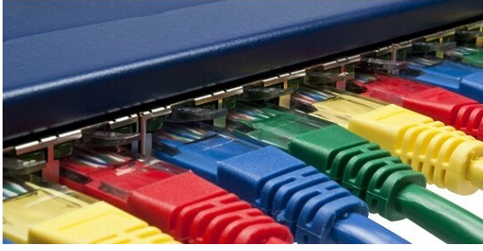

**WHAT IS ETHERNET?**

Ethernet is the traditional technology for connecting devices in a wired local area network (LAN) or wide area network. It enables devices to communicate with each other via a protocol, which is a set of rules or common network language.

Ethernet is a type of communication protocol that is created at Xerox PARC in 1973 by Robert Metcalfe and others, which connects computers on a network over a wired connection. It is a widely used LAN protocol, which is also known as Alto Aloha Network. It connects computers within the local area network and wide area network. Numerous devices like printers and laptops can be connected by [LAN and WAN](https://www.javatpoint.com/lan-vs-wan) within buildings, homes, and even small neighborhoods.

**ADVANTAGES OF ETHERNET:**

* Relatively low cost.
* Backward compatibility.
* Generally resistant to noise.
* Good data transfer quality.
* Speed.
* Reliability.
* Data security, as common firewalls can be used.

**DISADVANTAGES OF ETHERNET:**

* Intended for smaller, shorter-distance networks.
* Limited mobility.
* Use of longer cables can create cross-talk.
* Doesn't work well with real-time or interactive applications.
* Speeds decrease with increased traffic.
* Receivers don't acknowledge the reception of data packets.

**HOW DOES ETHERNET WORKS?**

At its core, Ethernet is a protocol that allows computers (from servers to laptops) to talk to each other over wired networks that use devices like routers, switches and hubs to direct traffic. Ethernet works seamlessly with wireless protocols, too.

Ethernet works by breaking up information being sent to or from devices, like a personal computer, into short pieces of different sized bits of information called frames. Those frames contain standardized information such as the source and destination address that helps the frame route its way through a network.

And because computers on a LAN typically shared a single connection, Ethernet was built around the principal of CSMA/CD, or carrier-sense multiple access with collision detection. Basically, the protocol makes sure that the line is not in use before sending any frames out. Today, that is far less important than it was in the early days of networking because devices generally have their own private connection to a network through a switch or node. And because Ethernet now operates using full duplex, the sending and receiving channels are also completely separate, so collisions can't actually occur over that leg of their journey.

**THE EVOLUATION OF ETHERNET/ HISTORY OF ETHERNET:**

The Ethernet protocol connects LANs, WANs, Internet, cloud, IoT devices, Wi-Fi systems into one seamless global communications network.

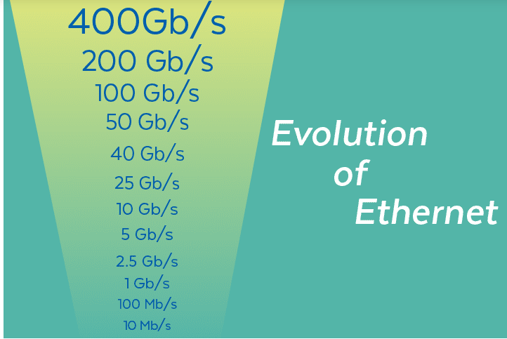

Ethernet is one of the original networking technologies, having been [invented 50 years ago](https://www.networkworld.com/article/972044/ethernet-at-50-bob-metcalfe-pulls-down-the-turing-award.html). And yet, because of the simplicity by which the communications protocol can be deployed and its ability to incorporate modern advancements without losing backwards compatibility, Ethernet continues to reign as the de facto standard for computer networking. As artificial intelligence (AI) workloads increase, network industry giants are teaming up to ensure Ethernet networks can keep pace and satisfy AI's high performance networking requirements.

At its core, Ethernet is a protocol that allows computers (from servers to laptops) to talk to each other over wired networks that use devices like routers, switches and hubs to direct traffic. Ethernet works seamlessly with wireless protocols, too.

Its ability to work within almost any environment has led to its universal adoption around the world. This is especially true because it allows organizations to use the same Ethernet protocol in their local area network (LAN) and their wide-area network (WAN). That means that it works well in data centers, in private or internal company networks, for internet applications and almost anything in between. It can even support the most complex forms of networking, like virtual private networks (VPNs) and [software-defined networking](https://www.networkworld.com/article/963971/what-sdn-is-and-where-its-going.html) deployments.

Ethernet has no problem handling bandwidth-intensive applications such as video streaming or voice over IP applications. And on the other end, its simplicity also enables it to work with very tiny, relatively unsophisticated devices such as those that make up the [Internet of Things](https://www.networkworld.com/article/963923/what-is-iot-the-internet-of-things-explained.html) (IoT), without any special configuration required.

**TYPES OF ETHERNET:**

**1. FAST ETHERNET:**

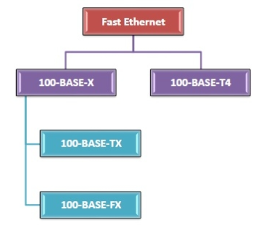

It is an Ethernet network capable of 100 Mbit/s data transmission. It may use twisted pairs or fiber optic cables. (The earlier 10 Mbit/s Ethernet is still deployed and utilized but lacks the bandwidth required for specific network video scenarios.)

Most network-connected devices, like laptops and network cameras, include a 100BASE-TX/10BASE-T Ethernet interface, often referred to as a 10/100 interface, that supports both 10 Mbit/s and Fast Ethernet. Cat-5 cable is the type of twisted pair cable which enables Fast Ethernet.

**2. GIGABIT ETHERNET.**

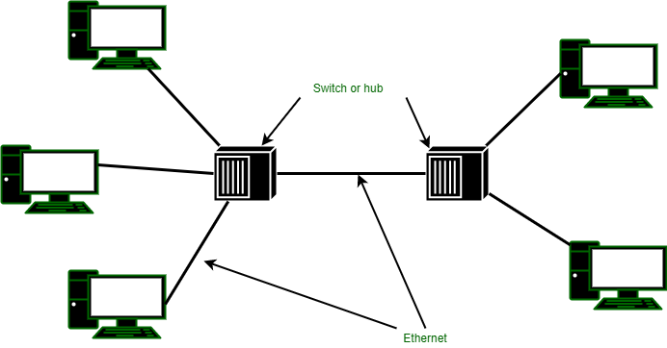

Gigabit Ethernet, which might alternatively be based on twisted pair or fiber optic cable, provides a data transfer rate of one gigabit per second (1 Gbit/s) and is gaining in popularity. It is anticipated to supersede Fast Ethernet as the de facto norm in the near future.

Cat-5e is the kind of twisted pair cable which enables Gigabit Ethernet, in which all four types of twisted wires are used to accomplish high data speeds. Cat-5e cables or higher are suggested for networked video systems. Most interfaces are interoperable with 10 and 100 Mbit/s Ethernet and therefore are frequently referred to as 10/100/1000 interfaces.

**PRACTICAL – III**

**……INTERNET…..**

* **Internet Diagram**

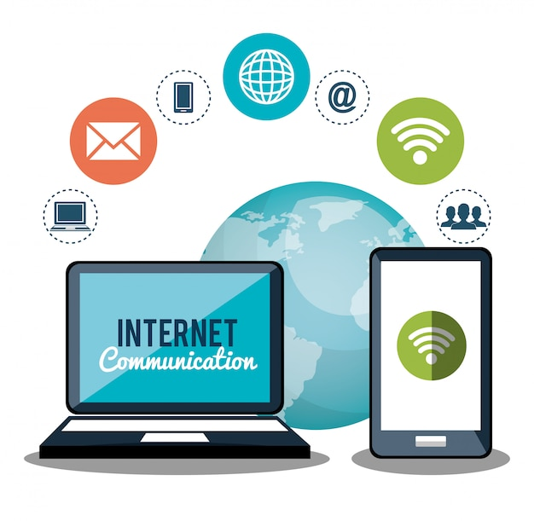

* **Internet Info**

The Internet is theforemost important tool and the prominent resource that is being used by almost every person across the globe. It connects millions of computers, webpages, websites, and servers. Using the internet we can send emails, photos, videos, and messages to our loved ones. Or in other words, the Internet is a widespread interconnected network of computers and electronic devices(that support Internet). It creates a communication medium to share and get information online. If your device is connected to the Internet then only you will be able to access all the applications, websites, social media apps, and many more services. The Internet nowadays is considered the fastest medium for sending and receiving information.

* **Who invented internet?**

Vinton Cerf and Bob Kahn

* **How does internet work?**

The actual working of the internet takes place with the help of [clients and servers](https://www.geeksforgeeks.org/client-server-model/). Here the client is a laptop that is directly connected to the internet and servers are the computers connected indirectly to the Internet and they are having all the websites stored in those large computers. These servers are connected to the internet with the help of [ISP (Internet Service Providers)](https://www.geeksforgeeks.org/isp-full-form/) and will be identified with the IP address.

Each website has its Domain name as it is difficult for any person to always remember the long numbers or strings. So, whenever you search for any domain name in the search bar of the browser the request will be sent to the server and that server will try to find the IP address from the Domain name because it cannot understand the domain name. After getting the IP address the server will try to search the IP address of the Domain name in a Huge phone directory that in networking is known as a [DNS server (Domain Name Server)](https://www.geeksforgeeks.org/domain-name-system-dns-in-application-layer/). For example, if we have the name of a person and we can easily find the Aadhaar number of him/her from the long directory as simple as that.

So after getting the IP address, the browser will pass on the further request to the respective server and now the server will process the request to display the content of the website which the client wants. If you are using a wireless medium of Internet like 3G and 4G or other mobile data then the data will start flowing from the optical cables and will first reach towers from there the signals will reach your cell phones and PCs through electromagnetic waves and if you are using routers then optical fiber connecting to your router will help in connecting those light-induced signals to electrical signals and with the help of ethernet cables internet reaches your computers and hence the required information.

* **Advantages**
* **Online Banking and Transaction:**The Internet allows us to transfer money online through the net banking system. Money can be credited or debited from one account to the other.
* **Education, Online Jobs, Freelancing:**Through the Internet, we are able to get more jobs via online platforms like Linkedin and to reach more job providers. Freelancing on the other hand has helped the youth to earn a side income and the best part is all this can be done via the INTERNET.
* **Entertainment:**There are numerous options for entertainment online we can listen to music, play games can watch movies, and web series, and listen to podcasts, youtube itself is a hub of knowledge as well as entertainment.
* **Best Communication Medium:**The communication barrier has been removed from the Internet. You can send messages via email, Whatsapp, and Facebook. Voice chatting and video conferencing are also available to help you to do important meetings online.
* **GPS Tracking and google maps:**Yet another advantage of the internet is that you are able to find any road in any direction, and areas with less traffic with the help of GPS on your mobile.
* **Disadvantages**
* **Time Wastage:** Wasting too much time on the internet surfing social media apps and doing nothing decreases your productivity rather than wasting time on scrolling social media apps one should utilize that time in doing something skillful and even more productive.
* **Bad Impacts on Health**: Spending too much time on the internet causes bad impacts on your health physical body needs some outdoor games exercise and many more things. Looking at the screen for a longer duration causes serious impacts on the eyes.
* **Cyber Crimes:**[Cyberbullying](https://www.geeksforgeeks.org/what-is-cyber-bullying-definition-types-effects-laws/), spam, viruses, hacking, and stealing data are some of the crimes which are on the verge these days. Your system which contains all the confidential data can be easily hacked by [cybercriminals](https://www.geeksforgeeks.org/cyber-criminals-and-its-types/).
* **Effects on Children:**Small children are heavily addicted to the Internet watching movies, and games all the time is not good for their overall personality as well as social development.
* **Bullying and Spreading Negativity:**The Internet has given a free tool in the form of social media apps to all those people who always try to spread negativity with very revolting and shameful messages and try to bully each other which is wrong.
* **TYPES OF INTERNET**

• Dial-Up Connection

• Broadband Connection.

• DSL

• Cable

• Satellite Connection

• Wireless Connection

• Cellular

• ISDN

**…….INTRANET……**

* **Intranet Diagram**

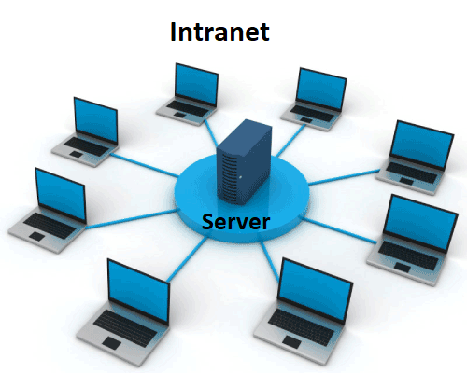

* **What is intranet?**

An intranet is a kind of private [network](https://www.geeksforgeeks.org/what-is-computer-networking/). For example, an intranet is used by different organizations and only members/staff of that organization have access to this. It is a system in which multiple computers of an organization (or the computers you want to connect) are connected through an intranet. As this is a private network, so no one from the outside world can access this network. So many organizations and companies have their intranet network and only its members and staff have access to this network. This is also used to protect your data and provide [data security](https://www.geeksforgeeks.org/data-security/) to a particular organization, as it is a private network and does not leak data to the outside world

* **How are intranet used?**

An intranet software is mainly used by organizations as a tool :

* Intranet share organizational updates.
* Intranets become the center repository where important information. news and company data are stored. We can store files using intranet.
* Easy to communicate with employees. They create employee directories and organization charts readily available, improving internal corporate communications. Intranet connect employees of the organization
* Easy to access information. Using intranet collaborate with teams across borders
* Productivity increase using Intranet.
* Give employees a voice in the organization
* **How does intranet works?**

An intranet is a network confined to a company, school, or organization that works like the Internet. Let us understand more about the working of the intranet with the help of a diagram, as shown below:

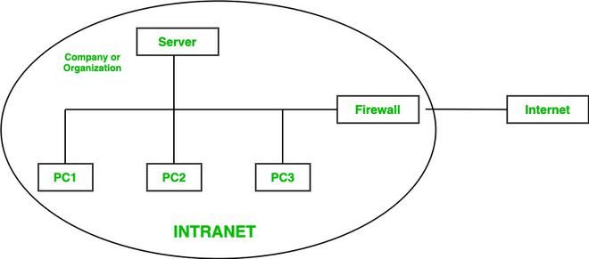

Here in this diagram, a company or an organization has created its private network or intranet for its work(intranet network is under the circle). The company or organization has many employees(in this diagram, we have considered 3). So, for their access, they have PC 1, PC 2, and PC 3(In the real world there are many employees as per the requirements of an organization). Also, they have their server for files or [data](https://www.geeksforgeeks.org/what-is-data/) to store, and to protect this private network, there is a [Firewall](https://www.geeksforgeeks.org/introduction-of-firewall-in-computer-network/). This firewall protects and gives security to the intranet [server](https://www.geeksforgeeks.org/introduction-of-server/) and its data from getting leaked to any unwanted user. So, a user who has access to the intranet can only access this network. So, no one from the outside world can access this network. Also, an intranet user can access the [internet](https://www.geeksforgeeks.org/internet-and-its-services/)but a person using the internet cannot access the intranet network.

* **Advantages**
* In the intranet, the cost of conveying data utilizing the intranet is very low.
* Using intranet employees can easily get data anytime and anywhere.
* It is easy to learn and use.
* It can be utilized as a correspondence center point where employees can store data at whatever point they need and download files in just a few seconds.
* It connects employees with each other.
* The documents stored on the intranet are much more secure.
* **Disadvantages**
* The expense of actualizing intranets is normally high.
* The staff of the company or organization require special training to know how to use the system.
* Data overloading.
* Although the intranet provides good security, but it still lacks in some places.

**……EXTRANET…..**

* **Extranet Diagram**

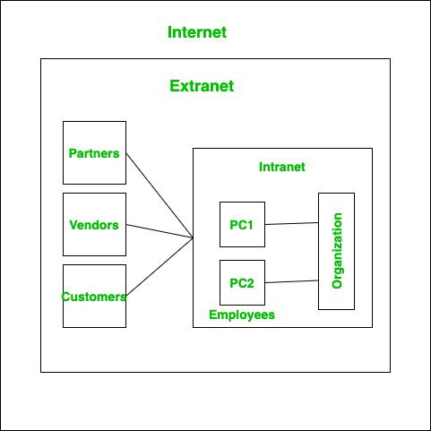

* **What is Extranet?**

An extranet is an organization’s private network and its available only for selected users. It’s a way to connect to third parties like vendors, customers, and partners in a secure and controlled way. The users typically have a login mechanism such as username and password to access the network. Extranet in simple terms provides a secure network for an organization to share information with relevant people outside the organization. It is part of an organization’s intranet divided via a firewall.

* **How are Extranet used**

An extranet provides an organization's external partners with access to select internal information and applications. They are particularly effective in cases where an organization needs to share large volumes of data

* **How does Extranet Works?**

An extranet is a private network similar to an intranet, but typically open to external parties, such as business partners, suppliers, key customers, etc. The main purpose of an extranet is to allow users to exchange data and applications, and share information.

* **Advantages**
* **Security:** Extranet is formed as a Virtual private network ([VPN](https://www.geeksforgeeks.org/virtual-private-network-vpn-introduction/)) as it assures a protected and secure communication across the network. The information shared between the organizations could be highly confidential and an extra level of security makes sure that none of it is lost or accessed by anyone else other than the parties involved.
* **Data:**Sometimes there could be a large amount of data to be transferred between organizations. An extranet allows a large amount of data transfer across the network in a secure fashion.
* **Network Sharing:**One or multiple organizations could connect via the extranet. For example, three organizations collaboratively working on the same project could make use of an extranet or an e-commerce site sharing its network with various small businesses.
* **Communication:** It is a medium for internal and external members to connect or organizations to connect to third parties. Instead of allowing third parties in the company’s intranet network and giving access to the internal resources, the extranet provides a lot more flexibility and security for everyone to communicate.
* **Disadvantages**
* **Complex Security:**Extranet needs an additional firewall if hosted on its own server which expands workload and complex security mechanism.
* **Hosting:**Hosting could be an issue as it requires a high bandwidth internet connection. A High bandwidth internet connection may not be possible for everyone, which would lead to inefficiency in work.
* **Expensive:** It is costly compared to intranet due to the extra layer of security and hosting charges.
* **limited:**It can only be accessed through the internet. So, the work would came to halt or slow down if the internet goes down.

|  |  |  |
| --- | --- | --- |
| **Adress Class** | **Range** | **Default Subnet Mask** |
| A | 1.0.0.0 to 126.255.255.255 | 255.0.0.0 |
| B | 128.0.0.0 to 191.255.255.255 | 255.255.0.0 |
| C | 192.0.0.0 to 223.255.255.255 | 255.255.255.0 |
| D | 224.0.0.0 to 239.255.255.255 | Reserved for Multicasting |
| E | 240.0.0.0 to 254.255.255.255 | Experimental |

**Note : Class A addresses 127.0.0.0 to 127.255.255.255 cannot**