ASSIGNMENT 3

Multivariate Linear Regression

Mahima V PES1201700665

Amrita hegde PES1201700970

Chaitra H P PES1201701370

Problem Statement:

Use Multivariate linear Regression on the iris dataset to predict the classification.Also find the model accuracy.

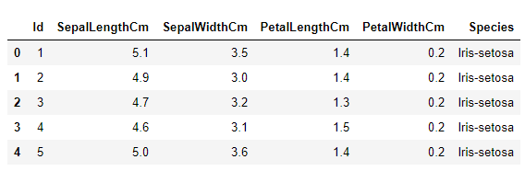

Theta : [[1.76405235 0.40015721 0.97873798 2.2408932 1.86755799]]

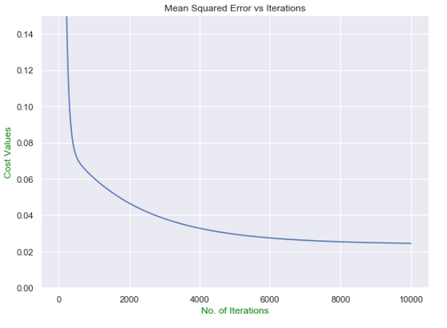

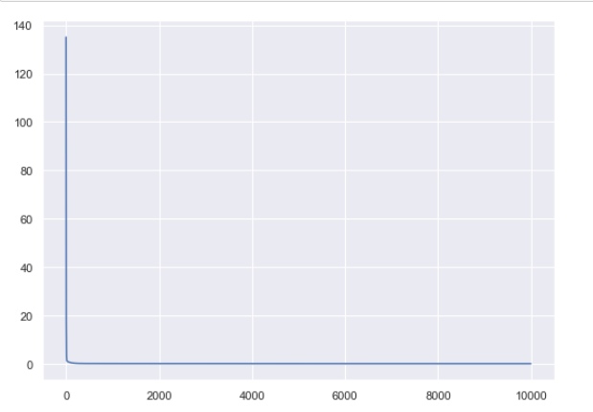

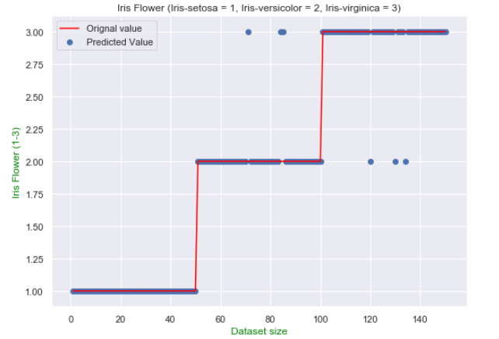

The model predicted values of Iris dataset with an overall accuracy of 96.0