ASSIGNMENT 5

Moving Averages

Mahima V PES1201700665

Amrita hegde PES1201700970

Chaitra H P PES1201701370

Problem Statement:

Use Moving Average to forecast values in a dataset that has trend component.

Plotting Data

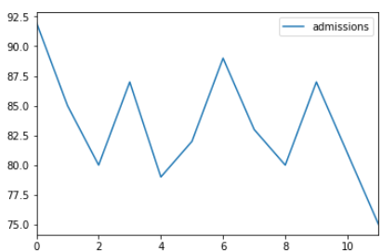

MSE = [17.99999887 24.6328125 24.92571524 21.48610899]

Best MSE = 17.99999886972364

MA = 81.0

After Forecasting Values

