ASSIGNMENT 5

Weighted Moving Averages

Mahima V PES1201700665

Amrita hegde PES1201700970

Chaitra H P PES1201701370

Problem Statement:

Use Weighted Moving Average to forecast values in a dataset that has trend component and plot the results to compare with actual values.

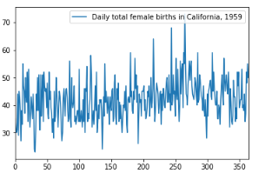

Best MSE = 47.17514578536712

Optimal n = 47

MA = 43.54609929078014

