ASSIGNMENT 5

Simple Exponential Smoothing

Mahima V PES1201700665

Amrita hegde PES1201700970

Chaitra H P PES1201701370

Problem Statement:

Apply Simple exponential smoothing on a dataset to forecast the values.Plot the graph of forecasted vs actual values to check accuracy.

Plotting the Data:

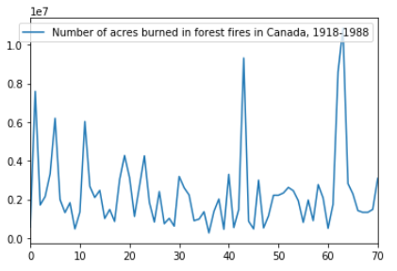

Best MSE = 4417861521188.411

Optimal alpha = 0.1

Next observation = 2610828.585561429

Plotting the data After Forecasting:

