ASSIGNMENT 3
Multivariate Linear Regression
Mahima V PES1201700665
Amrita hegde PES1201700970
Chaitra H P PES1201701370
Problem Statement:
Use Multivariate linear Regression on the iris dataset to predict the classification.Also find the model accuracy.
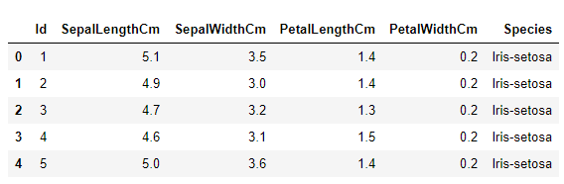
Theta : [[1.76405235 0.40015721 0.97873798 2.2408932 1.86755799]]

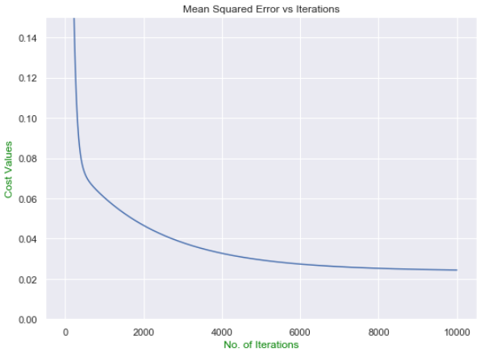
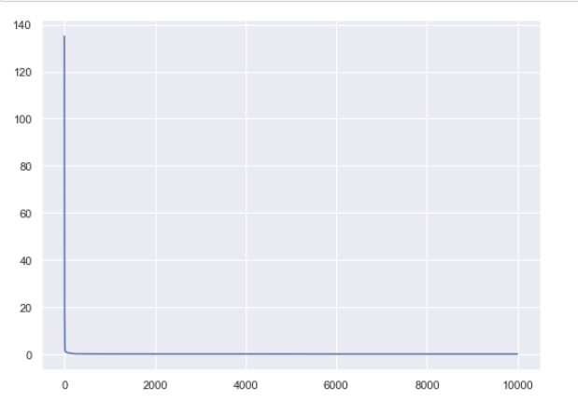

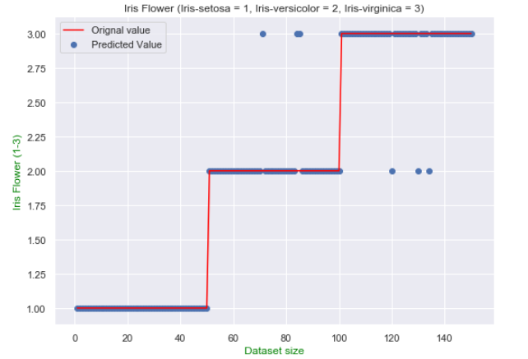

The model predicted values of Iris dataset with an overall accuracy of 96.0

