ASSIGNMENT 5
Moving Averages
Mahima V PES1201700665
Amrita hegde PES1201700970
Chaitra H P PES1201701370

Problem Statement:
Use Moving Average to forecast values in a dataset that has trend component.

Plotting Data
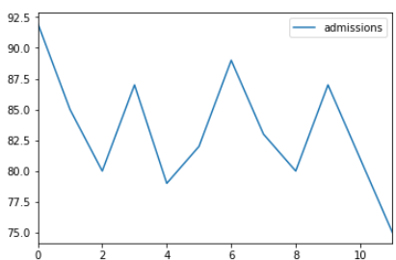

MSE = [17.99999887 24.6328125 24.92571524 21.48610899]
Best MSE = 17.99999886972364

MA = 81.0

After Forecasting Values
