ASSIGNMENT 5
Weighted Moving Averages
Mahima V PES1201700665
Amrita hegde PES1201700970
Chaitra H P PES1201701370
Problem Statement:
Use Weighted Moving Average to forecast values in a dataset that has trend component and plot the results to compare with actual values.
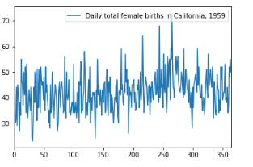
Best MSE = 47.17514578536712
Optimal n = 47

MA = 43.54609929078014
