ASSIGNMENT 5
Simple Exponential Smoothing
Mahima V PES1201700665
Amrita hegde PES1201700970
Chaitra H P PES1201701370

Problem Statement:
Apply Simple exponential smoothing on a dataset to forecast the values.Plot the graph of forecasted vs actual values to check accuracy.
Plotting the Data:
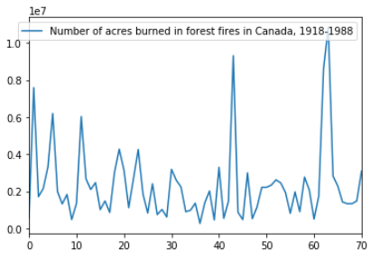

Best MSE = 4417861521188.411
Optimal alpha = 0.1

Next observation = 2610828.585561429

Plotting the data After Forecasting:

