* **Staging Publish**

Requirement: Update the Application:-

1. Bring the site down, update and bring it back up

2. Upload the content of v2 in different workspace which is a part of web service itself

3. Then swap v1 and v2.

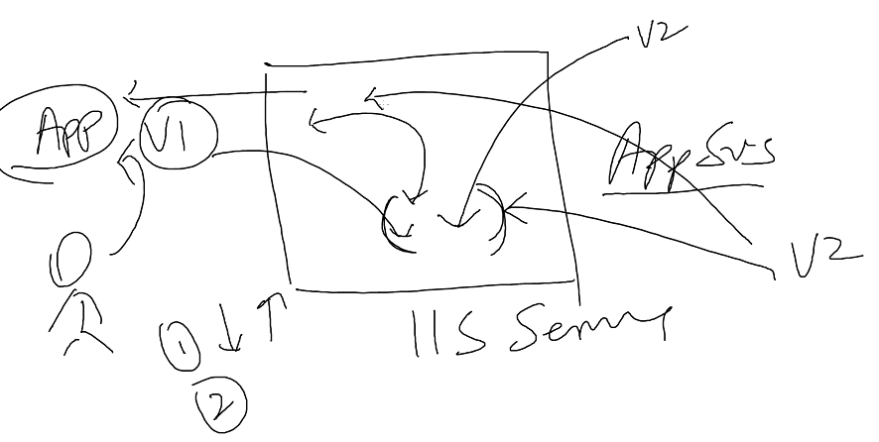

1. Create App service (Quickly and easily build web and mobile apps for any platform or device with Azure App Service.)
2. Using market place (can get different solutions), deploy web App
3. This works with DNS name(e.g. simplilearnweb)
4. Windows
5. Service plan
6. App Service Plan/ Location
7. Create App Service Plan(e.g. appsvsplan)
8. Select pricing

Website is ready, don’t have to build VM, configure IIS. My website is ready... just browse.

1. Put some template (download HTML5 Template)

**Using FTP:**

1. Copy the FTP hostname of App service and username and pate in FileZilla client.
2. We can use FTP, Web Deploy etc. to upload template to Web App

* Select Deployment Credentials (used with GIT and FTP) (download FillZilla, it uses port number: 21)
* Upload the files from local directories to remote Site( /site/wwwroot)

1. Create deployment slot i.e. staging area

* Upload the files from local directories to remote Site( /site/wwwroot)

1. Update production site, Now we can Swap from source to destination

**Using Visual Studio:**

1. Right click project – Publish Web App – Select Microsoft azure - select subscription –View(resource Group)
2. Create
3. If we want to create new then click new
4. Create

It will upload in production

* **DEMO Traffic Manager (Checking for Geo)**

1. Create two Web Sites

* WebAppUStm – upload some template using filezilla
* WebAppSEAtm

1. Create Traffic Manager profile – Add two end points

* Click on Endpoints – Add

Type: Azure Endpoint

Name: endpointUS

Target resource type: AppService

Target resource: WebAppUStm

Region Grouping: US

* Create

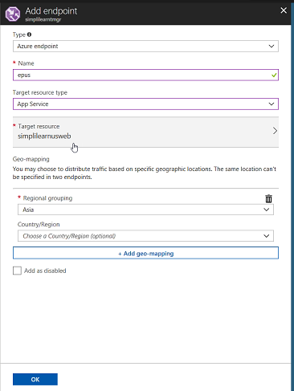

So, suppose I am in India then it will redirect me to server in US but technically it should redirect SEA.In Short, if I am in Asia and I want to access WebApp which is in US server then Asia region should be added in US Endpoint and vice versa.

**Azure SQL database**

**Using SQL Server management**

1. Create SQL database
2. Sample database
3. Configure Server
4. Pricing planes, DTU -database transaction plan(input and output speed control)

Storage- 4 DB

1. Create
2. Copy server name and Connect this to sql server management

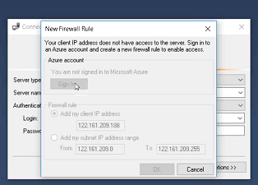

**Using visual studio**

1. Create sql server – it’s a logical entity we don’t pay for it
2. Create sql database
3. Access this using visual studio
4. Open sql server object explorer
5. Manage sql subscription
6. Close
7. Add sql server - Connect to cloud server

**How to add Active Directory admin:**

1. Select sql server
2. Configure Active directory admin
3. Set admin

* Selet sql database –export - storage account – create container – select the container – password
* Show the files:

SQL storage – blobs – sql export - .bacpac file

* Open SQL server and import database
* Creating Automation Account

Automation Account – RunBooks – backup sql blobs –import – schedule this

* Geo replication

Select database – Geo-replication – West US – target server – configure pricing – ok

**Elastic pool**

1. Select SQL elastic pool
2. Create server with username and password
3. Pricing tier
4. Configure pool DTU = 200, space 250 GB
5. Create
6. Now start adding database

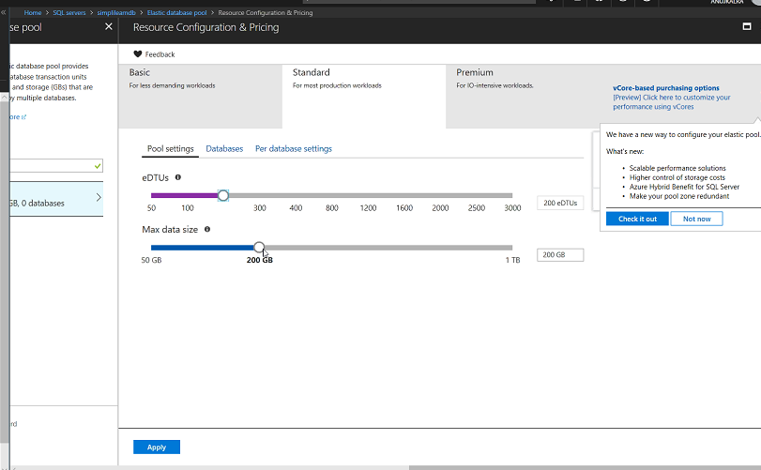

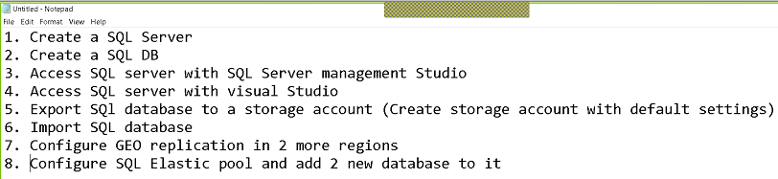

**Application insight**

1. Create Web Application
2. Turn on Application insight
3. Create
4. Create web app in Visual studio
5. Right click application And add application insight

**Load Balancer**

1. Create two VMs (keep both the VMs in same availability set and same network)
2. Set no firewall
3. Create load balancer

Load balancer are of two types internal and public

SKU is new, availability zone is new (related to infrastructure)

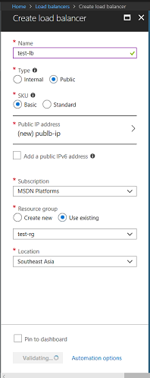

1. Backend pool is where traffic will be routed.

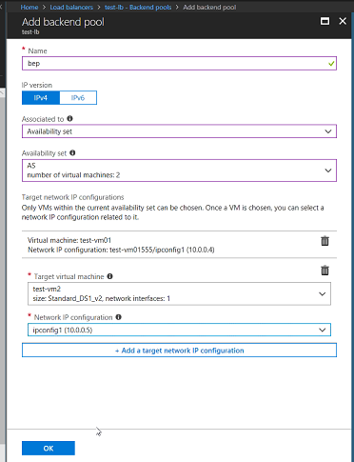

1. Health probes (if one VM stopped working then Load balancer should not send any connection to that VM, health probe keeps checking the service)

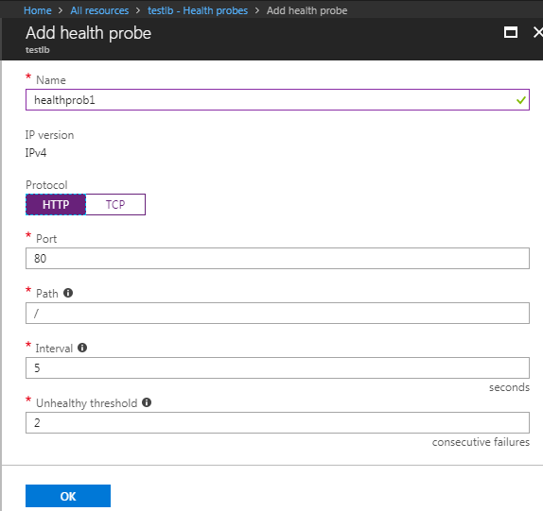

1. Load Balancing rules

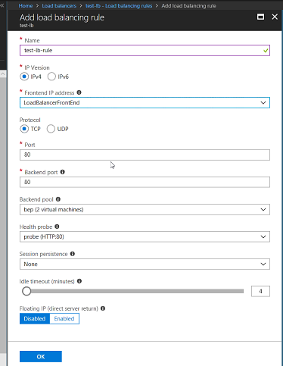

Load Balancer is ready.

1. If we will install IIs on both the Machines then our Load Balancer will work

**Traffic Manager**

1. Create app service in Central Us
2. Create another web app in southeast Asia
3. Add traffic manager

All resources are in different resource group

1. Upload a file using FTP in one web app
2. Go to traffic manager and add two end points
3. Run the respective web app in particular country.

User will get the app which is near to the user’s data center

1. Add another load balancer

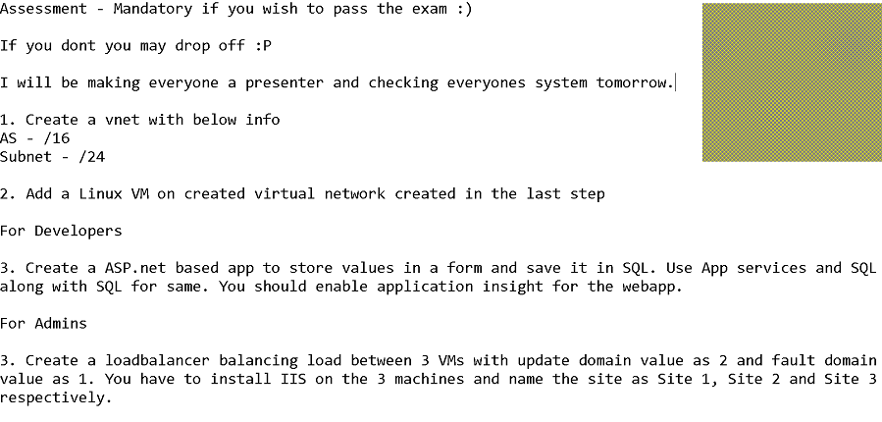

Labs:

1. Create app service

This is the application which is deployed in cloud and we have to add authentication to this app.

1. Go to authentication and authorization
2. Select AD

Express

Advance

1. Create
2. Set App service authentication – on
3. Click Active Directory Authentication – Express
4. Create App
5. Ok

Now will create a user account

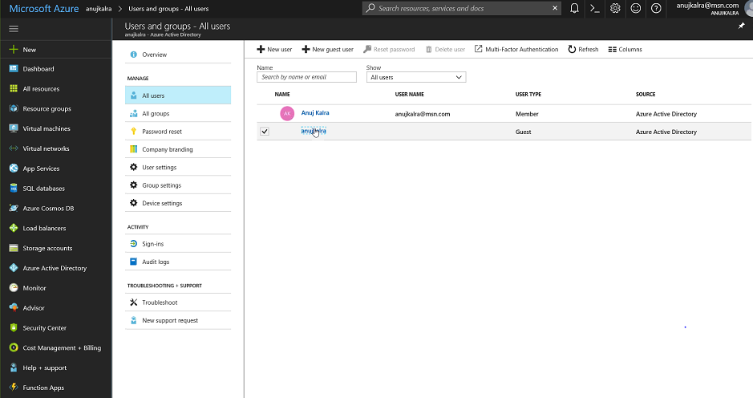

1. Select Azure Active Directory
2. All users
3. Create guest user and activate the user
4. Now browse the application
5. And login using new user
6. Create new Web App
7. To Add app- go to AD
8. Enterprise Application
9. New application
10. Ok take me to new app registration
11. Create new app registration
12. Single sign on url – copy the url of app
13. Check the registered app in Active directory
14. App registrations
15. Add end points
16. Copy any end point and run in browser
17. Now select advance

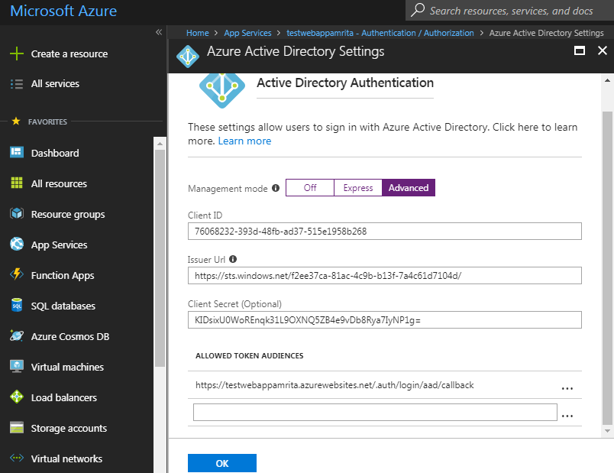

1. Save
2. Open with chrome