1. If you wanted to force traffic flowing to and from VM to pass over your corporate network before traveling to internet what resource do you use?

User defined routes and network appliances

User-defined, routes in Azure to override Azure's default system routes, or to add additional routes to a subnet's route table.

1. Can we have multiple instances of a web application

Yes, auto calling works on this.

1. Web app pricing plans

Basic

Shared

Free

Standard

1. When creating an Azure Web App, a production deployment slot is automatically provisioned that represents your live Web App.

TRUE

1. In addition to the Production deployment slot, how many additional deployment slots can you create with the Standard Pricing Plan?

4 slots

1. Where are all deployment slots for the same Web App hosted?

Within the same virtual machine (VM) instance as the Production deployment slot

All deployment slots for the same Web App are hosted within the same Virtual Machine (VM). This is especially important to remember when stress testing a non-production deployment slot prior to swapping it into production. A significant amount of load on a non-production deployment slot can affect the performance of the live, production Web App.

1. Along with swapping Web App content when deployment slots are swapped, which configurations are moved to the destination slot?  
     
   Select all that apply

Connection strings

General settings (Always On, Web Sockets, .NET version, etc)

Handler mappings

Application and site diagnostics settings

Monitoring settings

1. Two Web Apps cannot share the same web hosting plan

Two Web Apps are able to share the same hosting plan, as long as they are created within the same region, resource group and subscription.

1. The Classic Azure Portal supports migrating a Web Apps between hosting plans?

The existing Azure portal does not support migrating Web Apps between hosting plans.

1. The Azure Portal supports migrating a Web Apps between hosting plans?

TRUE

11. You have the following C# code for retrieving a Connection String for a SQL Azure database named "myDatabase" for use within the app. Line numbers are for reference only.

1. using System;

2. using System.Configuration;

[...]

3. var connString = string.Empty

Choose which line of code to replace Line # 3 to make this snippet work as expected.

var connString = ConfigurationManager.ConnectionStrings["myDatabase"].ConnectionString

1. You have the following Node.js code for retrieving a Connection String for a SQL Azure database named "myDatabase" for use within the app.

var connString = string.Empty

Choose which line of code can be used to make this snippet work as expected.

var connString = process.env.SQLAZURECONNSTR_myDatabase;

1. Both Connection Strings and App Settings can be modified when accessed from application code?

App Settings and Connection Strings are read-only when accessed from application code. To modify their values, you must either use the Management Portal, Azure Management API, Azure Powershell, or Xplat-CLI.

1. When configuring Request Handlers, what format is required for the Processor Path?

The Processor Path is required to be an Absolute path.  
  
If the directory the processor you're using is located is:  
C:\intepub\wwwroot\bin\php  
Then the Processor Path must be like the following:  
C:\inetpub\wwwroot\bin\php\php-cgi.exe

1. When using the PHP support built in to Azure Web Apps, do you need to manually configure the PHP Request Handler mapping? 

No, the only time you need to configure the PHP request handler mapping would be if you are using a different PHP runtime that the one included with Azure.

1. Only a single Application can be hosted within a Web App. Multiple Web Apps need to be created to host multiple applications.

Yes, Multiple applications can be hosted within a single Web App by configuring a Virtual Directory for each as an Application within the "Virtual Applications and Directories" configuration.  
A direct analogy to this are Virtual Applications within IIS. In fact, Web Apps on Azure are hosted using IIS web server behind the scenes.

1. What DNS record type is set when mapping a Custom Domain to be an alias for the default {sitename}.azurewebsites.net domain name assigned to a Web App by Azure?

CNAME

1. What DNS record type is set when mapping the IP Address for a Web App to a Custom Domain? 

A

1. The DNS records for your Web App are managed directly within the Application Settings in Azure.

FALSE

1. Which App Service Pricing Plans support Custom Domains? 

Free



Shared



Basic



Standard

1. Before mapping a Custom Domain to the "my-amazing-app" Web App using a DNS alias to the IP Address, the custom domain name needs to have a CNAME record created with what value?

awverify.my-amazing-app.azurewebsites.net

Setting up a CNAME record of "awverify.{sitename}.azurewebsites.net" (substitute the "{sitename}" with the name of the Azure Web App) within the DNS of the Custom Domain lets Azure verify that you either own or otherwise have control over the domain name.  
This CNAME record must be created on the Custom Domain name prior to setting up the Custom Domain within the Azure Web App configuration.

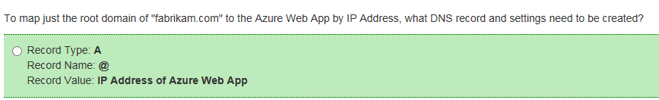

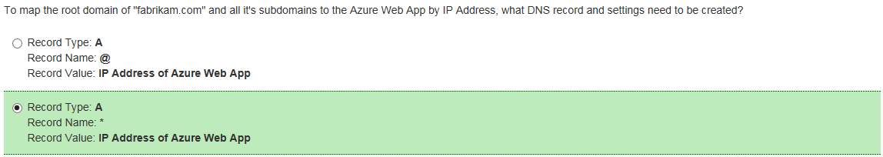

24

